Set 22: Molecular Nomenclature

Skill 22.01: Be able to name binary covalent compounds using the prefix system
Skill 22.02: Be able to apply the appropriate rules for naming a compound

Skill 22.01: Be able to name binary covalent compounds using the prefix system

Skill 22.01 Concepts

Binary covalent compounds are formed between two nonmetals (in general). The following prefixes can be used to denote the number of each element in the compound. Like binary ionic compounds, remember to change the ending to –ide. Using the prefixes indicated below, CO₂ would be called carbon dioxide.

Prefix | Number indicated
Mono- | 1
di- | 2
Tri- | 3
Tetra- | 4
Penta- | 5
Hexa- | 6
Hepta- | 7
Octa- | 8
Nona- | 9
Deca | 10

Skill 22.01 Problem 1
Name the following compounds:
- PCl₅

- PCl₃

- SF₆

- H₂O

- P₂O₅

Skill 22: Be able to apply the appropriate rules for naming a compound

Skill 22.02 Concepts

So far you have learned how to name many different types of compounds. Often times, however, the more confusing part is deciding when to apply which set of rules. The strategy outlined below is useful.

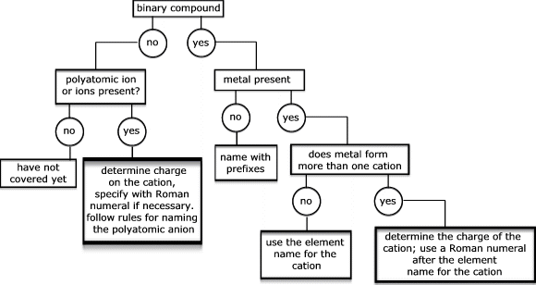
*two different elements only

Skill 22.02 Problem 1
Use the strategy outlined to name the following compounds:
- NaBr

- Li₂SO₄

- Pb(NO₃)₂

- CO₂

(e) CCl₄

Skill 22.02 Problem 2
Given the following systematic names, write the formula for each compound
(a) Vanadium(V) fluoride

(b) Sodium oxide

(c) Dihydrogen oxide

(d) Potassium cyanide

(e) Lead(IV) sulfide

(f) Aluminum hydrogen sulfite

