Set 23: Metallic Bonding

Skill 23.01: Explain the “electron sea model” involving delocalized electrons.
Skill 23.02: Explain how a bonding model involving delocalized electrons is consistent with the observed properties of metals (e.g., conductivity, malleability, ductility, and low volatility)
Skill 23.03: Use the electron sea model of metallic bonding to predict or make claims about the properties of metals or alloys.

Skill 23.01: Explain the “electron sea model” involving delocalized electrons.

Skill 23.01 Concepts

Although metal atoms always have least one valence electron, they do not share these valence electrons with neighboring atoms, nor do they lose their valence electrons. Instead, within the crowded lattice, the outer energy levels of the metal atoms overlap. This unique arrangement is describe as the electron sea model. The electron sea model proposes that all the metal atoms in a metallic solid contribute their valence electrons to form a “sea” of electrons. This sea of electrons surrounds the metal cations in the lattice.

The electrons present in the outer energy levels of the bonding metallic atoms are not held by any specific atom and can move easily from one atom to the next. Because they are free to move, they are often referred to as delocalized electrons. When the atom’s outer electrons move freely throughout the solid, a metallic cation is formed (Figure 1). Each such ion is bonded to all neighboring metal cations by the sea of valence electrons. A metallic bond is the attraction of a metallic cation for delocalized electrons.

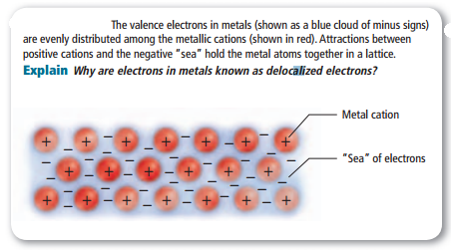
Figure 1. Delocalized electrons

Skill 23.01 Problem 1
Explain why metals are generally good conductors while ionic compounds are not.

Skill 23.02: Explain how a bonding model involving delocalized electrons is consistent with observed properties of metals (e.g., conductivity, malleability, ductility, and low volatility)

Skill 23.02 Concepts

The physical properties of metals can be explained by metallic bonding. These properties provide evidence of the strength of metallic bonds.

Melting and boiling points

The melting points of metals vary greatly. On the other hand, tungsten has a melting point of 3422ºC. In general, metals have moderately high melting points and high boiling points (Figure 2). The melting points are not as extreme as the boiling points because the cations and electrons are mobile in the metal. It does not take an extreme amount of energy for them to be able to move past each other. However, during boiling, atoms must be separated from the group of cations and electrons, which requires much more energy.

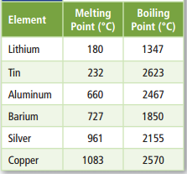
Figure 2. Melting and boiling points

Malleability, ductility, and durability

Metals are malleable, which means they can be hammered into sheets, and they are ductile, which means they can be drawn into wire. Figure 3 shows how the mobile particles involved in metallic bonding can be pushed or pulled past each other. Metals are generally durable. Although metallic cations are mobile in a metal, they are strongly attracted to the electrons surrounding them and are not easily removed from the metal.
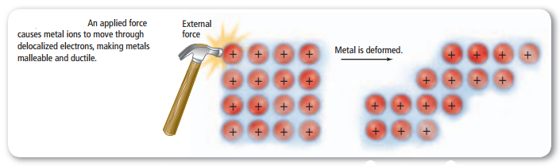
Figure 3. The movement of metal cations through delocalized electrons

Hardness and strength
The mobile electrons in transition metals consist not only of the two outer “s” electrons but also the inner “d” electrons. As the number of delocalized electrons increases, so do the properties of hardness and strength. For example, strong metallic bonds are found in transition metals such as chromium, iron, and nickel, whereas alkali metals are considered soft because they have only one delocalized electrons. Moreover, group I elements have large atomic radii so the delocalized electrons are further away from the nucleus resulting in a weaker metallic bond
Skill 23.02 Problem 1
Explain how a bonding model involving delocalized electrons is consistent with macroscopic properties of metals (e.g., conductivity, malleability, ductility, and low volatility)

Skill 23.02 Problem 2
Refer to the metal points in the figure below.
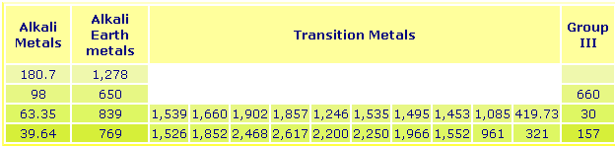
Account for the following differences between.

  - Na and Mg

  - Na and K

  - K and Fe

Skill 23.03: Students can use the electron sea model of metallic bonding to predict or make claims about the macroscopic properties of metals or alloys.
Skill 23.03 Concepts
An alloy is a material that contains more than one element and has the characteristic properties of metals. Due to the nature of metallic bonds, it is relatively easy to introduce other elements into the metallic crystal, forming an alloy.
Solution alloys are homogeneous mixtures in which the components are dispersed randomly and uniformly. Atoms of the solute can take positions normally occupied by a solvent atom, thereby forming a substitutional alloy, or they can occupy interstitial positions, thereby forming an interstitial alloy. These types are diagrammed in figure 3. Solid solution formation usually causes increase of electrical resistance and mechanical and decrease of plasticity of the alloy.
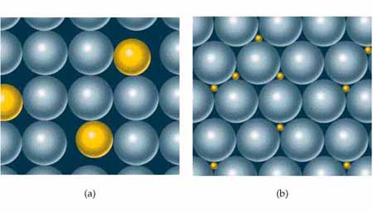
Figure 3: a) Substitutional and (b) interstitial alloys. The blue spheres representhost metal; the yellow spheres represent the other components of the alloy.
Substitutional alloys
Substitutional alloys are formed when the two metallic components have similar atomic radii and chemical-bonding characteristics. For example, silver and gold form such an alloy over the entire range of possible compositions. When two metals differ in radii by more than about 15 percent, solubility is more limited.
Interstitial alloys
For an interstitial alloy to form, the component present in the interstitial positions between the solvent atoms must have a much smaller covalent radius (greater than 15%) than the solvent atoms. Typically, an interstitial element is a nonmetal (but not necessarily) that participates in bonding to neighboring atoms. The presence of the extra bonds provided by the interstitial component causes the metal lattice to become harder, stronger, and less ductile. For example, steel is an alloy of iron that contains up to 3 percent carbon. Steel is much harder and stronger than pure iron. Other elements may also be added to form alloy steels. Vanadium and chromium may be added to impart strength and to increase resistance to fatigue and corrosion. For example, a rail steel used in Sweden on lines bearing heavy ore carriers contains 0.7 percent carbon, 1 percent chromium, and 0.1 percent vanadium.
Skill 23.03 Problem 1
To make Au stronger and harder, it is often alloyed with other metals, such as Cu and Ag. Consider two alloys, one of Au and Cu and one of Au and Ag, each with the same mole fraction of Au. For each alloy,
(a) Indicate whether the resulted alloy formed is substitutional or interstitial.
(b) Indicate which allow is harder. Justify your reasoning.

