Set 37.0: Phase Changes

Skill 37.01: Explain the relationship between equilibrium and changes of state
Skill 37.02: Interpret heating curves for a pure substance
Skill 37.03: Interpret cooling curves for a pure substance
Skill 37.04: Predict how changes in the conditions of a system at equilibrium will be affected according to Le Châtelier’s principle
Skill 37.05: Interpret phase diagrams

Skill 37.01: Explain the relationship between equilibrium and changes of state

Skill 37.01 Concepts

First semester you learned that matter on earth can exist in any of three states – gas, liquid, solid – and can change from one state to another. Table 1 lists the possible changes of state.

Table 1. Possible changes of state
Change of state | Name | Example
Solid → liquid | Melting | Ice → water
Solid → gas | Sublimation | Dry ice (solid CO₂) → CO₂ gas
Liquid → solid | Freezing | Water → ice
Liquid → gas | Vaporization | Water → water vapor
Gas → liquid | Condensation | Water vapor → water
gas → solid | Deposition | CO₂ gas → dry ice (solid CO₂)

Often times there are situations where two or more of the processes in table 1 are occurring at the same time. When two or more opposing physical or chemical changes occur at equal rates in a given closed system, the system is said to be at equilibrium. Consider the two flasks

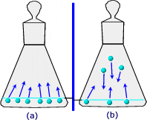
Figure 1. Equilibrium

When the molecules at the surface of the liquid have sufficient energy to escape the liquid, they evaporate. Initially, the molecular traffic is one way, the molecules are moving into empty space and the amount of liquid decreases.

As the number of gas molecules increases, some molecules condense, that is, they return to the liquid phase. Eventually a state of dynamic equilibrium is reached. A state of equilibrium is one where the rate of a forward process is exactly balanced by the rate of a reverse process. In other words, the rate of evaporation is equal to the rate of condensation,

H₂O(l)  H₂O(g)

The double arrow, , is used to indicate equilibrium between these two states.

Skill 37.02: Interpret heating curves for a pure substance

Skill 37.02 Concepts

A heating curve represents what occurs when a pure substance is heated at constant pressure over a given interval of time. As a substance is heated from a solid, it absorbs heat and the temperature increases as shown in figure 2 segment EA. Segment AB indicates the “melting/freezing” point of the substance. The temperature is unchanged during this interval because all the absorbed energy is going toward “loosening” the bonds in the solid. Once all the solid has been converted to a liquid, the temperature begins to rise once again, until segment CD is reached. Segment CD indicates the “boiling point” of the substance. The temperature remains unchanged during this interval because all the absorbed energy is going towards breaking the bonds between the liquid.

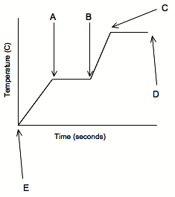
Figure 2. Heating curve

Skill 37.02 Problem 1
The melting point of an unknown substance is -20ºC and the boiling point is 76ºC. Sketch the heating curve for this substance. On the curve,

- label the “x” and “y” axis
- indicate the melting point
- indicate the boiling point

Skill 37.03: Interpret cooling curves for a pure substance

Skill 37.03 Concepts

The cooling curve shown in the figure below is a plot of temperature versus time for a process where energy is being taken away at a constant rate,

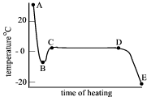

At point A the substance is a liquid. As the temperature drops, the substance remains a liquid until point B. At point B the substance begins to freeze. The reason why the temperature increases from points B to C is because as the substance solidifies (freezes) energy is released. All the points between C and D indicate the freezing temperature of the substance. The unexpected behavior at point B is also referred to as supercooling. A substance is said to be supercooled, when it remains a liquid at a lower than expected temperature.

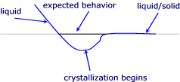

Skill 37.03 Problem 1
The cooling curve for a pure substance is shown below.

- What is the freezing point of the substance, how do you know?
- During which interval is the liquid phase in equilibrium with the solid phase?
- During which interval do the liquid and solid phases coexist?

Skill 37.04: Predict how changes in the conditions of a system at equilibrium will be affected according to Le Châtelier’s principle

Skill 37.04 Concepts

Le Châtelier’s principle is an important principle that enables one to predict how the changes in the conditions of a system at equilibrium will affect the equilibrium. Le Châtelier’s principle states that when a physical or chemical system at equilibrium is disturbed by application of a stress, the system attains a new equilibrium position that minimizes the stress.

Skill 37.04 Problem 1
Predict the changes on the following liquid-vapor equilibrium,

H₂O(l)  H₂O(g)

- an increase in temperature
- an increase in pressure
- an increase in volume

Skill 37.05: Interpret phase diagrams

Skill 37.05 Concepts

A phase diagram summarizes the conditions at which a substance exists as a solid, liquid, or gas
F
D
A

pressure
B
E
C

temperature

- D = critical temperature

lowest temperature above which a substance cannot be liquefied at any applied pressure

- ED = vapor/liquid equilibrium

Slope is always positive

- EF = solid/liquid equilibrium

Slope is positive for substances that are more dense when solid
Slope is negative for substances that are less dense when solid (water)

- E = triple point

Solid/liquid/vapor equilibrium

Skill 37.05 Problem 1
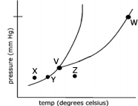

The phase diagram for a pure substance is shown above. Use this diagram and your knowledge about changes of phase to answer the following questions.

- What does point V represent? What characteristics are specific to the system only at point V?

- What does each point on the curve between V and W represent?

- Describe the changes that the system undergoes as the temperature slowly increases from X to Y to Z.

- In a solid-liquid mixture of this substance, will the solid float or sink? Explain.

