Set 25.0: Intermolecular Forces

Skill 25.01: Identify whether or not a given bond has dipole moment
Skill 25.02: Distinguish between polar and nonpolar molecules
Skill 25.03: Identify the intermolecular forces of attraction for a molecule
Skill 25.04: Describe the relationships between the structural features of molecules and the observed physical properties

Skill 25.01: Identify whether or not a given bond has dipole moment

Skill 25.01 Concepts

If one atom in a bond “wants” electrons more than the other, there is a shift in electron density toward this atom. For example, in HF, fluorine is more electronegative than H, therefore the electrons will spend more time on F than on H. This is illustrated below.

δ⁺ δ⁻
H – F

The δ⁺ indicates that there is a partial positive charge on H because the electrons are being pulled away be F. Hence, a partial negative charge results on F (δ⁻).

This uneven distribution of electrons can also be represented with an arrow,

H – F

A quantitative measure of this uneven distribution of electrons is called a dipole moment,

μ = Q x r

where Q is the product of the charge and r is the distance between charges.

Skill 25.01 Problem 1
Arrange the following molecules from low to high with respect to dipole moment

HF, HCl, HI, N₂

Skill 25.02: Distinguish between polar and nonpolar molecules

Skill 25.02 Concepts

Diatomic molecules containing different atoms (for example HCl, CO, HF) have dipole moments are said to be polar molecules. Diatomic molecules containing atoms of the same element (for example, N₂, H₂, O₂) do not have dipole moments are said to be nonpolar.

- Polar = Bonds with uneven distribution of charge (dipole)
- Nonpolar = bonds with even distribution of charge (no dipole)

Even if polar bonds are present in a molecule, the molecule will not necessarily have dipole. For example, consider CO₂,

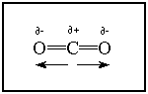

Although the both the C=O bonds are polar, the dipole moments in the molecule are considered vector quantities. This means that it has both magnitude and direction. The overall dipole in the molecule is equal to the vector sum of the bond moments. The two bond moments in O = C = O are equal in magnitude, but opposite in direction and therefore the sum of these dipoles is zero.

Because molecules are three dimensional, sometimes it is difficult, if not impossible to determine the polarity of molecule simply by looking at the structure on a two dimensional page. The following flow chart is useful however,

Ask: does the molecule have a central atom
no
Ask: are atoms the same? (yes or no)
yes
no
nonpolar
polar
Ask: are all the atoms bonded to the central atom the same (yes or no)
yes
no
Polar

Ask: are there any lone pairs on the central atom? (yes or no)
yes
yes
no

Polar
(Exceptions include: square planar and linear molecules, these are actually nonpolar)
nonpolar

Skill 25.02 Problem 1
Draw the lewis structures for the following molecules, then using the flow chart above, determine whether or not each molecule is polar or nonpolar
- SO₂ | - ClF₃
- CH₂F₂ | - I₃⁻

Skill 25.03: Identify the intermolecular forces of attraction for a molecule

Skill 21.03 Concepts

Intermolecular forces of attraction are the forces that hold molecules together. Although the attractive forces between molecules are generally weak, the dipole moments that result in polar molecules can cause these forces to be stronger than expected.

Dipole-Dipole forces of attraction

Dipole-Dipole forces of attraction occur between polar molecules

Example I

H and Cl are attracted on adjacent molecules

Hydrogen Bonding

A hydrogen bonded to a highly electronegative atom is attracted to an unshared pair of electrons of an electronegative atom in a nearby molecule

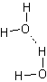

hydrogen is attracted to the lone pair of electrons on an adjacent water molecule

Occurs when hydrogen is bonded to F, O, or N

London Dispersion Forces

The intermolecular attractions resulting from the constant motion of electrons and the creation of instantaneous dipoles

Only intermolecular force acting between noble gases, nonpolar molecules, and slightly polar molecules

The larger the atom or molecule the stronger the London Dispersion forces

Intermolecular force | Examples | strength
London disperson | H₂, O₂, CH₄ | increasing strength
Dipole-induced | HCl with N₂ | increasing strength
Dipole-dipole | HCl, H₂S | increasing strength
Hydrogen bonding | H₂O, NH₃ | increasing strength

The following flowchart is useful for determining the types of intermolecular forces of attraction a molecule will undergo.

Ask: is the molecule polar or nonpolar
polar
nonpolar
London dispersion
Ask: is there hydrogen attached to oxygen, nitrogen, or fluorine? (yes or no)
yes
no
Hydrogen bonding
Dipole-dipole

Skill 25.03 Problem 1
Draw the Lewis structures for the following molecules, then using the flow charts above, determine whether or not each molecule is polar or nonpolar along with the types of intermolecular forces of attraction it would be expected to experience.

(a) BF₃
(b) CH₃COCH₃
(c) CH₃OH
(d) XeF₂

Skill 25.04: Describe the relationships between the structural features of molecules and the observed physical properties

Skill 25.04 Concepts

The physical properties of melting point, boiling point, vapor pressure, evaporation, viscosity, surface tension, and solubility are related to the strength of attractive forces between molecules. These attractive forces called Intermolecular Forces refer to a molecules ability to “stick together’.

- The greater the “stick togetherness” the high the melting point, boiling point, surface tension, and viscosity (the resistance to flow)

- The greater the “stick togetherness” the lower the vapor pressure

Skill 25.04 Problem 1
The structures and normal boiling points of dimethyl ether and ethanol are given in the table below.

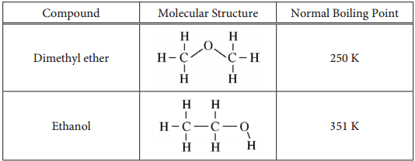

Which of the following diagrams best helps to explain the difference in boiling point of the two compounds? Justify your reasoning.

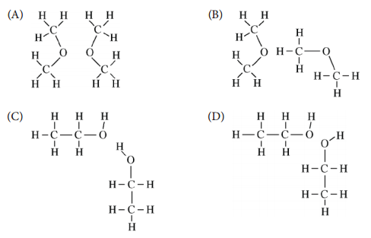

Skill 25.04 Problem 2
Arrange the following from low to high with respect to boiling point:

CO₂, N₂, H₂, O₂, I₂

Skill 25.04 Problem 3
Rank the following compounds from low to high with respect to boiling point.
Justify your reasoning.

Compound | Formula
Propane | CH₃CH₂CH₃
Propanone | CH₃COCH₃
1-propanol | CH₃CH₂CH₂OH

Skill 25.04 Problem 4
If the pressure of each gas is increased at constant temperature until condensation
occurs, which gas will condense at the lowest pressure? In each case, justify your answer.
(A) Methane (CH₄)
(B) Ethane (CH₃CH₃)
(C) Butane (CH₃CH₂CH₂CH₃)
(D) All the gases will condense at the same pressure.

