Set 15: Periodic Trends

Skill 15.01: Be able to identify alkali metals, alkali earth metals, halogens, noble gases, groups, and periods
Skill 15.02: Be able to compare and contrast metals, nonmetals, and metalloids
Skill 15.03: Describe, in terms of atomic structure, the causes for the following periodic trends: atomic radii, ionization energy, and electronegativity
Skill 15.04: Define ionization energy, describe how it changes going across/down the periodic table
Skill 15.05: Be able to identify the group to which an element belongs given its first five ionizations energies
Skill 15.06: Define atomic radii, describe how it changes going across/down the periodic table
Skill 15.07: Arrange ions in order with respect to atomic radius
Skill 15.08: Define electronegativity, describe how it changes going across/down the periodic table

Skill 15.01: Be able to identify alkali metals, alkali earth metals, halogens, noble gases, groups, and periods

Skill 15.01 Concepts

The vertical columns on the periodic table are groups

Rows are called periods

The elements can be classified as metals, nonmetals, or metalloids

The elements can be further classified as follows:

- Group 1 elements are called the alkali metals
- Group 2 elements are called the alkali earth metals
- Group 17 elements are called the halogens
- Group 18 elements are called the noble gases

1A | 2A | 3B | 4B | 5B | 6B | 7B | 8B | 8B | 8B | 1B | 2B | 3A | 4A | 5A | 6A | 7A | 8A
1 | 2 | 3 | 4 | 5 | 6 | 7 | 8 | 9 | 10 | 11 | 12 | 13 | 14 | 15 | 16 | 17 | 18
1  H  1.0 |  |  |  |  |  |  |  |  |  |  |  |  |  |  |  |  | 2  He  4.0
3  Li  6.9 | 4  Be  9.0 |  |  |  |  |  |  |  |  |  |  | 5  B  10.8 | 6  C  12.0 | 7  N  14.0 | 8  O  16.0 | 9  F  19.0 | 10  Ne  20.1
11  Na  23.0 | 12  Mg  24.3 |  |  |  |  |  |  |  |  |  |  | 13  Al  27.0 | 14  Si  28.1 | 15  P  31.0 | 16  S  32.1 | 17  Cl  35.5 | 18  Ar  40.0
19  K  39.1 | 20  Ca  40.1 | 21  Sc  45.0 | 22  Ti  47.9 | 23  V  50.9 | 24  Cr  52.0 | 25  Mn  54.9 | 26  Fe  55.9 | 27  Co  58.9 | 28  Ni  58.7 | 29  Cu  63.6 | 30  Zn  65.4 | 31  Ga  69.7 | 32  Ge  72.6 | 33  As  74.9 | 34  Se  79.0 | 35  Br  79.9 | 36  Kr  83.8
37  Rb  85.5 | 38  Sr  87.6 | 39  Y  88.9 | 40  Zr  91.2 | 41  Nb  92.9 | 42  Mo  95.9 | 43  Tc  98 | 44  Ru  101 | 45  Rh  103 | 46  Pd  106 | 47  Ag  108 | 48  Cd  112 | 49  In  115 | 50  Sn  119 | 51  Sb  122 | 52  Te  128 | 53  I  127 | 54  Xe  131
55  Cs  133 | 56  Ba  137 | 57  La  139 | 72  Hf  179 | 73  Ta  181 | 74  W  184 | 75  Re  186 | 76  Os  190 | 77  Ir  192 | 78  Pt  195 | 79  Au  197 | 80  Hg  201 | 81  Tl  204 | 82  Pb  207 | 83  Bi  209 | 84  Po  210 | 85  At  210 | 86  Rn  222
87  Fr  223 | 88  Ra  226 | 89  Ac  227 | 104 | 105 | 106 | 107 | 108 | 109 | 110 | 111 | 112 | 113 | 114
 |  |  |  | 58  Ce  140 | 59  Pr  141 | 60  Nd  144 | 61  Pm  147 | 62  Sm  150 | 63  Eu  152 | 64  Gd  157 | 65  Tb  159 | 66  Dy  163 | 67  Ho  165 | 68  Er  167 | 69  Tm  169 | 70  Yb  173 | 71  Lu  175
 |  |  |  | 90  Th  232 | 91  Pa  231 | 92  U  238 | 93  Np  237 | 94  Pu  242 | 95  Am  243 | 96  Cm  247 | 97  Bk  247 | 98  Cf  249 | 99  Es  254 | 100  Fm  253 | 101  Md  256 | 102  No  254 | 103  Lw  257

Skill 15.01 Problem 1
(a) Which side of the periodic table is associated with nonmetals? Metals?
(b) Identify whether each of the following is a metal, nonmetal, metalloid, or noble gas
Silicon

Sodium

Sulfur

Xenon

(c) Based on the electron arrangement of the electrons, indicate whether each atom is a metal or nonmetal.
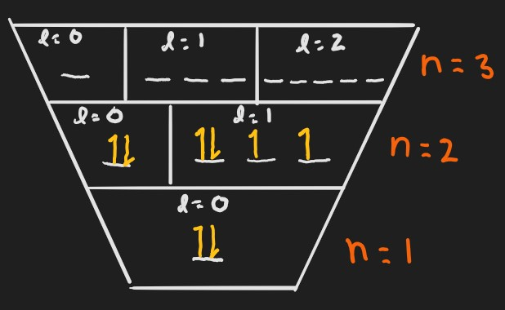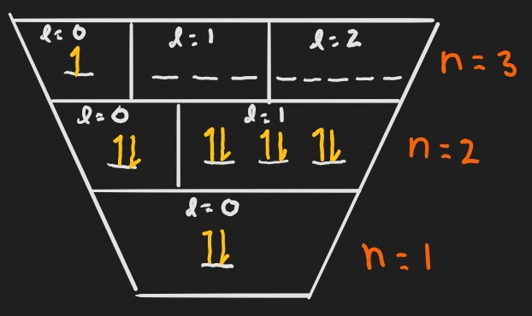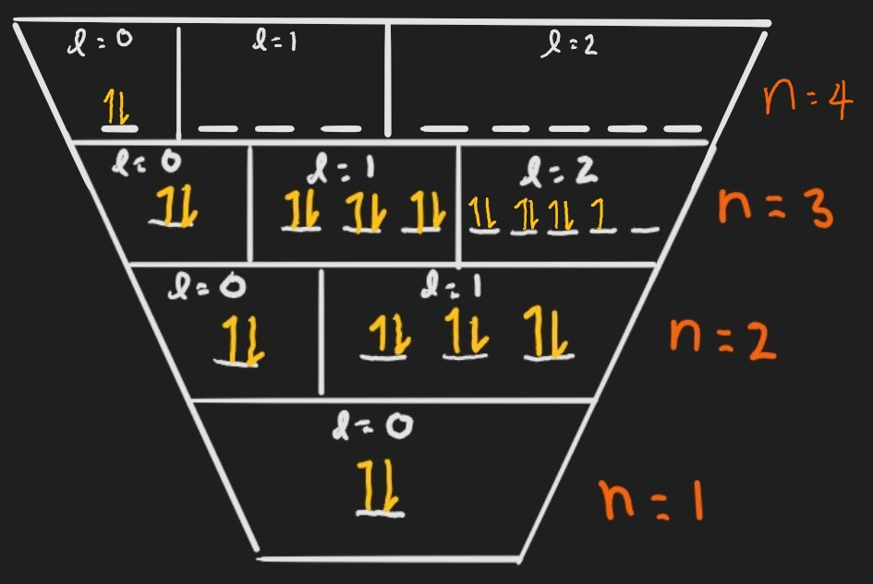

Skill 15.02: Be able to compare and contrast metals, nonmetals, and metalloids

Skill 15.02 Concepts

Metals tend to be shiny solids that are bendable and malleable and conduct heat and electricity well.

Nonmetals tend to be brittle and do not conduct heat or electricity well.

Metalloids (semimetals) can act, depending on circumstances like either metals or nonmetals. They are often referred to as semiconductors.

Skill 15.02 Problem 1
Metals, nonmetals, and metalloids can be described in terms of the above descriptions. Below are models that depict the arrangement of electrons in metals in nonmetals. Propose how metals and nonmetals could be described in terms of their electron arrangements.

Skill 15.03: Describe, in terms of atomic structure, the causes for the following periodic trends: atomic radii, ionization energy, and electronegativity

Skill 15.03 Concepts

All periodic trends can be understood in terms of three basic concepts:

- Electrons are attracted to the protons in the nucleus of an atom

- The closer an electron is to the nucleus, the more strongly it is attracted.
- The more protons in a nucleus, the more strongly an electron is attracted.

- Electrons are repelled by other electrons in an atom. So, if other electrons are between a valence electron and the nucleus, the valence electron will be less attracted to the nucleus. That’s called shielding.

- Completed shells (and to a lesser extent, completed subshells) are very stable. Atoms prefer to add or subtract valence electrons to complete shells if possible.

Skill 15.03 Problem 1
The diagrams below show the arrangement of electrons for different atoms. Complete the following based the diagrams.

I. II.
(a) For each atom circle the outer most electron(s).

(b) For which atom are the outer electrons most attracted to the nucleus? Explain.

(c) Both atoms shown are unstable. For each atom, indicate whether losing or gaining electrons would increase the stability of the atom.

Skill 15.04: Define ionization energy, describe how it changes going across/down the periodic table

Skill 15.04 Concepts

Ionization energy is defined as the minimum energy required to remove an electron from an atom.

Electrons are attracted to the nucleus of an atom, so it takes energy to remove an electron. The energy required to remove an electron from an atom is called the first ionization energy.

Once an electron has been removed, the atom becomes positively charged.

Moving from left to right across a period, ionization energy increases

Moving from left to right across a period, protons are added to the nucleus, which increases its positive charge. For this reason, the negatively charged valence electrons are more strongly attracted to the nucleus, which increases the energy required to remove them.

Electrons are also being added, and the shielding effect provided by the filling of the s sub shell causes a slight deviation in the trend in moving from group 2A to 3A. The deviation also arises from the fact that removing an electron from a full sub shell tends to take more energy than removing an electron from an unfilled sub shell.

Moving down a group, ionization energy decreases

Moving down a group, shells of electrons are added to the nucleus. Each inner shell shields the more distant shells from the nucleus, reducing the pull of the nucleus on the valence electrons and making them easier to remove.

Protons are also being added, but the shielding effect of the negatively charged electron shells cancels out the added positive charge.
Skill 15.04 Problem 1
(a) Arrange the following in order from low to high with respect to ionization energy. Justify your reasoning in terms of atomic principles.
Na, Li, K, Cs, Rb

Cl, Na, Al, S, Mg

Which atom depicted below would have the highest ionization energy? Explain.

I. 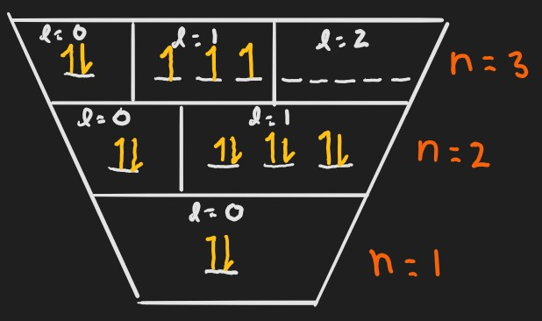 II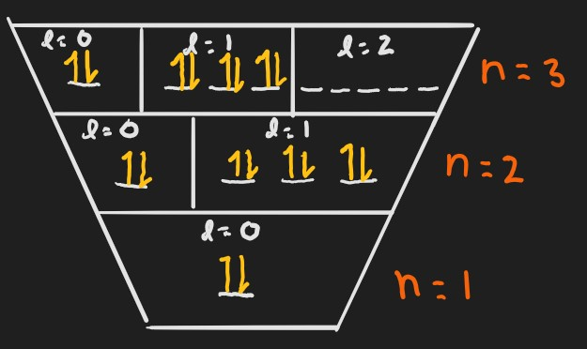
Which atom depicted below would have the highest ionization energy? Explain.
I.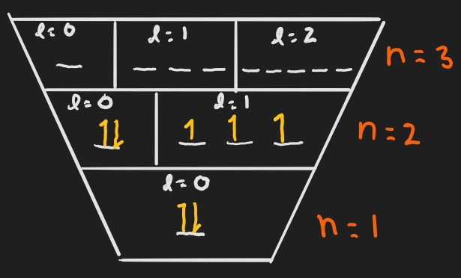II.

Skill 15.05: Be able to identify the group to which an element belongs given its first five ionizations energies

Skill 15.05 Concepts

The energy required to remove the first electron from an atom is also called the first ionization energy. Likewise, the energy required to remove the second electron from an atom is called the second ionization energy; the energy required to remove the third electron is called the third ionization energy, etc.

The second ionization energy is always greater than the first ionization energy, the third ionization energy is always greater than the second, and so on. This is because, once an electron has been removed from an atom, electron-electron repulsion decreases and the remaining valence electrons move closer to the nucleus, making them more difficult to remove.

For example, consider the first five ionization energies for an unknown element:

510 kJ/mol , 840 kJ/mol, 9300 kJ/mol, 16,000 kJ/mol, 18,000 kJ/mol

Notice the gradual increase from the first ionization to the second, then the large jump between the second and the third (~10x). This trend occurs because as electrons are removed, ionization energy increases gradually until a shell is empty, then it makes a BIG jump. The unknown element must therefore belong to group II, because the first two ionization energies are comparable.

Skill 15.05 Problem 1
The first three ionization energies of some element are as follows:

I₁ = 520 kJ/mol, I₂ = 7300 kJ/mol, I₃ = 11815 kJ/mol

Which atom shown below is most consistent with the data? Explain.

I. II.

The first five ionization energies of some element are as follows:

I₁ = 1086 kJ/mol, I₂ = 2350 kJ/mol, I₃ = 4620 kJ/mol, I₄ = 6220 kJ/mol, I₅ = 38,000kJ/mol

To which group does this element belong? Explain.

Skill 15.05 Problem 2
Consider the following electronic configurations for 3 different neutral atoms.

1s²2s²2p⁶
1s²2s²2p⁶3s¹
1s²2s²2p⁶3s²

(a) Which atom has the largest first ionization energy? Explain.

(b) Which atom has the smallest first ionization energy? Explain.

(c) Which atom has the largest second ionization energy? Explain.

Skill 15.06: Define atomic radii, describe how it changes going across/down the periodic table

Skill 15.06 Concepts

The atomic radius is the approximate distance from the nucleus of an atom to its valence electrons.

Moving from left to right across a period (Li to Ne, for instance), atomic radius decreases

Moving from left to right across a period, protons are added to the nucleus, so the valence electrons are more strongly attracted to the nucleus, decreasing the atomic radius.

Electrons are also being added, but they are all in the same shell at about the same distance from the nucleus, so there is not much of a shielding effect.

Moving down a group (Li to Cs, for instance), atomic radius increases

Moving down a group, shells of electrons are added to the nucleus. Each shell shields the more distant shells from the nucleus and the valence electrons get farther and farther away from the nucleus.

Protons are also being added, but shielding effects of the negatively charged electron shells cancels out the added positive charge.

Skill 15.06 Problem 1
Arrange the following from low to high with respect to atomic radius. Justify your reasoning.
Mg, Na, Ar, Al | Rb, K, Li, Cs

Skill 15.07: Arrange ions in order with respect to atomic radius

Skill 15.07 Concepts

Cations (positively charged ions) are smaller than atoms

When an electron is removed from an atom, forming a cation, the electron-electron repulsions are reduced an all of the valence electrons move closer to the nucleus.

Anions (negatively charged ions) are larger than atoms

When an electron is added to an atom, forming an anion, electron-electron repulsions increase, causing the valence electrons to move farther apart and increasing the radius.

To compare the atomic radii of ions, the electron/proton ratio must be considered. Consider the following example:

Arrange the following from high to low with respect to atomic radius:

Ca²⁺, K⁺, S²⁻, Ar

For each element, count the electrons and protons:

 | Ca²⁺ | K⁺ | S²⁻ | Ar
Electrons | 20-2=18 | 19-1=18 | 16+2=18 | 18
protons | 20 | 19 | 16 | 18

Notice all the elements have the same number of electrons, that is they are isoelectronic, therefore what causes one element to be larger or smaller is going to be determined by the number of protons. The element with the fewest protons will be the largest because its electrons experience the weakest attractive forces. The expected order from smallest to largest is therefore:

Ca²⁺, K⁺, Ar, S²⁻

Skill 15.07 Problem 1
(a) Which of the following has the smallest atomic radius? Explain.

Ne, O²⁻, Na⁺, Mg²⁺

(b) Which of the following has the smallest atomic radius? Explain.

Al³⁺, Ne, O²⁻, N³⁻

Skill 15.08: Define electronegativity, describe how it changes going across/down the periodic table

Skill 15.08 Concepts

Electronegativity refers to how strongly the nucleus of atom attracts the electrons of other atoms in a bond. Electronegativities of elements are estimated based on ionization energies and electron affinities.

Moving from left to right across a period, electronegativity increases

Protons are added as you move left to right, and therefore the attraction for electrons is greater.

Moving down a group, electronegativity decreases

Due to shielding, the protons in the nucleus do not have much of an affinity for electrons.

Skill 15.08 Problem 1
Arrange the following from low to high with respect to electronegativity.
(a) I, Cl, F, Br

(b) F, Mg, Na, Cl

Summary

The diagram below summarizes the trends covered in this topic

