Skill 13.01 Problem 1
Draw Bohr models for the following atoms:

- H, Li, Na
- Be, Mg, Ca
- C, Si, Ge
- Ne, Ar, Kr

What does each group of atoms have in common?
Group I | H | Li | Na
Group II | Be | Mg
Group IV | C | Si
Group VIII | Ne | Ar

Skill 13.02 Problem 1
- For the n=2, main energy level,
- How many sub-energy levels exist?

- What are their values?

- For the n=3, main energy level,
  - How many sub-energy levels exist?

  - What are their values?

- For the n=5, main energy level,
  - How many sub-energy levels exist?

  - What are their values?

Skill 13.02 Problem 2
a. What are the letter designations for the possible subshells on the n=2 main energy level?

- What are the letter designations for the possible subshells on the n=3 main energy level?

Skill 13.03 Problem 1
How many orientations are possible for each sub-energy level?
(a) l=s | (b) l=p | (c) l=d | (d) l=f

Skill 13.03 Problem 2
List the possible values of m_{l} for the l=f or l=3 sub-energy level.

Skill 13.03 Problem 3
Complete the n=4 main energy level. For each sub-energy level indicate the number of orientations (aka orbitals) with a “__”. Write the corresponding number below.
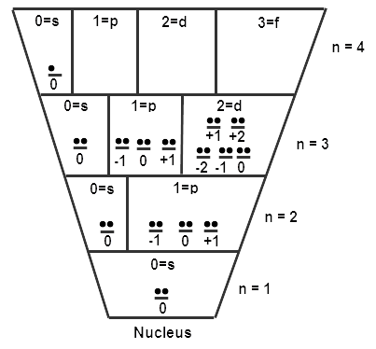

Skill 13.04 Problem 1
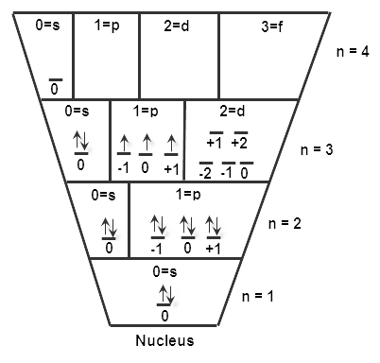
This electron has the following values:

n=3; l=1; m_{l}=+1; m_{s}= +1/2

Or we can also write it using the following short hand notation.

(3, 1, +1, +1/2)

The values in the shorthand method correspond to the following quantum numbers,

(n, l, m_{l}, m_{s})
Consider the atomic model of the atom shown above.
  - How many electrons are in this atom?

  - Assuming the atom is neutral, that is it has equal numbers of protons and electrons. What atom is represented by the diagram?

(c) What are the values of n, l, m_{l}, and m_{s} for each electron on the 3rd main energy level? List their values for each electron using the short hand method shown above.

Skill 13.05 Problem 1
(a) Show the filling of electrons for phosphorus in the diagram below.
(b) Predict whether phosphorus is paramagnetic or diamagnetic.
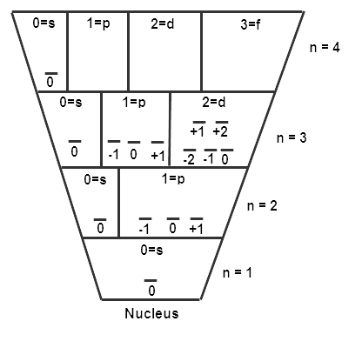

Skill 13.05 Problem 2
(a) Draw atomic diagrams for each of the following atoms.
(b) Predict whether each atom is paramagnetic or diamagnetic.
(a) Helium

(b) Nitrogen

(c) Chlorine

(d) Magnesium

