Set 35.0: Ideal Gas Law Applications

Skill 35.01: Use Dalton’s law of partial pressures to calculate partial pressures and total pressures
Skill 35.02: Calculate the pressure of a gas collected by water displacement
Skill 35.03: Use the ideal gas law to calculate the molar mass of a gas
Skill 35.04: Use the ideal gas law to calculate the density of a gas

Skill 35.01: Use Dalton’s law of partial pressures to calculate partial pressures and total pressures

Skill 35.01 Concepts

Thus far we have concentrated on the behavior or pure gaseous substances, but experimental studies often involve mixture of gases. In this case, and all cases involving mixtures of gases, the total gas pressure is related to partial pressures, that is, the pressures of the individual gas components in the mixture. Dalton’s law of partial pressures states that the total pressure of a mixture of gases is just the sum of the pressures that each gas would exert if it were present alone.

Consider the case in which two gases, A and B, are in a container of volume V. The pressure exerted by gas A is P_{A} the pressure exerted by gas B is P_{B}. The total pressure P_{T} is the result of the collision of both types of molecules A and B, with the walls of the container. Thus,

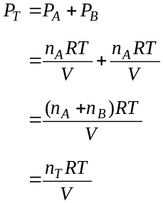

Notice that the total pressure is depends on the total number of moles present only, not the nature of the gas molecules.

Skill 35.01 Problem 1
3.0 moles of oxygen gas and 1.0 mole of nitrogen gas are confined to a 5.0 L container at 273 K. What is the total pressure?

Skill 35.01 Problem 2
Three of the primary components of air are carbon dioxide, nitrogen, and oxygen. In a sample containing a mixture of these gases at one atmosphere, the partial pressures of carbon dioxide and nitrogen are given as P_{CO2} = 0.285 mm Hg and P_{N2} = 593.525 mm Hg. What is the partial pressure of oxygen?
Skill 35.01 Problem 3
A 2.5 L flask at 15ºC contains a mixture of N₂, He, and Ne. The partial pressures are 0.32 atm for N₂, 0.15 atm for He, and 0.42 atm for Ne.
Calculate the total pressure of the mixture.

Calculate the moles of each gas present in the mixture

Skill 35.02: Calculate the pressure of a gas collected by water displacement

Skill 35.02 Concepts

Dalton’s law of partial pressures s useful for calculating volumes of gases collected over water. For example, when potassium chlorate (KClO₃) is heated, it decomposes into KCl and O₂:

2KClO₃(s) → 2KCl(s) + 3O₂(g)

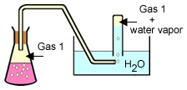

Initially the bottle is completely filled with water shown in the diagram. As oxygen gas is generated, the gas bubbles displace the water from the bottle. The oxygen gas collected in this way is not pure however. The total gas pressure is equal to the sum of the pressures exerted by the oxygen gas and the water vapor,

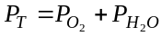

Consequently, we must take into consideration the pressure caused by the presence of water vapor when we calculate the amount of O₂ generated.

Skill 35.02 Problem 1
A student collected a 90.0 mL sample of an unknown gas at 25ºC. The total pressure was 721.2 mm Hg. The water vapor pressure at 25ºC is . 23.76 mm Hg. What is the pressure of the dry gas? | 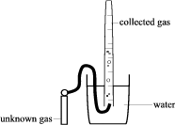

Skill 35.03: Use the ideal gas law to calculate the molar mass of a gas

Skill 35.03 Concepts

The ideal gas law can be used to calculate the molar mass of a gas sample. Suppose that the pressure, volume, and temperature are known for a gas sample of a given mass. The number of moles (n) in the sample can be calculated using the ideal gas law. Then the molar mass (grams per mole) can be calculated by dividing the known mass by the number of moles.

This is illustrated in the following example,

Example

A student collected a 90.0 mL sample of an unknown gas at 25ºC. The pressure of the dry gas was 721.2 mm Hg. The mass of the tank containing the unknown gas before the reaction was 1003.079 g. The mass of the tank containing the unknown gas after the reaction was 1003.065 g. What is the molar mass of the gas?

Solution

The molar mass of a gas can be expressed as follows

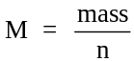

The moles of gas, n, can be calculated using the ideal gas equation, PV =nRT. Rearranging,

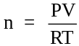

According to the data,

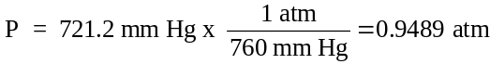

V = 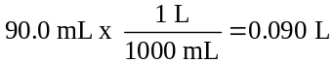

R = 0.0821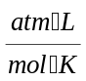

T = 25ºC +273 = 298 K

mass = 1003.079 g – 1003.065 g = 0.014 g

Substituting to find moles, n,

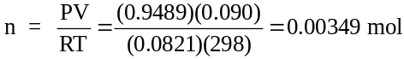

Substituting to find the molar mass,

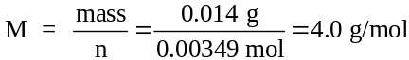

Skill 35.03 Problem 1
At 28ºC and 740 mm Hg pressure, 1.00 L of an unidentified gas has a mass of 5.16 g. What is the molar mass of this gas?
Calculate the moles of gas

Calculate the experimental molar mass of the oxygen gas.

Skill 35.03 Problem 2
Oxygen gas generated by the decomposition of potassium chlorate was collected by water displacement. The mass of the test tube and contents before the reaction was 23.00 g. The mass of the test tube and contents after the reaction was 22.84. The volume of oxygen collected at 24ºC and atmospheric pressure of 762 mm Hg was 128 mL. (vapor pressure H₂O @ 24ºC = 23.76 mm Hg)
Calculate the pressure of the dry oxygen gas

Calculate the mass of oxygen gas produced

Calculate the moles of oxygen gas produced

Calculate the experimental molar mass of the oxygen gas

Skill 35.04: Use the ideal gas law to calculate the density of a gas

Skill 35.04 Concepts

The ideal gas law can also be used to calculate the density of a gas. An equation showing the relationship between density, pressure, temperature, and molar mass can be derived from the ideal gas law, and the molar mass equation,

PV=nRT and

Rearranging the molar mass equation and substituting yields,

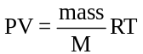

Rearranging the above equation,

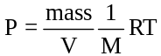

In the above equation, notice that D=mass/V. Substituting and rearranging once more,

PM = DRT

The above equation enables one to find the density of a gas if the pressure, temperature, and molar mass are known.

Skill 35.04 Problem 1
What is the density of a sample of ammonia gas (NH₃) if the pressure is 705 mm Hg and the temperature is 63ºC?

Skill 35.04 Problem 2
One method for estimating the temperature of the center of the sun is based on the assumption that the center consists of gases that have an average molar mass of 2.00 g/mol. If the density of the center is 1.4 x 10³ g/L at a pressure of 1.30 x 10⁹ atm, calculate its temperature in Celsius.

