Set 29: Stoichiometry Intro

Skill 29.01: Be able to interpret a reaction both symbolically and pictorially
Skill 29.02: Be able to interpret a balanced reaction in terms of molecules, moles, and grams
Skill 29.03: Be able to interpret a graphical depiction of a reaction
Skill 29.04: Be able to identify a limiting and excess reactant

Skill 29.01: Be able to interpret a reaction both symbolically and pictorially

Skill 29.01 Concepts

A chemical reaction indicates how atoms or compounds react to form products. They can be used to figure out how much of a compound you will need, or maybe how much you started with, or how much you want to make. Consider for example the reaction between hydrogen and oxygen to make water,

Symbolically this reaction can be written as follows,

H₂ + O₂ → H₂O

Or pictorially,
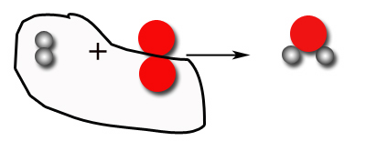
Figure 1. Unbalanced reaction between hydrogen and oxygen

Notice that when the above quantities of hydrogen and oxygen react to form water, only one molecule of water can be made and there is a leftover oxygen atom. In order for all the reactants to react, the reaction must be balanced,

2H₂ + O₂ → 2H₂O

Pictorially, the balanced reaction can be written as follows,
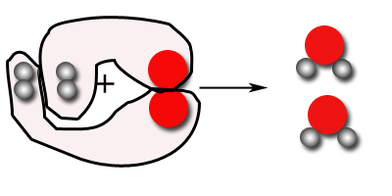
Figure 2. Balanced reaction between hydrogen and oxygen

Notice that when the above quantities react to form water, all the reactants are used up. Furthermore, when they react, exactly two molecules of water are produced, the same as that predicted by the balanced reaction.

Skill 29.01 Problem 1
Carbon monoxide (CO) and oxygen gas (O₂) react form carbon dioxide (CO₂)

- Write a balanced reaction for this process
- Draw pictures to show the formation of carbon dioxide from its reactants.

Skill 29.02: Be able to interpret a balanced reaction in terms of molecules, moles, and grams

Skill 29.02 Concepts

From the above example, it should be clear that a balanced reaction shows the ratio in which molecules and atoms react. It also enables one to make predictions about the amount of products, which can be formed. Table 1 summarizes several ways in which one can interpret the balanced reaction described above,

Table 1. Interpretation of a balanced reaction
2H₂ | O₂ | 2H₂O
2 molecules | 1 molecule | 2 molecule
2 x (6.022 x 10²³ molecules) | 6.022 x 10²³ molecules | 2 x (6.022 x 10²³ molecules)
2 moles | 1 mole | 2 moles
4 grams | 32 grams | 36 grams

Skill 29.02 Problem 1
For the reaction represented by
N_{2(g)} + 3H_{2(g)} → 2NH_{3(g)}
At constant temperature and pressure, which of the following statements is/are true?
- 6.022 x 10²³ molecules of nitrogen and 3 x (6.022 x 10²³ ) molecules of hydrogen react to yield 2 x (6.022 x 10²³ ) molecules of ammonia
- 1 molecule of nitrogen and 3 molecules of hydrogen react to yield 2 molecules of ammonia
- 1 atom of nitrogen and 3 atoms of hydrogen react to yield 2 atoms of ammonia
- 1 mole of nitrogen and 3 moles of hydrogen react to yield 2 moles of ammonia
- 28 grams of nitrogen and 6 grams of hydrogen react to yield 34 grams of ammonia

Skill 29.03: Be able to interpret a graphical depiction of a reaction

Skill 29.03 Concepts

In addition, the reaction between hydrogen and oxygen to form water can be depicted graphically as follows,

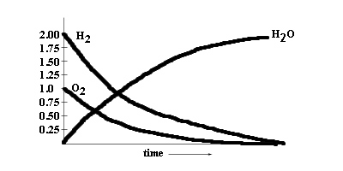
Figure 3. Graphical depiction of the reaction between hydrogen and oxygen

Notice in the figure above that if we start out with 2 moles of hydrogen and 1 mole of oxygen at time 0, 2 moles are formed.

Skill 29.03 Problem 1
Carbon monoxide (CO) and oxygen gas (O₂) react form carbon dioxide (CO₂). On the graph provided, draw a sketch of how the reactants and products change over time.
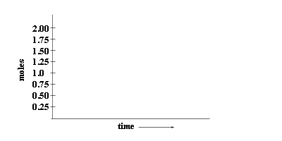

Skill 29.04: Be able to identify a limiting and excess reactant

Skill 29.04 Concepts

So far you have leaned that when provided the amounts indicated by the balanced reaction, all the reactants are consumed and the amount of product formed can be predicted from the balanced reaction. For example, when provided with 2 moles of H₂ and 1 mole of O₂, 100% of your reactants are used up to produce 2 moles of H₂O.

2H₂ + O₂ → 2H₂O

More often than not however, all the reactants are not used up. Consider for example what happens if you were provided 3 moles of hydrogen and 2 moles of oxygen. Pictorially this looks as follows,

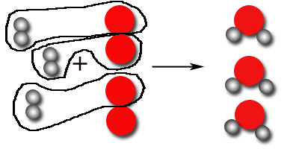
Figure 4. Reaction of hydrogen and oxygen to form water

Notice that in the above reaction all of the hydrogen has been used up. And that the amount of water formed is therefore limited by the amount of hydrogen available. For this reason, hydrogen is called the Limiting Reactant. Likewise, after the reaction is complete, there is excess oxygen. Hence oxygen is referred to as the Excess Reactant.

Skill 29.04 Problem 1
For each of the following,

- Write a balanced reaction for this process
- Draw a picture of what happens when 2 moles of nitrogen gas react with 3 moles of hydrogen gas.
- Identify the limiting and excess reactant
2 moles of nitrogen gas (N₂) and 3 moles of hydrogen gas (H₂) react to form ammonia (NH₃).
2 moles of NO and 2 moles of O₂ react to form NO₂
2 moles of P₄ and 5 moles of O₂ react to form P₂O₅

Skill 29.04 Problem 2
Nitrogen gas (N₂) and hydrogen gas (H₂) react to form ammonia (NH₃). Given 2 moles of nitrogen and 3 moles of hydrogen, draw a sketch of how the reactants and products change over time.
