Name _______________________________________________________________________________________

|  |
| --- |
| **Comparison of Bond Types** |

|  |
| --- |
| **Your Tasks (Mark these off as you go)** |
| * Define key vocabulary * Connect to the bonding simulator * Investigate ionic bonding * Investigate diatomic molecules * Investigate molecules with more than two atoms * Receive credit for this lab |

* + **Define key vocabulary**

**Ionic bond**

|  |
| --- |
|  |

**Covalent bond**

|  |
| --- |
|  |

**Valence electron**

|  |
| --- |
|  |

**Electronegativity**

|  |
| --- |
|  |

**Diatomic molecule**

|  |
| --- |
|  |

**Molecule**

|  |
| --- |
|  |

* + **Connect to the bonding simulator**

In this investigation you will bond select atoms. Based upon the types of atoms that you choose to combine, you will create either an ionic compound or a covalent compound. You will have the opportunity to analyze the differences between these different types of compounds and to predict the number of atoms needed to create each, as well as learn how to appropriately name them.

To get started, use a computer, tablet or mobile device, to navigate to the website:

<http://www.teachchemistry.org/bonding>.

You should see the picture below on your screen.

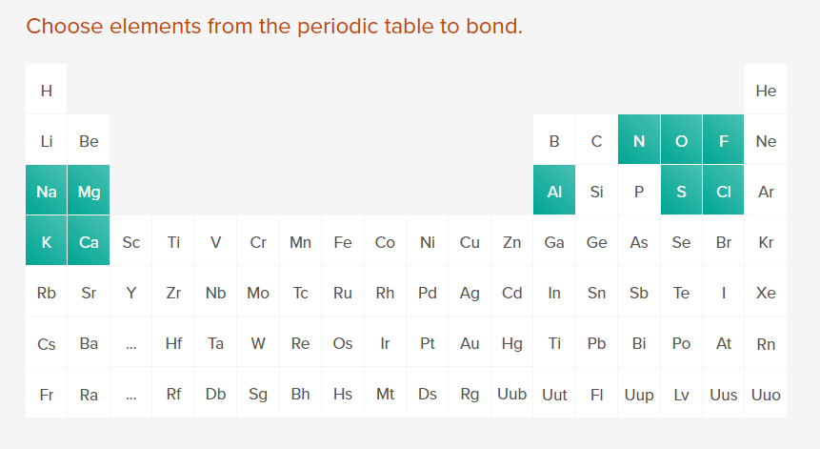

* + **Investigate ionic bonding**

|  |  |
| --- | --- |
| Choose Sodium (Na).   * Locate the Element type and record this in data table 1 * Locate the Electronegativity and record this in data table 1 * The dots surrounding the symbol indicate the valence electrons. Count the dots and record the number as the valence electrons in data table 1 * Based on the number of valence electrons, predict the charge on sodium. Record this in data table 1. |  |
| Choose Fluorine (F).   * Locate the Element type and record this in data table 1 * Locate the Electronegativity and record this in data table 1 * The dots surrounding the symbol indicate the valence electrons. Count the dots and record the number as the valence electrons in data table 1 * Based on the number of valence electrons, predict the charge on fluorine. Record this in data table 1. |  |
| Answer the question on the screen, “What type of bond is this combination likely to form?”  Record the correct answer in data table 2 |  |
| Choose the appropriate number of atoms to make the bond. Keep trying until you get it correct. |  |
| Watch the final animation closely (it will play continuously). Record the name and formula for the compound in data table 2 |  |
| Reset the selected data using the reset symbol. |  |

**Data Table 1**

|  |  |  |  |  |  |  |  |  |  |  |  |  |
| --- | --- | --- | --- | --- | --- | --- | --- | --- | --- | --- | --- | --- |
| Using a periodic table, complete the table below, then use the simulation to check each of your predictions: | | | | | | | | | | | | |
| **M/NM = type (metal (M) or nonmetal (NM))**  **VE = valence electrons**  **E = electronegativity**  **C = charge**  **I/M = ionic (I) or molecular (M)**  **F = formula of compound** | | | | | | | | | | | | |
| **Atom**  **#1** | **M/NM** | **E** | **VE** | **C** | **Atom**  **#2** | **M/NM** | **E** | **VE** | **C** | **I/M** | **F** | **Name of compound** |
| **Na** |  |  |  |  | **F** |  |  |  |  |  |  |  |
| **Ca** |  |  |  |  | **Cl** |  |  |  |  |  |  |  |
| **Na** |  |  |  |  | **O** |  |  |  |  |  |  |  |
| **K** |  |  |  |  | **F** |  |  |  |  |  |  |  |
| **Mg** |  |  |  |  | **Cl** |  |  |  |  |  |  |  |
| **Ca** |  |  |  |  | **N** |  |  |  |  |  |  |  |
| **Al** |  |  |  |  | **S** |  |  |  |  |  |  |  |

* + **Investigate diatomic molecules**

|  |  |
| --- | --- |
| Select 2 fluorine atoms. How many valence   * Locate the Element type and record this in data table 2 * Locate the Electronegativity and record this in data table 2 * The dots surrounding the symbol indicate the valence electrons. Count the dots and record the number as the valence electrons in data table 2 * Based on the number of valence electrons, predict the charge on fluorine. Record this in data table 2 |  |
| Answer the question on the screen, “What type of bond is this combination likely to form?”  Record the correct answer in data table 2 |  |
| Choose the appropriate number of atoms to make the bond. Keep trying until you get it correct. |  |
| Watch the final animation closely (it will play continuously). Record the Lewis dot structure of the molecule, the molecular formula, and its shape (geometry) in data table 2 |  |

**Data Table 2**

|  |  |  |  |  |  |
| --- | --- | --- | --- | --- | --- |
| Make predictions in the following table. Once completed, check your answers using the simulation. | | | | | |
| **LD = Lewis dot structure**  **M/NM = type (metal (M) or nonmetal (NM))**  **E = electronegativity**  **I/M = ionic (I) or molecular (M)**  **F = formula of compound**  **G = geometry** | | | | | |
| **LD**  **atom** | **F** | **O** | **Cl** | **S** | **N** |
| **M/NM** |  |  |  |  |  |
| **E** |  |  |  |  |  |
| **I/M** |  |  |  |  |  |
| **LD**  **molecule** |  |  |  |  |  |
| **F** |  |  |  |  |  |
| **G** |  |  |  |  |  |

* + **Investigate molecules with more than two atoms**

More than two atoms can also be combined to form a covalent molecule. These molecules may form different shapes and will also follow a particular naming system. Select the following combinations of atoms, and complete the rest of the table as you interact with the simulation:

|  |  |  |  |  |
| --- | --- | --- | --- | --- |
| **1st atom choice** | **2nd atom choice** | **Predict Formula** | **Molecular Name** | **Geometry** |
| **S** | **F** |  |  |  |
| **N** | **Cl** |  |  |  |
| **Cl** | **F** |  |  |  |

* + **Compare ionic and covalent bonding**

Compare data tables 1 and 2. How do ionic compounds and molecules differ with respect to the following properties: valence electrons, electronegativity, type (metal or nonmetal)

|  |
| --- |
|  |

How is naming ionic and covalent compounds different? Use specific examples in your answer.

|  |
| --- |
|  |

Based on your knowledge of ionic and covalent bonds, complete the missing portions of the following table:

|  |  |  |
| --- | --- | --- |
| **Name** | **Formula** | **Ionic or Covalent?** |
| Beryllium bromide |  |  |
|  | PF3 |  |
| Sulfur diiodide |  |  |
| Strontium Phosphide |  |  |
|  | Cs3N |  |
|  | H2O |  |

* + **Receive Credit for this lab**

Submit your completed lab to receive credit.