|  |
| --- |
| **Density** |

|  |
| --- |
| **Your Tasks (Mark these off as you go)** |
| * Assign group roles * Review density * Complete the pre-lab questions * Explore the density simulator * Determine the density of different object * Complete the data analysis * Write a conclusion * Complete the post-lab questions * Receive credit for this lab |

* **Assign group roles**

Before you continue, record your group number, then collaborate with your group and assign each person a role. Each role and a description is provided below.

|  |  |
| --- | --- |
| **Project manager (PM)** | Leads the team discussion and keeps the team on task and on schedule. Make sure the final lab is submitted. |
| **Recorder (R)** | Ensures that all members have correct answers. |
| **Communication Specialist (CS)** | Presents answers (or questions) to the class, instructor, or other teams. |
| **Strategic Analyst (SA)** | Considers how the team is working and ensures all voices are heard |

|  |  |
| --- | --- |
| **Group Number:** | |
| **Name** | **Role** |
|  |  |
|  |  |
|  |  |
|  |  |

* **Review Density**

Density is a measure of the amount of mass per unit volume. Stated mathematically,

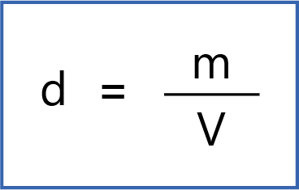

An example of how density can be calculated is illustrated below,

Example 1

The density can be calculated by dividing

the mass by the volume. Notice that the

Units cannot be reduced, so they are reported as

g/mL

Mass = 2.01 g

Volume = 1.98 mL

d = $\frac{2.01g}{1.98mL}=1.02g/{mL}$

Example 2

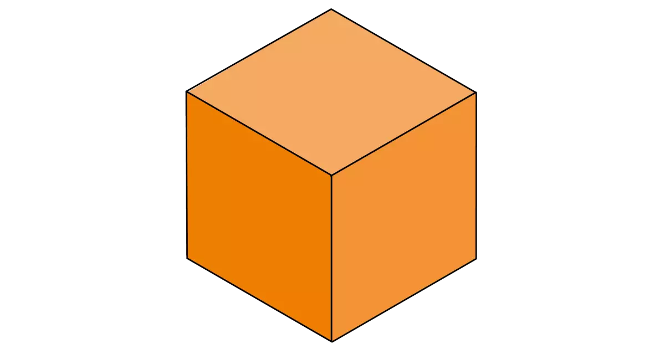

Mass = 10.00 g

Length of cube = 2.0 cm

Volume = 2.0 cm x 2.0 cm x 2.0 xm = 8.0 cm3

d =

In this example, the volume had to be

calculated. The units cannot be reduced

and are reported as g/cm3

|  |  |
| --- | --- |
| The mass of the liquid in the graduated cylinder shown is 29.01 g. What is the density? |  |
| The length of one side of a cube is indicated on the ruler. If the mass of the cube is 5.00 g, what is the density? |  |

* **Complete the pre-lab questions**

Can density be used to determine whether or not an object will sink or float?

|  |
| --- |
|  |

What is the density of water?

|  |
| --- |
|  |

What are some substances that float on water? What are substances that do not float?

|  |
| --- |
|  |

* **Explore the density simulator**

Navigate to density simulator

<http://www.simbucket.com/density/>

Watch the video on how to use the density simulator

|  |
| --- |
|  |
| <https://drive.google.com/file/d/1y_aAmnaizXhaA4rRjemQB1dn6TaIuMDn/view?usp=sharing> |

* **Determine the density of different objects**

To determine the density of objects using the simulator, refer to the diagram and instructions below,

* Set the fluid density to the density of water, 1g/mL
* Determine the mass for the first object, gold, by measuring it on the balance
* Record mass in the data table below
* Determine the volume for the first object, gold, by measuring the displacement of water when the object is completely submerged in the water. This means you take the difference between the volume of water before the object (25.5 mL) was added and after the object was added.
* Record volume in the data table below
* Determine if the first object sinks or floats.
* Record whether or not the first object sinks or floats in the data table below.
* Calculate the density for the first object by dividing mass by volume.
* Record the density in the data table below.
* Repeat steps 3-10 for each of the remaining objects.

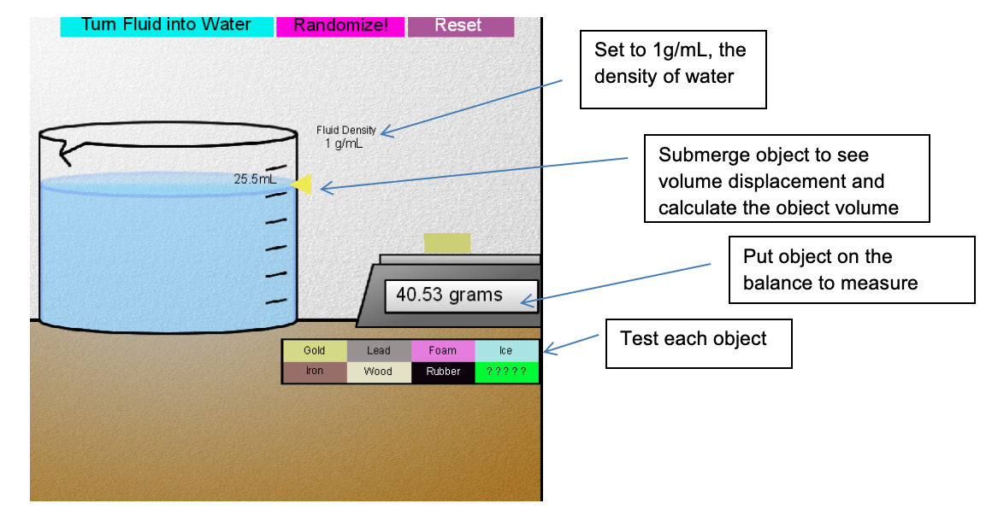

For each object record the following,

* The mass of each object
* The volume of each object
* The density of each object
* Whether each object sinks or floats

|  |  |  |  |  |
| --- | --- | --- | --- | --- |
| **Substance** | **Mass** | **Volume** | **Density** | **Float or Sink in Water** |
| **Gold** |  |  |  |  |
| **Lead** |  |  |  |  |
| **Foam** |  |  |  |  |
| **Ice** |  |  |  |  |
| **Iron** |  |  |  |  |
| **Wood** |  |  |  |  |
| **Rubber** |  |  |  |  |
| **?????** |  |  |  |  |

* **Complete the data analysis**

Which objects sank? Which objects floated?

|  |
| --- |
|  |

How does density impact the ability of an object to sink or float

|  |
| --- |
|  |

In water, how does mass have to compare to volume in order for the object to float?

|  |
| --- |
|  |

* **Write a conclusion**

What did you learn?

|  |
| --- |
|  |

Use the Internet to search for densities. What was the unknown object?

|  |
| --- |
|  |

* **Complete the post-lab questions**

What happens when objects with a density of more than one are placed in water?

|  |
| --- |
|  |

What happens when objects with a density of less than one are placed in water?

|  |
| --- |
|  |

* **Receive Credit for this lab**

Each group member must complete and submit their own lab to receive credit