Name _______________________________________________________________________________________

|  |
| --- |
| **Intermolecular Forces** |

|  |
| --- |
| **Your Tasks (Mark these off as you go)** |
| * Define key vocabulary * Measure the polarity of different molecules * Determine the boiling point of different molecules * Determine the type of intermolecular forces of attraction between molecules * Interpret your results * Receive credit for this lab |

* + **Define key vocabulary**

**Bond dipole**

|  |
| --- |
|  |

**Polar molecule**

|  |
| --- |
|  |

**Nonpolar molecule**

|  |
| --- |
|  |

**Intermolecular force**

|  |
| --- |
|  |

**Dipole-dipole force of attraction**

|  |
| --- |
|  |

**London Dispersion force of attraction**

|  |
| --- |
|  |

**Hydrogen bond**

|  |
| --- |
|  |

* + **Measure the polarity of different molecules**

In this portion of the lab you will measure the polarity of different molecules. We will do this be observing the degree that different substances are deflected when they are approached by a charged rod. This process is illustrated below,

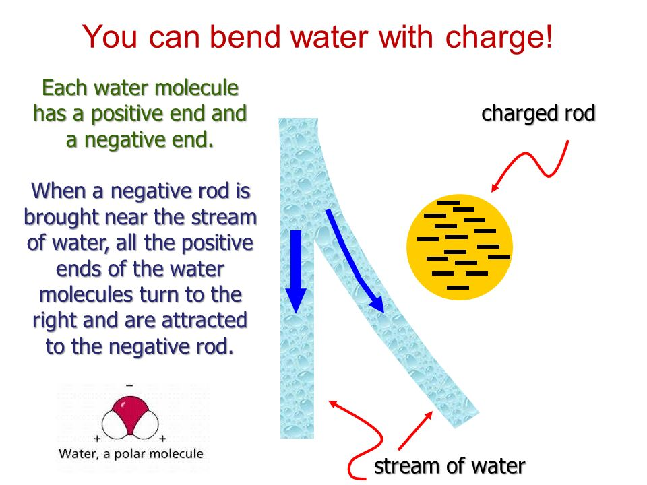

|  |  |
| --- | --- |
| **Procedure** | |
| Assemble the buret. Make sure it is in the closed position. |  |
| Position a flask below the buret, then transfer ~10 mL of the first liquid to the buret |  |
| Charge a plastic rod by rubbing it with a cloth or your hair. This removes electrons and causes the rod to develop a positive charge. | Image result for charged rod by rubbing |
| Open the buret. If you do not see a steady stream of liquid, the buret is clogged. Unclog the buret before you continue. |  |
| Once you have a steady stream of liquid leaving the buret, without letting the rod touch the liquid, bring the charged rod close to the stream and observe what happens. Record the degree of deflection on a scale of 0 to 2. (0=no deflection; 1=some deflection; 2=strong deflection). |  |
| * DO NOT discard the liquid. Let it drain back into the container from which you retrieved it. * Repeat the above with the remaining liquids. | |

**Data Table 1. Indicate the name of each liquid you have been provided**

|  |  |  |  |  |  |  |  |
| --- | --- | --- | --- | --- | --- | --- | --- |
|  | **Water** |  |  |  |  |  |  |
| **Deflection**  **0 = none**  **1 = some**  **2 = strong** |  |  |  |  |  |  |  |

* + **Determine the boiling point of different molecules**

Look up the boiling point for each of the liquids you tested. Record the boiling points in the table below.

**Data Table 1. Indicate the name of each liquid you have been provided**

|  |  |  |  |  |  |  |  |
| --- | --- | --- | --- | --- | --- | --- | --- |
|  | **Water** |  |  |  |  |  |  |
| **Boiling Point** |  |  |  |  |  |  |  |

* + **Determine the type of intermolecular forces of attraction between molecules**

Look up the Lewis structures for each of the molecules you tested. Draw the Lewis Structures. For each molecule, indicate whether it is polar or nonpolar, then indicate the type of intermolecular forces of attraction it undergoes.

|  |  |  |  |
| --- | --- | --- | --- |
| **Molecule tested** | **Lewis structure** | **Polar/nonpolar** | **Intermolecular Forces** |
| Water |  |  |  |
|  |  |  |  |
|  |  |  |  |
|  |  |  |  |
|  |  |  |  |
|  |  |  |  |
|  |  |  |  |

* + **Interpret your results**

Summarize the purpose of this experiment

|  |
| --- |
|  |

In your own words, summarize what you did in order to accomplish the purpose.

|  |
| --- |
|  |

In your own words, summarize what you did in order to accomplish the purpose.

|  |
| --- |
|  |

Look at the Lewis structures you drew. Discuss the correlation between the structural properties of the molecules and the extent they were deflected.

|  |
| --- |
|  |

Discuss the correlation between the degree that the molecules deflected and their boiling point.

|  |
| --- |
|  |

* + **Receive Credit for this lab**

Submit your completed lab to receive credit.