Name _______________________________________________________________________________________

|  |
| --- |
| **Interpreting the Hydrogen Emission Spectrum** |

|  |
| --- |
| **Your Tasks (Mark these off as you go)** |
| * Build a visible spectrometer * Calibrate your spectrometer * Explore atoms with charges * Identify the particles that contribute to the mass of an atom * Interpret nuclear notation * Test your understanding * Receive credit for this lab |

* + **Build a visible spectrometer**

A visible spectrometer is a scientific instrument used to separate and measure the visible components of different light sources. Follow the instructions below to build your own!



|  |  |
| --- | --- |
| Obtain a box. A cereal box works great, but any box of similar shape will also work. Once you have your box,   * Tape your box together so that there are no openings * lab the box as shown. Make sure you label one side as “front”, another as “top”, and another as “back”. | The Helpful Art Teacher: Designing Your Own Cereal Box using Photoshop |
| Turn you box so that the front faces you and the top is facing up. Cut a 3 x 3 cm square in the front of your box as shown. |  |
| Turn your box around so that the back faces you and the top is facing up. Cut a 4 x 3 mm slit in the back of your box as shown. |  |
| Orientate your box so that back faces you and the top is facing up.  Cut a flap in the top of your box as shown. |  |
| Cut out a copy of a ruler. Open the flap and secure the ruler to the inside of the box along the back. |  |
| Obtain a piece of diffraction grating and tape the grating over the 3 cm x 3 cm hole in the front of your box. |  |
| Test your spectrometer. Point your spectrometer at the hydrogen light source and align the light source with the slit. Look through the window. If you see the distinct bands of hydrogen you spectrometer works, if not try rotating the diffraction grading and try again. |  |

* + **Calibrate your spectrometer**

Just hydrogen, mercury also produces a unique pattern of lights. A convenient source of mercury are halogen lights. The emission spectrum for mercury is shown below.

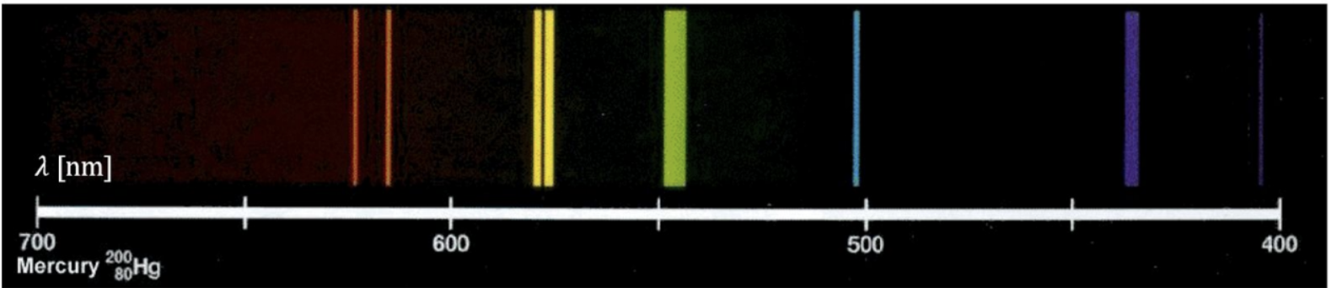

In the data table below, record the wavelength of the following lines

|  |  |
| --- | --- |
| Locate the |  |
|  |  |

|  |  |  |
| --- | --- | --- |
| **Number of protons** | **Neutrons required to make a “stable” atom** | **Electrons required to make a neutral atom** |
| 10 |  |  |
|  |  |  |
|  |  |  |
|  |  |  |
|  |  |  |

|  |
| --- |
| What particles surround the center of the atom? |
|  |

|  |
| --- |
| What is the charge on a proton? |
|  |

|  |
| --- |
| What is the charge on an electron? What makes an atom neutral? |
|  |

* + **Explore atoms with charges**

|  |  |
| --- | --- |
| Create an atom by dragging and dropping 5 protons, 5 neutrons, and 5 electrons.  Display the “Net Charge” window.  Add more electrons so the atom has more than 5. Record the number of protons, neutrons, electrons, and the net charge.  Remove electrons so the atom has less than 5. Record the number of protons, neutrons, electrons, and the net charge.  Repeat the above process for different numbers of protons, neutrons, electrons. Each time record the Net Charge and the identity of the atom. |  |

|  |  |  |  |  |
| --- | --- | --- | --- | --- |
| **Atom** | **Protons** | **Neutrons** | **Electrons** | **Net Charge** |
|  |  |  |  |  |
|  |  |  |  |  |
|  |  |  |  |  |
|  |  |  |  |  |
|  |  |  |  |  |

|  |
| --- |
| What is a rule for making an atom with a positive charge? |
|  |

|  |
| --- |
| What is a rule for making an atom with a negative charge? |
|  |

|  |
| --- |
| Do neutrons affect the overall charge of the atom? |
|  |

|  |  |  |  |
| --- | --- | --- | --- |
| Consider the atoms with the following protons and electrons. For each atom, determine its identity and the net charge. | | | |
| **Atom** | **Protons** | **Electrons** | **Charge** |
|  | 3 | 2 |  |
|  | 4 | 2 |  |
|  | 5 | 2 |  |
|  | 7 | 10 |  |
|  | 8 | 10 |  |
|  | 9 | 10 |  |
|  | 10 | 10 |  |

* + **Identify the particles that contribute to the mass of an atom**

|  |  |
| --- | --- |
| Reset the simulator |  |
| Create a stable, neutral Boron atom by dragging and dropping 5 protons, 5 neutrons, and 5 electrons.  Display the “Mass Number” window.  Record the mass of Boron in the table below.  Add an electron to your Boron atom, re-record the mass.  Take away two electrons from your Boron atom, re-record the mass  Take away a neutron. Indicate the atom, then record the number of protons, neutrons, electrons, and the mass.  Take away a proton. Indicate the atom, then record the number of protons, neutrons, electrons, and the mass.  Drag and drop different amounts of protons, neutrons, and electrons, to create at least 3 more additional atoms. Record the identify of the atom, along with the number of protons, neutrons, electrons, and mass for each. |  |

|  |  |  |  |  |
| --- | --- | --- | --- | --- |
| **Atom** | **Protons** | **Neutrons** | **Electrons** | **Mass** |
| Boron | 5 | 5 | 5 | 10 |
| Boron | 5 | 5 | 6 |  |
| Boron | 5 | 5 | 4 |  |
|  |  |  |  |  |
|  |  |  |  |  |
|  |  |  |  |  |
|  |  |  |  |  |
|  |  |  |  |  |

|  |
| --- |
| Which particles determine the mass of the atom? |
|  |

|  |  |  |  |  |
| --- | --- | --- | --- | --- |
| Complete the table below by filling in the boxes shaded red. Assume each atom is neutral. | | | | |
| **Atom** | **Protons** | **Neutrons** | **Electrons** | **Mass** |
| Carbon | 6 |  |  | 12 |
| Carbon | 6 |  |  | 14 |
|  | 12 |  |  | 25 |
|  | 11 | 12 |  |  |
| Argon |  |  |  | 40 |
| Zinc |  |  |  |  |

* + **Interpret nuclear notation**

|  |  |
| --- | --- |
| Open the Symbol screen  <https://phet.colorado.edu/sims/html/build-an-atom/latest/build-an-atom_en.html?screens=2> |  |
| Create some atoms by dragging and dropping protons, neutrons, and electrons.  Indicate what each part of the symbol represents below.  Describe how you can determine the value of each part. For example, to find the mass number you can add the protons and neutrons. |  |

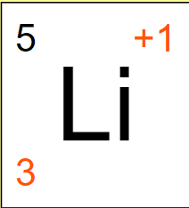

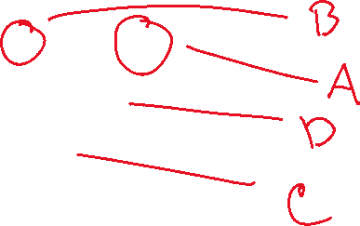

|  |  |  |
| --- | --- | --- |
|  | Representation | Describe how you can determine its value |
| A |  |  |
| B |  |  |
| C |  |  |
| D |  |  |

* + **Test your understanding**

|  |  |
| --- | --- |
| Navigate to the Build an Atom game  <https://phet.colorado.edu/sims/html/build-an-atom/latest/build-an-atom_en.html> |  |
| Play levels 1, 2, 3, 4. Once you have completed all four levels, take a screenshot of your results and paste it below. |  |

|  |
| --- |
| Paste a screenshot of your game results below. |
|  |

* + **Receive Credit for this lab**

Each group member must complete and submit their own lab to receive credit