|  |
| --- |
| **Making Water** |

|  |
| --- |
| **Your Tasks (Mark these off as you go)** |
| * Define key vocabulary * Review Avogadro’s law * Explore the gas phase reaction between hydrogen and oxygen * Calculate the experimental molar mass of dry ice * Interpret your results * Receive credit for this lab |

* **Define key vocabulary**

**STP**

|  |
| --- |
|  |

**Avogadro’s law**

|  |
| --- |
|  |

**Molar volume**

|  |
| --- |
|  |

* **Review Avogadro’s Law**

Previously learned that the volume a gas occupies is directly proportional to the moles of gas. The relationship is shown below.

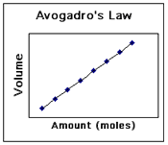

This relationship, also known as Avogadro’s Law is true regardless of the identity of the gas. Avogadro also established that the actual volume 1 mole of gas occupies at Standard Temperature and Pressure (STP) is always equal to 22.4 L. This is summarized below,



|  |
| --- |
| A flexible container holds 1 mole of H2 gas and 1 mole of O2 gas at STP. What is the volume of the container? |
|  |

That fact that Avogadro’s law is independent of the identity of the gas enabled scientist to study gas phase reactions. For example, consider the reaction between hydrogen gas and chlorine gas. According to the following reaction, if H2 and Cl2 were NOT diatomic molecules, 1 part hydrogen and 1 part chlorine would always produce 1 part HCl.

However, the fact that 1 part hydrogen gas and 1 part chlorine gas always resulted in 2 parts hydrochloric acid led scientists to conclude that both H2 and Cl2 were diatomic molecules. This is illustrated below,

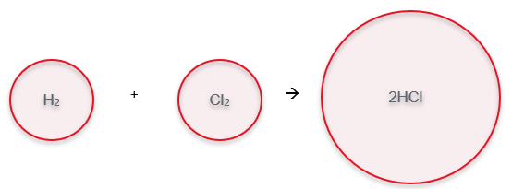

|  |  |
| --- | --- |
| The following gases are confined to a flexible container as shown,  A spark is used to ignite the mixture resulting in a reaction that produces HCl. Draw a picture to show what the contents in the container look like after the reaction is complete. What is the volume of the container after the reaction is complete? | |
| **Picture** | **Volume after reaction is complete** |
|  |  |
| Draw a picture to show what the contents in the container look like after the reaction is complete for the following mixtures. Then indicate the volume of the container after the reaction is complete. | |
| 2 L H2 and 1 L Cl2 | |
| **Picture** | **Volume after reaction is complete** |
|  |  |
| 1 L H2 and 2 L Cl2 | |
| **Picture** | **Volume after reaction is complete** |
|  |  |

|  |  |
| --- | --- |
| The following gases are confined to a flexible container as shown,  A spark is used to ignite the mixture resulting in a reaction that produces NH3. Draw a picture to show what the contents in the container look like after the reaction is complete. What is the volume of the container after the reaction is complete? | |
| **Picture** | **Volume after reaction is complete** |
|  |  |
| Draw a picture to show what the contents in the container look like after the reaction is complete for the following mixtures. Then indicate the volume of the container after the reaction is complete. | |
| 2 L N2 and 3 L H2 | |
| **Picture** | **Volume after reaction is complete** |
|  |  |
| 3 L N2 and 3 L H2 | |
| **Picture** | **Volume after reaction is complete** |
|  |  |
| 4 L N2 and 3 L H2 | |
| **Picture** | **Volume after reaction is complete** |
|  |  |

|  |  |
| --- | --- |
| The following gases are confined to a flexible container as shown,  A spark is used to ignite the mixture resulting in a reaction that produces H2O. Draw a picture to show what the contents in the container look like after the reaction is complete. What is the volume of the container after the reaction is complete? | |
| **Picture** | **Volume after reaction is complete** |
|  |  |
| Draw a picture to show what the contents in the container look like after the reaction is complete for the following mixtures. Then indicate the volume of the container after the reaction is complete. | |
| 2 L O2 and 2 L H2 | |
| **Picture** | **Volume after reaction is complete** |
|  |  |
| 4 L O2 and 2 L H2 | |
| **Picture** | **Volume after reaction is complete** |
|  |  |

* **Explore the gas phase reaction between hydrogen and oxygen**

The procedure below describes how you will collect different ratios of hydrogen gas and explore how they react.

|  |  |
| --- | --- |
| Label 3 flasks as follows.  Flask 1: 1/3 H2 & 2/3 O2  Flask 2: 1/2 H2 & 1/2 O2  Flask 3: 2/3 H2 & 1/3 O2  Mark Flask 1 at the 100 mL and 50 mL lines  Mark Flask 2 at the 75 mL line  Mark Flask 3 at the 100 mL and 50 mL lines  These marks will act as measuring points  Fit the flasks with the correct stopper; keep the stoppers near the correct flask when completing the lab |  |
| Partially fill a tray with water  Fill the flasks full of water and flip them into the tray so that you keep the flask full of water |  |
| Obtain about 3 grams of Zn metal and keep in a weigh boat  Add the Zn metal to the small test tube, then place the test tube in the test tube rack.  Fill the test tube about ¼ full with hydrochloric acid and stopper the test tube with the stopper/tubing apparatus  Allow some gas to escape to clear out the room air (N2) in the rubber tubing  Put the rubber tubing under the lip of the flask that is UNDER water   * Fill the 1/3 hydrogen flask with gas so that the water is displaced to the first line * Fill the 1/2 hydrogen flask so that the water is displaced to the 75 mL line * Fill the 2/3 hydrogen flask so that the water is displaced to the second line   When the hydrogen has been collected keep the flasks inverted in the tub. Be careful to not tip them over. |  |
| Obtain about 3 grams of potassium chlorate/manganese dioxide mixture (KClO3/MnO2) and add this to the large test tube.  Secure the test tube to the stand as shown in the diagram. It is important that the lamp is at the top of the tube, the tube is a 45 degree angle, and the opening is pointed away from people.  Stopper the test with the stopper/tubing apparatus  Position the test tube about 6 inches above the Bunsen Burner |  |
| Light the Bunsen Burner and slide it under the test tube. Carefully heat your test tube. Keep the reaction under control by using a small to medium flame on the Bunsen burner. |  |

* **Write a procedure to determine the molar mass of dry ice**

|  |
| --- |
| Watch the demonstration on how to collect carbon dioxide gas using the apparatus shown below. Then work with your group to develop a procedure to collect all the data necessary to determine the molar mass of dry ice. Your procedure must be written in such a way so that another chemistry student at Timberline HS could perform the experiment and obtain similar results. |
|  |

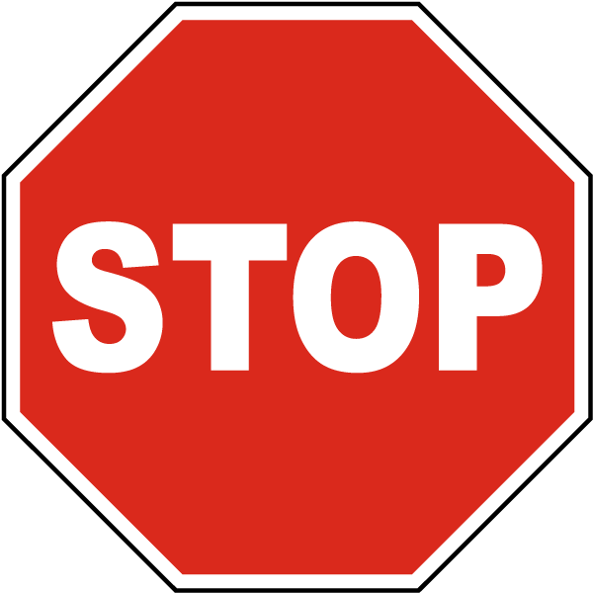

Before you continue have Ms. Pluska approve your procedure.

* **Collect the data necessary to determine the molar mass of dry ice**

|  |
| --- |
| * Test out the procedure you wrote above with a trial run. If you are satisfied with your procedure, you may continue, if not, go back and revise it. * Run your experiment three times. This will ensure you have sufficient data to calculate the average experimental molar mass of dry ice. Record all your data in the table below. |

**Data table**

|  |  |  |  |
| --- | --- | --- | --- |
| Trial | Mass of dry ice + test tube before | Mass of dry ice + test tube after | Volume of water collected |
| 1 |  |  |  |
| 2 |  |  |  |
| 3 |  |  |  |
| Atmospheric pressure |  | | |
| Temperature of water |  | | |

Observations

|  |
| --- |
|  |

* **Determine the experimental molar mass of dry ice**

|  |
| --- |
| Before you can calculate the molar mass, you must make sure each of the variables you recorded are in the proper units. For each trial (1) Calculate the mass of CO2 that sublimed (2) Convert the temperature in Celsius to Kelvin (3) Convert the volume of water collected to liters (4) Convert the atmospheric pressure to atmospheres. Record these new values in the table below. |
| |  |  |  |  |  | | --- | --- | --- | --- | --- | | Trial | Mass of CO2 the sublimed | Temperature in Kelvin | Volume of water in Liters | Pressure in atmospheres | | 1 |  |  |  |  | | 2 |  |  |  |  | | 3 |  |  |  |  | |

|  |
| --- |
| For each trail calculate the moles of carbon dioxide you collected using the ideal gas equation, PV = nRT. Recall that the value of R is 0.0821. |
| |  |  | | --- | --- | | Trial | Moles (n) | | 1 |  | | 2 |  | | 3 |  | |

|  |
| --- |
| For each trail calculate the experimental molar mass of dry ice. |
| |  |  | | --- | --- | | Trial | Molar Mass (g/moles) | | 1 |  | | 2 |  | | 3 |  | |

|  |
| --- |
| Calculate the average molar mass of dry ice based on your three trials. |
|  |

|  |
| --- |
| Calculate the actual molar mass of carbon dioxide given the values of carbon and oxygen on the periodic table. |
|  |

|  |
| --- |
| Calculate the percent error associated with your average molar mass obtained from your experiment. $$percent error= \frac{actual value-experimental value}{actual value} x 100$$ |
|  |

* **Interpret your results**

|  |
| --- |
| Answer the following in complete sentences. You must also be mindful of spelling, punctuation and overall writing quality. |
| What was the purpose of this experiment? |
|  |
| In your own words, summarize what you did to accomplish the purpose. |
|  |
| Summarize your findings along with the percent error associated with your results. In your summary you must include values you obtained. |
|  |
| Consider the gases below. If you conducted the same experiment with these gases, how would your results compare? Would the percent error be about the same, less, or more? |
| |  |  | | --- | --- | | Gas | Percent error same, less, or more | | N2 |  | | SF6 |  | | H2 |  | | Propane (C3H8) |  | |
| Indicate the effects of the following errors on the experimental value you obtained for the molar mass of dry ice. |
| |  |  |  | | --- | --- | --- | | Error | Major/Minor | Effect on the obtained value | | Carbon dioxide is soluble in  Water |  |  | | Condensation on the outside of the test tube |  |  | |

* **Receive Credit for this lab**

Each group member must complete and submit their own lab to receive credit