Name _______________________________________________________________________________________

|  |
| --- |
| **Moles mass atoms** |

|  |
| --- |
| **Your Tasks (Mark these off as you go)** |
| * Identify moles, mass, and atoms in a sample of an element * Convert between moles and mass * Convert between moles and atoms * Convert between grams and atoms * Receive credit for this lab |

* + **Identify moles, mass, and atoms in a sample of an element**

Previously we learned how to express the mass of an element in atomic mass units. The mass of any element can be identified by using the [periodic table](https://ptable.com/).

Below is a screenshot of oxygen from the periodic table you will be using for this lab. Notice the number on the bottom represents the mass of the element. In this lab, we will report all masses to the tenths place. So, in atomic mass units, the mass of oxygen would be written as 16.0 amu.



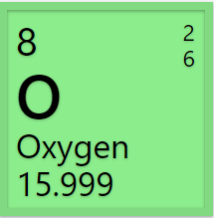

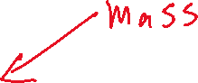

Atomic mass units are not a very useful measurement – we do not have an atomic mass unit balance! Grams however are. Recall that if we have an Avogadro’s amount (6.022 x 1023) of atoms, the mass of the element can be expressed in grams.

For example,

6.022 x 1023 atoms of oxygen = 16.0 g

This number is also equivalent to a mole,

1 mole = 6.022 x 1023 things

Putting this all together, we now have a relationship for moles, atoms, and mass,

1 mole = 6.022 x 1023 atom = mass of element (g)

|  |
| --- |
| Use the relationship below and the [periodic table](https://ptable.com/) to complete the following.  1 mole = 6.022 x 1023 atom = mass of element (g)  No math required! Note, that 6.022 x 1023 can also be written as 6.022E23 |
| What is the mass of 6.022 x 1023 atoms of the following? |
| (a) Iodine |
| (b) Lead |
| (c) Neon |
| How many atoms are in each of the following? |
| 1. 12.01 g carbon |
| 1. 85.47 g rubidium |
| (c) 118.71 g tin |
| What is the mass of 1 mole of the following? |
| (a) Tantalum |
| (b) Thallium |
| (c) Arsenic |
| How much in moles is each of the following? |
| 1. 6.94 g lithium |
| (b) 50.942 g vanadium |
| (c) 39.098 g potassium |

* + **Convert between moles and mass**

The relationship below can be used to calculate the mass and/or moles in a sample of atoms.

1 mole = mass of element (g)

When using this relationship, it is important to show your work. Using the units to guide you through the problem-solving process will help ensure you arrive at the correct result. Below is an example of how this can be done.

Example

Determine the number of moles in 8.0 g of oxygen.

To set up this problem we first identify the given which is 8.0 g of oxygen and the unknown which is moles.

|  |  |  |
| --- | --- | --- |
| **given** | **conversion** | **asked to find (unknown)** |
| **8.0 g oxygen** |  | **moles oxygen** |
|  |  |  |

Next, we identify the conversion factor.

1 mole = mass of element (g)

On the [periodic table](https://ptable.com/) we see that the mass of oxygen is 16.0 g,

1 mole oxygen = 16.0 g

So, we arrange the conversion factor such that what we are asked to find appears on top and what we are given appears on the bottom.



|  |  |  |
| --- | --- | --- |
| **given** | **conversion** | **asked to find (unknown)** |
| 8.0 g oxygen | **1 mole oxygen** | moles oxygen |
|  | **8.0 g oxygen** |  |

Now that we have set up our problem, we can solve for what we are asked to find. To do this, we multiply the quantities on top, then divide by the quantities on the bottom. The result is 0.50 moles oxygen. Notice, that the grams cancel, and we end with moles as our final unit.

|  |  |  |
| --- | --- | --- |
| **given** | **conversion** | **asked to find (unknown)** |
| 8.0 g oxygen | 1 mole oxygen | **0.50 moles oxygen** |
|  | 16.0 g oxygen |  |



|  |
| --- |
| For each of the following, complete the table, then calculate the result, |
| How much in moles 12.0 g of helium?   |  |  |  | | --- | --- | --- | | **given** | **conversion** | **asked to find (unknown)** | |  |  |  | |  |  |  | |
| How much in moles is 11.5 g of sodium   |  |  |  | | --- | --- | --- | | **given** | **conversion** | **asked to find (unknown)** | |  |  |  | |  |  |  | |
| How much in moles is 1.00 g of helium?   |  |  |  | | --- | --- | --- | | **given** | **conversion** | **asked to find (unknown)** | |  |  |  | |  |  |  | |
| How much in grams is 0.25 moles of argon?   |  |  |  | | --- | --- | --- | | **given** | **conversion** | **asked to find (unknown)** | |  |  |  | |  |  |  | |
| How much in grams is 0.50 moles of oxygen?   |  |  |  | | --- | --- | --- | | **given** | **conversion** | **asked to find (unknown)** | |  |  |  | |  |  |  | |
| How much in grams is 2.0 moles of lithium?   |  |  |  | | --- | --- | --- | | **given** | **conversion** | **asked to find (unknown)** | |  |  |  | |  |  |  | |

* + **Convert between moles and atoms**

The relationship below can be used to calculate the moles and/or the number of atoms in a sample of atoms.

1 mole = 6.022 x 1023 atoms

Just as before, when using this relationship, it is important to show your work. Using the units to guide you through the problem-solving process will help ensure you arrive at the correct result. Below is an example of how this can be done.

Example

Determine the number of moles in 3.011 x 1023 atoms of oxygen.

To set up this problem we first identify the given which is 3.011 x 1023 atoms of oxygen and the unknown which is moles. Note, that 3.011 x 1023 can also be written as 3.011E23

|  |  |  |
| --- | --- | --- |
| **given** | **conversion** | **asked to find (unknown)** |
| **3.011E23 atoms oxygen** |  | **moles oxygen** |
|  |  |  |

Next, we identify the conversion factor.

1 mole = 6.022 x 1023 atoms

So, we arrange the conversion factor such that what we are asked to find appears on top and what we are given appears on the bottom.



|  |  |  |
| --- | --- | --- |
| **given** | **conversion** | **asked to find (unknown)** |
| 3.011E23 atoms oxygen | **1 mole oxygen** | moles oxygen |
|  | **6.022E23 atoms** |  |

Now that we have set up our problem, we can solve for what we are asked to find. To do this, we multiply the quantities on top, then divide by the quantities on the bottom. The result is 0.50 moles oxygen. Notice, that the grams cancel, and we end with moles as our final unit.

|  |  |  |
| --- | --- | --- |
| **given** | **conversion** | **asked to find (unknown)** |
| 3.011E23 atoms oxygen | 1 mole oxygen | **0.50 moles oxygen** |
|  | 6.022E23 atoms |  |

How to type this calculation into google calculator is illustrated below,

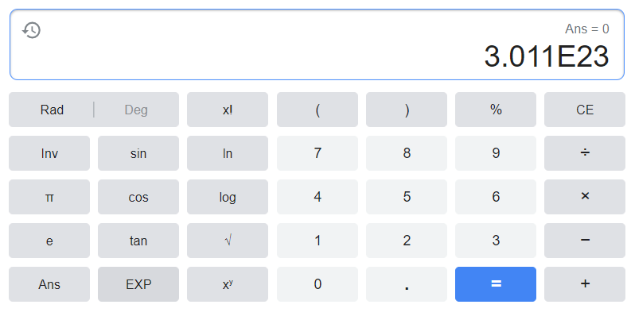



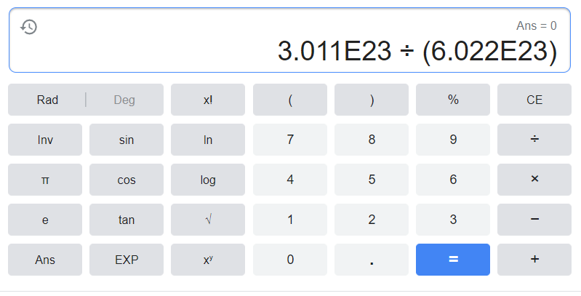

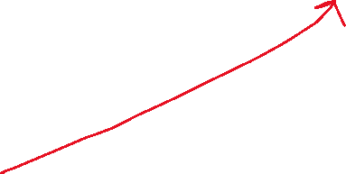

|  |
| --- |
| For each of the following, complete the table, then calculate the result, |
| How much in moles 3.011 x 1023 atoms of helium?   |  |  |  | | --- | --- | --- | | **given** | **conversion** | **asked to find (unknown)** | |  |  |  | |  |  |  | |
| How much in moles is 1.2044 x 1024 atoms of sodium?   |  |  |  | | --- | --- | --- | | **given** | **conversion** | **asked to find (unknown)** | |  |  |  | |  |  |  | |
| How much in moles is 2.50 x 1023 atoms of sulfur?   |  |  |  | | --- | --- | --- | | **given** | **conversion** | **asked to find (unknown)** | |  |  |  | |  |  |  | |
| How many atoms are in 0.50 moles of oxygen?   |  |  |  | | --- | --- | --- | | **given** | **conversion** | **asked to find (unknown)** | |  |  |  | |  |  |  | |
| How many atoms are in 0.25 moles of lead?   |  |  |  | | --- | --- | --- | | **given** | **conversion** | **asked to find (unknown)** | |  |  |  | |  |  |  | |
| How many atoms are in 2.5 moles of lithium?   |  |  |  | | --- | --- | --- | | **given** | **conversion** | **asked to find (unknown)** | |  |  |  | |  |  |  | |

* + **Convert between grams and atoms**

The relationship below can be used to calculate the moles, grams and/or the number of atoms in a sample of atoms.

1 mole = 6.022 x 1023 atoms = mass of element (g)

Just as before, when using this relationship, it is important to show your work. Using the units to guide you through the problem-solving process will help ensure you arrive at the correct result. Below is an example of how this can be done.

Example

Determine the mass of 3.011 x 1023 atoms of oxygen.

To set up this problem we first identify the given which is 3.011 x 1023 atoms of oxygen and the unknown which is grams of oxygen. Note, that 3.011 x 1023 can also be written as 3.011E23

|  |  |  |
| --- | --- | --- |
| **given** | **conversion** | **asked to find (unknown)** |
| **3.011E23 atoms oxygen** |  | **g oxygen** |
|  |  |  |

Next, we identify the conversion factor.

6.022 x 1023 atoms = mass of element (g)

On the [periodic table](https://ptable.com/) we see that the mass of oxygen is 16.0 g,

6.022 x 1023 atoms = 16.0 g

So, we arrange the conversion factor such that what we are asked to find appears on top and what we are given appears on the bottom.



|  |  |  |
| --- | --- | --- |
| **given** | **conversion** | **asked to find (unknown)** |
| 3.011E23 atoms oxygen | **16.0 g oxygen** | g oxygen |
|  | **6.022E23 atoms** |  |

Now that we have set up our problem, we can solve for what we are asked to find. To do this, we multiply the quantities on top, then divide by the quantities on the bottom. The result is 8.0 g oxygen. Notice, that the atoms cancel, and we end with grams as our final unit.

|  |  |  |
| --- | --- | --- |
| **given** | **conversion** | **asked to find (unknown)** |
| 3.011E23 atoms oxygen | 16.0 g oxygen | **8.0 g oxygen** |
|  | 6.022E23 atoms |  |

|  |
| --- |
| For each of the following, complete the table, then calculate the result, |
| What is the mass in grams of 3.011 x 1023 atoms of helium?   |  |  |  | | --- | --- | --- | | **given** | **conversion** | **asked to find (unknown)** | |  |  |  | |  |  |  | |
| What is the mass in grams of 1.2044 x 1024 atoms of sodium?   |  |  |  | | --- | --- | --- | | **given** | **conversion** | **asked to find (unknown)** | |  |  |  | |  |  |  | |
| What is the mass in grams of 2.50 x 1023 atoms of sulfur?   |  |  |  | | --- | --- | --- | | **given** | **conversion** | **asked to find (unknown)** | |  |  |  | |  |  |  | |
| How many atoms are in 8.0 g of oxygen?   |  |  |  | | --- | --- | --- | | **given** | **conversion** | **asked to find (unknown)** | |  |  |  | |  |  |  | |
| How many atoms are in 20.7 g of lead?   |  |  |  | | --- | --- | --- | | **given** | **conversion** | **asked to find (unknown)** | |  |  |  | |  |  |  | |
| How many atoms are in 1.75 g of lithium?   |  |  |  | | --- | --- | --- | | **given** | **conversion** | **asked to find (unknown)** | |  |  |  | |  |  |  | |

* + **Receive Credit for this lab**

Each group member must complete and submit their own lab to receive credit