Name \_\_\_\_\_\_\_\_\_\_\_\_\_\_\_\_\_\_\_\_\_\_\_\_\_\_\_\_\_\_\_\_\_\_\_\_\_\_\_\_\_\_\_\_\_\_\_\_\_\_\_\_\_\_\_\_\_\_\_\_\_\_\_\_\_\_\_\_\_\_\_\_\_\_\_\_\_\_\_\_\_\_\_\_\_\_\_

|  |
| --- |
| **States of Matter** |

|  |
| --- |
| **Your Tasks (Mark these off as you go)** |
| * Assign group roles * Explore physical changes * Explore chemical changes * Explore pure substances and mixtures * Explore heterogeneous and homogeneous mixtures * Propose a procedure to separate a mixture * Receive credit for this lab |

* + **Assign group roles**

Before you continue, record your group number, then collaborate with your group and assign each person a role. Each role and a description is provided below.

|  |  |
| --- | --- |
| **Project manager (PM)** | Leads the team discussion and keeps the team on task and on schedule. Make sure the final lab is submitted. |
| **Communication Specialist (CS)** | Presents answers (or questions) to the class, instructor, or other teams. |

|  |  |
| --- | --- |
| **Group Number:** | |
| **Name** | **Role** |
|  |  |
|  |  |

* + **Explore physical changes**

**Physical change** – the chemicals before and after are the same but the molecules have been rearranged.

* + For example, sugar and water are mixed. Sugar water is still similar to both sugar (sweet) and water (a liquid) but the molecules have been rearranged.
  + For example, wax is melted. Liquid candle wax is still similar to solid candle wax (same color and waxy feeling) but the molecules have spread out and move faster in the liquid.

A physical change can be represented in at least three ways as shown below,

|  |  |  |
| --- | --- | --- |
| Three different representations of freezing water | | |
| Visual Representation | Glass Measuring Beakers 40ml - Set of 6 | Low Form Beakers, Measuring Cups,  Borosiliate Beakers: Amazon.co.uk: Welcome | Ice cube Stock Photo by Pineapple_Studio | PhotoDune |
| Symbolic Representation | H2O(*l*) | H2O(*s*) |
| Molecular Representation |  |  |

|  |  |
| --- | --- |
| Explore your surroundings take pictures of physical changes occurring around you and insert them in the spaces below. Provide a description of the physical change that is occurring. | |
| **Picture** | **Description** |
|  |  |
|  |  |

* + **Explore chemical changes**

**Chemical change** – new chemicals are made from the chemicals before. The molecules from before have been broken down and reformed into new, different molecules after.

* + For example, water is split into hydrogen and oxygen. Water molecules as a gas put a flame out. But after splitting water, the hydrogen gas molecules explode in a flame and the oxygen molecules burn in the flame. The water molecules and broken down and reformed into new, different molecules after.
  + For example, a candle is burned. The wick turns from a white string to black ash. The molecules in the candle break down into CO2 and smoke. Candle wax and the wick will burn but the black ash, CO2 and smoke will not.

A chemical change can also be represented in at least three ways as shown below,

|  |  |
| --- | --- |
| Three different representations of decomposing water into the elements hydrogen and oxygen | |
| Visual Representation | Decomposition Reactions |
| Symbolic Representation | H2O(*l*) 🡪 H2(*g*) + O2(*g*) |
| Molecular Representation | Water splitting - Wikipedia |

|  |  |
| --- | --- |
| Explore your surroundings take pictures of chemical changes occurring around you and insert them in the spaces below. Provide a description of the physical change that is occurring. | |
| **Picture** | **Description** |
|  |  |
|  |  |

* + **Explore pure substances and mixture**

In a **pure substance**, only a single type of matter is present. In other words, only a single element or compound is present.

In a **mixture**, two or more pure substances are mixed.

Below are some examples,

|  |  |  |
| --- | --- | --- |
| **Substance** | **Classification** | **Justification** |
| Table salt | Pure substance | The chemical formula for table salt is NaCl. Pronounced, “sodium chloride”. NaCl is a single compound and therefore is a pure substance. |
| Hand Sanitizer | Mixture | Although the main ingredient in hand sanitizer is isopropyl alcohol or sometimes ethanol (C2H5OH), it also contains water among other ingredients. |

|  |  |  |
| --- | --- | --- |
| Explore your surroundings take pictures of pure substances and mixtures and insert them in the spaces below. For each picture provide a brief description and indicate whether the substance is pure or a mixture. | | |
| **Picture** | **Description** | **Pure substance or mixture** |
|  |  |  |
|  |  |  |

* + **Explore heterogenous and homogenous mixtures**

Mixtures can be further subdivided into two groups: homogeneous mixtures and heterogeneous mixtures

A **homogeneous mixture** is uniform throughout and is also referred to as a **solution.** The components of a homogeneous mixture are not visibly distinguishable.

A **heterogeneous mixture** is not the same throughout. The individual constituents are visibly distinguishable.

Below are some examples of homogeneous and heterogeneous mixtures,

|  |  |  |
| --- | --- | --- |
| **Mixture** | **Classification** | **Justification** |
| Salt water | Homogeneous mixture | When salt dissolves in water, the components that make up the mixture are visibly distinguishable. |
| Paper clip | Homogeneous mixture | A paper clip is a type of alloy made up of different metals. A paper clip is a homogeneous mixture because you cannot visibly distinguish the elements. |
| Rocks | Heterogeneous mixture | Rocks are made up of minerals which are typically visibly distinguishable |
| Oil and water | Heterogeneous mixture | Oil and water do not mix uniformly. Because the components are visibly distinguishable, this is a heterogeneous mixture. |

|  |  |  |
| --- | --- | --- |
| Explore your surroundings take pictures of heterogeneous and homogeneous mixtures and insert them in the spaces below. For each picture provide a brief description and indicate whether the substance is a heterogeneous or homogeneous mixture. | | |
| **Picture** | **Description** | **Homogeneous or heterogeneous** |
|  |  |  |
|  |  |  |
|  |  |  |

* + **Propose a procedure to separate a mixture**

A fundamental difference between pure substances and mixtures is the ability to separate the components using physical means. **If a substance can be separated by physical means it is classified as mixture; if it cannot, it is classified as a pure substance**. Two techniques that can be applied to separate the components of a mixture are described below.

Separation by filtration

Recall that heterogeneous mixtures have particles that are visibly distinguishable (think toppings a pizza) or sand in water.

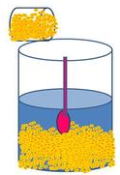

**Figure 1. Sand and water**

A technique for separating insoluble components from a liquid is filtration. **Filtration is a mechanical or physical process applied to separate insoluble particulates from a liquid**. For example, many acids dissolve iron but not gold. Thus, if we put our mixture into an appropriate acid, the acid would dissolve the iron and the gold would be left behind. The two could then be separated by filtration (figure 2)

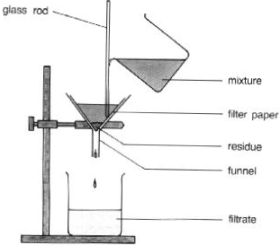

**Figure 2. Filtration procedure**

Separation by evaporation

Evaporation is another useful technique for separating a mixture. This process is illustrated below (Figure 2). When the saltwater solution is heated, the water evaporates, leaving the salt behind.

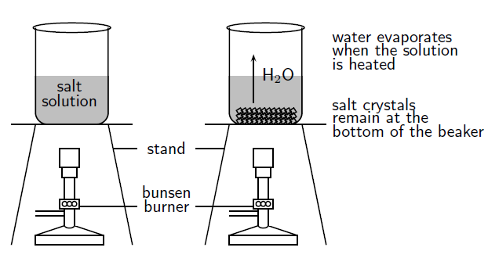

**Figure 2. Separation by evaporation**

|  |  |
| --- | --- |
| Refer to your pictures of heterogeneous and homogeneous mixtures. Describe how you could separate the components of one of your heterogeneous mixtures. Describe how you could separate the components of one of your homogeneous mixtures. | |
| **Heterogeneous separation procedure** | **Homogeneous separation procedure** |
|  |  |

|  |  |  |  |  |  |  |  |  |  |  |  |  |  |  |  |  |  |  |  |  |
| --- | --- | --- | --- | --- | --- | --- | --- | --- | --- | --- | --- | --- | --- | --- | --- | --- | --- | --- | --- | --- |
| Use the information below to propose a method for separating out a mixture of sand, salt, sugar, and iron.   |  |  |  |  |  | | --- | --- | --- | --- | --- | |  | **Sand** | **Salt** | **Sugar** | **Iron** | | **Ethanol** | Insoluble | Insoluble | Soluble | Insoluble | | **Water** | Insoluble | Soluble | Soluble | Insoluble | | **Attracted to a magnet** | No | No | No | Yes | |
|  |

* + **Receive Credit for this lab**

Each group member must complete and submit their own lab to receive credit