Name ____________________________________________________________________________Period ______

|  |
| --- |
| **Stoichiometry of Cookies** |

|  |
| --- |
| **Your Tasks (Mark these off as you go)** |
| * Define key vocabulary * Interpret a reaction symbolically and pictorially * Identify the mole ratio between different substances in a reaction * Identify a limiting and excess reactant * Prepare your cookies * Investigate the stoichiometry of cookies * Receive credit for this lab |

* + **Define key vocabulary**

**Stoichiometry**

|  |
| --- |
|  |

**Limiting Reactant**

|  |
| --- |
|  |

**Excess Reactant**

|  |
| --- |
|  |

**Percent Yield**

|  |
| --- |
|  |

* + **Interpret a reaction pictorially and symbolically**

A chemical reaction indicates how atoms or compounds react to form products. They can be used to figure out how much of a compound you will need, or maybe how much you started with, or how much you want to make. Let’s consider an example you are more familiar with, like making a pizza.

For our pizza we will assume that we need the following,

1 crust

34 slices of pepperoni

½ cup of marinara

1 cup of cheese

A balanced reaction could look something like the following,

1 crust + 34 pepperoni + .5 marinara + 1 cheese 🡪 1 pizza

We typically do not use fractions to show balanced reactions, so another way we could write the above reaction is as follows,

2 crust + 64 pepperoni + 1 marinara + 2 cheese 🡪 2 pizza

The above reaction can be represented pictorially as follows,

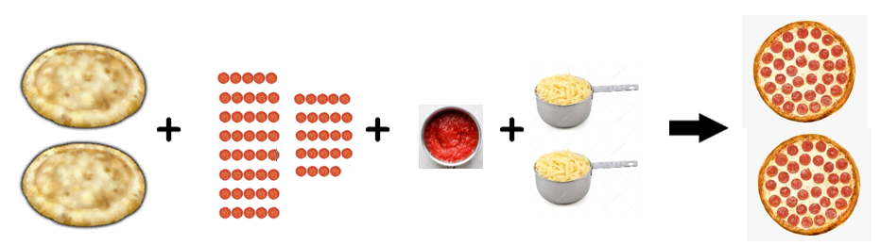

Just as we can represent the making of pizza with pictures and symbols, we can do the same with real chemical reactions. Consider the balanced reaction between hydrogen and oxygen to make water,

2H2 + O2 🡪 2H2O

Pictorially, the balanced reaction can be written as follows,

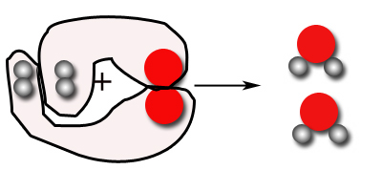

|  |
| --- |
| Nitrogen monoxide (NO) and oxygen gas (O2) react to form nitrogen dioxide (NO2)   1. Draw pictures to show the formation of nitrogen dioxide from its reactants. 2. Write a balanced reaction for this process |
|  |
| Nitrogen (N2) and hydrogen (H2) gas react to form ammonia (NH3)   1. Draw pictures to show the formation of ammonia from its reactants 2. Write a balanced reaction for this process |
|  |

* + **Identify the mole ratio between different substances in a chemical reaction**

The numbers in front of the substances involved in the chemical reaction represent the relative amounts we need for a reaction to take place. For example, to make 2 pizzas, we need 2 parts crust, 64 parts pepperoni, 1 part marinara, and 2 parts cheese.

2 crust + 64 pepperoni + 1 marinara + 2 cheese 🡪 2 pizza

For example, according to our balanced reaction above, we need two parts cheese to make two pizzas. Another way to write this is shown below,

2 parts cheese = 2 parts pizzas

Likewise, we need 2 parts crusts for every 64 parts pepperoni,

2 parts crusts = 64 parts pepperoni

These ratios allow us to make predictions about how much pizza we can make or how much of a reactant we need.

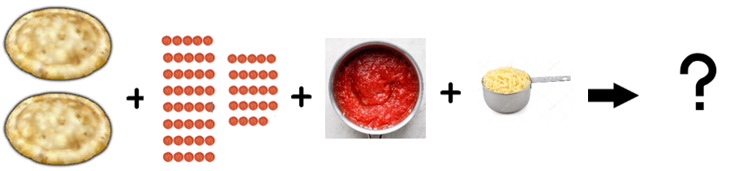

As an example, let’s consider the following problem illustrated above, *“How much pizza can be made given 1 cup of cheese and excess crust, pepperoni, and marinara?”.* To answer this question we need to know the ratio between the cheese and the pizza,

1 part cheese = 2 parts pizza

If 2 parts cheese makes 2 pizzas, then 1 part cheese makes 1 pizza. We can also write this mathematically as shown below. The example below illustrates how we can use the ratio as a conversion factor to convert from the amount of one substance to another.

|  |  |  |
| --- | --- | --- |
| **Given** | **Ratio** | **Unknown** |
| 1 cup cheese | 2 parts pizza | 1 pizza |
|  | 2 parts cheese |  |

|  |
| --- |
| Refer to the reaction for making pizza below,  2 crust + 64 pepperoni + 1 marinara + 2 cheese 🡪 2 pizza  For each of the following, (a) identify the ratio between what you are given and what you are asked to find. Arrange the ratio so that what you are converting to is on top and what you are given is on the bottom. Then, (b) calculate what you are asked to find (show the setup for your calculation in the table provided). The first one has been done for you as an example. |
| How much cheese needed for 16 pieces of pepperoni? |
| |  |  |  | | --- | --- | --- | | **Given** | **Ratio** | **Unknown** | | 16 pepperonis | 2 parts cheese | 0.5 Cheese | |  | 64 parts pepperoni |  | |
| How much marinara is needed for 0.5 parts cheese? |
| |  |  |  | | --- | --- | --- | | **Given** | **Ratio** | **Unknown** | |  |  |  | |  |  |  | |
| How much pizza can be made given 16 pieces of pepperoni? |
| |  |  |  | | --- | --- | --- | | **Given** | **Ratio** | **Unknown** | |  |  |  | |  |  |  | |

This concept can also be applied to chemical reactions. For example, we know hydrogen and oxygen react to make water according the reaction shown,

2H2 + O2 🡪 2H2O

But, what if instead we had only 1 hydrogen molecule? How much water could we make?

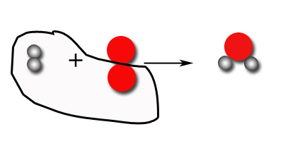

We see from the diagram above that we can make only 1. But we can also calculate this the same way we calculated the ingredients needed to make pizza. In the example below, the mole ratio is the ratio between what we are given and what we are asked to find in the balanced reaction.

|  |  |  |
| --- | --- | --- |
| Hydrogen and oxygen react to make water according to the balanced reaction below,  2H2 + O2 🡪 2H2O  How much water, in moles, can be made given 1 mole of hydrogen? | | |
| **Given** | **Mole ratio** | **Unknown** |
| 1 mole H2 | 2 H2O | 1 mole H2O |
|  | 2 H2 |  |

|  |
| --- |
| Refer to the reaction below,  2Al2O3 🡪 4Al + 3O2  For each of the following, (a) identify the ratio between what you are given and what you are asked to find. Arrange the ratio so that what you are converting to is on top and what you are given is on the bottom. Then, (b) calculate what you are asked to find (show the setup for your calculation in the table provided). The first one has been done for you as an example. |
| How oxygen (O2) in moles can be produced from 1 mole of aluminum oxide (Al2O3)? |
| |  |  |  | | --- | --- | --- | | **Given** | **Ratio** | **Unknown** | |  |  |  | |  |  |  | |
| How much aluminum oxide (Al2O3) is needed to produce 0.5 moles of aluminum (Al) |
| |  |  |  | | --- | --- | --- | | **Given** | **Ratio** | **Unknown** | |  |  |  | |  |  |  | |
| How much aluminum oxide (Al2O3) is needed to produce 0.75 moles of oxygen (O2)? |
| |  |  |  | | --- | --- | --- | | **Given** | **Ratio** | **Unknown** | |  |  |  | |  |  |  | |

* + **Identify a limiting and excess reactant**

The proportion of reactants needed to make two pizzas are illustrated by the balanced equation below,

2 crust + 64 pepperoni + 1 marinara + 2 cheese 🡪 2 pizza

More often than not however, we do not have exactly what we need. For example, what if we had the amounts shown below,

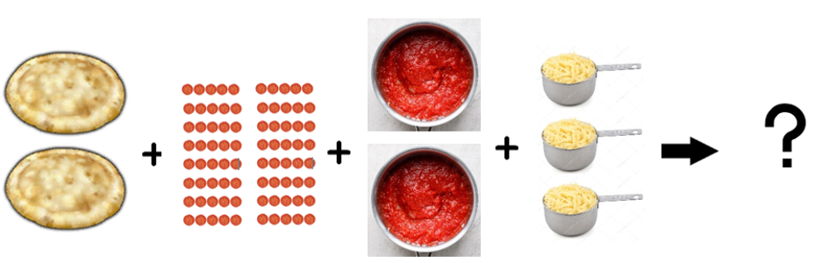

In the above example, we have 2 crusts, 80 pepperonis, 2 cups of marinara, and 3 cups of cheese. However, we can only make 2 pizzas, because the crusts *limit* the amount of pizza we can make. For this reason, the crust is called the *Limiting Reactant.* Likewise, after the pizzas are made, there is excess pepperoni, marinara, and cheese. These are referred to as the *Excess Reactants.*

|  |
| --- |
| Refer to the reaction for making pizza below,  2 crust + 64 pepperoni + 1 marinara + 2 cheese 🡪 2 pizza  For each of the following amounts determine the limiting reactant |
| 3 crusts, 80 pepperoni, 2 marinara, 3 cheese |
|  |
| 1 crust, 40 pepperoni, .5 marinara, .5 cheese |
|  |

Now lets consider what happens if you were provided 3 moles of hydrogen and 2 moles of oxygen and asked to make water (H2O). Pictorially this looks as follows,

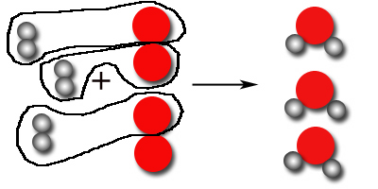

Notice that in the above reaction all the hydrogen has been used up. And that the amount of water formed is therefore limited by the amount of hydrogen available. For this reason, hydrogen is called the *Limiting Reactant.* Likewise, after the reaction is complete, there is excess oxygen. Hence. oxygen is referred to as the *Excess Reactant*.

|  |
| --- |
| For each of the following,   1. Draw a picture of what happens when the amounts given react 2. Identify the limiting and excess reactant |
| 3 moles of nitrogen gas (N2) and 3 moles of hydrogen gas (H2) react to form ammonia (NH3). |
|  |
| 3 moles of NO and 3 moles of O2 react to form NO2 |
|  |
| 3 moles of P4 and 5 moles of O2 react to form P2O5 |
|  |

* + **Prepare your cookies**

|  |
| --- |
| Below are the materials you will need for making your cookies,  0.50 cups sugar, 0.50 cups brown sugar, 0.67 cups butter, 1 egg, 0.50 teaspoon baking soda, 1 teaspoon vanilla, 0.50 teaspoon salt, 1.5 cups flour, 1.25 cups chocolate chips, mixing bowl, wooden spoon, measuring spoons, measuring cups, cookie sheet  Follow the steps below to prepare your cookies |
| 1. Mix sugars and margarine together until smooth 2. Add egg, salt, and vanilla and mix well 3. Stir in baking soda, flour, and chocolate chips 4. Wrap your dough in plastic wrap and write your name and period on the outside 5. Place your dough in the freezer for 15 minutes 6. While your dough is in the freezer, clean your area and mixing supplies 7. Remove your dough from the freezer 8. Make dough balls 3 cm in diameter and place these on the cookie sheet 9. Bake at 350oF for 10 minutes 10. Remove your cookies |

* + **Investigate the stoichiometry of cookies**

|  |
| --- |
| The ingredients required to make 24 cookies are listed below,  0.50 cups sugar, 0.50 cups brown sugar, 0.67 cups butter, 1 egg, 0.50 teaspoon baking soda, 1 teaspoon vanilla, 0.50 teaspoon salt, 1.5 cups flour, 1.25 cups chocolate chips  This can be represented by the following reaction,  0.5 sugar + 0.5 brown sugar + 0.67 butter + 1 egg + 0.5 baking soda + 1 vanilla + 0.5 salt + 1.5 flour + 1.25 chocolate chips 🡪 24 cookies  The reaction above contains lots of fractions. Scale the reaction so that there are only whole numbers in the balanced reaction. |
|  |

|  |
| --- |
| Suppose you have only the following materials:  1 dozen eggs, 4 ounces of vanilla, 1 pound of salt, 1 pound of baking soda, 3 cups of chocolate chips, 4 pounds of flour, 1 pound of butter, 4 pounds of sugar, and 2 pounds of brown sugar |
| For EACH ingredient determine how many cookies you could make |
|  |
| What is the maximum number of moles of cookies you can make with the provided ingredients? |
|  |
| Which ingredient is the limiting reactant? |
|  |
| Calculate the leftovers for EACH excess reactant. |
|  |

* + **Receive Credit for this lab**

Submit your completed lab to receive credit.