|  |
| --- |
| **Set 14. Photoelectron Spectroscopy and Electron Configurations** |

|  |
| --- |
| **Skill 14.01: Calculate the binding energy of an electron**  **Skill 14.02: Interpret photoelectron spectrums**  **Skill 14.03: Be able to write electron configurations for an element**  **Skill 14.04: Apply the Aufbau principle to write electron configurations for an element**  **Skill 14.05: Be able to write electron configurations given the periodic table**  **Skill 14.06: Be able to identify whether or not an atom is in its excited given its electron configuration**  **Skill 14.07: Be able to write abbreviated electron configurations**  **Skill 14.08: Be able to write electron configurations for ions** |

|  |
| --- |
| **Skill 14.01: Calculate the binding energy of an electron** |

**Skill 14.01 Concepts**

Each electron in an atom is attracted to the nucleus. The energy necessary to separate an electron from an atom is called the electron’s **binding energy**. In **photoelectron spectroscopy** a beam of x-rays is directed at a sample of atoms. The x-rays have much more energy than is necessary to knock these electrons out of the atom, producing a stream of electrons called “photoelectrons”. Because the x-rays have more energy than the binding energy, the photoelectrons exit the atom with a (relatively) large amount of kinetic energy.

The binding energy is the difference between the incoming photon’s energy and the kinetic energy of the photoelectron.

*Ebinding energy = Eincoming photon – Ekinetic energy*

Consider the model of Boron below,

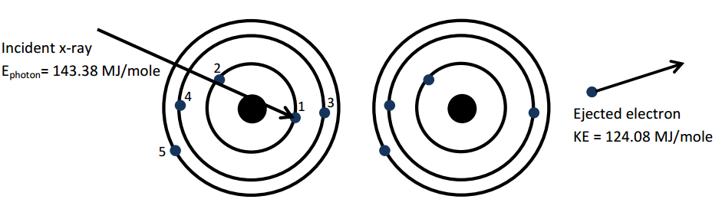

The energy of the incoming photon is 143.38 MJ/mole and the kinetic energy of the ejected electron is 124.08 MJ/mole. There the binding energy is,

143.38 MJ/mole – 124.08 MJ/mole

**Skill 14.01 Problem 1**

|  |
| --- |
| Imagine a sample of neutral boron atoms being struck with x-rays. There are five possible outcomes, depicted below. The boron atoms are depicted using the shell model. |
|  |
| 1. For all five situations, circle the electron that has been ejected from the atom. |
| 1. Complete the table below,  |  |  |  | | --- | --- | --- | | Electron | Kinetic energy | Binding Energy | | 1 |  |  | | 2 |  |  | | 3 |  |  | | 4 |  |  | | 5 |  |  | |

|  |
| --- |
| 1. On the table above, note which electrons have the same kinetic energy after being separated from the atom. |
| 1. What do the electrons with the same kinetic energy after ejection have in common with each other? |

|  |
| --- |
| **Skill 14.02: Interpret photoelectron spectrums** |

**Skill 14.02 Concepts**

Often the data from photoelectron spectroscopy is displayed as a graph of the binding energies. Consider the following model for fluorine,

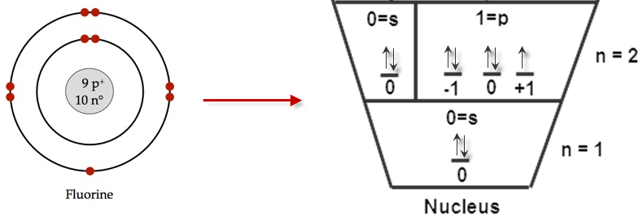

The graph of the binding energies of the electrons is as follows,

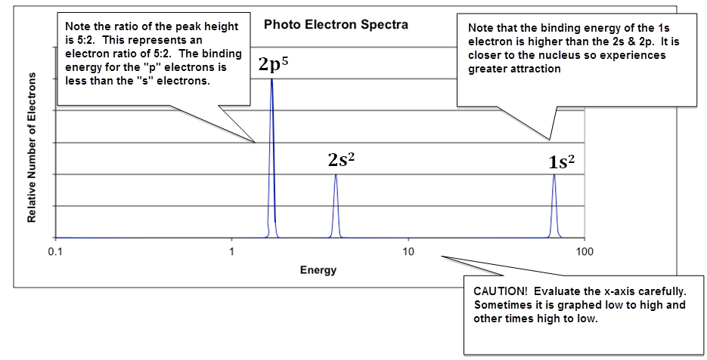

Comparison of spectra beautifully demonstrates how the actual energy of energy levels varies as the nuclear charge, *Z*, increases. This in turn illustrates why each element has a unique atomic spectrum!

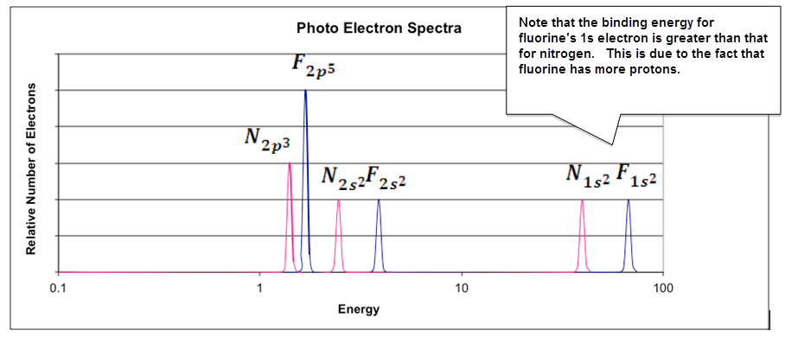

**Skill 14.02 Problem 1**

|  |
| --- |
|  |
| 1. Identify the element and write its electron configuration. |
| 1. The two electrons closest to the nucleus have been labeled on the spectrum. Using this as a guide, label the rest of the peaks. |
| 1. Sketch the expected spectrum of phosphorus on the graph, making sure to show the relative changes in positions (not the exact energy) of the peaks and the relative intensity of each peak. |
| 1. A student makes the following claim regarding the PES spectra of Mg2+ and Ne. Is the statement true or false? Justify your answer. (NOTE, Isoelectronic is just a fancy word that means “having the same number of electrons”) |

**Skill 14.02 Problem 2**

|  |
| --- |
| A portion of the PES spectra for phosphorus and sulfur depicting the 3p and 3s electrons is shown above. Although the nuclear charge for sulfur is **GREATER** than phosphorus, the binding energy for the 3p electrons is unexpectedly **LOWER** for sulfur. Justify this observation in terms of repulsive and attractive forces. |
|  |

Now consider the spectrum for scandium (21 electrons). The peak at 433 represents the 1s electrons and the peak at 3.24 represents the 3p electrons. But notice what happens as move left from 3.24. We see a single electron followed by 2 electrons.

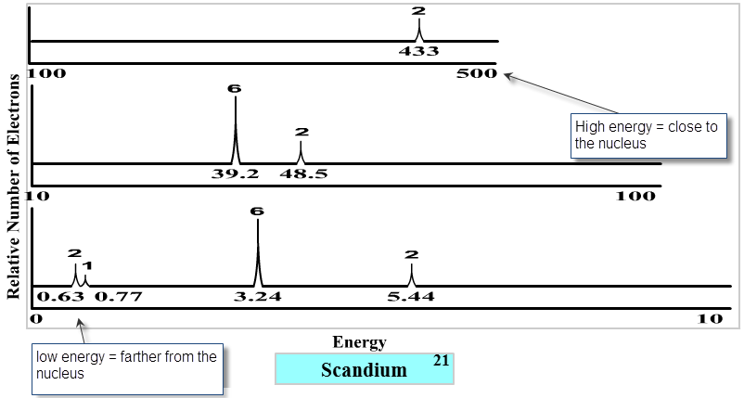

Weird!

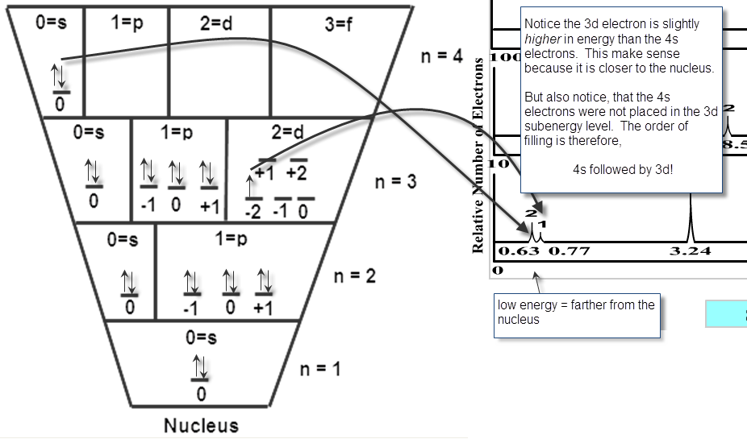

You can think of this behavior as a tug-a-war for stability. While a filled sub-energy level is more stable than an unfilled energy level, electrons also want to be close to the nucleus. As it turns out, atoms will most always fill their 4s sub-energy level before filling their 3d sub-energy level.

**Skill 14.02 Problem 3**

|  |
| --- |
|  |
| 1. Label each peak in the spectrum using the notation illustrated in **Skill 10.02 Problem 1.** |
| 1. If one electron is removed from scandium, which electron requires the least amount of energy to remove? Circle this electron on the spectrum. |
| 1. Sketch the expected spectrum of calcium on the graph, making sure to show the relative changes in positions (not the exact energy) of the peaks and the relative intensity of each peak. |
| **Skill 14.03: Be able to write electron configurations for an element** |

**Skill 14.03 Concepts**

Photoelectron spectroscopy provides direct evidence for the arrangement of electrons in the atom. Consider the following atomic model and spectrum for fluorine,

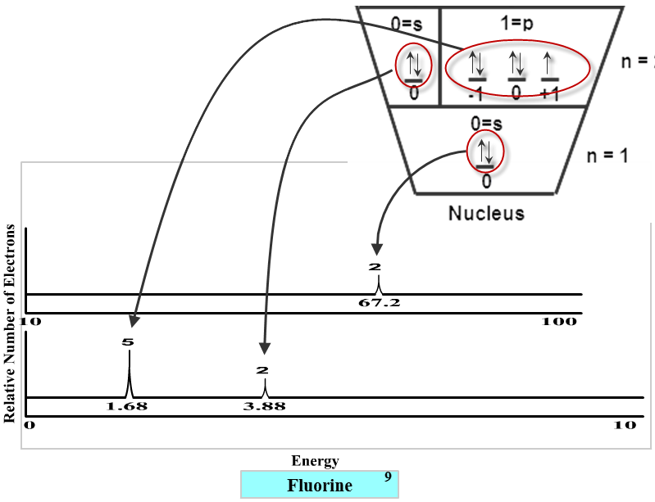

The electron configuration for an atom is used to describe the energies of all the electrons in an atom. And the rules for writing electron configurations are a direct outcome of photoelectron spectroscopy.

**Recall the following letter designations for the subshell *l* and the maximum number of allowed electrons in each subshell**

**0 => s => 2**

**1 => p => 6**

**2 => d => 10**

**3 => f => 14**

When writing electron configurations, the principle quantum number (*n*) serves as the coefficient in the electron configuration and the sub-energy level to which the electrons belong is written next.

Finally, the number of electrons in the sub-energy level is denoted with a superscript.

For fluorine, the electron configuration would be written as follows, 1s22s22p5

**Skill 14.03 Problem 1**

|  |
| --- |
|  |
| 1. Draw photoelectric spectra for the atoms shown above. Draw each spectra on top of the other and make sure that the relative energies of each shell are correct. |
| 1. Write the corresponding electron configurations for elements shown. |

|  |
| --- |
| **Skill 14.04: Apply the Aufbau principle to write electron configurations for an element** |

**Skill 14.04 Concepts**

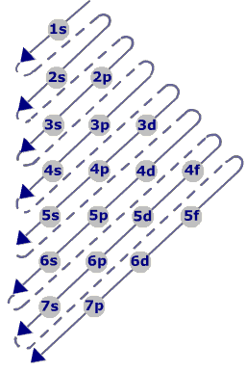

The process for writing electron configurations is based on the Aufbau principle (The German word for building up). This principle dictates that as protons are added one by one to the nucleus to build up the elements, electrons are similarily added to the atomic orbitals. The figure shown right illustrates the order in which electrons are added.

**Skill 14.04 Problem 1**

|  |
| --- |
| Refer to figure 1 to write the ground state electron configurations for the following atoms: |
| (a) Ne |
| (b) K |
| (c) Al |
| (d) Cr |
| (e) Cu |

The placement of potassium’s outer most electrons in the 4s as opposed to the 3d is strongly supported by experimental evidence. The driving force behind electron arrangements in atoms is stability. Atoms gain stability by filling subshells. The single electron in potassium is placed in the s first because it more closely fills this subshell. **There is an irregularity in the pattern for both Cr and Cu however. You wrote 4s13d5 not 4s23d4 and 4s13d10 not 4s23d9. The reason for this irregularity is that a slightly greater stability is associated with the half filled and filled d orbital.**

|  |
| --- |
| **Skill 14.05: Be able to write electron configurations given the periodic table** |

**Skill 14.05 Concepts**

A final note on electron configurations is the relationship between figure 1 and the periodic table. This relationship is illustrated in the figure below.

|  |  |  |  |  |
| --- | --- | --- | --- | --- |
|  |  |  |  | s |
| s | | p | |
|  |
| d |

The periodic table can be used for deducing electron configurations. The periodic table is constructed from four blocks: the s, p, d, and f block.

* The s block is groups 1 and 2. Notice it is only two elements wide and can hold a maximum of two electrons.
* The p block is groups 13-18. Notice it is 6 elements wide and can hold a maximum of 6 electrons.
* The d block is groups 3-12. Notice it is 10 elements wide and can hold a maximum of 10 electrons.

The f block is 14 elements wide and can hold a maximum of 14 electrons

**Skill 14.05 Problem 1**

|  |
| --- |
| Using only the periodic table, write the electron configurations for the following: |
| 1. Ne and Na |
| 1. Ar and Ca |
| 1. Kr and I |

|  |
| --- |
| **Skill 14.06: Be able to identify whether or not an atom is in its excited given its electron configuration** |

**Skill 14.06 Concepts**

All the electron configurations encountered so far are called ground state electron configurations. That is all the electrons are in their ground state, or most stable state. As you have seen before, electrons can be excited. When this happens an electron in its ground state can move to a more energetic state. For example, the ground state electron configuration for helium is 1s2, however an excited configuration could be 1s12s1. Notice that in the excited configuration, an electron in the 1s energy level was promoted to the 2s energy level.

**Skill 14.06 Problem 1**

|  |
| --- |
| Which of the following represents an electron configuration of an atom, which has been excited? How do you know?  (a) 1s22s12p63s1  (b) 1s22s22p63s23p64s23d9  (c) 1s22s22p53s23p64s23d9  (d) 1s22s22p63s23p64s23d104p5 |
|  |

|  |
| --- |
| **Skill 14.07: Be able to write abbreviated electron configurations** |

**Skill 14.07 Concepts**

Notice in practice 3 that the electron configuration of the noble gas atom (group 18) that directly precedes any element is identical to the early part of the electron configuration for that element. For example, the noble gas that directly precedes chlorine (Cl, atomic number 17) is neon (Ne, atomic number 10). The first 10 electrons in Cl can thus be replaced with the Ne symbol, and the electron configuration of Cl can be written [Ne]3s23p5.

**Skill 14.07 Problem 1**

|  |
| --- |
| Write the abbreviated electron configurations for the following: |
| Sb |
| Hg |
| Mo |
| Ba |

|  |
| --- |
| **Skill 14.08: Be able to write electron configurations for ions** |

**Skill 14.08 Concepts**

Atoms are neutral because their numbers of electrons and protons are equal. When they are not equal they become charged. An atom or molecule with a charge is called an **ion**.

* Anions are negatively charged ions. The are formed when an atom or molecule gains an electron:

Cl + e- 🡪 Cl-

**In general, nonmetals gain electrons to become anions**

* Cations are positively charged ions. They are formed when an atom or molecule loses an electron:

Na 🡪 Na+ + e-

**In general, metals lose electrons to become cations**

Atoms tend to gain or lose electrons so they can obtain a noble gas configuration.

For example the electron configuration for He is:

1s2

The electron configuration for Li is:

1s22s1

Li loses an electron to become “like” He:

1s22s1 🡪 1s2  + e-

OR

Li 🡪 Li+ + e-

Notice that Li obtains a positive charge because it loses an electron.

**Skill 14.08 Problem 1**

|  |  |
| --- | --- |
| For each element below:  a. write the electron configuration for the neutral element  b. indicate the most probably ion formed  c. write the electron configuration for the ion formed | |
| Be | Mg |
| Al | Ga |
| N | P |