**Skill 22.01 Problem 1**

|  |
| --- |
| Name the following compounds: |
| 1. PCl5 |
| 1. PCl3 |
| 1. SF6 |
| 1. H2O |
| 1. P2O5 |

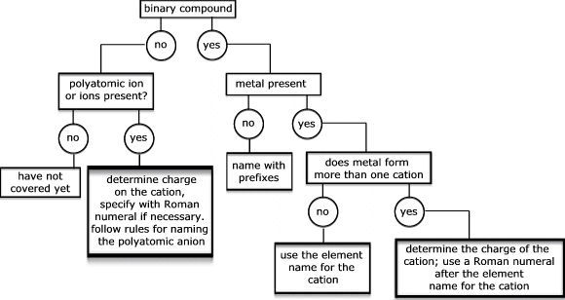

*two different elements only

**Skill 22.02 Problem 1**

|  |
| --- |
| Use the strategy outlined to name the following compounds: |
| 1. NaBr |
| 1. Li2SO4 |
| 1. Pb(NO3)2 |
| 1. CO2 |
| (e) CCl4 |

**Skill 22.02 Problem 2**

|  |
| --- |
| Given the following systematic names, write the formula for each compound |
| (a) Vanadium(V) fluoride |
| (b) Sodium oxide |
| (c) Dihydrogen oxide |
| (d) Potassium cyanide |
| (e) Lead(IV) sulfide |
| (f) Aluminum hydrogen sulfite |