Set 34: Sampling Distributions

Skill 34.1: Estimating a population from a sample
Skill 34.2: Build a sampling distribution of the mean
Skill 34.3: Apply the Central Limit Theorem to sample means
Skill 34.4: Apply the Central Limit Theorem to describe a sampling distribution quantitatively
Skill 34.5: Determine Whether a Statistic Is a Biased or Unbiased Estimator
Skill 34.6: Use the Central Limit Theorem to calculate probabilities for sample means

Skill 34.1: Estimating a Population from a Sample

Skill 34.1 Concepts

In statistics, we often want to learn about a large population. Since collecting data for an entire population is often impossible, researchers may use a smaller sample of data to try to answer their questions.

To do this, a researcher might calculate a statistic such as mean or median for a sample of data. Then they can use that statistic as an estimate for the population value they really care about.

For example, suppose that a researcher wants to know the average weight of all Atlantic Salmon fish. It would be impossible to catch every single fish. Instead, the researchers might collect a sample of 50 fish off the coast of Nova Scotia and determine that the average weight of those fish is x. If the same researchers collected 50 new fish and took the new average weight, that average would likely be slightly different than the first sample average.

The image below shows how sample size affects the shape of a sample distribution and the sample mean. As the sample size gets larger, the sample tends to look more like the population, and the sample mean is more likely to be close to the true population mean. In larger samples, extreme values have less influence on the mean, so the estimate of the population mean is usually more stable and reliable.

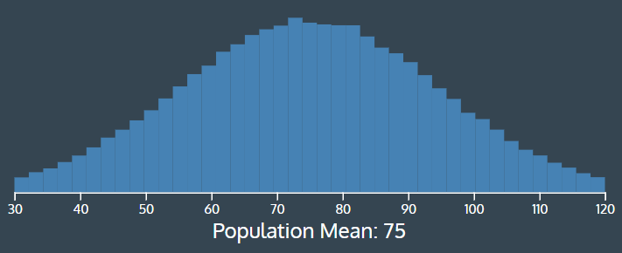
Sample size = 10
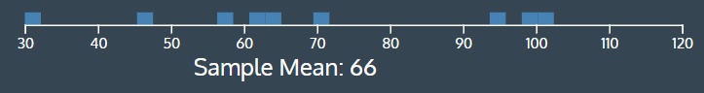
Sample size = 50
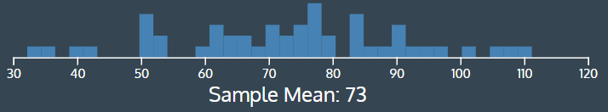
Sample size 100
Sample size = 100
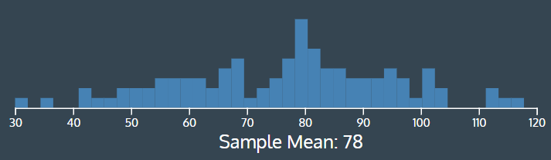
Sample size = 200
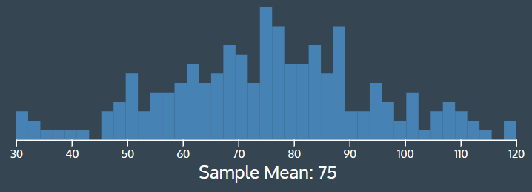

Skill 34.1 Exercise 1

Skill 34.2: Estimating a Population from a Sample

Skill 34.2 Concepts

In statistics, we often want to learn about a large population. Since collecting data for an entire population is often impossible, researchers may use a smaller sample of data to try to answer their questions.
To do this, a researcher might calculate a statistic such as mean or median for a sample of data. Then they can use that statistic as an estimate for the population value they really care about.
For example, suppose that a researcher wants to know the average weight of all Atlantic Salmon fish. It would be impossible to catch every single fish. Instead, the researchers might collect a sample of 50 fish off the coast of Nova Scotia and determine that the average weight of those fish is x. If the same researchers collected 50 new fish and took the new average weight, that average would likely be slightly different than the first sample average.
The numpy.random package has several functions that we can use to simulate random sampling.

Code
import numpy as np
import pandas as pd
import matplotlib.pyplot as plt
import seaborn as sns
population = pd.read_csv("salmon.csv", delimiter = "\t")
salmon_population = population['Salmon_Weight']

sample_size = 50
sample_means = []

# loop 500 times to get 500 random sample means
for i in range(500):
# take a sample from the data:
samp = np.random.choice(salmon_population, sample_size, replace = False)
# calculate the mean of this sample:
this_sample_mean = np.mean(samp)
# append this sample mean to a list of sample means
sample_means.append(this_sample_mean)

# plot all the sample means to show the sampling distribution
sns.histplot(sample_means, stat='density')
plt.title("Sampling Distribution of the Mean")
plt.show()

Output
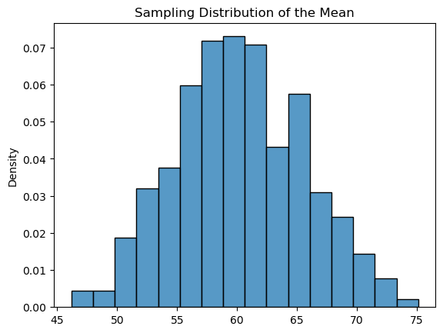

Note that we can look at a sampling distribution for any statistic. For example, we could estimate the sampling distribution of the maximum by calculating the maximum of each sample, rather than the mean (as shown above).

Skill 34.2 Exercise 1

Skill 34.3: Apply the Central Limit Theorem to Sample Means

Skill 34.3 Concepts

So far, we’ve defined the term sampling distribution and shown how we can simulate an approximated sampling distribution for a few different statistics (mean, maximum, variance, etc.). The Central Limit Theorem (CLT) allows us to specifically describe the sampling distribution of the mean.

The CLT states that the sampling distribution of the mean is normally distributed as long as the population is not too skewed or the sample size is large enough. Using a sample size of n > 30 is usually a good rule of thumb, regardless of what the distribution of the population is like. If the distribution of the population is normal, the sample size can be smaller than that.

Let’s take another look at the salmon weight to see how the CLT applies here. The first plot below shows the population distribution. The salmon weight is skewed right, meaning the tail of the distribution is longer on the right than on the left.

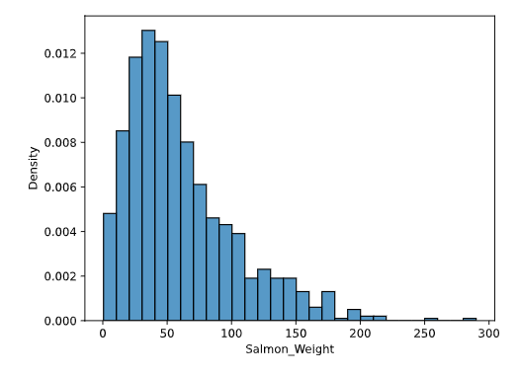
Next, we repeatedly took samples of size 100, found their means, and graphed those means. When we compare that graph to a normal curve, they are almost the same shape.

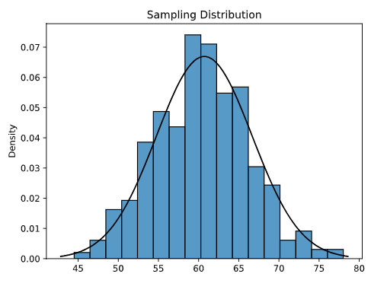
Note that the CLT only applies to the sampling distribution of the mean and not other statistics like maximum, minimum, and variance!

Skill 34.3 Exercise 1

Skill 34.4: Apply the Central Limit Theorem to describe a sampling distribution quantitatively

Skill 34.4 Concepts

Now that we’ve examined the CLT from a high level, let’s get into the details.

The CLT not only establishes that the sampling distribution will be normally distributed, but it also allows us to describe that normal distribution quantitatively.

Normal distributions are described by their mean μ (mu) and standard deviation σ (sigma).

Let’s break this down,

- We take samples of size n from a population (that has a true population mean μ and standard deviation of σ) and calculate the sample mean x.
- Given that n is sufficiently large (n > 30), the sampling distribution of the means will be normally distributed with:
  - mean x approximately equal to the population mean μ
  - standard deviation equal to the population standard deviation divided by the square root of the sample size. We can write this out as:

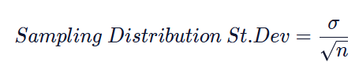
As an example of this, let’s look again at our salmon fish population. In the last exercise, we saw that the sampling distribution of the mean was normally distributed. In the plot below, we can see that the mean of the simulated sampling distribution is approximately equal to the population mean.

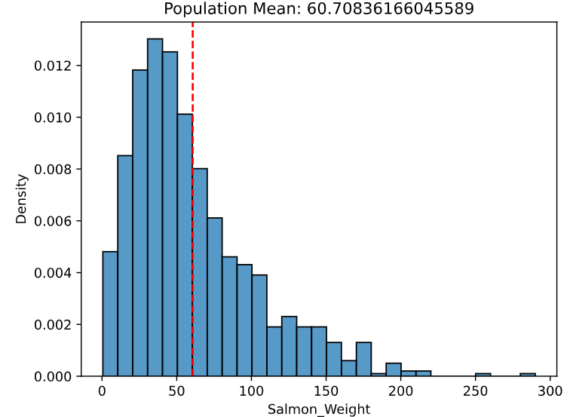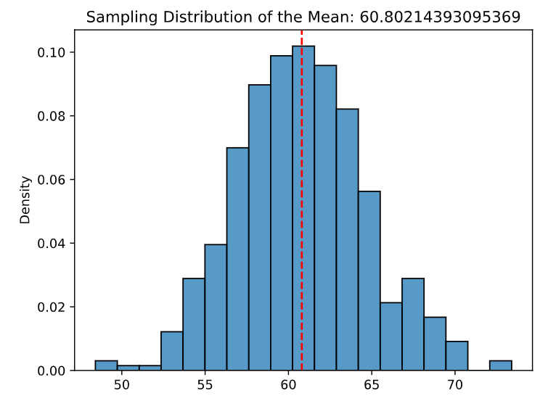

The sampling distribution of the mean is normally distributed, with standard deviation equal to the population standard deviation (often denoted as the greek letter, sigma) divided by the square root of the sample size (often denoted as n):



The standard deviation of the sampling distribution of the mean is called the standard error of the mean. Since we often do not know the population standard deviation, we usually estimate the standard error using the sample standard deviation. This tells us how much sample means are expected to vary from sample to sample

Standard Error = 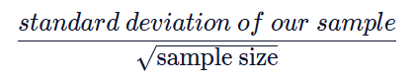

Two important things to note about this formula is that:
- As sample size increases, the standard error will decrease.
- As the population standard deviation increases, so will the standard error.
Skill 34.4 Exercise 1

Skill 34.5: Determine Whether a Statistic Is a Biased or Unbiased Estimator

Skill 34.5 Concepts
According to the Central Limit Theorem, the sampling distribution of the sample mean is centered at the population mean. This is true for the sample mean, but not for every statistic. We can build sampling distributions for many statistics, such as:
- mean
- median
- maximum / minimum
- variance
Since the sample mean is centered at the population mean, it is called an unbiased estimator. In general, a statistic is an unbiased estimator if its sampling distribution is centered at the true population value.

The maximum is one example of a biased estimator, meaning that the mean of the sampling distribution of the maximum is not centered at the population maximum.
Suppose the population values are:

2, 5, 7, 9, 12

The true population maximum is 12. But, if you keep taking small samples, many of them will not include 12. Their sample maximum might be 7, 9, or 5. Over many samples, the average sample maximum will usually be less than 12.

Skill 34.5 Exercise 1

Skill 34.6: Use the Central Limit Theorem to calculate probabilities for sample means

Skill 34.6 Concepts

Once we know the sampling distribution of the mean, we can use it to estimate the probability of observing a particular range of sample means, given some information about the population. To do this, we use the cumulative distribution function (CDF) of the normal distribution.

Let’s work through this with our salmon example. Suppose we are transporting salmon and want to make sure the crate is strong enough to hold their weight.

- Suppose the salmon population has an average weight of 60 lbs and a standard deviation of 40 lbs.
- We have a crate that can support 750 lbs, and we want to transport 10 fish at a time.
- We want to calculate the probability that the average weight of those 10 fish is less than or equal to 75 lbs (750 ÷ 10)

Using the Central Limit Theorem, we model the mean weight of 10 randomly sampled salmon as approximately normally distributed with mean 60 and standard error 40/10

Using the Central Limit Theorem, we model the mean weight of 10 randomly sampled salmon as approximately normally distributed with mean 60 and standard error 40/sqrt(10)​. We can then use this distribution to calculate the probability that the mean weight of 10 randomly sampled fish is less than or equal to 75 lbs.
​
Code
x = 75
mean = 60
std_dev = 40
samp_size = 10
standard_error = std_dev / (samp_size**.5)
# remember that **.5 is raising to the power of one half, or taking the square root
stats.norm.cdf(x,mean,standard_error)
Output
0.882

The calculation above returns 0.882, or a probability of 88.2% that the average weight of our sample of 10 fish will be less than or equal to 75.

Skill 34.6 Exercise 1

