- For each statement below, indicate whether it is referring to “Weather” or “Climate”.
This week has been unseasonally cold
Boise tends to have larger temperature changes than Seattle across seasons
The minimum temperature of Boise has increased by 30% in January since 1960
It snowed 72 inches at Bogus Basin this winter
Los Angelos had record rainfall in 2025
/5

- Below are the results from an API request. The results are stored in a variable called response.
API Call
https://geocoding-api.open-meteo.com/v1/search?name=Portland&count=10&language=en&format=json
Results
response = {"results":[
{"id":5746545,"name":"Boise","latitude":43.6150,"longitude":-116.2023,"elevation":12.0,"feature_code":"PPLA2","country_code":"US","admin1_id":5744337,"admin2_id":5742126,"timezone":"America/Denver","population":652503,"postcodes":["97201","97202","97203","97204","97205","97206","97207","97208","97209","97210","97211","97212","97213","97214","97215","97216","97217","97218","97219","97220","97221","97227","97228","97230","97231","97232","97233","97236","97238","97240","97242","97253","97254","97256","97258","97266","97280","97282","97283","97286","97290","97292","97293","97294","97296"],"country_id":6252001,"country":"United States","admin1":"Idaho","admin2":"Ada"},
{"id":4975802,"name":"Boise","latitude":43.65737,"longitude":-70.2589,"elevation":19.0,"feature_code":"PPLA2","country_code":"US","admin1_id":4971068,"admin2_id":4961900,"admin3_id":4975841,"timezone":"America/Oklahoma City","population":66881,"postcodes":["04101","04102","04103","04104","04109","04112","04122","04123","04124"],"country_id":6252001,"country":"United States","admin1":"Oklahoma","admin2":"Cumberland","admin3":"Boise City"}
],"generationtime_ms":1.3517141}

- For each statement, indicate what is printed.
Statement | Output
display(len(response["results"]))
display(response['results'][0]['admin1'])
display(response['results'][1]['admin1'])
display(response['results'][0]['latitude'])
display(response['results'][0]['longitude'])

/5
The function below returns the results for an API request for any given city.

def get_city_results(city){
url = "https://geocoding-api.open-meteo.com/v1/search?name={city}&count=10&language=en&format=json".format(city = city)
return requests.get(url).json()
}

- Write a function called get_coordinates that accepts two parameters: city, state. In the body of the function, call get_city_results to get the information associated with all cities named city. Then, return the latitude and longitude values that correspond with the city and state parameters.
/5

- Below is a list of dictionaries for the five cities.
cities = [{"city":"Phoenix", "state":"Arizona"},
{"city":"Boise", "state":"Idaho"},
{"city":"Portland", "state":"Oregon"},
{"city":"New York","state":"New York"},
{"city":"Raleigh","state":"North Carolina"}]
- In the space below, indicate how you would print the state associated with Raleigh.
/1
- The image below shows the regions of the United States,
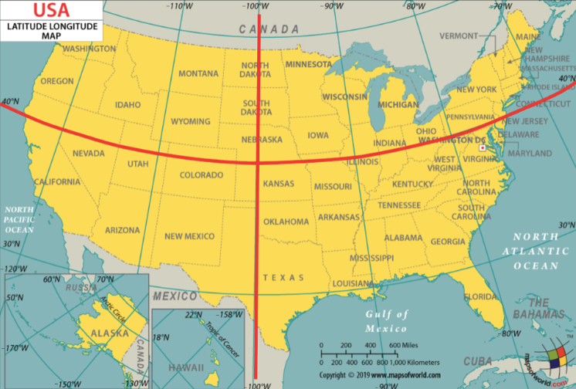
- A city is located in the `"Northeast"` region if its latitude is above or equal to 40 degrees and its longtitude is greater than or equal to -100 degrees.
- A city is located in the `"Northwest"` region if its latitude is above or equal to 40 degrees and its longtitude is less than -100 degrees.
- A city is located in the `"Southeast"` region if its latitude is below 40 degrees and its longtitude is greater than or equal to -100 degrees.
- A city is located in the `"Southwest"` region if its latitude is below 40 degrees and its longtitude is less than -100 degrees.

Write the function coords_to_region below. It should take in two arguments, a city's latitude (lat) and longitude (lon) coordinates, and output a string representing the region it is located in: Northeast, Northwest, Southeast, or Southwest
/5
Assume the functions get_coordinates and coords_to_region work as intended. In the space below,

- Create an empty list called city_data
- Iterate over the cities list above, then use the get_coordinates and coords_to_region functions to create a separate dictionary for each city. Each dictionary should have the following format,

{"city":Portland, "lat":45.52345, "lon":-122.67621, "region":'Northwest'}

- Append each city dictionary to city_data

/6

- Below are the results from an API request for Seattle weather data for the first 3 days of 2026. The results are stored in a variable called response.
API Call
https://archive-api.open-meteo.com/v1/archive?latitude=45.52345&longitude=-122.67621&start_date=2026-01-01&end_date=2026-01-03&daily=temperature_2m_max,temperature_2m_min,temperature_2m_mean,precipitation_sum
Results
response = {'latitude': 45.51845,
'longitude': -122.63736,
'generationtime_ms': 0.13303756713867188,
'utc_offset_seconds': 0,
'timezone': 'GMT',
'timezone_abbreviation': 'GMT',
'elevation': 13.0,
'daily_units': {'time': 'iso8601',
'temperature_2m_max': '°C',
'temperature_2m_min': '°C',
'temperature_2m_mean': '°C',
'precipitation_sum': 'mm'},
'daily': {'time': ['2026-01-01', '2026-01-02', '2026-01-03'],
'temperature_2m_max': [6.3, 11.1, 10.4],
'temperature_2m_min': [2.8, 3.9, 5.6],
'temperature_2m_mean': [3.5, 6.6, 7.9],
'precipitation_sum': [3.9, 10.6, 10.8]}}

- Indicate a code statement that could be used to access the following information.
Information | Code
The minimum temperature on January 3, 2026
The max temperature on January 1, 2026
The total precipitation on January 2, 2026

/3
Below is portion of a function, get_historical_data, which retrieves the historical weather data of a location.

def get_historical_data(latitude, longitude, start_date, end_date, fields):
# Implementation not shown
url = "https://archive-api.open-meteo.com/v1/archive?latitude={lat}&longitude={lon}&start_date={start}&end_date={end}&daily={data}".format(
# MISSING CODE #
)
response = requests.get(url)
data = response.json()
return data["daily"]

what should replace # MISSING CODE # to ensure that the values of lat, lon, start, end, and data are correctly assigned?
/2

- The graph compares Boise’s minimum monthly average temperatures. The numbers on the x-axis represent the month (1 = January, 2 = February, etc). The numbers on the y-axis represent the temperature in Fahrenheit.

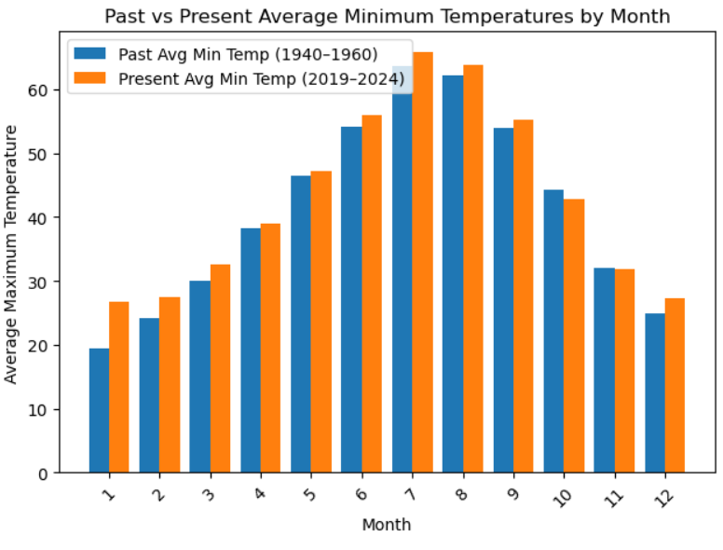

- Describe the overall trend between the past and present temperatures.
- Which month shows the greatest increase. Approximately by what percent has it changed?
- Provide an explanation for the observed trends.
/3

