GitHub Workshop Lab Guide - Windows

Your Tasks (Mark these off as you go)
- Create a GitHub account
- Configure your username and email
- Install Visual studio code
- Install the Jupyter Notebook extension
- Clone a repository
- Complete your assignment with Visual Studio Code

- Create a GitHub account

Following the tutorial below to get started with GitHub
Navigate to the following address,  http://github.com  then, click Sign up | 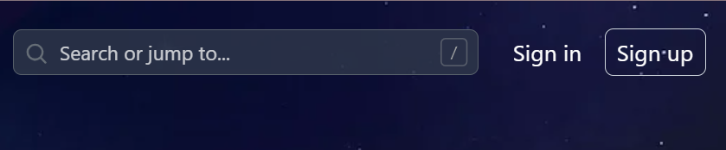
Enter your email, then click Continue | 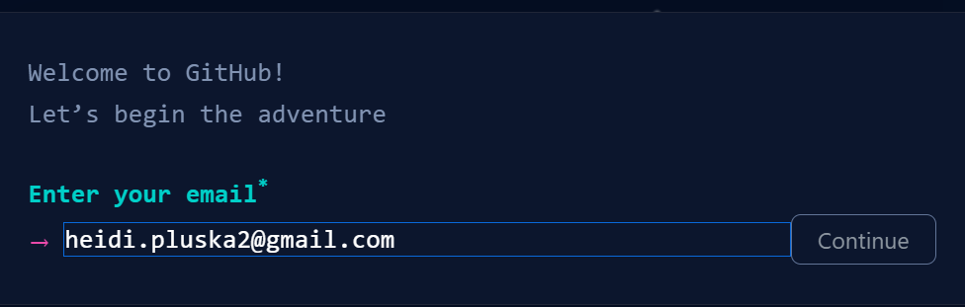
Create a password and click Continue | 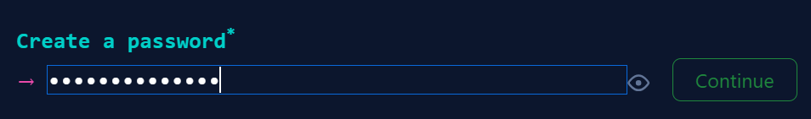
Create username (This username will be public and viewable by everyone) and click Continue | 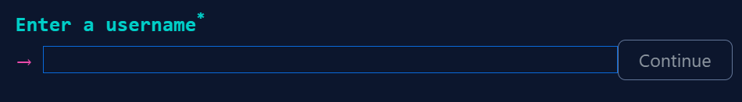
Indicate whether or not you want to receive product updates and click Continue. | 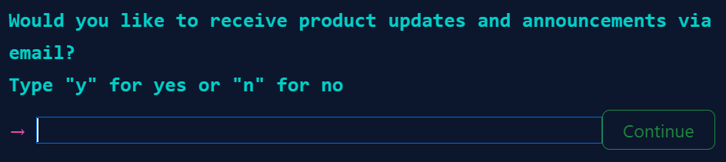
Solve the puzzle to verify your account | 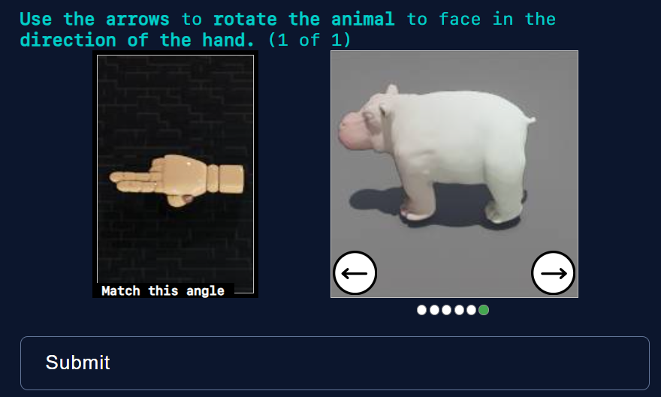
Click Create Account when done
Check your email and Enter code. | 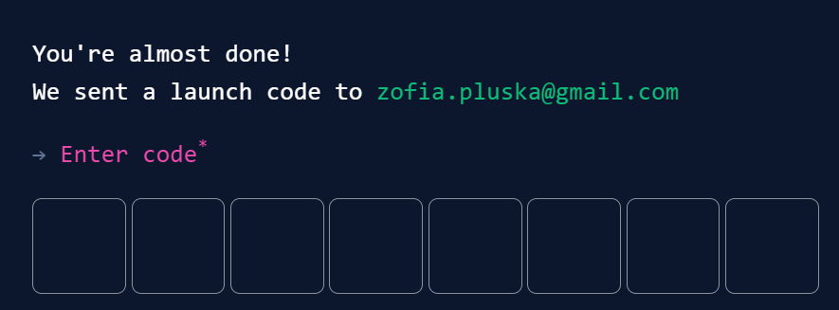
Select Just me and Student | 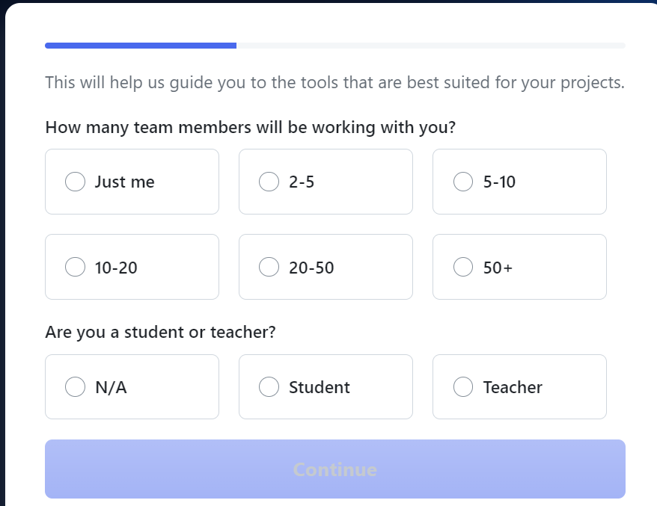
Scroll to the bottom and click Skip personalization | 

- Install Anaconda
Following the tutorial below to install Anaconda
Navigate to the following address,  https://www.anaconda.com/download  then, click Get Started | 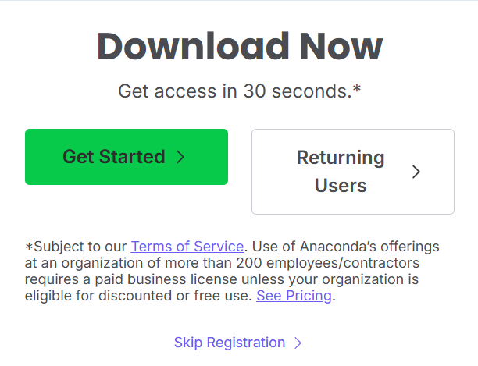
Click Sign up with Email | 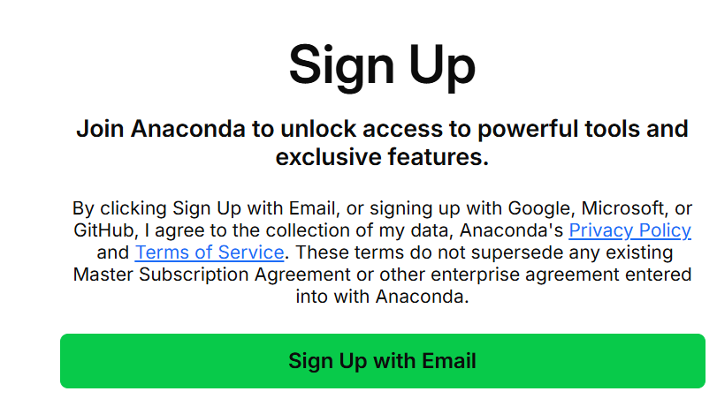
Verify your email address | 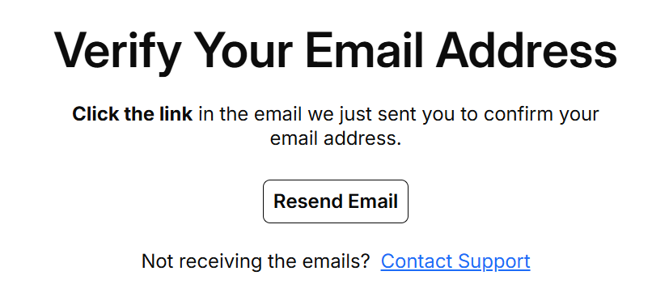
Continue through the prompts, then select the Windows Installer | 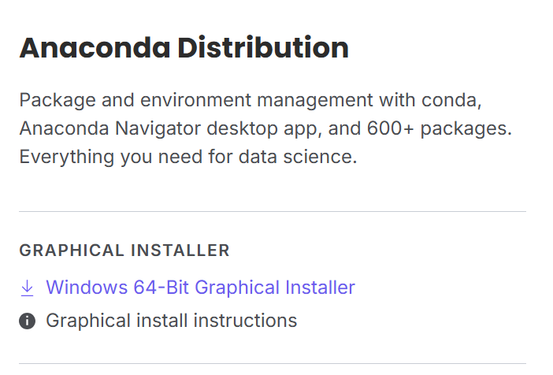
Locate the downloaded file in your downloads file and continue with the install | 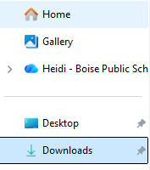

- Install Visual Studio Code
Follow the tutorial below to install Visual Studio Code
Navigate to https://code.visualstudio.com/download and download Visual Studio Code | 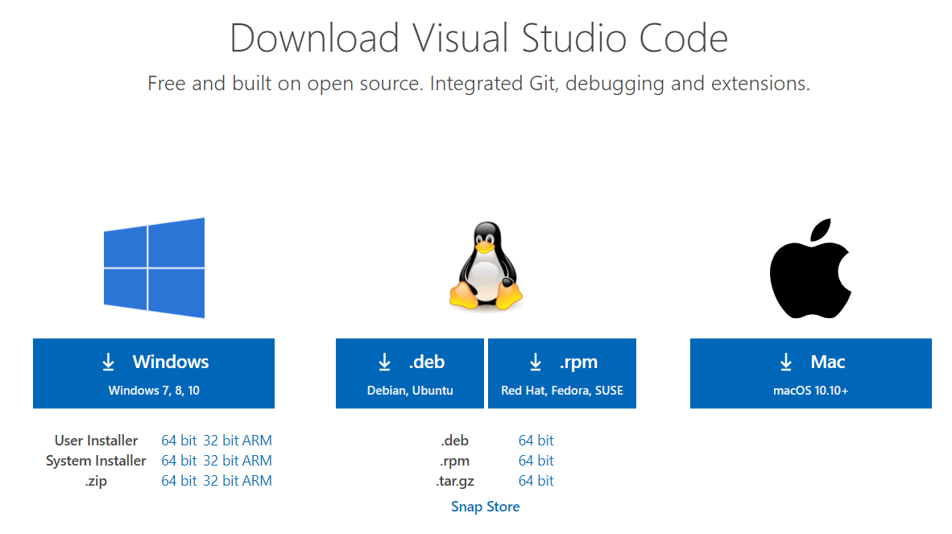
Locate the file and install per your operation system | 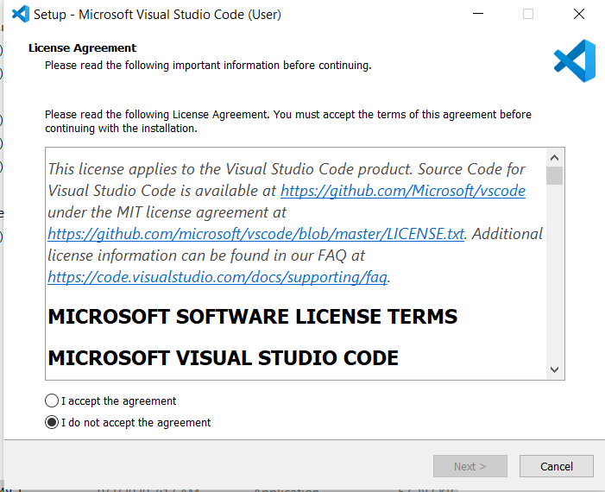

- Configure your username and email

Log in to GitHub and locate your no-reply email  - Click on Settings from your start menu  - In the left menu, click on Emails  - In the Primary Email Address section copy the no-reply email provided in the text | 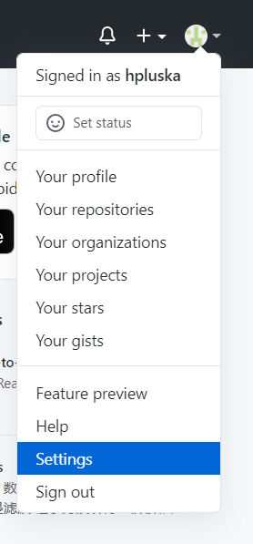  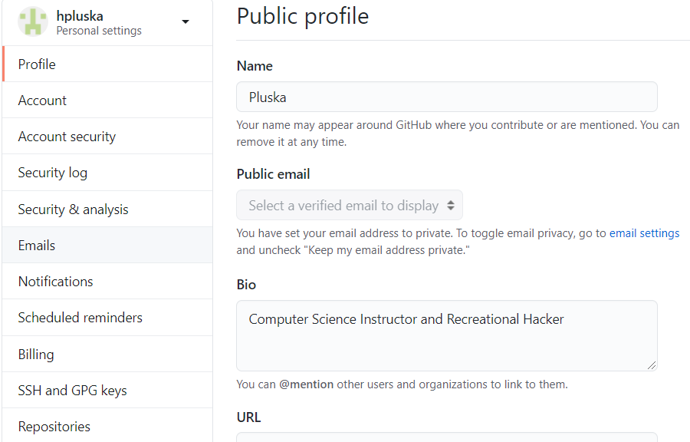  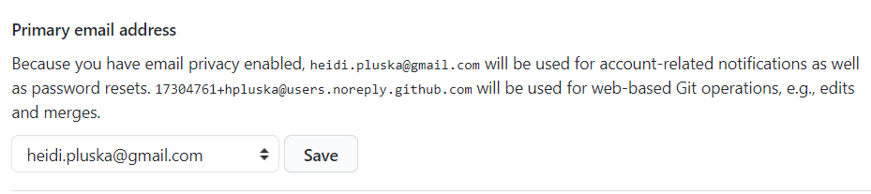
Open a Terminal  - Open Visual Studio Code  - From the menu at the top, select Terminal, New Terminal | 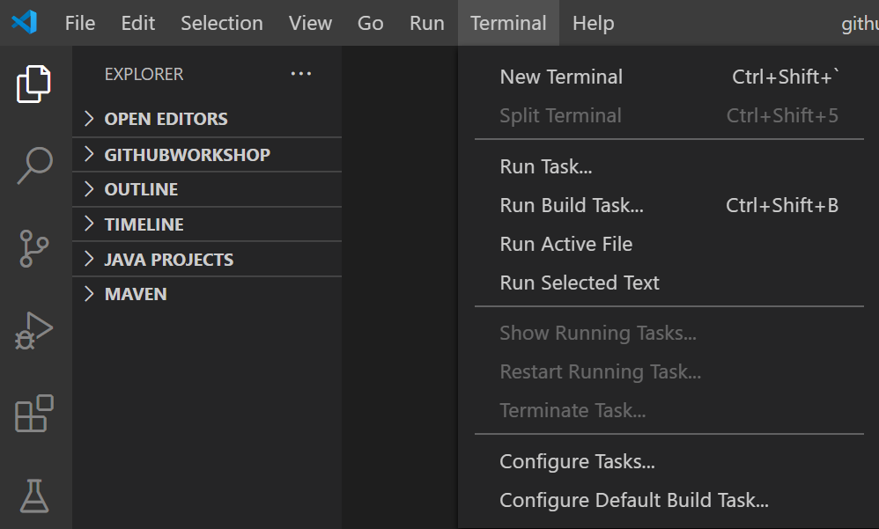
Set the Git commit username and email on your local computer to the ones you used on your GitHub account.  - Locate the terminal window at the bottom of the screen.  - At the terminal prompt, type the following command, paste the email you just copied in between the quotes, then hit Enter.  git config --global user.email "paste the email you just copied here”  - To set your username, copy the following command, type your GitHub username in the quotes, then hit Enter.  git config --global user.name "paste your username here" | 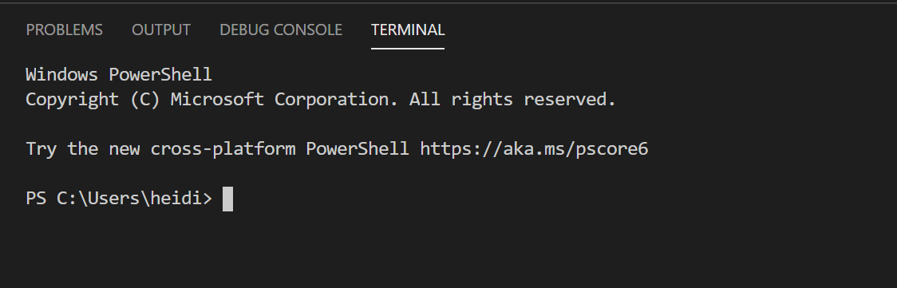

- Clone a repository

Locate the GitHub assignment link in Google Classroom | 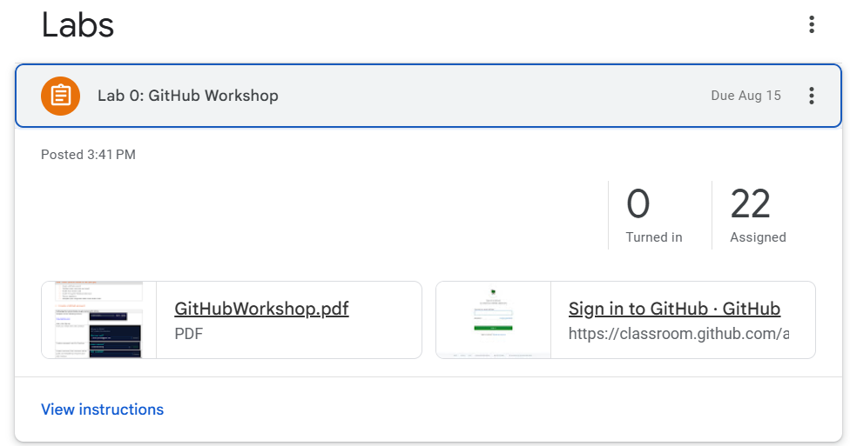
Locate your name to join the classroom | 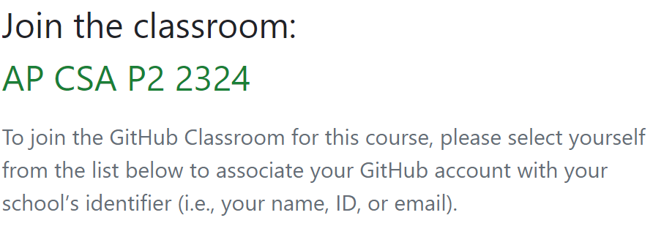
Click the green button to accept the assignment | 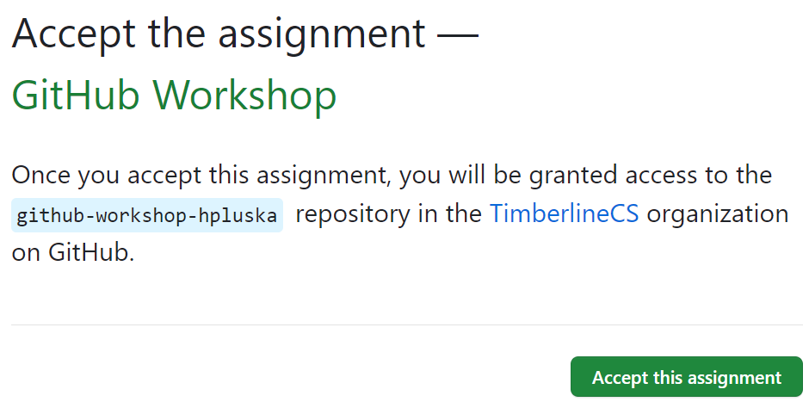
Refresh this page to see the link to the assignment. | 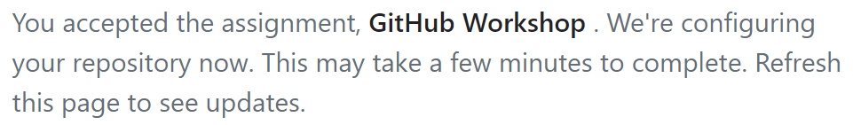
Click on the blue link to go to the assignment repository. | 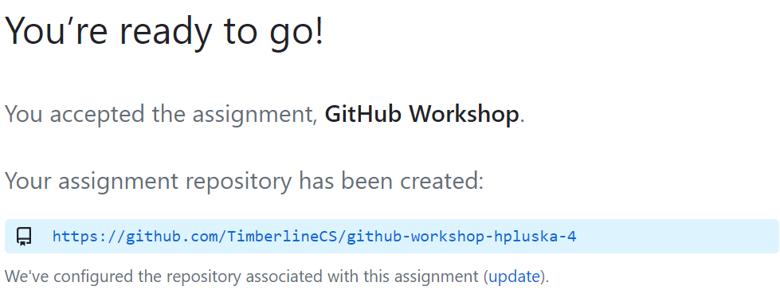
In the GitHub assignment repository you just accepted, locate the Code button and copy the https link. Make sure HTTPS is selected. | 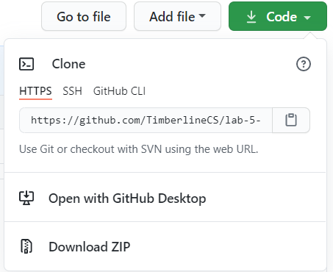
Return to Visual Studio Code  - Click on the Control Source icon in the left menu  - Click on the Clone Repository button | 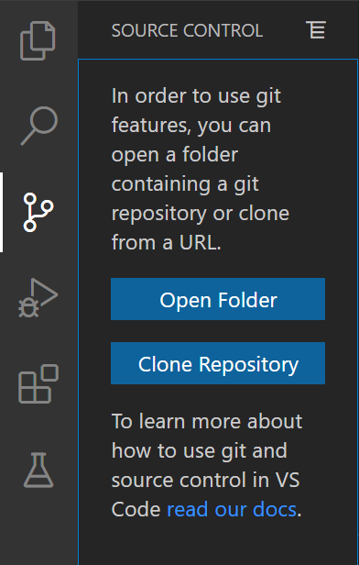
Locate the text box at the top of the window and paste the URL to the repository you just copied, then click Enter | 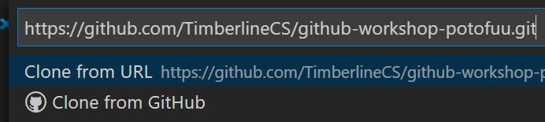
Navigate to where you would like to store the repository.  The click Select Repository Location | 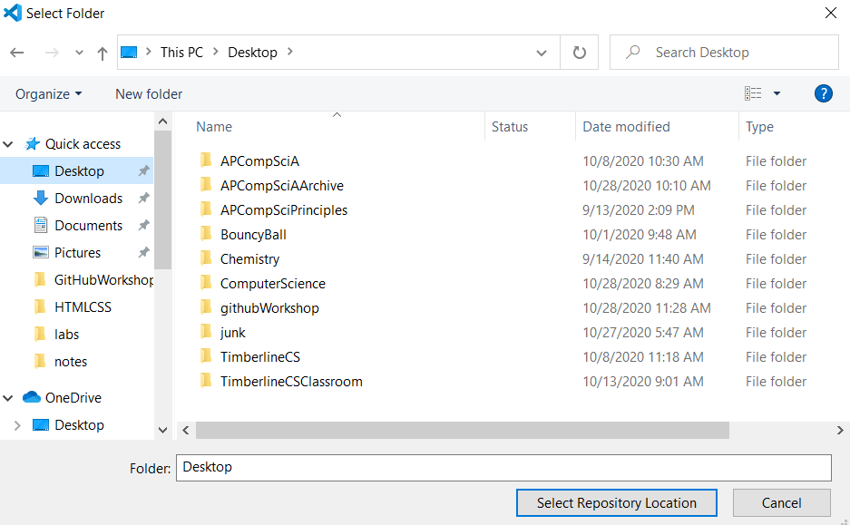  MAKE SURE you know where you save your repository! I recommend creating a folder on your computer called APCSPrinciples and storing all your course content there.
In the bottom right corner of the screen locate the Would you like to open the cloned repository? Window. Click the Open button | 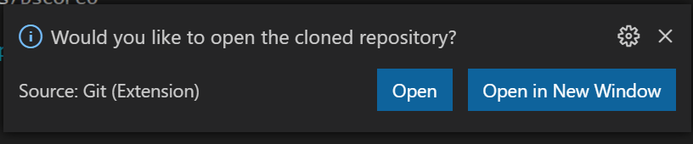

- Complete your assignment in Visual Studio Code

- Locate the README.md file in the left menu and click on it. | 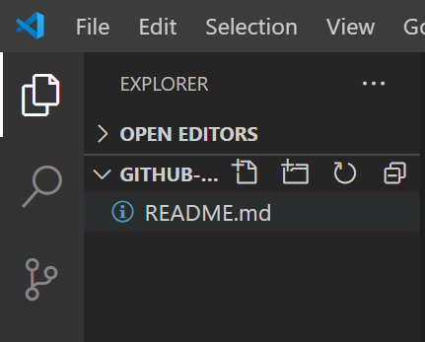
The file you clicked on is now open in the editor window.  The README contains the instructions for completing this lab. | 