Set 0: The Print Function

Skill 0.1: I can explain the purpose of a built-in function
Skill 0.2: I can interpret a built-in Python function
Skill 0.3: I can explain the process of function invocation
Skill 0.4: I can explore the print function
Skill 0.5: I can apply the escape and new line characters
Skill 0.6: I can use multiple arguments in a print function
Skill 0.7: I can use keyword arguments in the print function

Skill 0.1: I can explain the purpose of a built-in function

Skill 0.1 Concepts

Look at the line of code below,

print("Hello, World!")

The word print in the line of code above is the function name. You've probably encountered the term function many times before, during math classes. You can probably also list several names of mathematical functions, like sine or log.
Python functions, however, are more flexible, and can contain more content than their mathematical siblings.
A function (in this context) is a separate part of the computer code able to:
- cause some effect (e.g., send text to the terminal, create a file, draw an image, play a sound, etc.); this is something completely unheard of in the world of mathematics;
- evaluate a value (e.g., the square root of a value or the length of a given text) and return it as the function's result; this is what makes Python functions the relatives of mathematical concepts.
Moreover, many Python functions can do the above two things together.
Skill 0.1 Exercise 1

Skill 0.2: I can interpret a built-in Python function

Skill 0.2 Concepts

We know that a function may have:

- an effect
- a result.

There's also a third, very important, function component ‒ the argument(s).

Mathematical functions usually take one argument. For example, sin(x) takes an x, which is the measure of an angle.

Python functions, on the other hand, are more versatile. Depending on the individual needs, they may accept any number of arguments ‒ as many as necessary to perform their tasks. Note: When we said any number, that includes zero ‒ some Python functions don't need any argument.

Regardless of the needed/provided arguments, Python functions require the presence of a pair of parentheses ‒ opening and closing ones, respectively.

If you want to deliver one or more arguments to a function, you place them inside the parentheses. If you're going to use a function which doesn't take any argument, you still have to have the parentheses.

print("Hello, World!")
The print function requires parentheses whether or not there is an argument

print()

Skill 0.2 Exercise 1

Skill 0.3: I can explain the process of function invocation

Skill 0.3 Concepts

To understand function invocation let’s consider what happens when Python encounters the code below,

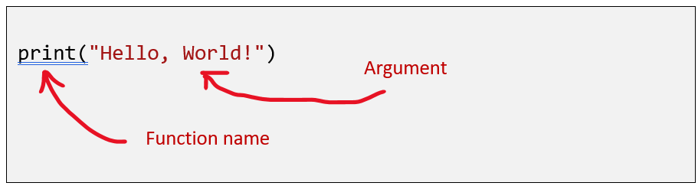

- First, Python checks if the name specified is legal (it browses its internal data in order to find an existing function of the name; if this search fails, Python aborts the code)
- Second, Python checks if the function's requirements for the number of arguments allows you to invoke the function in this way (e.g., if a specific function demands exactly two arguments, any invocation delivering only one argument will be considered erroneous, and will abort the code's execution)
- Third, Python leaves your code for a moment and jumps into the function you want to invoke; of course, it takes your argument(s) too and passes it/them to the function;
- Fourth, the function executes its code, causes the desired effect (if any), evaluates the desired result(s) (if any) and finishes its task;
- Finally, Python returns to your code (to the place just after the invocation) and resumes its execution.

Skill 0.3 Exercise 1

Skill 0.4: I can explore the print function

Skill 0.4 Concepts

The signature for the print function is shown below. According to the signature, the print function can accept many parameters or none at all.

print(*objects, sep=' ', end='\n', file=sys.stdout, flush=False)

We will begin our exploration of the print function by answering the following questions,

1. What effect does the print() function cause?

The effect is very useful and very spectacular. The print function:

- takes its arguments (it may accept more than one argument and may also accept less than one argument)
- converts them into human-readable form if needed (as you may suspect, strings don't require this action, as the string is already readable)
- and sends the resulting data to the output device (usually the console); in other words, anything you put into the print() function will appear on your screen.

No wonder then, that from now on, you'll utilize print() very intensively to see the results of your operations and evaluations.

2. What arguments does print() expect?

Any. We'll show you soon that print() is able to operate with virtually all types of data offered by Python. Strings, numbers, characters, logical values, objects ‒ any of these may be successfully passed to print().

3. What value does the print() function return?

None. Its effect is enough.

A function invocation is one of many possible kinds of Python instructions. Of course, any complex program usually contains many more instructions than one.

Python's syntax is quite specific. Below lists some guidelines for writing instructions in Python.

- Unlike most programming languages, Python requires that there cannot be more than one instruction in a line. For example, the following would produce an error,

Code | Output
print("Python is awesome!") round(5.2) | SyntaxError: invalid syntax

- A line can be empty (i.e., it may contain no instruction at all)

Code | Output
print("Python is awesome!")  print(round(5.2)) | Python is awesome!  5

- Python allows one instruction to spread across more than one line (which may be helpful when your code contains complex constructions).

Code | Output
print("Python is awesome!",  "Python is awesome!",  "Python is awesome!") | Python is awesome! Python is awesome! Python is awesome!

Now let’s look at what happens when the print function is invoked without an argument. Notice, in the code below, that the empty print() invocation is not as empty as you may have expected ‒ it outputs a new line.

Code | Output
print("The itsy bitsy spider")  print()  print("climbed up the waterspout.") | The itsy bitsy spider  climbed up the waterspout.

Skill 0.4 Exercise

Skill 0.5: I can apply the escape and new line characters

Skill 0.5 Concepts

We have seen that we can use an empty print() invocation to create a new line. This is not the only way to produce a new line. Now we are going to learn another way.

Below we've modified the code from above. Look at it carefully. Notice it produces the same output, but in a different way.

Code | Output
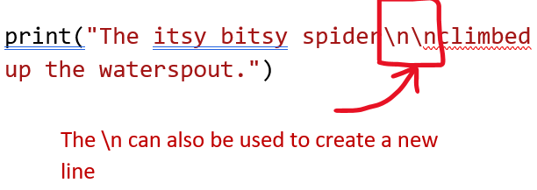 | The itsy bitsy spider  climbed up the waterspout.

The backslash (\) has a very special function when used inside strings ‒ this is called the escape character. The backslash serves as an announcement, that the next character after the backslash has a different meaning. In the example above, the letter n after the backslash means “new line”.

There are other letters that can be used after the backslash. For example, a t after the backslash means “tab”. We will learn more about escape characters in a few lessons.

Skill 0.5 Exercise 1

Skill 0.6: I can use multiple arguments in a print function

Skill 0.6 Concepts

So far, we have tested the print() function behavior with no arguments, and with one argument. It's also worth trying to feed the print() function with more than one argument.

Look at the example below,

Code | Output
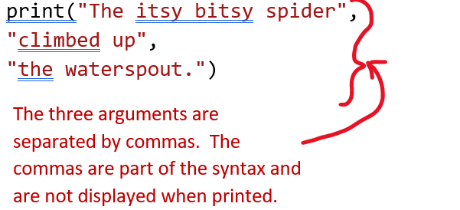 | 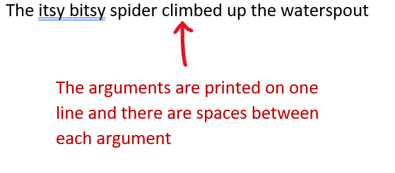

In the example above, there is one print() function invocation, but it contains three arguments. All of them are strings. The arguments are separated by commas.

In this case, the commas separating the arguments play a completely different role than the comma inside the string. The former is a part of Python's syntax, while the latter is intended to be shown in the console.

Also, notice,

- The print() function invoked with more than one argument outputs them all on one line;
- The print() function puts a space between the outputted arguments.

Skill 0.6 Exercise 1

Skill 0.7: I can use keyword arguments in the print function

Skill 0.7 Concepts

Python offers another mechanism for the passing of arguments, which can be helpful when you want to change the behavior of the print function. We aren't going to explain it in depth right now. For now, we will just explore how it works.

The mechanism is called keyword arguments. The print() function has two keyword arguments that you can use for your purposes. The first is called end and is illustrated below,

Code | Output
print("My name is", "Python.", end=" ")  print("Monty Python.")  The end key word consists of the key word, end, an equal sign and a value assignment. It must be the last argument in the print statement | My name is Python. Monty Python.  Assigning an empty space to the end keywork, overrides the default value (\n) and causes everything to print on one line

To use the end keyword, we have to use some basic rules,

- A keyword argument consists of three elements: a keyword identifying the argument (end here); an equal sign (=); and a value assigned to that argument;
- Any keyword arguments have to be put after the last positional argument (this is very important)

In the example above, we have made use of the end keyword argument and set it to a string containing one space. As you can see, the end keyword argument determines the characters the print() function sends to the output once it reaches the end of its positional arguments. The default behavior reflects the situation where the end keyword argument is implicitly used in the following way: end="\n".

The default separator for the arguments in the print function is a space. But, we can change this behavior with the sep keyword.

Code | Output
print("My", "name", "is", "Monty", "Python.", sep="-") | My-name-is-Monty-Python.

By assigning the keyword sep to a dash, the print() function uses a dash, instead of a space, to separate the outputted arguments.

Skill 0.7 Exercise 1

