Set 22: Creating, Loading, and Selecting Data with Pandas

Skill 22.1: Explain the purpose of pandas
Skill 22.2: Create a DataFrame from a dictionary
Skill 22.3: Create a DataFrame from a list
Skill 22.4: Load and save a CSV file
Skill 22.5: Inspect a DataFrame
Skill 22.6: Select columns from a DataFrame
Skill 22.7: Select rows from a DataFrame
Skill 22.8: Select rows with logic
Skill 22.9: Set row indices

Skill 22.1: Explain the purpose of Pandas

Skill 22.1 Concepts

Pandas is a Python module for working with tabular data (i.e., data in a table with rows and columns). Tabular data has a lot of the same functionality as Excel, but pandas adds the power of Python.

To get access to the pandas module, it requires that the module be installed. If you have Anaconda installed, pandas is already installed.

The pandas is usually imported at the top of a Python file under the alias pd,

import pandas as pd

If we need to access the pandas module, we can do so by operating on pd.

In this lesson, you’ll learn the basics of working with a single table in pandas. More specifically, you will learn how to,

- Create a table from scratch
- Load data from another file
- Select certain rows or columns of a table

Skill 22.2: Create a DataFrame from a dictionary

Skill 22.2 Concepts

A DataFrame is an object that stores data as rows and columns. You can think of a DataFrame as a spreadsheet or as a Google Sheets table. You can manually create a DataFrame or fill it with data from a CSV, or an Excel spreadsheet.

DataFrames have rows and columns. Each column has a name, which is a string. Each row has an index, which is an integer. DataFrames can contain many different data types: strings, ints, floats, tuples, etc.

You can pass in a dictionary to pd.DataFrame(). Each key is a column name and each value is a list of column values. The columns must all be the same length or you will get an error. Below is an example,

Code
import pandas as pd

my_dictionary = {
'name': ['John Smith', 'Jane Doe', 'Joe Schmo'],
'address': ['123 Main St.', '456 Maple Ave.', '789 Broadway'],
'age': [34, 28, 51]
}

my_df = pd.DataFrame(my_dictionary)
print(my_df)

Output
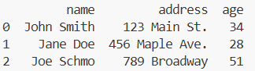

Skill 22.2 Exercise 1

Skill 22.3: Create a DataFrame from a list

Skill 22.3 Concepts

You can also add data to a DataFrame using lists.

For example, you can pass in a list of lists, where each one represents a row of data. The columns keyword argument can be used to pass a list of column names.

Code
my_list = [
['John Smith', '123 Main St.', 34],
['Jane Doe', '456 Maple Ave.', 28],
['Joe Schmo', '789 Broadway', 51]
]
fields=['name', 'address', 'age']
my_df = pd.DataFrame(my_list, columns = fields)
print(my_df)

Output
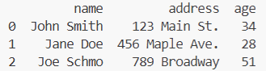

Skill 22.3 Exercise 1

Skill 22.4: Load and save a CSV file

Skill 22.4 Concepts

CSV (comma separated values) is a text-only spreadsheet format. You can find CSVs in lots of places:

- Online datasets (here’s an example from data.gov)
- Export from Excel or Google Sheets
- Export from SQL

The first row of a CSV contains column headings. All subsequent rows contain values. Each column heading and each variable is separated by a comma:

column1,column2,column3
value1,value2,value3

Below is an example with real data,

name,cake_flavor,frosting_flavor,topping
Chocolate Cake,chocolate,chocolate,chocolate shavings
Birthday Cake,vanilla,vanilla,rainbow sprinkles
Carrot Cake,carrot,cream,cheese almonds

When you have data in a CSV, you can load it into a DataFrame in Pandas using the read_csv() method.

csv_data.csv
name,cake_flavor,frosting_flavor,topping
Chocolate Cake,chocolate,chocolate,chocolate shavings
Birthday Cake,vanilla,vanilla,rainbow sprinkles
Carrot Cake,carrot,cream,cheese almonds
Code
df = pd.read_csv('csv_data.csv')
print(df)
Output
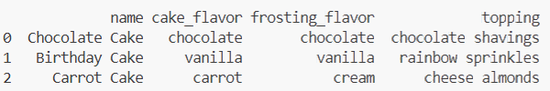

We can also save data to a CSV, using the to_csv() method

DataFrame df

Code
df.to_csv('new_csv_data.csv')
new_csv_data.csv
name,cake_flavor,frosting_flavor,topping
Chocolate Cake,chocolate,chocolate,chocolate shavings
Birthday Cake,vanilla,vanilla,rainbow sprinkles
Carrot Cake,carrot,cream,cheese almonds

In the example above, the to_csv() method is called on df (which represents a DataFrame object). The name of the CSV file is passed in as an argument (new_csv_data.csv). By default, this method will save the CSV file in your current directory.

Skill 22.4 Exercise 1

Skill 22.5: Inspect a DataFrame

Skill 22.5 Concepts

When we load a new DataFrame from a CSV, we want to know what it looks like.

If it’s a small DataFrame, you can display it by typing print(df).

If it’s a larger DataFrame, it’s helpful to be able to inspect a few items without having to look at the entire DataFrame.

The method head() gives the first 5 rows of a DataFrame. If you want to see more rows, you can pass in the positional argument n. For example, df.head(10) would show the first 10 rows.

The method info() gives some statistics for each column.

csv_data.csv
name,cake_flavor,frosting_flavor,topping
Chocolate Cake,chocolate,chocolate,chocolate shavings
Birthday Cake,vanilla,vanilla,rainbow sprinkles
Carrot Cake,carrot,cream,cheese almonds
Oreo Cake,chocolate,vanilla,oreo cookies
Lemon Cake,lemon,vanilla,candied lemon rind
German Chocolate Cake,chocolate salted caramel,coconut-pecan,pecans
Code
df = pd.read_csv('csv_data.csv')
print(df.head())
Output
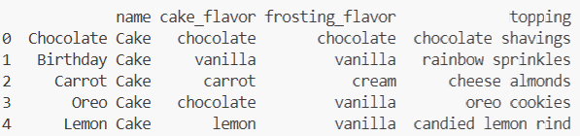
Code
print(df.head(2))
Output
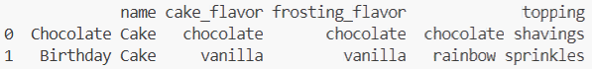
Code
print(df.info())
Output
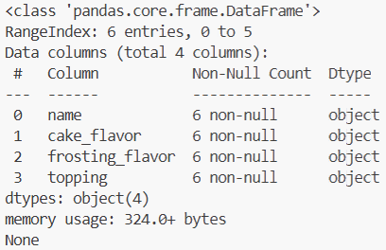

Skill 22.5 Exercise 1

Skill 22.6: Select columns from a DataFrame

Skill 22.6 Concepts

Now we know how to create and load data. Let’s select parts of those datasets that are interesting or important to our analyses.

Suppose you have the DataFrame called cakes,

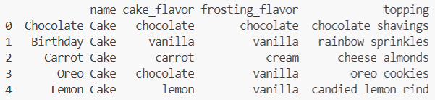

Perhaps you want to take the average or plot a histogram of a column. To do either of these tasks, you’d need to select the column.

There are two possible syntaxes for selecting all values from a column,

- Select the column as if you were selecting a value from a dictionary using a key. In our example, we would type cakes['name'] to select the ages.
- If the name of a column follows all the rules for a variable name (doesn’t start with a number, doesn’t contain spaces or special characters, etc.), then you can select it using the following notation: df.name_of_column_to_select. In our example, we would type cakes.name.
DataFrame cakes

Code
print(cakes["topping"])

Output
0 chocolate shavings
1 rainbow sprinkles
2 cheese almonds
3 oreo cookies
4 candied lemon rind
Code
print(cakes.topping)

Output
0 chocolate shavings
1 rainbow sprinkles
2 cheese almonds
3 oreo cookies
4 candied lemon rind

When you have a larger DataFrame, you might want to select just a few columns.

For instance, check out the DataFrame of orders from ShoeFly.com,

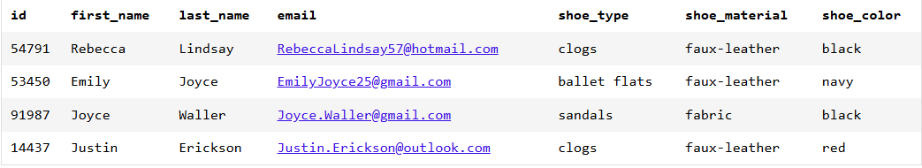

We might just be interested in the customer’s last_name and email. We want a DataFrame like this,
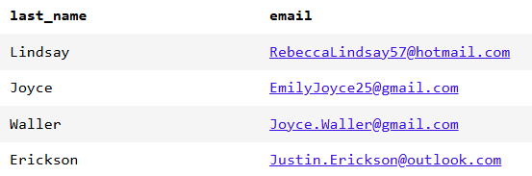

To select two or more columns from a DataFrame, we use a list of the column names.

DataFrame orders

Code
new_df = orders[['last_name', 'email']]
DataFrame new_df
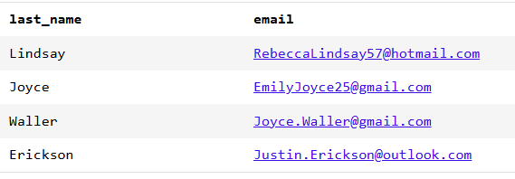

Note: Make sure that you have a double set of brackets ([[]]), or this command won’t work!

Skill 22.6 Exercises 1 & 2

Skill 22.7: Select rows from a DataFrame

Skill 22.7 Concepts

Let’s revisit our orders from ShoeFly.com,



Maybe our Customer Service department has just received a message from Joyce Waller, so we want to know exactly what she ordered. We want to select this single row of data.

DataFrames are zero-indexed, meaning that we start with the 0th row and count up from there. Joyce Waller’s order is the 2nd row. The example below illustrates how we can select it,

DataFrame orders

Code
row_2 = df.iloc[2]
print(row_2)
DataFrame new_df
id 91987
first_name Joyce
last_name Waller
email Joyce.Waller@gmail.com
shoe_type sandals
shoe_material fabric
shoe_color black
Name: 2, dtype: object

You can also select multiple rows from a DataFrame.

Below some examples from the ShoeFly.com’s orders DataFrame.

DataFrame orders
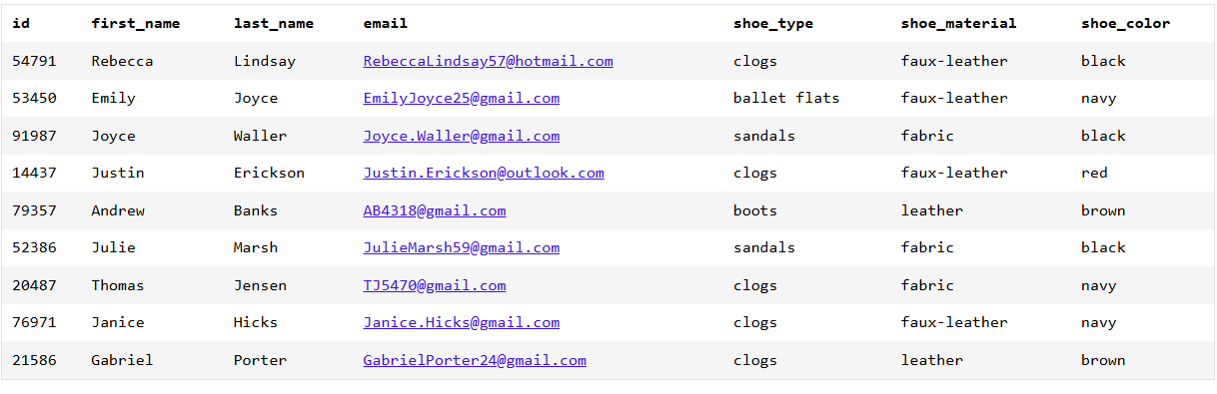
Code | Explanation
orders.iloc[3:7] | Selects all rows starting at the 3rd row and up to but not including the 7th row (i.e., the 3rd row, 4th row, 5th row, and 6th row)
Output
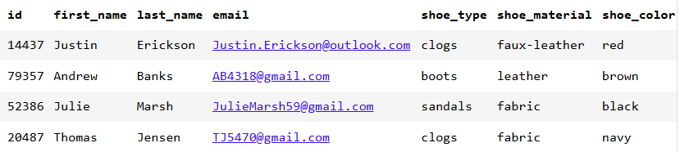
Code | Explanation
orders.iloc[:4] | Selects all rows up to, but not including the 4th row (i.e., the 0th, 1st, 2nd, and 3rd rows)
Output
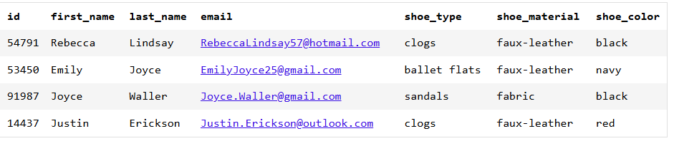
Code | Explanation
orders.iloc[-3:] | Selects all rows up to, but not including the 4th row (i.e., the 0th, 1st, 2nd, and 3rd rows)
Output
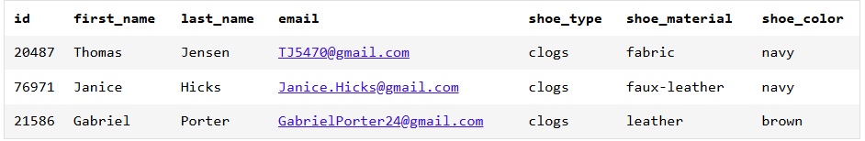

Skill 22.7 Exercises 1

Skill 22.8: Select rows with logic

Skill 22.8 Concepts

You can select a subset of a DataFrame by using the Boolean logical statements we’ve learned about previously. For example,

df[df.MyColumnName == desired_column_value]

Below are some examples,

DataFrame orders
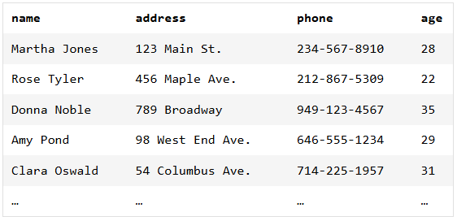
Code | Explanation
over_30 = df[df.age == 30]  print(over_30) | An empty DataFrame is returned because there are no customers with equal to 30
Output
Empty DataFrame
Columns: [name, address, phone, age]
Index: []
Code | Explanation
over_30 = df[df.age > 30]  print(over_30) | Returns a DataFrame with the customers over 30
Output
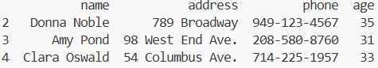
Code | Explanation
c = df[df.name != 'Clara Oswald']  print(c) | Returns a DataFrame of all the customers not named Clara Oswald
Output
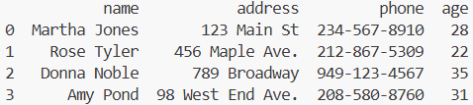
You can also combine multiple logical statements, as long as each statement is in parentheses.

For instance, suppose we wanted to select all rows where the customer’s age was under 30 or the customer’s name was “Martha Jones”,

DataFrame orders

Code | Explanation
results = df[(df.age < 30) |  (df.name == 'Martha Jones')]  print(results) | Returns a DataFrame of the customer’s whose age is under 30 or whose name is “Martha Jones”:
Output
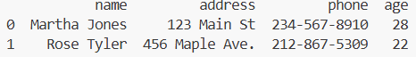
Code | Explanation
results = df[df.name.isin(['Martha Jones',  'Rose Tyler',  'Amy Pond'])]  print(results) | Uses the isin command to return a DataFrame of the customers whose name appears in a list of values.
Output
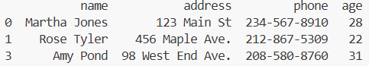

Skill 22.8 Exercise 1

Skill 22.9: Set row indices

Skill 22.9 Concepts

When we select a subset of a DataFrame using logic, we end up with non-consecutive indices. This is inelegant and makes it hard to use .iloc().

Example below illustrates this problem.
results = df[df.name.isin(['Martha Jones',  'Rose Tyler',  'Amy Pond'])]  print(results) | Uses the isin command to return a DataFrame of the customers whose name appears in a list of values.  Notice the output contains non-consecutive indices
Output


We can fix this using the method reset_index(). For example, here is a DataFrame called df with non-consecutive indices,

results = df[df.name.isin(['Martha Jones',  'Rose Tyler',  'Amy Pond'])]  results2 = results.reset_index()  print(results2) | If we use the command df.reset_index(), we get a new DataFrame with a new set of indices.  Notice, the old indices are stored in a new column called index.
Output
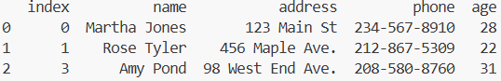

Notice in the above example, the old indices have been moved into a new column called 'index'. Unless you need those values for something special, it’s probably better to use the keyword drop=True so that you don’t end up with that extra column.

results = df[df.name.isin(['Martha Jones',  'Rose Tyler',  'Amy Pond'])]  results2 = results.reset_index(drop = True)  print(results2) | Adding the keyword drop = True removes the extra column.
Output
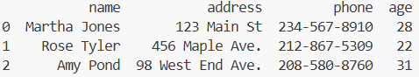

Using reset_index() will return a new DataFrame, but we usually just want to modify our existing DataFrame. If we use the keyword inplace=True we can just modify our existing DataFrame.
results = df[df.name.isin(['Martha Jones',  'Rose Tyler',  'Amy Pond'])]  results.reset_index(drop = True, inplace = True)  print(results) | Adding the keyword inplace = True allows us to modify the current DataFrame without creating a new one.
Output


Skill 22.9 Exercise 1

