Set 22: Aggregate Statistics with Pandas

Skill 22.1: Describe the purpose of an aggregate statistic
Skill 22.2: Calculate column statistics
Skill 22.3: Apply pandas functions to compute aggregate statistics
Skill 22.4: Apply lambda functions to calculate aggregate statistics
Skill 22.5: Compute aggregate statistics using multiple columns
Skill 22.6: Create a pivot table with pandas

Skill 22.1: Describe the purpose of an aggregate statistic

Skill 22.1 Concepts

An aggregate statistic is a way of creating a single number that describes a group of numbers. Common aggregate statistics include mean, median, and standard deviation.

More specifically, aggregate statistics:

- Reduce complexity by condensing many data points into a single number or a small set of numbers
- Describe overall behavior of a dataset (e.g., typical value, spread, totals)
- Enable comparisons between groups, time periods, or categories
- Support decision-making by highlighting trends rather than individual noise

Skill 22.1 Exercise 1

Skill 22.2: Calculate column statistics

Skill 22.2 Concepts

Aggregate functions summarize many data points (i.e., a column of a dataframe) into a smaller set of values.
Some examples of aggregate functions built into Pandas are illustrated below,

Code
display(customers.head())
Output | Explanation
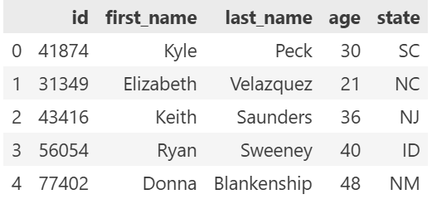 | Prints the first 5 rows of of the customers dataframe
Code
print(customers.age.median())

Output | Explanation
33.0 | Prints the median of the values in the age column
Code
print(customers.state.nunique())

Output | Explanation
46 | Prints the number of unique values in the state column
Code
print(customers.state.unique())

Output | Explanation
['ME' 'DE' 'KS' 'AZ' 'GA' 'NY' 'WV' 'NH' 'WI' 'MI' 'ND' 'IN' 'NC' 'AL'  'PA' 'MA' 'MO' 'AK' 'MN' 'SD' 'HI' 'WA' 'MD' 'FL' 'CT' 'WY' 'IA' 'OR'  'KY' 'CA' 'IL' 'NJ' 'NV' 'NM' 'OK' 'TX' 'MT' 'CO' 'UT' 'LA' 'RI' 'ID'  'SC' 'MS' 'OH' 'VA'] | Prints a list of the unique values in the state column

The following table summarizes some of the more common commands,

Method | Description
mean | Average of all values in column
std | Standard deviation
median | Median
max | Maximum value in column
min | Minimum value in column
count | Number of values in column
nunique | Number of unique values in column
unique | List of unique values in column
value_counts | counts how many times each unique value appears

Skill 22.2 Exercise 1

Skill 22.3: Apply pandas functions to compute aggregate statistics

Skill 22.3 Concepts

When we have a bunch of data, we often want to calculate aggregate statistics (mean, standard deviation, median, percentiles, etc.) over certain subsets of the data.

Let’s revisit our customer data which contains some new columns.

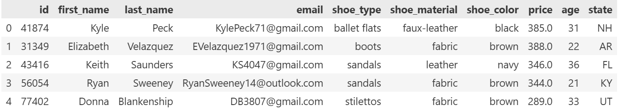

Below illustrates how we could calculate the average cost of each type of shoe

Code
print(customers.groupby('shoe_type').price.mean())

Output
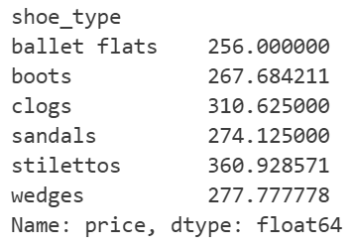

Below is an explanation of each part of the code above,

1. customers
Your pandas DataFrame with customer info (including shoe_type and price).

2. .groupby('shoe_type')
This groups the rows by the type of shoe.
So all "sneakers" together, all "boots" together, all "sandals" together, etc.
At this stage, pandas is just organizing the data—no math yet.

3. .price
From each shoe_type group, this selects the price column.
You’re telling pandas:
“Within each shoe type, look at the prices.”

4. .mean()
This calculates the average (mean) price for each shoe type.
So pandas:
- Takes all prices for sneakers → computes their average
- Takes all prices for boots → computes their average
- …and so on

The syntax above can be summarized as follows,

df.groupby('CATEGORY_COLUMN').NUMERIC_COLUMN.AGGREGATION()

After using groupby, we often need to clean our resulting data.

The groupby function creates a new Series, not a DataFrame. In the previous example, the indices of the Series were different values of shoe_type, and the name property was price.

Usually, we’d prefer that those indices were actually a column. In order to get that, we can use reset_index(). This will transform our Series into a DataFrame and move the indices into their own column.

Generally, you’ll always see a groupby statement followed by reset_index. The example below illustrates the effect of reset_index().

Code
display(customers.groupby('shoe_type').price.mean())

Output | Explanation
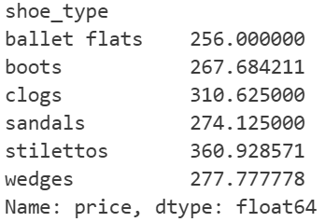 | Returns a series with no index column
Code
display(customers.groupby('shoe_type').price.mean().reset_index())

Output | Explanation
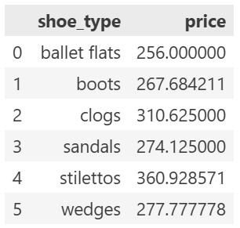 | reset_index() transforms the series into a dataframe and moves the indices to their own column

Skill 22.3 Exercise 1

Skill 22.4: Apply lambda functions to calculate aggregate statistics

Skill 22.4 Concepts

Sometimes, the operation that you want to perform is more complicated than mean or count. In those cases, you can use the apply method and lambda functions, just like we did for individual column operations. Note that the input to our lambda function will always be a list of values.

A great example of this is calculating percentiles. Suppose we have a DataFrame of employee information called df that has the following columns,

- id: the employee’s id number
- name: the employee’s name
- wage: the employee’s hourly wage
- category: the type of work that the employee does

Our data might look something like this,

id | name | wage | category
10131 | Sarah Carney | 39 | product
14189 | Heather Carey | 17 | design
15004 | Gary Mercado | 33 | marketing
11204 | Cora Copaz | 27 | design

If we want to calculate the 75th percentile (i.e., the point at which 75% of employees have a lower wage and 25% have a higher wage) for each category, we can use the following combination of apply and a lambda function,

Code
high_earners = df.groupby('category').wage
.apply(lambda x: np.percentile(x, 75))
.reset_index()

Output
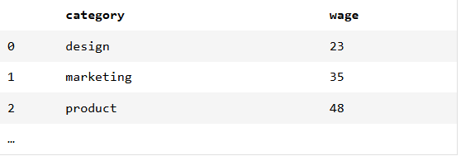

Skill 22.4 Exercise 1

Skill 22.5: Compute aggregate statistics using multiple columns

Skill 22.5 Concepts

Sometimes, we want to group by more than one column. We can easily do this by passing a list of column names into the groupby method.

Imagine that we run a chain of stores and have data about the number of sales at different locations on different days,
Location | Date | Day of Week | Total Sales
West Village | February 1 | W | 400
West Village | February 2 | Th | 450
Chelsea | February 1 | W | 375
Chelsea | February 2 | Th | 390

We suspect that sales are different at different locations on different days of the week. To test this hypothesis, we could calculate the average sales for each store on each day of the week across multiple months. The code would look like this,

Code
df.groupby(['Location', 'Day of Week'])['Total Sales'].mean().reset_index()

Output
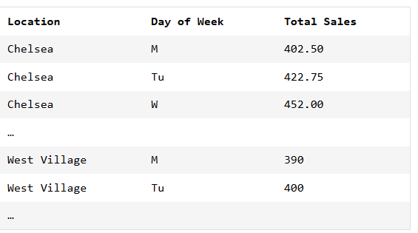

Skill 22.5 Exercise 1

Skill 22.6: Create a pivot table with pandas

Skill 22.6 Concepts

When we perform a groupby across multiple columns, we often want to change how our data is stored. For instance, recall the example where we are running a chain of stores and have data about the number of sales at different locations on different days,

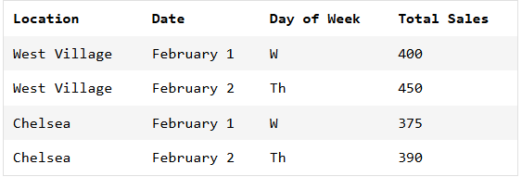

We suspected that there might be different sales on different days of the week at different stores, so we performed a `groupby` across two different columns (`Location` and `Day of Week`). This gave us results that looked like this,

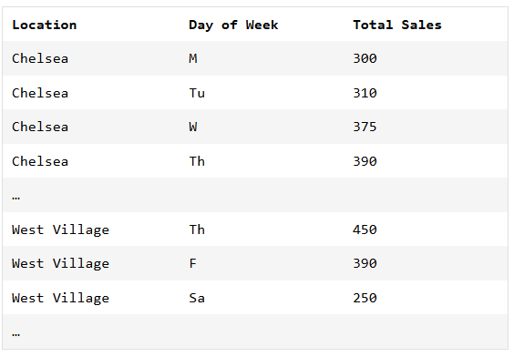

To test our hypothesis, it would be more useful if the table was formatted like this,

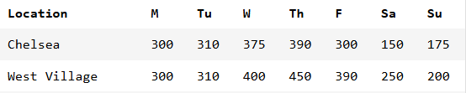

Reorganizing a table in this way is called pivoting. The new table is called a pivot table.

In pandas, the command for pivot is,

df.pivot(columns='ColumnToPivot',
index='ColumnToBeRows',
values='ColumnToBeValues')

Below is an example using our sales data,

Code
# First use the groupby statement:
unpivoted = df.groupby(['Location', 'Day of Week'])['Total Sales'].mean().reset_index()
# Now pivot the table
pivoted = unpivoted.pivot(
columns='Day of Week',
index='Location',
values='Total Sales')

Output


Just like with groupby, the output of a pivot command is a new DataFrame, but the indexing tends to be “weird”, so we usually follow up with reset_index().

Skill 22.6 Exercise 1

