Set 23: Multiple Tables with Pandas

Skill 23.1: Describe how data can be stored across multiple tables to reduce redundancy
Skill 23.2: Identify information by connecting data across multiple tables
Skill 23.3: Apply the merge() method to combine tables
Skill 23.4: Rename columns to support merging tables.
Skill 23.5: Compare inner and outer merges
Skill 23.6: Concatenate DataFrames

Skill 23.1: Describe how data can be stored across multiple tables to reduce redundancy

Skill 23.1 Concepts

To efficiently store data, we often spread related information across multiple tables.

For instance, imagine that we own an e-commerce business and we want to track the products that have been ordered from our website.

We could have one table with all the following information,

- order_id
- customer_id
- customer_name
- customer_address
- customer_phone_number
- product_id
- product_description
- product_price
- quantity
- timestamp

However, a lot of this information would be repeated. If the same customer makes multiple orders, that customer’s name, address, and phone number will be reported multiple times. If the same product is ordered by multiple customers, then the product price and description will be repeated. This will make our orders table big and unmanageable.

So instead, we can split our data into three tables,

- orders would contain the information necessary to describe an order: order_id, customer_id, product_id, quantity, and timestamp
- products would contain the information to describe each product: product_id, product_description and product_price
- customers would contain the information for each customer: customer_id, customer_name, customer_address, and customer_phone_number

In this lesson, we will learn the Pandas commands that help us work with data stored in multiple tables.

Skill 23.1 Exercise 1

Skill 23.2: Identify information by connecting data across multiple tables

Skill 23.2 Concepts

Suppose we have the following three tables that describe our eCommerce business:

Orders
order_id | customer_id | product_id | quantity | timestamp
1 | 2 | 3 | 1 | 2017-01-01
2 | 2 | 2 | 3 | 2017-01-01
3 | 3 | 1 | 1 | 2017-01-01
4 | 3 | 2 | 2 | 2017-02-01
5 | 3 | 3 | 3 | 2017-02-01
6 | 1 | 4 | 2 | 2017-03-01
7 | 1 | 1 | 1 | 2017-02-02
8 | 1 | 4 | 1 | 2017-02-02

Products
product_id | description | price
1 | thing-a-ma-jig | 5
2 | whatcha-ma-call-it | 10
3 | doo-hickey | 7
4 | gizmo | 3

Customers
customer_id | customer_name | address | phone_number
1 | John Smith | 123 Main St. | 212-123-4567
2 | Jane Doe | 456 Park Ave. | 949-867-5309
3 | Joe Schmo | 798 Broadway | 112-358-1321

If we just look at the orders table, we can’t really tell what’s happened in each order. However, if we refer to the other tables, we can get a more complete picture.

Let’s examine the order with an order_id of 1. It was purchased by Customer 2. To find out the customer’s name, we look at the customers table and look for the item with a customer_id value of 2. We can see that Customer 2’s name is Jane Doe and that she lives at 456 Park Ave.

Doing this kind of matching is called merging two DataFrames.

Skill 23.2 Exercise 1

Skill 23.3: Apply the merge() method to combine tables

Skill 23.3 Concepts

It is easy to do this kind of matching for one row, but what if we wanted to do this for many rows, or an entire column?

The pandas merge() method looks for columns that are common between two DataFrames and then looks for rows where those column’s values are the same. It then combines the matching rows into a single row in a new table.

Below is an example,

Data
Sales | Targets
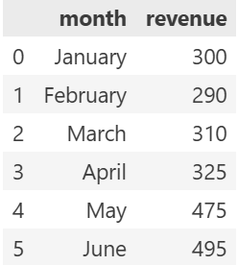 | 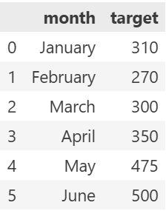

Code
sales_targets = pd.merge(sales, targets)
display(sales_targets)
Output
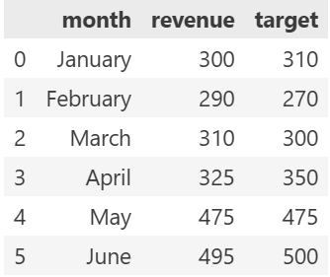

Merge can also be applied to join two or more tables by chaining commands,

Data
sales | targets | men_women
 |  | 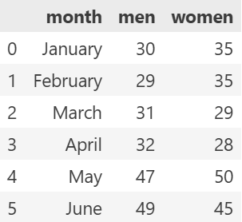

Code
combined = sales.merge(targets).merge(men_women)
display(combined)
Output
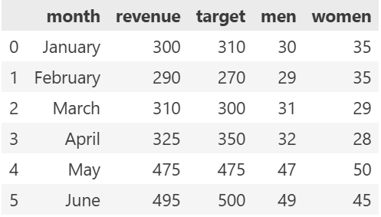

Combining the data allows us to answer different questions than we couldn’t answer if it were separated. Below is an example,

Data

Question
Is revenue greater for the months when more women’s t-shirts are sold?
Code
results = combined[(combined.revenue > combined.target) &
(combined.women > combined.men)]
display(results)
Output
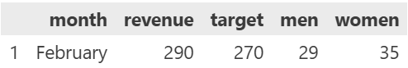

Skill 23.3 Exercise 1

Skill 23.4: Rename columns to support merging tables.

Skill 23.4 Concepts

In the previous example, the merge() function “knew” how to combine tables based on the columns that were the same between two tables. For instance, products and orders both had a column called product_id. This won’t always be true when we want to perform a merge.

Generally, the products, customers, and orders DataFrames would not have the columns product_id, customer_id, or order_id. Instead, they would all be called id.

Customers
id | customer_name | address | phone_number
1 | John Smith | 123 Main St. | 212-123-4567
2 | Jane Doe | 456 Park Ave. | 949-867-5309
3 | Joe Schmo | 798 Broadway | 112-358-1321

Products
id | description | price
1 | thing-a-ma-jig | 5
2 | whatcha-ma-call-it | 10
3 | doo-hickey | 7
4 | gizmo | 3

Orders
id | customer_id | product_id | quantity | timestamp
1 | 2 | 3 | 1 | 2017-01-01
2 | 2 | 2 | 3 | 2017-01-01
3 | 3 | 1 | 1 | 2017-01-01
4 | 3 | 2 | 2 | 2017-02-01
5 | 3 | 3 | 3 | 2017-02-01
6 | 1 | 4 | 2 | 2017-03-01
7 | 1 | 1 | 1 | 2017-02-02
8 | 1 | 4 | 1 | 2017-02-02

How would this affect our merges???

Because the id columns would mean something different in each table, our default merges would be wrong.

One way that we could address this problem is to use rename() to rename the columns for our merges. In the example below, we will rename the column id to customer_id, so that orders and customers have a common column for the merge.

Data
customers | orders
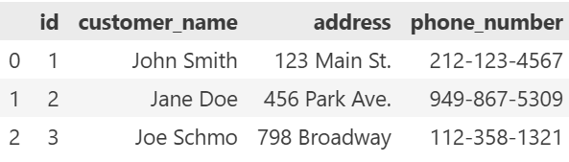 | 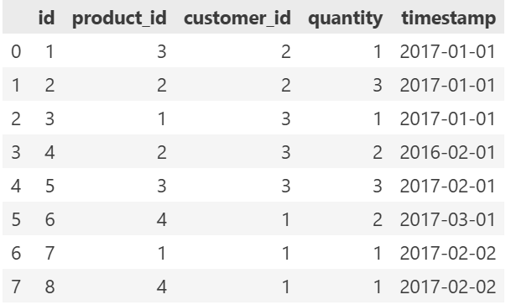

Code
customers.rename(columns = {"id":"customer_id"}, inplace = True)
customer_orders = customers.merge(orders)
display(customer_orders)
Output
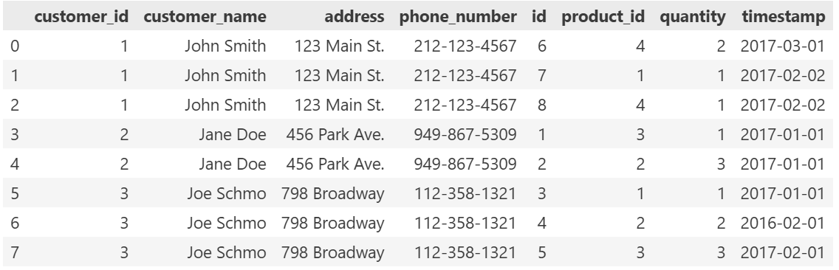

Skill 23.4 Exercise 1

Skill 23.5: Compare inner and outer merges

Skill 23.5 Concepts

In our previous examples, there were always matching values when we were performing our merges. What happens when that isn’t true?

Imagine that our products table is out of date and is missing the newest product: Product 5. What happens when someone orders it?

Data
orders | products
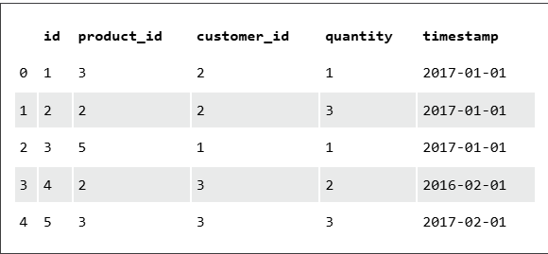 | 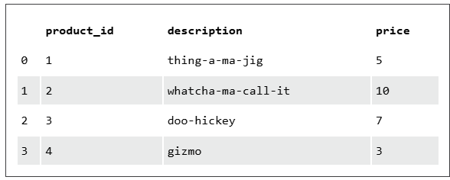

Code
merged_df = orders.merge(products)
display(merged_df)
Output
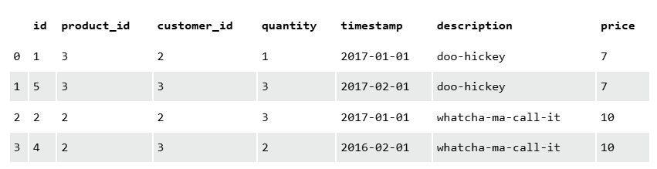

Check out the results above.. The order with id = 3 is missing!

When we merge two DataFrames whose rows don’t match perfectly, we lose the unmatched rows.

This type of merge (where we only include matching rows) is called an inner merge. There are other types of merges that we can use when we want to keep information from the unmatched rows.

Suppose that two companies, Company A and Company B have just merged. They each have a list of customers, but they keep slightly different data. Company A has each customer’s name and email. Company B has each customer’s name and phone number. They have some customers in common, but some are different.

If we wanted to combine the data from both companies without losing the customers who are missing from one of the tables, we could use an Outer Join. An Outer Join would include all rows from both tables, even if they don’t match. Any missing values are filled in with None or nan (which stands for “Not a Number”).

Data
company_a | company_b
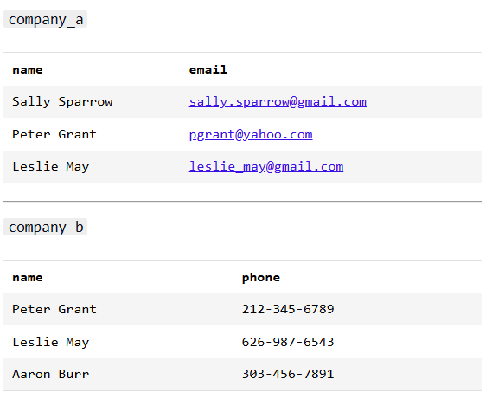 | 

Code
pd.merge(company_a, company_b, how='outer')
Output
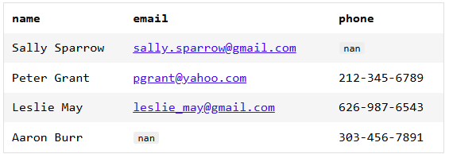

Skill 23.5 Exercise 1

Skill 23.6: Concatenate DataFrames

Skill 23.6 Concepts

Sometimes, a dataset is broken into multiple tables. For instance, data is often split into multiple CSV files so that each download is smaller.

When we need to reconstruct a single DataFrame from multiple smaller DataFrames, we can use the concat() method. This method only works if all of the columns are the same in all of the DataFrames.

Below is an example,

Data
df_1 | df_2
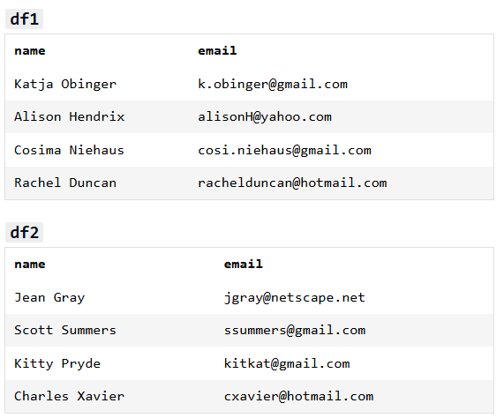 | 

Code
pd.concat([df1, df2])
Output
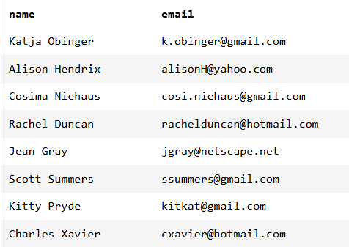

merge combines DataFrames by matching rows using shared columns, adding information across tables.
concat combines DataFrames by stacking rows or columns together without matching values.
In short, use merge to match data and concat to append data.

Skill 23.6 Exercise 1

