Set 28: Summarizing Relationships Between Quantitative and Categorical Features

Skill 28.1: Calculate differences in mean and median between groups in a dataset
Skill 28.2: Interpret differences in mean and median between groups using box plots
Skill 28.3: Interpret differences in mean and median between groups using histograms
Skill 28.4: Interpret the association between a quantitative variable and a non-binary categorical variable.

Skill 28.1: Calculate differences in mean and median between groups in a dataset

Skill 28.1 Concepts

Examining the relationship between variables can give us key insight into our data. In this lesson, we will cover ways of assessing the association between a quantitative variable and a categorical variable.

The dataset below contains information about students at two Portuguese schools.
- school: the school each student attends, Gabriel Periera ('GP') or Mousinho da Silveria ('MS')
- address: the location of the student’s home ('U' for urban and 'R' for rural)
- absences: the number of times the student was absent during the school year
- Mjob: the student’s mother’s job industry
- Fjob: the student’s father’s job industry
- G3: the student’s score on a math assessment, ranging from 0 to 20
students
 | school | address | absences | Mjob | Fjob | G3
0 | GP | U | 6 | at_home | teacher | 6
1 | GP | U | 4 | at_home | other | 6
2 | GP | U | 10 | at_home | other | 10
3 | GP | U | 2 | health | services | 15
4 | GP | U | 4 | other | other | 10

Suppose we want to know: Is a student’s score (G3) associated with their school (school)? If so, then knowing what school a student attends gives us information about what their score is likely to be. For example, maybe students at one of the schools consistently score higher than students at the other school.
To start answering this question, we can save the scores from each school into two separate lists and calculate the mean and median of the scores for each school.

Code
import pandas as pd
students = pd.read_csv('data.csv', delimiter = "\t")
display(students.head())

# Gets the scores of from GP
gp_students = students[students.school == 'GP']['G3']
# Gets the scores of from MS
ms_students = students[students.school == 'MS']['G3']

# Calculates the mean for students at both schools
gp_mean = gp_students.mean()
ms_mean = ms_students.mean()

# Calculates the median for students at both schools
gp_median = gp_students.median()
ms_median = ms_students.median()

print(gp_mean, ms_mean)
print(gp_median, ms_median)

Output
10.489971346704872 9.847826086956522
11.0 10.0

We can further calculate the differences in the mean and median for each dataset,

Code
mean_diff = gp_mean - ms_mean
median_diff = gp_median - ms_median

print(mean_diff)
print(median_diff)
Output
0.6421452597483501
1.0

We can see above that GP students have a higher mean and median. Additionally, the mean difference is 0.64 and the median difference is 1.0.

Highly associated variables tend to have a large mean or median difference. Since “large” could have different meanings depending on the variable, we will go into more detail in the next section.

Skill 28.1 Exercise 1

Skill 28.2: Interpret differences in mean and median between groups using box plots

Skill 28.2 Concepts

The difference in mean math scores for students at GP and MS was 0.64. How do we know whether this difference is considered small or large? To answer this question, we need to know something about the spread of the data.

One way to get a better sense of spread is by looking at a visual representation of the data. Side-by-side box plots are useful in visualizing mean and median differences because they allow us to visually estimate the variation in the data. This can help us determine if mean or median differences are “large” or “small”.
Let’s take a look at side by side boxplots of math scores at each school,
Code
sns.boxplot(data = students, x = 'school', y = 'G3', hue = 'school', legend = True)
plt.show()

Output
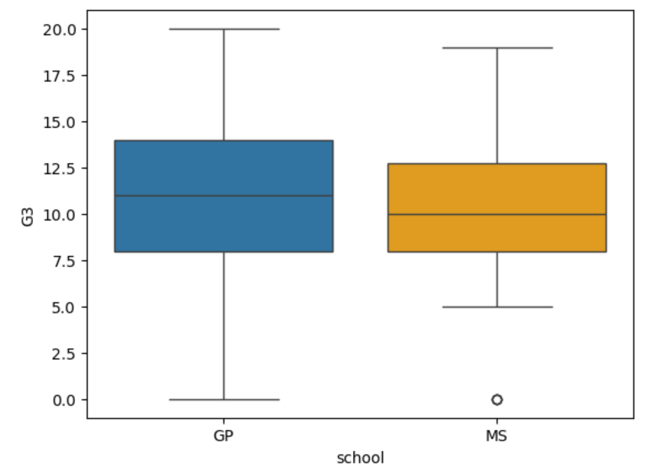
Interpretation
According to the plots, the schools appear to be associated with G3 score — GP students tend to score slightly higher.
However,
- The difference in center is small.
- There is heavy overlap.
- The association would likely be described as weak to moderate, not strong.

Looking at the plot above, we can clearly see that there is a lot of overlap between the boxes (i.e. the middle 50% of the data). Therefore, we can be more confident that there is not much difference between the math scores of the two groups.

In contrast, suppose we saw the following plot,

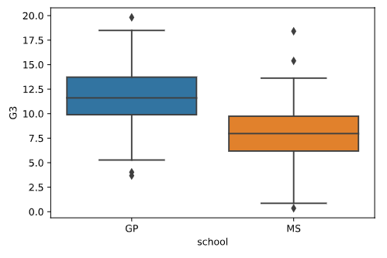
In this version, the boxes barely overlap, demonstrating that the middle 50% of scores are different for the two schools. This would be evidence of a stronger association between school and math score

Skill 28.2 Exercise 1

Skill 28.3: Interpret differences in mean and median between groups using histograms

Skill 28.3 Concepts

Another way to explore the relationship between a quantitative variable and a categorical variable is by creating overlapping histograms. This allows us to compare the shapes of the distributions for each group on the same set of axes.

In the code below, setting alpha = 0.5 makes each histogram partially transparent so that both distributions can be seen at the same time.

We also use density=True. This is important when overlapping histograms because it changes the y-axis from showing raw frequencies (counts) to showing density. When density=True, the total area of each histogram is scaled to equal 1. In other words, each histogram represents a relative distribution rather than the total number of observations.

This matters because different groups may have different sample sizes. If we plotted raw counts, the group with more observations would naturally have taller bars, even if the overall shape of the distribution were similar. Using density removes the influence of sample size and allows us to fairly compare

- Where values tend to cluster
- How spread out each group is
- Whether one group has more relative mass in certain ranges

By using transparency (alpha) and density scaling (density=True), overlapping histograms become a powerful way to compare the shape of distributions across categories.

Code
plt.hist(gp_students , color="blue", label="GP", density=True, alpha=0.5)
plt.hist(ms_students , color="red", label="MS", density=True, alpha=0.5)
plt.legend()
plt.show()

Output
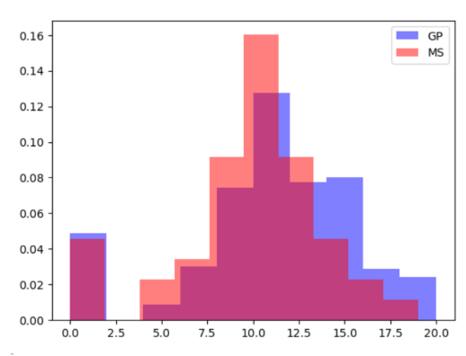
Interpretation
According to the histograms,
- MS students are more concentrated around scores near 10.
- GP students appear slightly shifted to the right.
- GP students have a higher density of scores in higher ranges (like 14–18)
- There is substantial overlap between the two groups.
- The association would likely be described as weak to moderate, not strong.

Skill 28.3 Exercise 1

Skill 28.4: Interpret the association between a quantitative variable and a non-binary categorical variable

Skill 28.4 Concepts

In each of the previous exercises, we assessed whether there was an association between a quantitative variable (math scores) and a BINARY categorical variable (school). The categorical variable is considered binary because there are only two available options, either MS or GP. However, sometimes we are interested in an association between a quantitative variable and non-binary categorical variable. Non-binary categorical variables have more than two categories.

When looking at an association between a quantitative variable and a non-binary categorical variable, we must examine all pair-wise differences. For example, suppose we want to know whether or not an association exists between math scores (G3) and (Mjob), a categorical variable representing the mother’s job. This variable has five possible categories: at_home, health, services, teacher, or other. There are actually 10 different comparisons that we can make. For example, we can compare scores for students whose mothers work at_home or in health; at_home or other; at home or `services; etc.. The easiest way to quickly visualize these comparisons is with side-by-side box plots.

Code
sns.boxplot(data = students,
x = 'Mjob',
y = 'G3',
hue='Mjob',
legend=False
)
plt.show()

Output
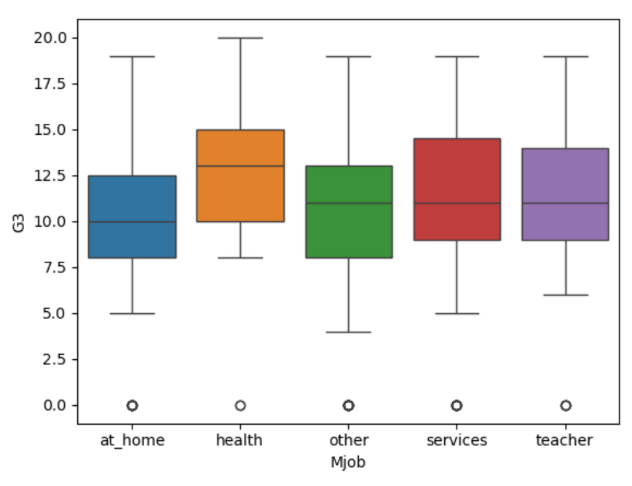
Interpretation
There is some evidence that G3 scores differ by mother’s job category — particularly that students with mothers in health professions may score slightly higher.
However:
- The medians differ only modestly.
- The distributions overlap substantially.
- Within-group variation is large.
- The association appears weak to moderate at most

Visually, we need to compare each box to every other box. While most of these boxes overlap with each other, there are some pairs for which there are some apparent differences. For example, scores appear to be higher among students with mothers working in health than among students with mothers working at home or in an “other” job. If there are ANY pairwise differences, we can say that the variables are associated; however, it is more useful to specifically report which groups are different.

Skill 28.4 Exercise 1

