Set 27: Summarizing Relationships Between Quantitative Features

Skill 27.1: Interpret the relationship between two quantitative variables using a scatter plot
Skill 27.2: Quantify the strength and direction of a linear relationship using covariance
Skill 27.3: Quantify and interpret the strength and direction of a linear relationship using Pearson correlation
Skill 27.4: Evaluate the limitations of correlation when assessing relationships between variables

Skill 27.1: Interpret the relationship between two quantitative variables using a scatter plot

Skill 27.1 Concepts

When associations exist between variables, it means that information about the value of one variable gives us information about the value of the other variable. In this lesson, we will cover ways of examining an association between two quantitative variables.

The dataset below contains information about Texas housing rentals on Craigslist. The data dictionary is as follows,
- price: monthly rental price in U.S.D.
- type: type of housing (eg., 'apartment', 'house', 'condo', etc.)
- sqfeet: housing area, in square feet
- beds: number of beds
- baths: number of baths
- lat: latitude
- long: longitude
Except for type, all of these variables are quantitative.

housing
 | price | type | sqfeet | beds | baths | lat | long
0 | 615 | apartment | 364 | 0 | 1.0 | 35.1653 | -101.8840
1 | 1346 | apartment | 816 | 1 | 1.0 | 32.9865 | -96.6860
2 | 900 | apartment | 500 | 1 | 1.0 | 30.2355 | -97.7292
3 | 650 | apartment | 700 | 1 | 1.0 | 26.1923 | -98.2657
4 | 1330 | apartment | 1040 | 2 | 2.0 | 30.6380 | -96.2940

One of the best ways to quickly visualize the relationship between quantitative variables is to plot them against each other in a scatter plot. This makes it easy to look for patterns or trends in the data. Let’s start by plotting the area of a rental against its monthly price to see if we can spot any patterns.

Code
import pandas as pd
import matplotlib.pyplot as plt
housing = pd.read_csv('housing.csv', delimiter = "\t")
display(housing.head())

plt.scatter(x = housing.price, y = housing.sqfeet)
plt.xlabel('Rental Price (USD)')
plt.ylabel('Area (Square Feet)')
plt.show()

Output
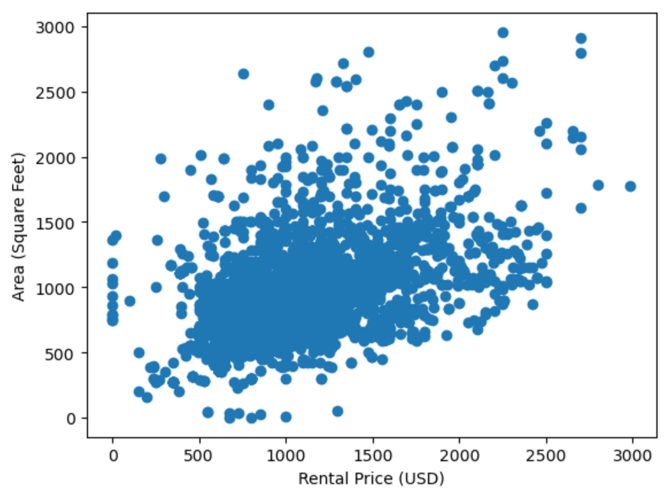

While there’s a lot of variation in the data, it seems like more expensive housing tends to come with slightly more space. This suggests an association between these two variables.

It’s important to note that different kinds of associations can lead to different patterns in a scatter plot. For example, the following plot shows the relationship between the age of a child in months and their weight in pounds. We can see that older children tend to weigh more but that the growth rate starts leveling off after 36 months:
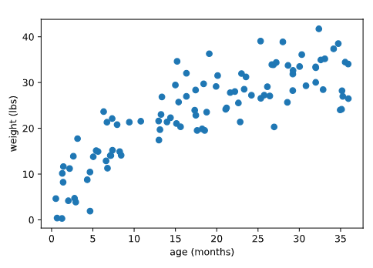

If we don’t see any patterns in a scatter plot, we can probably guess that the variables are not associated. For example, a scatter plot like this would suggest no association,

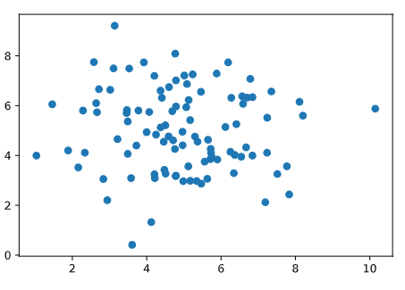
Skill 27.1 Exercise 1

Skill 27.2: Determine the direction of a linear relationship using covariance

Skill 27.2 Concepts
Beyond visualizing relationships, we can also use summary statistics to quantify the direction of linear associations. Covariance is a summary statistic that measures how two quantitative variables vary together and indicates the direction of their linear relationship. A linear relationship is one in which a straight line would best describe the pattern of points in a scatter plot.
Covariance is a numerical measure that describes how two quantitative variables change together. It helps us determine whether the variables tend to increase together, decrease together, or move in opposite directions.

More specifically:
- If two variables tend to increase at the same time (or decrease at the same time), their covariance is positive.
- If one variable tends to increase while the other decreases, their covariance is negative.
- If there is no consistent pattern in how they move together, the covariance is close to zero.
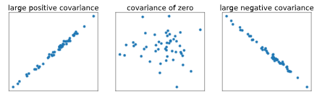
To calculate covariance, we can use the cov() method from NumPy, which produces a covariance matrix for two or more variables.
Data

Code
cov_price_sqfeet = housing[['price', 'sqfeet' ]].cov()
print(cov_price_sqfeet)

Output
price sqfeet
price 150471.613578 65426.516235
sqfeet 65426.516235 110668.978017

Variance in price - spread
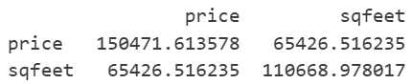
Variance in square feet - spread

What does 65426.516235 mean? The positive value tells us: As square footage increases, price tends to increase. And, is a measure of linear association between the price and square footage.
Skill 27.2 Exercise 1

Skill 27.3: Quantify and interpret the strength and direction of a linear relationship using Pearson correlation

Skill 27.3 Concepts

Like covariance, Pearson correlation (often referred to simply as “correlation”) measures the direction and strength of a linear relationship between two quantitative variables. Correlation is a standardized form of covariance, meaning it adjusts for the scale of the variables. Because it ranges from -1 to +1, it is easier to interpret than covariance.
- Variables with a strong positive linear association will have a correlation close to +1.
- Variables with a strong negative linear association will have a correlation close to -1.
- Variables with little to no linear association will have a correlation close to 0.

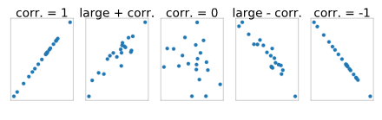
The pearsonr() function from scipy.stats can be used to calculate correlation as follows:

Data

Code
from scipy.stats import pearsonr
# returns two values as a tuple, the first value is the correlation
result = pearsonr(housing.price, housing.sqfeet)
corr_price_sqfeet = result[0]

Output
0.5070065351127468

Generally, a correlation larger than about .3 indicates a linear association. A correlation greater than about .6 suggestions a strong linear association.

Skill 27.3 Exercise 1

Skill 27.4: Evaluate the limitations of correlation when assessing relationships between variables

Skill 27.4 Concepts

It’s important to note that there are some limitations to using correlation or covariance as a way of assessing whether there is an association between two variables. Because correlation and covariance both measure the strength of linear relationships with non-zero slopes, but not other kinds of relationships, correlation can be misleading.

For example, the four scatter plots below all show pairs of variables with near-zero correlations. The bottom left image shows an example of a perfect linear association where the slope is zero (the line is horizontal). Meanwhile, the other three plots show non-linear relationships — if we drew a line through any of these sets of points, that line would need to be curved, not straight!

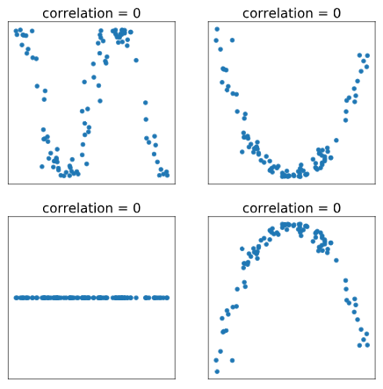

Skill 27.4 Exercise 1

