Set 31: Rules of Probability

Skill 31.1: Distinguish between independent and dependent events
Skill 31.2: Determine whether two events are mutually exclusive
Skill 31.3: Apply the addition rule to calculate the probability the one or both events occur
Skill 31.4: Interpret and use conditional probability notation for dependent events
Skill 31.5: Apply the multiplication rule to calculate the probability that two events occur simultaneously
Skill 31.6: Use tree diagrams to represent multi-step probability experiments
Skill 31.7: Apply Bayes’ theorem to calculate the probability of a reverse condition given

Skill 31.1: Distinguish between independent and dependent events

Skill 31.1 Concepts

Imagine that we flip a fair coin 5 times and get 5 heads in a row. Does this affect the probability of getting heads on the next flip? Even though we may feel like it’s time to see “tails”, it is impossible for a past coin flip to impact a future one. The fact that previous coin flips do not affect future ones is called independence. Two events are independent if the occurrence of one event does not affect the probability of the other.

Are there cases where previous events DO affect the outcome of the next event? Suppose we have a bag of five marbles: two marbles are blue and three marbles are red. If we take one marble out of the bag, what is the probability that the second marble we take out is blue?

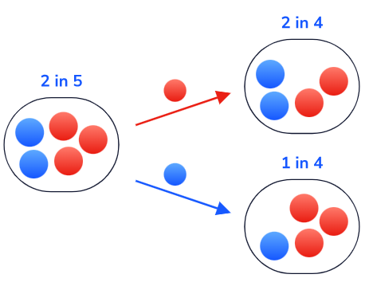

This describes two events that are dependent. The probability of grabbing a blue marble in the second event depends on whether we take out a red or a blue marble in the first event.

What if we had put back the first marble? Is the probability that we pick a blue marble second independent or dependent on what we pick out first? In this case, the events would be independent.

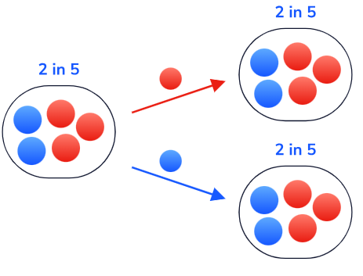
Why do we care if events are independent or dependent? Knowing this helps us quantify the probability of events that depend on preexisting knowledge. This helps researchers understand and predict complex processes such as:
- Effectiveness of vaccines
- The weather on a particular day
- Betting odds for professional sports games
Skill 31.1 Exercise 1

Skill 31.2: Determine whether two events are mutually exclusive

Skill 31.2 Concepts
Two events are considered mutually exclusive if they cannot occur at the same time. For example, consider a single coin flip: the events “tails” and “heads” are mutually exclusive because we cannot get both tails and heads on a single flip.
We can visualize two mutually exclusive events as a pair of non-overlapping circles. They do not overlap because there is no outcome for one event that is also in the sample space for the other:
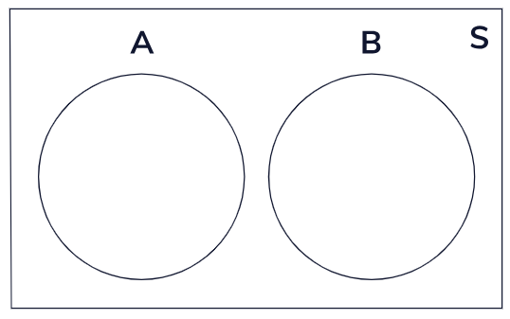
What about events that are not mutually exclusive? If event A is rolling an odd number and event B is rolling a number greater than two, these events are not mutually exclusive. They have an intersection of {3, 5}. Any events that have a non-empty intersection are not mutually exclusive.
Skill 31.2 Exercise 1

Skill 31.3: Apply the addition rule to calculate the probability the one or both events occur

Skill 31.3 Concepts

Now that we can distinguish between mutually exclusive and not mutually exclusive events, we can apply the addition rule to calculate the probability that one or both events occur.
Let’s return to one of our first examples: event A is rolling an odd number on a six-sided die and event B is rolling a number greater than two. What if we want to find the probability of one or both events occurring? This is the probability of the union of A and B,
P(A or B)

We can visualize this calculation as follows,
Not mutually exclusive events A and B
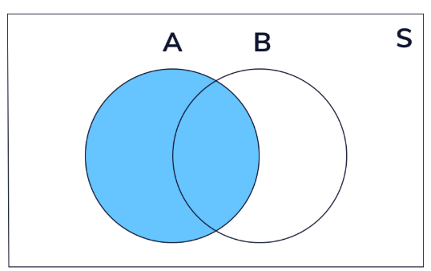 | 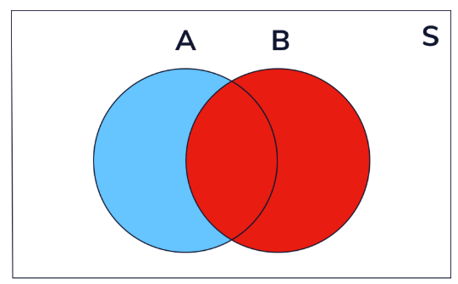 | 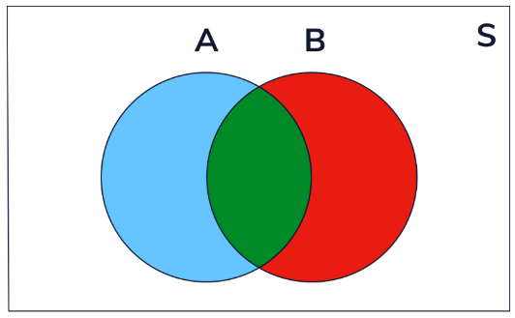
P(A or B) = P(A) | P(A or B) = P(A) + P(B) | P(A or B) = P(A) + P(B) – P(A and B)

This visual above represents the addition rule formula, which is,

P(A or B)=P(A)+P(B)−P(A and B)

What if the events are mutually exclusive? On a single die roll, if event A is that the roll is less than or equal to 2 and event B is that the roll is greater than or equal to 5, then events A and B cannot both happen.

Mutually exclusive events A and B
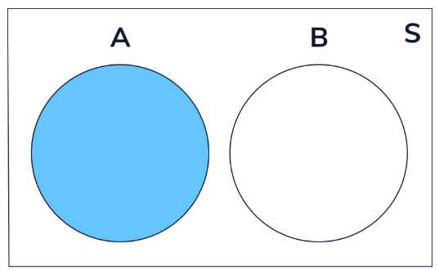 | 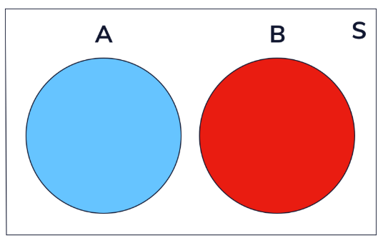
P(A or B) = P(A) | P(A or B) = P(A) + P(B)

For mutually exclusive events, the addition rule formula is,

P(A or B)=P(A)+P(B)

Because the intersection is empty, so we don’t need to remove any overlap between the two events.

Let’s consider some examples,

EXAMPLE 1: Calculate the probability of rolling a die once and getting an even number or an odd number
Step 1: Is this a mutually exclusive or not mutually exclusive? | The situation is mutually exclusive because you cannot get roll an even number and an odd number at the same time. So,  P(A or B)=P(A)+P(B)
Step 2: What is P(A)? | All the possible even numbers are: 2, 4, 6 (3 total). All the possible rolls are 1, 2, 3, 4, 5, 6 (6 total). So, the probability of rolling 1 even number is 3/6
Step 3: What is P(B)? | All the possible odd numbers are: 1, 3, 5 (3 total). All the possible rolls are 1, 2, 3, 4, 5, 6 (6 total). So, the probability of rolling 1 odd number is 3/6
Step 4: What is P(A or B)? | P(A or B) = P(A) + P(B) = 3/6 + 3/6 = 1  Conclusion: There is a 100% probability of rolling an even (A) or odd (B) number

EXAMPLE 2: Calculate the probability of rolling a die once and getting an odd number or a number greater than 2
Step 1: Is this a mutually exclusive or not mutually exclusive? | The situation is not mutually exclusive because you can roll an odd number greater than 2.  P(A or B)=P(A)+P(B)−P(A and B)
Step 2: What is P(A)? | All the possible odd numbers are: 1, 3, 5 (3 total). All the possible rolls are 1, 2, 3, 4, 5, 6 (6 total). So, the probability of rolling 1 odd number is 3/6
Step 3: What is P(B)? | All the numbers greater than 2 are 3, 4, 5, 6 (4 total). All the possible rolls are 1, 2, 3, 4, 5, 6 (6 total). So the probability of rolling a number greater than 2 is 4/6.
Step 4: What is P(A and B)? | P(A and B) is the intersection of P(A) and P(B).  P(A) = {1, 3, 5}  P(B) = {3, 4, 5, 6}  P(A and B) = {3, 5}  All the possible rolls are 1, 2, 3, 4, 5, 6 (6 total). So the probability of rolling a 3 or 5 (2 total) is 2/6.
Step 5: What is P(A or B)? | P(A or B)=P(A)+P(B)−P(A and B) = 3/6 + 4/6 – 2/6 = 5/6  Conclusion: There is a 83% probability of rolling an odd number or a number greater than 2.

Use the addition rule when finding the probability that Event A OR Event B occurs (the union of two events), meaning one event happens, the other happens, or both happen.

Skill 31.3 Exercise 1

Skill 31.4: Interpret and use conditional probability notation for dependent events

Skill 31.4 Concepts

If we want to calculate the probability that a pair of dependent events both occur, we need to define conditional probability. Using a bag of marbles as an example, let’s remind ourselves of the definition of dependent events,

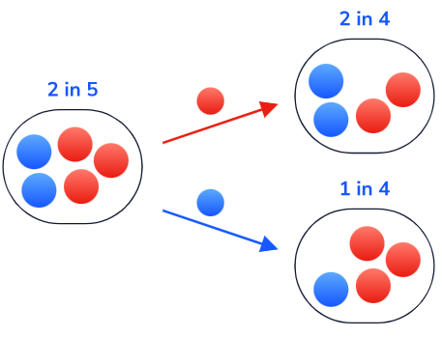
If we pick two marbles from a bag of five marbles without replacement, the probability that the second marble is red depends on the color of the first marble. We have a special name for this: conditional probability. In short, conditional probability measures the probability of one event occurring, given that another one has already occurred.

We denote the word “given” with a vertical line. For example, if we want to represent the probability that we choose a red marble given the first marble is blue, we can write,

P(Red Second∣Blue First)

From the above diagram, we know that,

P(Red Second∣Blue First)=3/4
What if we picked out two marbles with replacement? What does the conditional probability look like? Well, let’s think about this. Regardless of which marble we pick out first, it will be put back into the bag. Therefore, the probability of picking out a red marble or a blue marble second is unaffected by the first outcome.
Therefore, for independent events, we can say the following,
P(A∣B) = P(A)
And
P(B∣A) = P(B)​
Skill 31.4 Exercises 1 & 2

Skill 31.5: Apply the multiplication rule to calculate the probability that two events occur simultaneously

Skill 31.5 Concepts

We have looked at the addition rule, which describes the probability one event OR another event (or both) occurs. What if we want to calculate the probability that two events happen simultaneously? For two events, A and B, this is P(A and B) or the probability of the intersection of A and B.

The general formula for the probability that two events occur simultaneously is,
P(A and B) = P(A) ⋅ P(B∣A)

Let’s return to our marbles to visualize an example,

We have five marbles: two are blue, and three are red. If we pick two marbles without replacement. What if we want to know the probability of choosing a blue marble first AND a blue marble second?
Taking conditional probability into account, the multiplication rule for these two dependent events is,
P(Blue 1st and Blue 2nd )= P(Blue 1st) ⋅ P(Blue 2nd ∣ Blue 1st )
To answer the question above,
P(Blue 1st and Blue 2nd )= 2/5 * 1/4 = 2/20 => 1/10
For independent events, we can simplify this formula slightly. We know from the previous section, that for independent events,
P(A∣B) = P(A)
And
P(B∣A) = P(B)​
So,
P(A and B) = P(A) ⋅ P(B∣A) = P(A) ⋅ P(B)

Now, let’s return to our previous example but replace the marbles…
If we have five marbles: two are blue, and three are red. If we pick two marbles with replacement. What is the probability of choosing a blue marble first and a blue marble second?
P(Blue 1st and Blue 2nd )= P(Blue) ⋅ P(Blue)

P(Blue 1st and Blue 2nd )= 2/5 * 2/5 = 4/25

Use the multiplication rule when finding the probability that Event A AND Event B occurs (the intersection of two events), meaning both events happen.

Skill 31.5 Exercise 1

Skill 31.6: Use tree diagrams to represent multi-step probability experiments

Skill 31.6 Concepts

In each of the examples above we calculated one potential outcome when picking two marbles out of the bag. What if we wanted to visualize all possible outcomes?

One way to visualize all possible outcomes of a pair of events is a tree diagram.

Tree diagrams have the following properties,

- Each branch represents a specific set of events.
- The probabilities of the terminal branches (all possible sets of outcomes) sum to one.
- We multiply across branches (using the multiplication rule!) to calculate the probability that each branch (set of outcomes) will occur.

Let’s look at the simplest example: flipping a fair coin twice. Event A is that we get tails on the first flip, and event B is that we get tails on the second flip. P(A) = P(B) = 0.5, so according to our formula, the probability of getting tails on both flips would be,

P(A and B)=0.5 ⋅ 0.5 = 0.25

Visually on a tree diagram, we see,

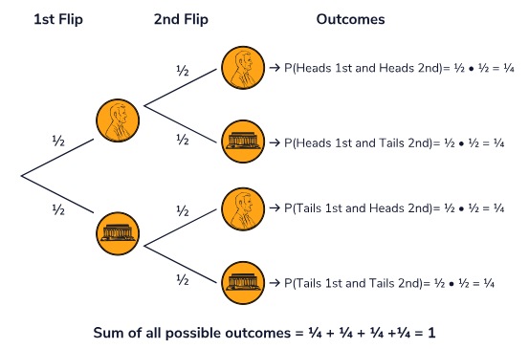

Skill 31.6 Exercise 1

Skill 31.7: Apply Bayes’ theorem to calculate the probability of a reverse condition given

Skill 31.7 Concepts

We have introduced conditional probability as a part of the multiplication rule for dependent events. However, let’s go a bit more in-depth with it as it is a powerful probability tool that has real-world applications.

Suppose that the following is true (this is shown in the first set of branches in the diagram below):
- 20 percent of the population has strep throat.
- 80 percent of the population does not have strep throat.
Now suppose that we test a bunch of people for strep throat. The possible results of these tests are shown in the next set of branches,
- The probability of a person testing positive given they already have strep throat (P(+ | ST))
- The probability of a person testing negative given they already have strep throat (P(- | ST))
- The probability of a person testing positive given they do not have strep throat (P(+ | NO ST))
- The probability of a person testing negative given they do not have strep throat (P(- | NO ST))

P(ST and +) = P(ST) * P(+)
.20 * .85 = .17
Test Positive (+)
P(+ | ST) = .85

Strep Throat (ST)
P(ST) = .20

P(ST and -) = P(ST) * P(-)
.20 * .15 = .03
Test Negative (-)
P(- | ST) = .15

P(NO ST and +) = P(NO ST) * P(+)
.80 * .02 = .016
Test Positive (+)
P(+ | NO ST) = .02

No Strep Throat (NO ST)
P(NO ST) = .80

P(NO ST and -) = P(NO ST) * P(-)
.80 * .98 = .784
Test Positive (-)
P(- | NO ST) = .98

What if a person wanted to know the probability of having strep throat given a positive test? That is,

P( ST | +)

We can approach this two ways…

Method 1

Notice P( ST | +) is the reverse of what the probabilities show in the tree. To calculate this, we can use Baye’s theorem.

$$P(B | A)= \frac{P\left(A \right|B)*P(B)}{P(A)}$$
Using Bayes’ Theorem where B = ST and A = +/-,

$$P\left(ST \right| +)= \frac{P\left(+ \right|ST)*P(ST)}{P(+)}$$
Those that have strep throat is,

$$P\left(ST\right)= .20$$

Those that have strep throat and test positive is,
$$P\left(+ \right|ST)= .85$$

But, what about P(+)?

Well, let’s think about this. There are four possible outcomes:
- Having strep throat and testing positive
- Having strep throat and testing negative
- Not having strep throat and testing positive
- Not having strep throat and testing negative
We only care about the two outcomes where a patient tests positives for P(+). Therefore, we can say,
P (+) = P (ST and +) + P (NO ST and +)
P (+) = 0.17 + .016
P (+) = 0.186​
Finally, if we plug all of these into the Bayes’ theorem formula, we get:

$$P\left(ST \right| +)= \frac{.85*.20}{.186}$$

$$P\left(ST \right| +)= .914$$

Based on this result, there is a 91.4% chance that you actually have strep throat given you test positive.

Method 2

Now, let’s consider this another way,

Consider population size of 1000. Based on the table,

20% have strep throat. 100 * .2 = 200
80% do not have strep throat. 100 * .8 = 800

Of the 20% that have strep throat, 85% test positive = 200 * .85 = 170
Of the 80% that do not have strep throat, 2% test positive = 800 * .02 = 16

The total that have tested positive is 170 + 16 = 186
Of those that test positive, 170 had strep throat so,

P( ST | + ) = 170/186 = .914

Skill 31.7 Exercise 1

