Set 32: Introduction to Probability Distributions

Skill 32.1: Apply np.random.choice() to simulate random outcomes from a set of values
Skill 32.2: Interpret a binomial probability mass function (PMF)
Skill 32.3: Use the probability mass function (PMF) to calculate the probability of a specific value
Skill 32.4: Use the probability mass function (PMF) to calculate the probability of a range of values
Skill 32.5: Use the cumulative distribution function (CDF) to calculate the probability of a range of values
Skill 32.6: Use a probability density function (PDF) to describe the distribution of a continuous random variable

Skill 32.1: Apply np.random.choice() to simulate random outcomes from a set of values

Skill 32.1 Concepts

A random variable is, in its simplest form, a function. In probability, we often use random variables to represent random events. For example, we could use a random variable to represent the outcome of a die roll: any number between one and six.

Random variables must be numeric, meaning they always take on a number rather than a characteristic or quality. If we want to use a random variable to represent an event with non-numeric outcomes, we can choose numbers to represent those outcomes. For example, we could represent a coin flip as a random variable by assigning “heads” a value of 1 and “tails” a value of 0.

In this lesson, we will use random.choice(a, size = size, replace = True/False) from the numpy library to simulate random variables in python. In this method:
- a is a list or other object that has values we are sampling from
- size is a number that represents how many values to choose
- replace can be equal to True or False, and determines whether we keep a value in a after drawing it (replace = True) or remove it from the pool (replace = False).
Code
import numpy as np

# 7 is not included in the range function
die_6 = range(1, 7)

rolls = np.random.choice(die_6, size = 2, replace = True)
print(rolls)
Output
[4 3]

Skill 32.1 Exercise 1

Skill 32.2: Interpret a binomial probability mass function (PMF)

Skill 32.2 Concepts

Previously we learned about discrete and random variables. Below are examples of discrete and continuous random variables.

Discrete Random Variables

Random variables with a countable number of possible values are called discrete random variables. For example, rolling a regular 6-sided die would be considered a discrete random variable because the outcome options are limited to the numbers on the die.

Discrete random variables are also common when observing counting events, such as how many people entered a store on a randomly selected day. In this case, the values are countable in that they are limited to whole numbers (you can’t observe half of a person).
Continuous Random Variables
When the possible values of a random variable are uncountable, it is called a continuous random variable. These are generally measurement variables and are uncountable because measurements can always be more precise – meters, centimeters, millimeters, etc.
For example, the temperature in Los Angeles on a randomly chosen day is a continuous random variable. We can always be more precise about the temperature by expanding to another decimal place (96 degrees, 96.44 degrees, 96.437 degrees, etc.).
A probability mass function (PMF) is a type of probability distribution that defines the probability of observing a particular value of a discrete random variable. For example, a PMF can be used to calculate the probability of rolling a three on a fair six-sided die.
There are certain kinds of random variables (and associated probability distributions) that are relevant for many different kinds of problems. These commonly used probability distributions have names and parameters that make them adaptable for different situations.
For example, suppose that we flip a fair coin some number of times and count the number of heads. The probability mass function that describes the likelihood of each possible outcome (eg., 0 heads, 1 head, 2 heads, etc.) is called the binomial distribution. The parameters for the binomial distribution are:
- n for the number of trials (eg., n=10 if we flip a coin 10 times)
- p for the probability of success in each trial (probability of observing a particular outcome in each trial. In this example, p= 0.5 because the probability of observing heads on a fair coin flip is 0.5)
If we flip a fair coin 10 times, we say that the number of observed heads follows a Binomial(n=10, p=0.5) distribution. The graph below shows the probability mass function for this experiment. The heights of the bars represent the probability of observing each possible outcome as calculated by the PMF.
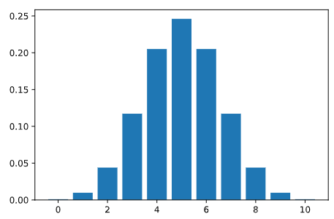
Skill 32.2 Exercise 1

Skill 32.3: Use a probability mass function (PMF) to calculate the probability of a specific value

Skill 32.3 Concepts

The binom.pmf() method from scipy.stats can be used to compute the binomial distribution’s PMF for any specified value of x (also called k). Where x is the number of successes you are asking about.
This method takes 3 values,
- x: the value of interest
- n: the number of trials
- p: the probability of success
For example, suppose we flip a fair coin 10 times (n) and count the number of heads. We can use the binom.pmf() function to calculate the probability of observing all the possibilities for the number of heads.

Code
# import necessary library
import scipy.stats as stats

for k in range(11):
print("P(X = {k}) = {stat}".format(k = k,
stat = round(stats.binom.pmf(x, 10, 0.5),6)))

Output
P(X = 0) = 0.000977
P(X = 1) = 0.009766
P(X = 2) = 0.043945
P(X = 3) = 0.117188
P(X = 4) = 0.205078
P(X = 5) = 0.246094
P(X = 6) = 0.205078
P(X = 7) = 0.117187
P(X = 8) = 0.043945
P(X = 9) = 0.009766
P(X = 10) = 0.000977

Skill 32.3 Exercise 1

Skill 32.4: Use a probability mass function (PMF) to calculate the probability of a range of values

Skill 32.4 Concepts

We have seen that we can calculate the probability of observing a specific value using a probability mass function. What if we want to find the probability of observing a range of values for a discrete random variable? One way we could do this is by adding up the probability of each value.

For example, let’s say we flip a fair coin 5 times, and want to know the probability of getting between 1 and 3 heads. We can visualize this scenario with the probability mass function:

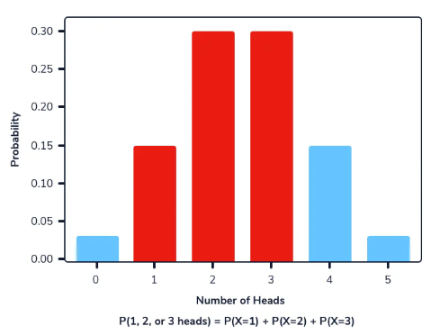

P(1 to 3 heads) = P(X=1) + P(X=2) + P(X=3)

P(1 to 3 heads) = 0.1562 + 0.3125 + 0.3125

P(1 to 3 heads) = 0.7812​
We can use the same binom.pmf() method from the scipy.stats library to calculate the probability of observing a range of values. As mentioned in a previous exercise, the binom.pmf method takes 3 values:
- x: the value of interest
- n: the sample size
- p: the probability of success
For example, we can calculate the probability of observing between 2 and 4 heads from 10 coin flips as follows:
Code
# import necessary library
import scipy.stats as stats

print(stats.binom.pmf(2, n=10, p=.5) +
stats.binom.pmf(3, n=10, p=.5) +
stats.binom.pmf(4, n=10, p=.5))

Output
0.36621093749999994

When there are many possible values of interest, this task of adding up probabilities can be difficult. If we want to know the probability of observing 8 or fewer heads from 10 coin flips, we need to add up the values from 0 to 8:

Code
import scipy.stats as stats

flips_0_8 = stats.binom.pmf(0, n = 10, p = 0.5)
flips_0_8 += stats.binom.pmf(1, n = 10, p = 0.5)
flips_0_8 += stats.binom.pmf(2, n = 10, p = 0.5)
flips_0_8 += stats.binom.pmf(3, n = 10, p = 0.5)
flips_0_8 += stats.binom.pmf(4, n = 10, p = 0.5)
flips_0_8 += stats.binom.pmf(5, n = 10, p = 0.5)
flips_0_8 += stats.binom.pmf(6, n = 10, p = 0.5)
flips_0_8 += stats.binom.pmf(7, n = 10, p = 0.5)
flips_0_8 += stats.binom.pmf(8, n = 10, p = 0.5)

print(flips_0_8)

Output
0.98926

This involves a lot of repetitive code. Instead, we can also use the fact that the sum of the probabilities for all possible values is equal to 1,

Code
import scipy.stats as stats

flips_0_8 = 1 - (stats.binom.pmf(9, n=10, p=.5) + stats.binom.pmf(10, n=10, p=.5))

print(flips_0_8)

Output
0.98926

Skill 32.4 Exercise 1

Skill 32.5: Use the cumulative distribution function to calculate the probability of a range of values

Skill 32.5 Concepts
We’ve seen that the probability mass function (PMF) tells you the chance of getting exactly a certain value (like exactly 6 heads).
The cumulative distribution function (CDF) tells you the chance of getting that value or anything smaller. You can think of the CDF as a running total of probabilities as you move from left to right on the number line.
Because the probabilities for all possible values add up to 1, the CDF:
- starts near 0 (at very small values),
- adds more probability as x gets larger,
- and eventually reaches 1 at the largest possible value.
In the previous section, we showed how the PMF can be used to calculate the probability of getting less than 3 heads out of 10 coin flips by adding the probabilities of getting 0, 1, and 2 heads. The CDF gives the same answer by calculating P(X≤2). In this case, using the CDF is simpler than the PMF because it requires one calculation instead of three.

The image below shows the relationship between the probability mass function and the cumulative distribution function. The left plot is the PMF, while the right plot is the corresponding CDF. When looking at the graph of a CDF, each y-axis value is the sum of the probabilities less than or equal to it in the PMF.

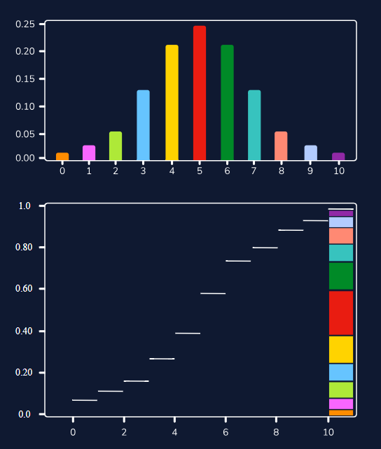

We can use the binom.cdf() method from the scipy.stats library to calculate the cumulative distribution function. This method takes 3 values:

- x: the value of interest, looking for the probability of this value or less
- n: the sample size
- p: the probability of success

Calculating the probability of observing 6 or fewer heads from 10 fair coin flips (0 to 6 heads) mathematically looks like the following,
P(6 or fewerheads) = P(0 to 6 heads)

In python, we can use the following code,

Code
import scipy.stats as stats

print(stats.binom.cdf(6, 10, 0.5))

Output
0.828125

We can also use a cumulative distribution function to calculate the probability of a specific range by taking the difference between two values from the cumulative distribution function. For example, to find the probability of observing between 3 and 6 heads, we can take the probability of observing 6 or fewer heads and subtracting the probability of observing 2 or fewer heads. This leaves a remnant of between 3 and 6 heads.
The visualization below demonstrates how this works. It is important to note that to include the lower bound in the range, the value being subtracted should be one less than the lower bound. In this example, we wanted to know the probability from 3 to 6, which includes 3.
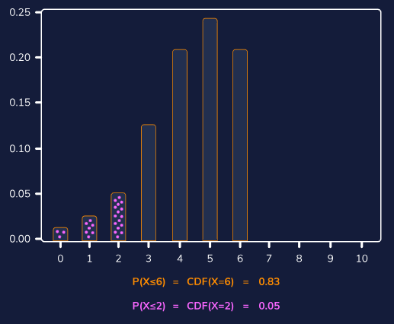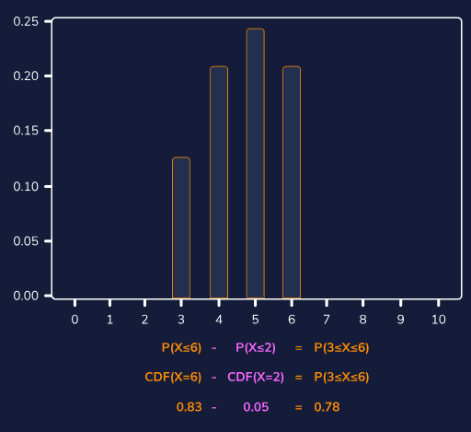

In python, we can use the following code,

Code
import scipy.stats as stats

print(stats.binom.cdf(6, 10, 0.5) - stats.binom.cdf(2, 10, 0.5))

Output
0.7734375

To calculate the probability of observing more than 6 heads from 10 fair coin flips we subtract the value of the cumulative distribution function at 6 from 1. Mathematically, this looks like the following:
P(more than 6 heads) = 1 − P(6 or fewer heads)

Note that “more than 6 heads” does not include 6. In python, we would calculate this probability using the following code,
Code
import scipy.stats as stats

print(1 - stats.binom.cdf(6, 10, 0.5))

Output
0.171875

Skill 32.5 Exercise 1

Skill 32.6: Use a probability density function (PDF) to describe the distribution of a continuous random variable

Skill 32.6 Concepts

Similar to how discrete random variables relate to probability mass functions, continuous random variables relate to probability density functions (PDF). A PDF describes how the values of a continuous variable are spread out across its entire range of possible values.

When graphed, a probability density function is a curve across all possible values the random variable can take on, and the total area under this curve adds up to 1.
The following image shows a probability density function. The highlighted area represents the probability of observing a value within the highlighted range.
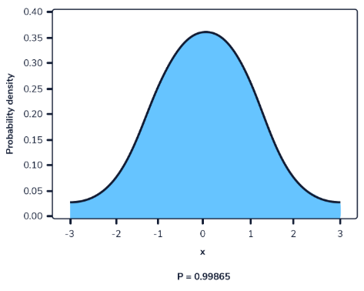

In a probability density function, we cannot calculate the probability at a single point. This is because the area of the curve underneath a single point is always zero. The image below illustrates this.

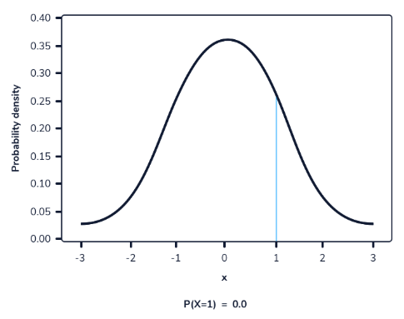

As we can see from the visual above, as the interval becomes smaller, the width of the area under the curve becomes smaller as well. When trying to evaluate the area under the curve at a specific point, the width of that area becomes 0, and therefore the probability equals 0.

We can calculate the area under the curve using the cumulative distribution function for the given probability distribution.

For example, heights fall under a type of probability distribution called a normal distribution. The parameters for the
normal distribution are the mean and the standard deviation, and we use the form Normal(mean, standard deviation) as shorthand.

We know that women’s heights have a mean of 167.64 cm with a standard deviation of 8 cm, which makes them fall under the Normal(167.64, 8) distribution.
Let’s say we want to know the probability that a randomly chosen woman is less than 158 cm tall. We can use the cumulative distribution function to calculate the area under the probability density function curve from 0 to 158 to find that probability.
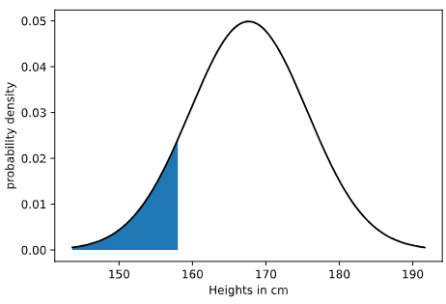
We can calculate the area of the blue region in Python using the norm.cdf() method from the scipy.stats library. This method takes on 3 values:
- x: the value of interest
- loc: the mean of the probability distribution
- scale: the standard deviation of the probability distribution
Code
import scipy.stats as stats

print(stats.norm.cdf(158, 167.64, 8))

Output
0.11410165094812996
We can take the difference between two overlapping ranges to calculate the probability that a random selection will be within a range of values for continuous distributions. This is essentially the same process as calculating the probability of a range of values for discrete distributions.
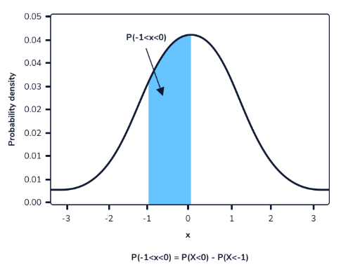
Let’s say we wanted to calculate the probability of randomly observing a woman between 165 cm to 175 cm, assuming heights still follow the Normal(167.74, 8) distribution. We can calculate the probability of observing these values or less. The difference between these two probabilities will be the probability of randomly observing a woman in this given range. This can be done in python using the norm.cdf() method from the scipy.stats library. As mentioned before, this method takes on 3 values:
- x: the value of interest
- loc: the mean of the probability distribution
- scale: the standard deviation of the probability distribution
Code
import scipy.stats as stats

print(stats.norm.cdf(175, 167.74, 8) - stats.norm.cdf(165, 167.74, 8))

Output
0.45194145326220503

We can also calculate the probability of randomly observing a value or greater by subtracting the probability of observing less than the given value from 1. This is possible because we know that the total area under the curve is 1, so the probability of observing something greater than a value is 1 minus the probability of observing something less than the given value.

Let’s say we wanted to calculate the probability of observing a woman taller than 172 centimeters, assuming heights still follow the Normal(167.74, 8) distribution. We can think of this as the opposite of observing a woman shorter than 172 centimeters. We can visualize it this way:
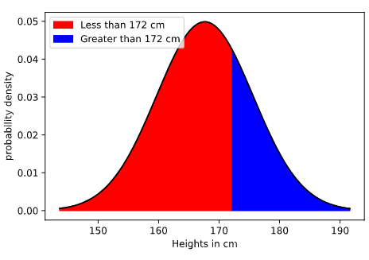
We can use the following code to calculate the blue area by taking 1 minus the red area:
Code
import scipy.stats as stats

print(1 - stats.norm.cdf(172, 167.74, 8))

Output
0.2971898709083267

Skill 32.6 Exercise 1

