Set 31: Poisson Distributions and Properties of Expectation and Variance

Skill 31.1: Identify when a Poisson distribution, a binomial distribution or a normal distribution is appropriate
Skill 31.2: Calculate the probabilities of exact values using the Probability Mass Function (PMF)
Skill 31.3: Calculate the probabilities of a range of values using the Cumulative Distribution Function (CDF)
Skill 31.4: Interpret the lambda (λ) parameter
Skill 31.5: Explain how lambda (λ) determines the spread of a Poisson Distribution
Skill 31.6: Calculate and interpret the expected value of a binomial distribution
Skill 31.7: Calculate the variance of a binomial distribution
Skill 31.8: Reason about center and spread after transforming random variables

Skill 31.1: Identify when a Poisson distribution, a binomial distribution or a normal distribution is appropriate

Skill 31.1 Concepts

There are numerous probability distributions used to represent almost any random event. In the previous lesson, we learned about the binomial to represent events like any number of coin flips as well as the normal distribution to represent events such as the height of a randomly selected woman.
The Poisson distribution is another common distribution, and it is used to describe the number of times a certain event occurs within a fixed time or space interval. For example, the Poisson distribution can be used to describe the number of cars that pass through a specific intersection between 4pm and 5pm on a given day. It can also be used to describe the number of calls received in an office between 1pm to 3pm on a certain day.
- A Poisson distribution models the number of times a random event occurs in a fixed time or space interval
- A binomial distribution models the number of successes in a fixed number of trials
- A normal distribution models how a continuous numerical variable is spread around a center value

The Poisson distribution is defined by the rate parameter, symbolized by the Greek letter lambda, λ. Lambda represents the expected value - or the average value - of the distribution. For example, if our expected number of customers between 1pm and 2pm is 7, then we would set the parameter for the Poisson distribution to be 7. The PMF for the Poisson(7) distribution is as follows,
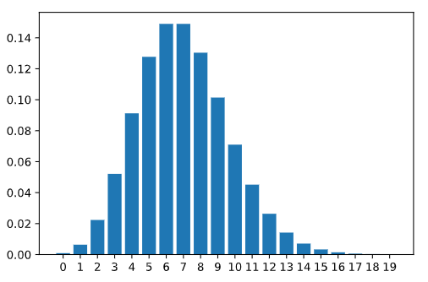

Skill 31.1 Exercise 1
Skill 31.2: Calculate the probabilities of exact values using the Probability Mass Function (PMF)

Skill 31.2 Concepts

The Poisson distribution is a discrete probability distribution, so it can be described by a probability mass function and cumulative distribution function.

For example, suppose that we expect it to rain 10 times in the next 30 days. The number of times it rains in the next 30 days is “Poisson distributed” with λ = 10.

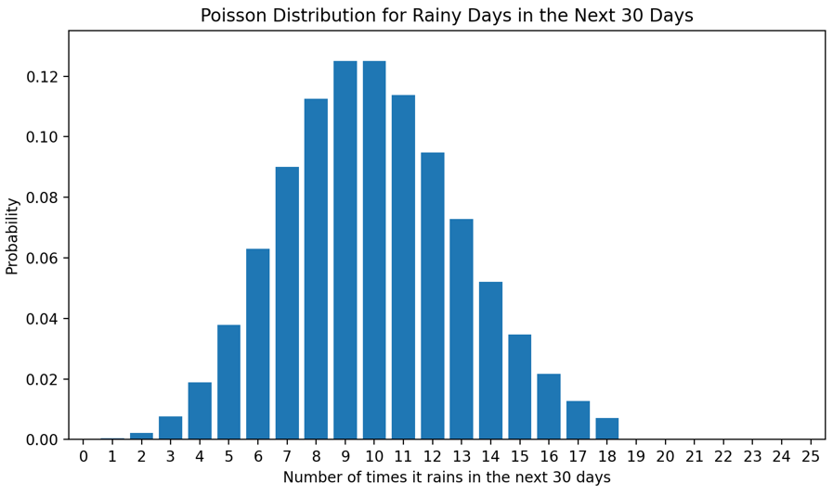
We can calculate the probability of exactly 6 times of rain using the poisson.pmf() method in the scipy.stats library,

Code
import scipy.stats as stats
# expected value = 10, probability of observing 6
stats.poisson.pmf(6, 10)

Output
np.float64(0.06305545800345125)

Like previous probability mass functions of discrete random variables, individual probabilities can be summed together to find the probability of observing a value in a range.

For example, if we expect it to rain 10 times in the next 30 days, the number of times it rains in the next 30 days is “Poisson distributed” with lambda = 10. We can calculate the probability of 12-14 times of rain as follows,

Code
import scipy.stats as stats
# expected value = 10, probability of observing 12-14
stats.poisson.pmf(12, 10) + stats.poisson.pmf(13, 10) + stats.poisson.pmf(14, 10)
Output
np.float64(0.21976538076223123)

Skill 31.2 Exercise 1

Skill 31.3: Calculate the probabilities of a range of values using the Cumulative Distribution Function (CDF)

Skill 31.3 Concepts

We can use the poisson.cdf() method in the scipy.stats library to evaluate the probability of observing a specific number or less given the expected value of a distribution.

Let’s return to our rain example with λ = 10.



What if we wanted to calculate the probability of observing 6 or fewer rain events in the next 30 days.

Code
stats.poisson.cdf(6, 10)

Output
np.float64(0.130141420882483)

This means that there is roughly a 13% chance that there will be 6 or fewer rainfalls in the month in question.

We can also use this method to evaluate the probability of observing a specific number or more given the expected value of the distribution. For example, if we wanted to calculate the probability of observing 12 or more rain events in the next 30 days when we expected 10, we could do the following,

Code
1 - stats.poisson.cdf(11, 10)

Output
np.float64(0.30322385369689386)
This means that there is roughly a 30% chance that there will be 12 or more rain events in the month in question.
Note that we used 11 in the statement above even though 12 was the value given in the prompt. We wanted to calculate the probability of observing 12 or more rains, which includes 12. stats.poisson.cdf(11, 10) evaluates the probability of observing 11 or fewer rains, so 1 - stats.poisson.cdf(11, 10) would equal the probability of observing 12 or more rains.

Summing individual probabilities over a wide range can be cumbersome. It is often easier to calculate the probability of a range using the cumulative distribution function instead of the probability mass function. We can do this by taking the difference between the CDF of the larger endpoint and the CDF of one less than the smaller endpoint of the range.

For example, while still expecting 10 rainfalls in the next 30 days, we could use the following code to calculate the probability of observing between 12 and 18 rainfall events,

Code
stats.poisson.cdf(18, 10) - stats.poisson.cdf(11, 10)

Output
np.float64(0.29603734909303947)

Skill 31.3 Exercise 1

Skill 31.4: Interpret the lambda (λ) parameter

Skill 31.4 Concepts

Earlier, we mentioned that the parameter lambda (λ) is the expected value (or average value) of the Poisson distribution. But what does this mean?

Let’s put this into context: let’s say we are salespeople, and after many weeks of work, we calculate our average to be 10 sales per week. If we take this value to be our expected value of a Poisson Distribution, the probability mass function will look as follows,

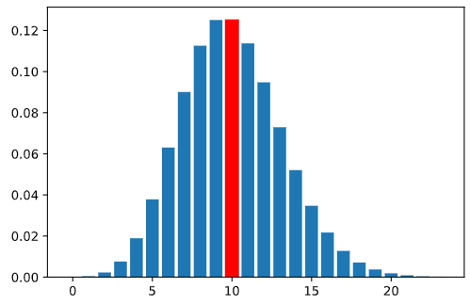

The tallest bar represents the value with the highest probability of occurring. In this case, the tallest bar is at 10. This does not, however, mean that we will make 10 sales. It means that on average, across all weeks, we expect our average to equal about 10 sales per week.

Let’s look at this another way. Let’s take a sample of 1000 random values from the Poisson distribution with the expected value of 10. We can use the poisson.rvs() method in the scipy.stats library to generate random values for the 1000 trials.

Code
# simulates 1000 event counts from a Poisson distribution with lambda = 10
rvs = stats.poisson.rvs(10, size = 1000)
Output
[ 8 13 9 7 10 8 3 12 12 9 9 8 11 10 12 12 12 16 10 9 11 9 11 12
3 5 5 12 9 15 14 5 21 8 9 8 11 9 14 13 14 8 10 7 9 2 8 7
...
12 10 10 11 11 8 9 8 11 8 8 7 8 15 16 9 17 6 9 6 11 16 12 13
15 8 10 9 7 16 13 13 2 9 10 14 8 9 5 10 10 8 15 7 6 14 4 12
15 15 8 8 12 9 15 8 6 11 7 11 13 14 11 8]

The histogram of this sampling looks like the following:
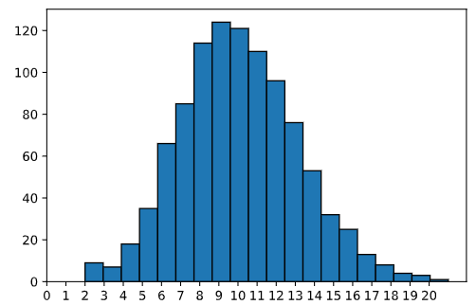

We can see observations of as low as 2 but as high as 20. The tallest bars are at 9 and 10. If we took the average of the 1000 random samples, we get a mean close to 10.

Code
rvs = stats.poisson.rvs(10, size = 1000)
print(rvs.mean())
rvs = stats.poisson.rvs(10, size = 1000)
print(rvs.mean())
rvs = stats.poisson.rvs(10, size = 1000)
print(rvs.mean())
rvs = stats.poisson.rvs(10, size = 1000)
print(rvs.mean())
Output
10.074
10.083
9.978
10.105

The value for each simulation above is very close to 10, confirming that over the 1000 observations, the expected value (or average) is 10.
When we talk about the expected value, we mean the average over many observations. This relates to the Law of Large Numbers: the more samples we have, the more likely samples will resemble the true population, and the mean of the samples will approach the expected value. So even though the salesperson may make 3 sales one week, they may make 16 the next, and 11 the week after. In the long run, after many weeks, the expected value (or average) would still be 10.

Skill 31.4 Exercise 1

Skill 31.5: Explain how lambda (λ) determines the spread of a Poisson Distribution

Skill 31.5 Concepts

Probability distributions also have calculable variances. Variances are a way of measuring the spread or dispersion of values and probabilities in the distribution. For the Poisson distribution, the variance is simply the value of lambda (λ), meaning that the expected value and variance are equivalent in Poisson distributions.

We know that the Poisson distribution must be a discrete positive random variable (think, a salesperson cannot have less than 0 sales, a shop cannot have fewer than 0 customers), so as the expected value increases, the number of possible values the distribution can take on would also increase.

The first plot below shows a Poisson distribution with lambda equal to three, and the second plot shows a Poisson distribution with lambda equal to fifteen. Notice that in the second plot, the spread of the distribution increases. Also, take note that the height of the bars in the second bar decrease since there are more possible values in the distribution.

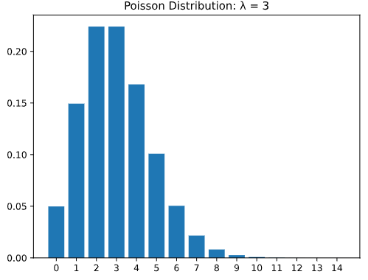
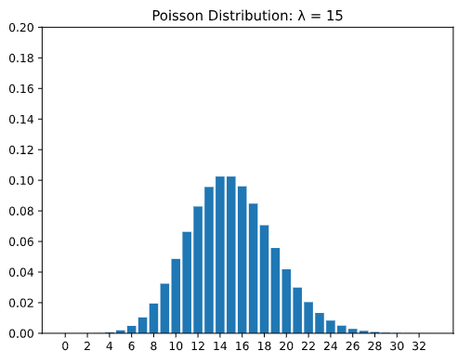
As we can see, as the parameter lambda increases, the variance — or spread — of possible values increases as well.

We can calculate the variance of a sample using the numpy.var() method,

Code
rand_vars = stats.poisson.rvs(4, size = 1000)
print(np.var(rand_vars))
rand_vars = stats.poisson.rvs(4, size = 1000)
print(np.var(rand_vars))
rand_vars = stats.poisson.rvs(4, size = 1000)
print(np.var(rand_vars))
Output
4.070975000000001
3.846991
4.157975

Because this is calculated from a sample, it is possible that the variance might not equal EXACTLY lambda. However, we do expect it to be relatively close when the sample size is large, like in this example.

Skill 31.5 Exercise 1

Skill 31.6: Calculate and interpret the expected value of a binomial distribution

Skill 31.6 Concepts

Other types of distributions have expected values and variances based on the given parameters, just like the Poisson distribution. Recall that the Binomial distribution has parameters n, representing the number of events and p, representing the probability of “success” (or the specific outcome we are looking for occurring).

Consider the following scenario: we flip a fair coin 10 times and count the number of heads we observe. How many heads would you expect to see? You might naturally think 5, and you would be right! What we are doing is calculating the expected value without even realizing it. We take the 10 coin flips and multiply it by the chance of getting heads, or one-half, getting the answer of 5 heads. And that is exactly the equation for the expected value of the binomial distribution:

Expected(# of Heads) = E(X) = n × p

Note that if we were counting the number of heads out of 5 fair coin flips, the expected value would be,

5 × 0.5 = 2.5

It is ok for the expected value to be a fraction or have decimal values, though it would be impossible to observe 2.5 heads.

Let’s look at a different example. Let’s say we forgot to study, and we are going to guess B on all 20 questions of a multiple-choice quiz. If we assume that every letter option (A, B, C, and D) has the same probability of being the right answer for each question, how many questions would we expect to get correct? n would equal 20, because there are 20 questions, and p would equal 0.25, because there is a 1 in 4 chance that B will be the right answer. Using the equation, we can calculate:
Expected(#rightanswers) = E(X) = 20 × 0.25 = 5

Skill 31.6 Exercise 1

Skill 31.7: Calculate the variance of a binomial distribution

Skill 31.7 Concepts

The variance of a binomial distribution is how much the expected value of success may vary. In other words, it is a measurement of the spread of the probabilities to the mean/expected value.

Variance for the Binomial distribution is similarly calculated to the expected value using the n (# of trials) and p (probability of success) parameters. Let’s use the 10 fair coin flips example to try to understand how variance is calculated. Each coin flip has a certain probability of landing as heads or tails: 0.5 and 0.5, respectively.

The variance of a single coin flip will be the probability that the success happens times the probability that it does not happen: p·(1-p), or 0.5 x 0.5. Because we have n = 10 number of coin flips, the variance of a single fair coin flip is multiplied by the number of flips. Thus, we get the equation,
Variance(# of Heads )= Var(X) = n × p × (1 − p)
Variance(# of Heads) = 10 × 0.5 × (1 − 0.5) = 2.5
Let’s consider our 20 multiple choice quiz again. The variance around getting an individual question correct would be p·(1-p), or 0.25 x 0.75. We then multiply this variance for all 20 questions in the quiz and get,
Variance(# of Correct Answers) = 20 × 0.25 × (1 − 0.25) = 3.75
We would expect to get 5 correct answers, but the overall variance of the probability distribution is 3.75.

Skill 31.7 Exercise 1

Skill 31.8: Reason about center and spread after transforming random variables

Skill 31.8 Concepts
So far, we have used the Poisson distribution to model event counts and used expected value and variance to describe the center and spread of a distribution. In data science, we often do more than just model one random variable. We also:
- combine counts from different sources
- rescale values into new units
- add constants to correct or adjust measurements
- estimate how much variability to expect after combining or transforming data
These ideas help us interpret models, compare datasets, and understand how uncertainty changes when data is transformed. This is useful whether the original variable follows a binomial, normal, or Poisson distribution
Expected values add

If two random variables represent two separate counts, then the expected total is the sum of the two expected values:

E(X+Y)=E(X)+E(Y)

Data science example

Suppose a website gets an average of 120 signups per day from search traffic and 45 signups per day from email traffic.

If X is daily signups from search and Y is daily signups from email, then

E(X + Y) = 120 + 45 = 165

Scaling changes the expected value

If every value is multiplied by a constant, the expected value is multiplied by that constant too:

E(aX)=aE(X)

Data science example

Suppose X is the number of purchases in an hour, and each purchase is worth $8 in profit. Then total hourly profit is 8X, so

E(8X) = 8E(X)

If the expected number of purchases is 20, then expected profit is,

8 * 20 = $160

Adding a constant shifts the mean

If a constant is added to every value, the expected value shifts by that constant:

E(X+a)=E(X)+a

Data science example

Suppose a sensor is discovered to read every temperature 2 degrees too low.
If X is the recorded temperature, the corrected value is X+2.
Then the corrected average is

E(X+2)=E(X)+2

Adding a constant changes the center, but not the underlying randomness.

Adding a constant does not change the variance

Variance measures spread. If you add the same constant to every value, the spread stays the same:

Var(X+a) = Var(X)

Data science example

If all house-price predictions were adjusted upward by $5,000 because of a tax-credit correction, the predictions would all shift, but their spread would stay the same.
The average prediction changes, but the variability does not
Scaling changes variance more dramatically

If a random variable is multiplied by a constant, the variance is multiplied by the square of that constant:

Var(aX) = a²Var(X)

Data science example

Consider a game of flipping coins. If a user flips a penny and gets heads they get 1 point. If X is the number of heads in 10 fair coin flips. Then the variance is,

Var(X) = 10(0.5)(1−0.5) = 2.5

Now suppose a user flips a nickel and gets heads, they earn 5 points. Let 𝑌 be the total points earned in 10 fair coin flips. Since each head is worth 5 points, Y = 5X. Then:

Var(Y) = Var(5X) = 5²⋅2.5 = 62.5

The coin flips are equally random in both games; only the scoring scale changes, so the variance scales by 5².

Independent variances add

If two random variables are independent, the variance of their sum is the sum of their variances:

Var(X+Y) = Var(X) + Var(Y)

Data science example
Suppose X is the daily number of app crashes on Android and Y is the daily number on iPhone.
If those counts are treated as independent, then the variability in the total daily crashes is
Var(X+Y)=Var(X)+Var(Y)

Skill 31.8 Exercise 1

