Set 33: Mean Hypothesis Testing

Skill 33.1: Recognize that a sample result may not be enough to support a claim
Skill 33.2: Define a null and alternative hypothesis
Skill 33.3: Determine the null distribution
Skill 33.4: Determine whether the alternative hypothesis is left-tailed, right-tailed, or two-tailed
Skill 33.5: Calculate and interpret the p-value
Skill 33.6: Compare the p-value to a significance threshold

Skill 33.1: Recognize that a sample result may not be enough to support a claim

Skill 33.1 Concepts
When we collect data from a sample, the results will almost never match the population perfectly. Sample means and sample proportions naturally vary from one sample to another, even when nothing unusual is happening. Because of this, a sample result that seems higher, lower, or different at first glance does not automatically provide strong evidence that something unusual is going on.
Let’s revisit an example from the previous set. The histogram below shows the actual salmon population weights. We can see from the plot that the salmon weight is skewed right, meaning the tail of the distribution is longer on the right than on the left.

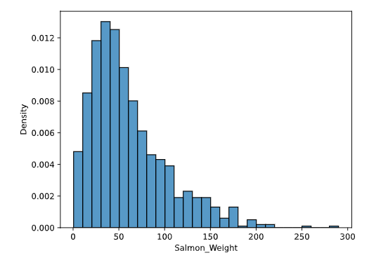
The code below calculates the mean weight for 500 random samples of 50 salmon each, and the plot shows the distribution of those sample means. Notice that the distribution is centered near 60 pounds, which means that sample means close to 60 are the most common. At the same time, the sample means are not all identical. Some are lower, and some are higher, simply because of random sampling variation. This is exactly why a single sample result is not enough on its own. Before we treat a sample result as meaningful, we need to decide whether it is truly unusual or just part of the variation we expect from random samples.

Code
import numpy as np
import pandas as pd
import matplotlib.pyplot as plt
import seaborn as sns
population = pd.read_csv("salmon.csv", delimiter = "\t")
salmon_population = population['Salmon_Weight']

sample_size = 50
sample_means = []

# loop 500 times to get 500 random sample means
for i in range(500):
# take a sample from the data:
samp = np.random.choice(salmon_population, sample_size, replace = False)
# calculate the mean of this sample:
this_sample_mean = np.mean(samp)
# append this sample mean to a list of sample means
sample_means.append(this_sample_mean)

# plot all the sample means to show the sampling distribution
sns.histplot(sample_means, stat='density')
plt.title("Sampling Distribution of the Mean")
plt.show()

Output
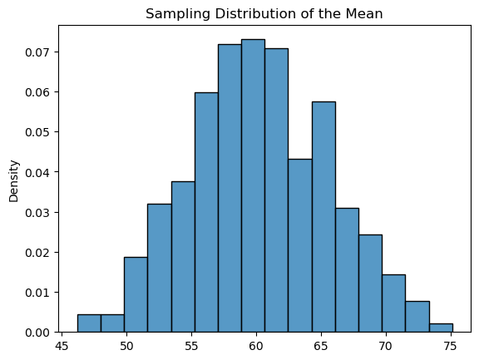

For example, based on the distribution above, a sample of 50 salmon with an average weight of 58, doesn’t appear to be unusual.

Skill 33.1 Exercise 1

Skill 33.2: Define a null and alternative hypothesis

Skill 33.2 Concepts
The histogram above shows that sample means close to 60 pounds are common, even though they are not all exactly 60. Because of this, a sample mean that is a little above or below 60 is not automatically surprising. What matters is whether the sample result is unusual compared to the kind of variation we expect from random samples.
Now suppose a fisherman catches 50 salmon at a secret location and the sample has an average weight of 65 pounds. Since 65 is higher than 60, it might seem like the salmon at the secret location are larger. However, one sample alone is not enough to prove that claim. A sample mean of 65 pounds could still be the result of random chance.
To investigate the idea statistically, we need to turn the claim into a testable question. Asking “Are the salmon from the secret location bigger?” is too vague. A better question is: Is the mean weight of salmon from the secret location greater than 60 pounds?
To investigate this claim, we write two competing hypotheses. The null hypothesis is the starting assumption. It says that the salmon at the secret location are not actually larger on average, and that their mean weight is still 60 pounds. The alternative hypothesis is the claim we are testing. It says that the salmon at the secret location do have a larger mean weight than the general population. We write these as, where μ is pronounced mu.

H₀: μ = 60
The population mean weight of salmon at the secret location is 60 pounds.
Hₐ: μ > 60
The population mean weight of salmon at the secret location is greater than 60 pounds.

If the null hypothesis is true, then a sample mean of 65 pounds must be explained as a result of normal sampling variation. If that result seems too unusual under the null hypothesis, then we gain evidence in favor of the alternative hypothesis.

Skill 33.2 Exercise 1

Skill 33.3: Identify the null distribution

Skill 33.3 Concepts

Now that we have our null hypothesis, we can generate a null distribution: the distribution of the statistic we are interested in across many repeated samples, assuming the null hypothesis is true. In the salmon example, this is the distribution of mean salmon weights for many random samples of size 50, assuming the true population mean is 60 pounds.

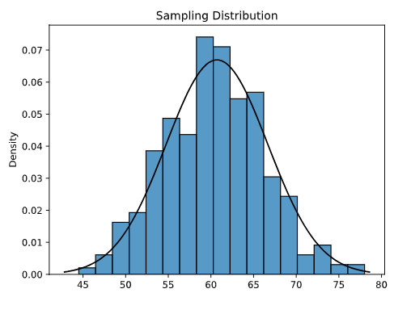
If the null hypothesis is true, then the sample mean of 65 pounds from the secret location is simply one possible value from this null distribution. The graph below shows that 65 pounds falls to the right of the population mean of 60 pounds. Although it is still within the range of the null distribution, it is in a region with less density, meaning that sample means this large occur less often by chance.


Population mean
Sample mean from secret location
Skill 33.3 Exercise 1

Skill 33.4: Determine whether the alternative hypothesis is left-tailed, right-tailed, or two-tailed

Skill 33.4 Concepts
The tail of a hypothesis test is determined by the alternative hypothesis.
- If the alternative hypothesis claims that the population mean is greater than the null value, the test is right-tailed.
- If the alternative hypothesis claims that the population mean is less than the null value, the test is left-tailed.
- If the alternative hypothesis claims that the population mean is different from the null value, the test is two-tailed.
In our salmon example, the null hypothesis is that the mean weight of salmon at the secret location is 60 pounds, the same as the general population:
H₀: μ = 60

Right-Tailed Test
Suppose we want to investigate whether the salmon at the secret location are larger on average. That gives us the alternative hypothesis:
Hₐ: μ > 60
Because the alternative hypothesis uses a greater than sign, this is a right-tailed test. This means we are looking for evidence in the right tail of the null distribution, where sample means are larger than expected under the null hypothesis. Since the observed sample mean was 65 pounds, we want to know how unusual it would be to get a sample mean of 65 or greater if the true population mean were really 60 pounds. In the graph below, the red region shows the part of the null distribution at or above the observed sample mean. This shaded right tail represents the outcomes that would count as evidence against the null hypothesis.
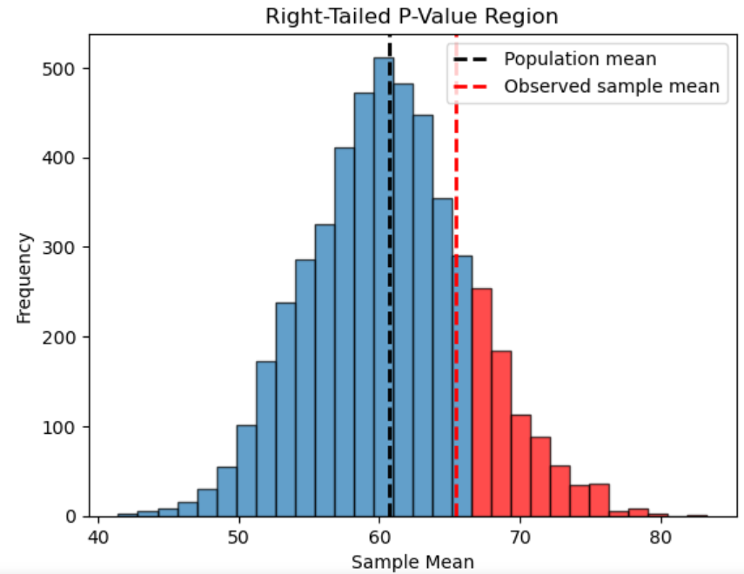
Two-Tailed Test
Additionally, we can investigate whether the mean weight of salmon at the secret location is different from 60 pounds. In that case, the alternative hypothesis is
H_{a}: μ ≠ 60
We observed a sample mean of 65 pounds for the salmon caught at the secret location, which is 5 pounds higher than the population mean of 60 pounds under the null hypothesis. In the first version of the hypothesis test, we focused on the probability of observing a sample mean that is at least 5 pounds greater than the population mean. For the alternative hypothesis described here, we are interested in the probability of observing a sample mean that is at least 5 pounds different from the population mean in either direction. That means we include sample means that are 65 or greater and sample means that are 55 or less.
Visually, this is the part of the null distribution that is at least 5 pounds away from the population mean, shown in red below. Because the alternative hypothesis includes values in both tails of the distribution, this is called a two-tailed test.
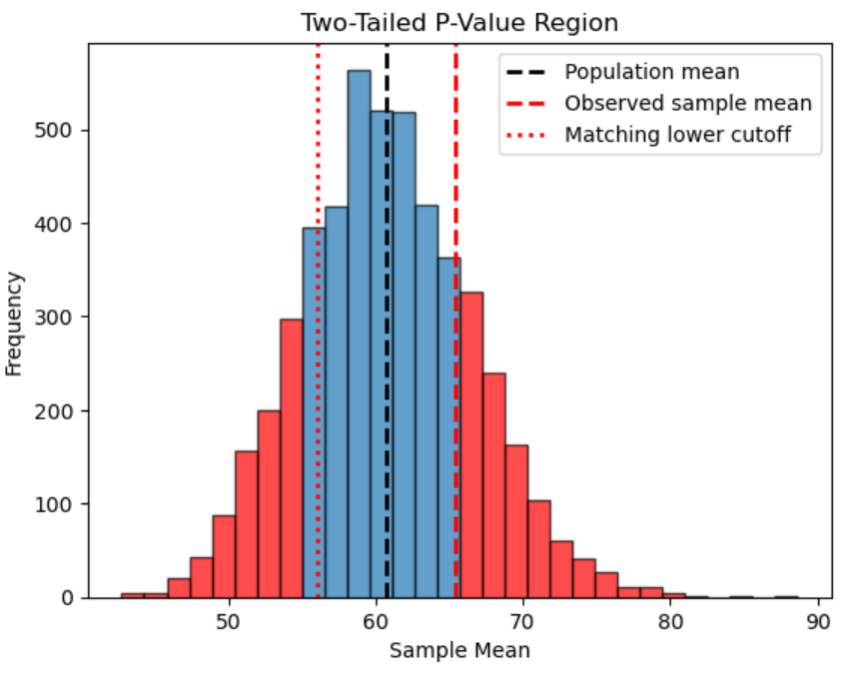
Left-Tailed Test

Finally, we could investigate whether the salmon at the secret location are smaller on average. Suppose that instead of observing a sample mean of 65 pounds, we had taken a sample of 50 salmon from the secret location and found an average weight of 55 pounds. In that case, the alternative hypothesis would be:

Hₐ: μ < 60

Because the alternative hypothesis uses a less than sign, this is a left-tailed test. This means we are looking for evidence in the left tail of the null distribution, where sample means are smaller than expected under the null hypothesis. Since the observed sample mean is 55 pounds, we want to know how unusual it would be to get a sample mean of 55 or less if the true population mean were really 60 pounds. This is shown visually below,

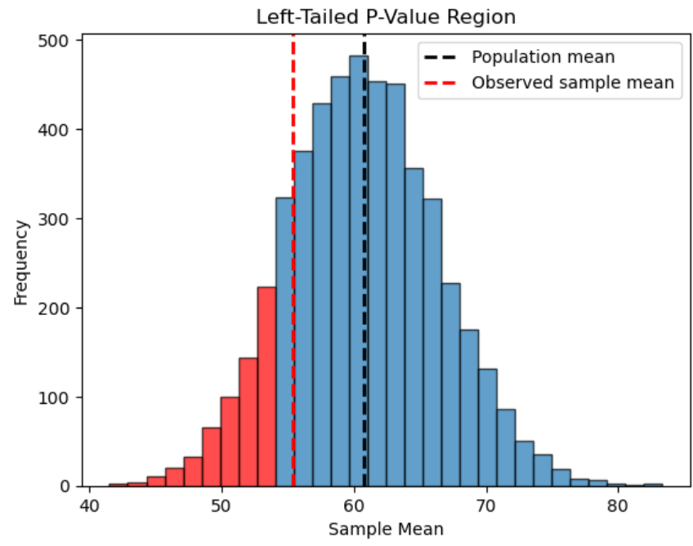
Skill 33.4 Exercise 1

Skill 33.5: Calculate and interpret the p-value

Skill 33.5 Concepts

Once we have written the null and alternative hypotheses and identified the correct tail for the test, the next step is to calculate the p-value. The p-value measures how likely it would be to observe a sample result at least as extreme as the one we got, if the null hypothesis were true.

In our salmon example, the null hypothesis is that the mean weight of salmon at the secret location is the same as the mean weight of the general salmon population. We will use Python’s ttest_1samp() function to compare the observed sample of 50 salmon from the secret location to the population mean
H₀: μ = population mean
Right-Tailed Test
Suppose we want to investigate whether the salmon at the secret location are heavier on average than the general population. In that case, the hypothesis is,
Hₐ: μ > population mean

In the example below, the sample of 50 salmon from the secret location is stored in secret_location_sample. We can calculate the p-value for this right-tailed test by setting the alternative attribute to greater.

Code
import pandas as pd
from scipy.stats import ttest_1samp

salmon = pd.read_csv("salmon.csv", delimiter="\t")
salmon_weight = salmon.Salmon_Weight
pop_mean = salmon_weight.mean()

secret_location_sample = [64, 66, 63, 67, 65, 68, 62, 64, 66, 65,
67, 63, 64, 66, 68, 65, 64, 67, 66, 65,
63, 64, 66, 67, 65, 68, 64, 63, 66, 67,
65, 64, 66, 68, 67, 65, 64, 66, 67, 63,
65, 66, 64, 67, 68, 65, 64, 66, 67, 65]

result = ttest_1samp(secret_location_sample, pop_mean, alternative="greater")
print(result.pvalue)

Output
1.7908697375689077e-26

In this case, the p-value is extremely small, about 1.8 × 10⁻²⁶. This means that if the true mean weight of salmon at the secret location were really the same as the mean weight of the general population, then observing a sample mean this high would be extremely unlikely just by chance.

Because the p-value is so small, we reject the null hypothesis. This gives strong evidence that the mean weight of salmon at the secret location is greater than the mean weight of the general salmon population.
Two-Tailed Test
Now suppose we want to investigate whether the salmon at the secret location are simply different in average weight from the general population. In that case, the hypothesis is,

Hₐ: μ ≠ population mean

In the example below, we use the same sample to calculate the p-value, but set the alternative attribute to two-sided.

Code
import pandas as pd
from scipy.stats import ttest_1samp

salmon = pd.read_csv("salmon.csv", delimiter="\t")
salmon_weight = salmon.Salmon_Weight
pop_mean = salmon_weight.mean()

secret_location_sample = [64, 66, 63, 67, 65, 68, 62, 64, 66, 65,
67, 63, 64, 66, 68, 65, 64, 67, 66, 65,
63, 64, 66, 67, 65, 68, 64, 63, 66, 67,
65, 64, 66, 68, 67, 65, 64, 66, 67, 63,
65, 66, 64, 67, 68, 65, 64, 66, 67, 65]

result = ttest_1samp(secret_location_sample, pop_mean, alternative="two-sided")
print(result.pvalue)

Output
3.5817394751378154e-26
Again, the p-value is extremely small. This means that if the true mean weight at the secret location were really the same as the general population mean, then getting a sample mean this far from the population mean in either direction would be very unlikely just by chance.
Because the p-value is so small, we reject the null hypothesis. This gives strong evidence that the mean weight of salmon at the secret location is different from the mean weight of the general salmon population.
Left-Tailed Test
Now suppose we want to investigate whether the weight of the salmon at the secret location is less on average than the general population. In that case, the hypothesis is:
Hₐ: μ < population mean
To model this situation, we use a different secret_location_sample data set where each value is 10 less than the original. This gives us a sample with a much lower mean, which lets us examine a left-tailed test. The alternative attribute is set to less to indicate a left-tailed p-value.
Code
import pandas as pd
from scipy.stats import ttest_1samp

salmon = pd.read_csv("salmon.csv", delimiter="\t")
salmon_weight = salmon.Salmon_Weight
pop_mean = salmon_weight.mean()

secret_location_sample2 = [54, 56, 53, 57, 55, 58, 52, 54, 56, 55,
57, 53, 54, 56, 58, 55, 54, 57, 56, 55,
53, 54, 56, 57, 55, 58, 54, 53, 56, 57,
55, 54, 56, 58, 57, 55, 54, 56, 57, 53,
55, 56, 54, 57, 58, 55, 54, 56, 57, 55]

result = ttest_1samp(secret_location_sample2, pop_mean, alternative="less")
print(result.pvalue)

Output
7.165872758612355e-29
The p-value for this test is extremely small. It tells us that if the true mean weight at the secret location were really the same as the general salmon population mean, then getting a sample mean this low would be very unlikely just by chance.
Because the p-value is so small, we reject the null hypothesis. This gives strong evidence that the mean weight of salmon at the secret location is less than the mean weight of the general salmon population.
Skill 33.5 Exercise 1

Skill 33.6: Compare the p-value to a significance threshold

Skill 33.6 Concepts

While it is perfectly reasonable to report the exact p-value, many data scientists also compare the p-value to a predetermined threshold to decide whether a result is statistically significant. This threshold is called the significance level, or alpha (α). A common choice is 0.05, although this value is somewhat arbitrary. If the p-value is less than the chosen threshold, the result is considered statistically significant, and we reject the null hypothesis in favor of the alternative hypothesis. If the p-value is greater than or equal to the threshold, we fail to reject the null hypothesis.

Using a smaller threshold makes it harder to declare a result statistically significant. This reduces the chance of mistakenly rejecting the null hypothesis when it is actually true, but it also makes it less likely that we will detect a real effect.

The p-values associated with our salmon samples are both below the 0.05 threshold:

Right-tailed test
Hₐ: μ > population mean
p = 1.7908697375689077e-26

Two-tailed test
Hₐ: μ ≠ population mean
p = 3.5817394751378154e-26

Because both p-values are far below 0.05, we reject the null hypothesis in both cases.

In the right-tailed test, this gives strong evidence that the mean weight of salmon at the secret location is greater than the population mean.

In the two-tailed test, this gives strong evidence that the mean weight of salmon at the secret location is different from the population mean.

Skill 33.6 Exercise 1

