Set 37: Median Hypothesis Testing

Skill 37.1: Explain when the median is a more appropriate measure of center than the mean
Skill 37.2: Define null and alternative hypotheses for a population median
Skill 37.3: Recognize that sample medians vary from sample to sample
Skill 37.4: Interpret the purpose of and structure of a bootstrap median function
Skill 37.5: Use a simulated distribution of medians to calculate and interpret a p-value

Skill 37.1: Explain when the median is a more appropriate measure of center than the mean

Skill 37.1 Concepts

In previous lessons, we used the mean to describe the center of a quantitative distribution and to test claims about a population mean. The mean is a useful measure of center when a distribution is fairly symmetric and does not contain extreme outliers. However, if the mean is sensitive to unusually large or unusually small values, a few extreme observations can pull the mean away from where most of the data are located.

The median is another measure of center for quantitative data. It is the middle value when the data are arranged in order. Unlike the mean, the median is much less affected by extreme values. Because of this, the median is often a better measure of center when a distribution is skewed or contains outliers.

For example, personal income data are often skewed right. Most people earn incomes in a lower or middle range, while a smaller number of people earn very large incomes. Those very large incomes can pull the mean upward, making it less representative of a typical person. In a distribution like this, the median often gives a better sense of a typical value because it is resistant to the influence of those extreme incomes. This skewed relationship is illustrated in the box plot below.

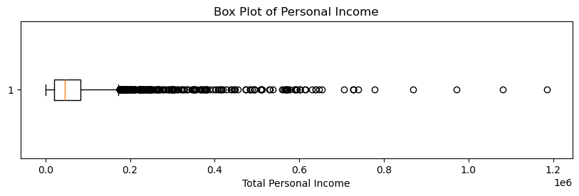

The long right tail and large number of high-income outliers show that a small number of unusually large incomes pull the mean upward. Because of this, the median is a more appropriate measure of center for this distribution.

Skill 37.1 Exercise 1

Skill 37.2: Define null and alternative hypotheses for a population median

Skill 37.2 Concepts

In the previous skill, we saw that the median is often a more appropriate measure of center than the mean when a quantitative distribution is skewed or contains extreme outliers. If we want to investigate a claim about the center of a skewed population, we may want to test a claim about the population median rather than the population mean.

A hypothesis test begins with two competing statements about the population. The null hypothesis is the starting assumption. It states that the population median is equal to some claimed value. The alternative hypothesis is the claim we are investigating. It states that the population median is greater than, less than, or different from that null value.

For example, suppose we want to investigate whether the median yearly income of adults in a city is greater than $45,000. We could write the hypotheses as,

H₀: the population median income is $45,000
Hₐ: the population median income is greater than $45,000

If the null hypothesis is true, then a sample median that is a little above or below $45,000 could still happen just because of random sampling variation. To decide whether an observed sample median provides strong evidence against the null hypothesis, we need to compare it to what we would expect from repeated samples under the null assumption.
As with mean and binomial hypothesis tests, the form of the alternative hypothesis determines the direction of the test:
- If the alternative says the population median is greater than the null value, the test is right-tailed
- If the alternative says the population median is less than the null value, the test is left-tailed
- If the alternative says the population median is different from the null value, the test is two-tailed
Skill 37.2 Exercise 1

Skill 37.3: Recognize that sample medians vary from sample to sample

Skill 37.3 Concepts

We’ve previously learned that sample means and sample proportions naturally vary from one sample to another. The same idea is true for sample medians. Even when the population itself has not changed, different random samples from that population will usually produce slightly different median values. This happens because each sample contains different observations.

Suppose we are interested in the median yearly income of adults in a city. If we take one random sample of adults and calculate the sample median income, then take another random sample of the same size, the two sample medians will probably not be exactly the same. One sample might happen to include more higher-income adults, while another might include more lower-income adults. Because of this, sample medians naturally vary from sample to sample.
The histograms below show the medians from repeated random samples of adult incomes from the same population. Notice that the sample medians are not all identical. Some are lower and some are higher, simply because different random samples contain different people. As the number of repeated samples increases, the overall pattern becomes easier to see.
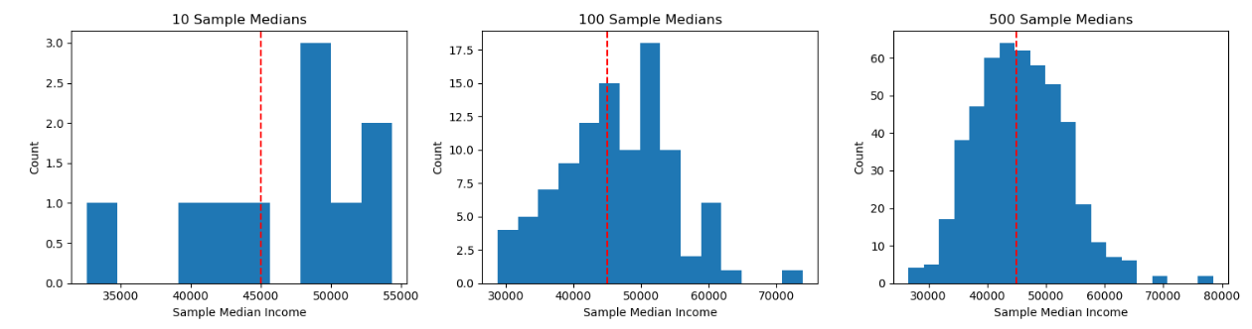
Suppose the null hypothesis states that the population median income in a city is $45,000. We can see from the histogram with 10 samples that several sample medians are much higher than this. However, these results alone are not enough to conclude that the population median is greater than $45,000. A sample median slightly above or below the null value could easily happen by chance. To decide whether an observed sample median provides strong evidence against the null hypothesis, we need to take many samples so we can better understand how sample medians vary.
The distribution of 500 sample medians helps us see more clearly which values are common and which values are unusual. If an observed sample median falls in a part of the distribution that happens only rarely, then it may provide evidence against the null hypothesis.
Skill 37.3 Exercise 1

Skill 37.4: Interpret the purpose of and structure of a bootstrap median function

Skill 37.4 Concepts
In the previous skill, we saw that sample medians vary from sample to sample. To better understand that variation, we can use simulation. One way to do this is with a bootstrap median function, which repeatedly resamples the observed data and calculates the median for each resample.
Let’s return to our income data, which came from the Integrated Public Use Microdata Series (IPUMS) and is based on a sample from the 2024 American Community Survey (ACS). This dataset does not represent the full population of all adults in the United States. Instead, it is a sample from the 2024 ACS that we filtered to include adults age 25 and older with positive income. When we use bootstrapping, we repeatedly resample from this observed sample to study how the sample median income might vary from sample to sample.
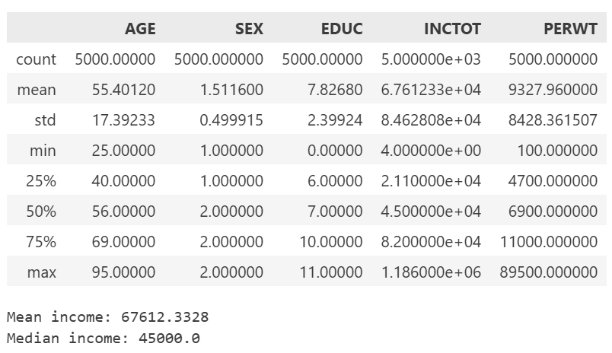
Code
import pandas as pd
import numpy as np

income_data = pd.read_csv("income.csv")

def bootstrap_median(original_sample, label, replications):
just_one_column = original_sample[label]
medians = []

for i in range(replications):
bootstrap_sample = np.random.choice(just_one_column,
size=len(just_one_column),
replace=True)
resampled_median = np.median(bootstrap_sample)
medians.append(resampled_median)

return medians

The most important line in the function is,

bootstrap_sample = np.random.choice(just_one_column,
size=len(just_one_column),
replace=True)

This line builds one bootstrap sample. It randomly selects values from the original sample until the new sample is the same size as the original one. Because replace=True, each value is put back after it is chosen, so it can appear again in the resample. This means a bootstrap sample may contain repeated values and may leave out others. Sampling with replacement is essential because it creates new resamples that are similar to the original sample, but not identical to it. That is what allows the median to vary across bootstrap samples.

A bootstrap median function is useful because it organizes this whole process into a single reusable tool. Instead of writing the same simulation steps again and again, we can call the function with a sample, a variable name, and a number of replications, and the function will return the simulated medians for us.

Once we generate many bootstrapped sample medians, we can graph them to see their distribution, measure how much they vary, and use that distribution to support inference about the population median.

Code
import matplotlib.pyplot as plt

boot_medians = bootstrap_median(income_data, "INCTOT", 500)
original_sample_median = np.median(income_data["INCTOT"])

plt.figure(figsize=(10, 5))
plt.hist(boot_medians, bins=30)
plt.axvline(original_sample_median, linestyle="--", label=f"Original Sample Median = {original_sample_median:,.0f}")
plt.xlabel("Bootstrapped Sample Median Income")
plt.ylabel("Count")
plt.title("Distribution of 500 Bootstrapped Sample Medians")
plt.legend()
plt.show()

Output
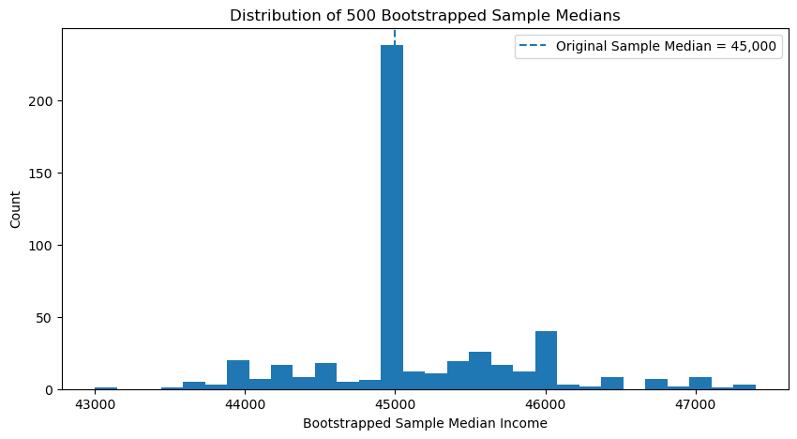

Skill 37.4 Exercise 1

Skill 37.5: Use a simulated distribution of medians to calculate and interpret a p-value

Skill 37.5 Concepts

In the previous skill, we used a bootstrap median function to generate many sample medians from the same dataset. Those simulated medians form a distribution that helps us understand how much the sample median can vary from sample to sample.

We can now use that distribution to ask an inferential question. Suppose the null hypothesis states that the population median income in a city is $45,000. We then take a sample and calculate its median income. Imagine that the observed sample median is $47,500.
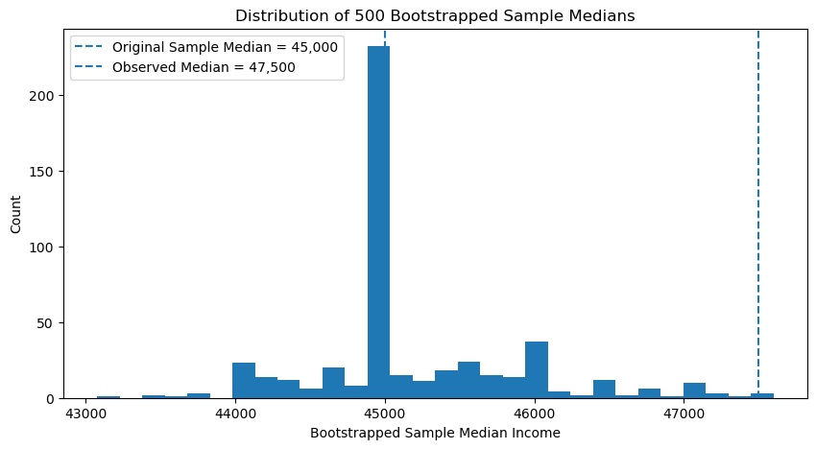

In the histogram above, most of the bootstrapped sample medians are clustered near the original sample median, while $47,500 falls far to the right of the main distribution. This suggests that a sample median of $47,500 may be unusual. However, the graph alone does not tell us exactly how unusual it is. To confirm this more precisely, we can calculate a p-value, which measures the proportion of simulated medians that are at least as large as $47,500. If that proportion is very small, then $47,500 would be considered unusual under the null hypothesis and would provide evidence against it.

To estimate the p-value, we count the proportion of simulated medians that are in the appropriate tail of the distribution.

For a right-tailed test:
- count the simulated medians that are greater than or equal to the observed sample median

For a left-tailed test:
- count the simulated medians that are less than or equal to the observed sample median

For a two-tailed test:
- count the simulated medians that are at least as far from the null value as the observed sample median, in either direction

A small p-value means the observed sample median would happen only rarely if the null hypothesis were true. This provides evidence against the null hypothesis. A large p-value means the observed sample median is fairly believable under the null hypothesis, so the data do not provide strong evidence against the null.

Code
boot_medians = bootstrap_median(income_data, "INCTOT", 500)
observed_median = 47500
count = sum(1 for median in boot_medians if median >= observed_median)
p_value = count / len(boot_medians)
print(p_value)
Output
0.008

The p-value of 0.008 means that only 0.8% of the simulated sample medians were at least as large as $47,500. Since this is a very small proportion, the observed sample median appears unusual under the null hypothesis. This provides evidence that the population median income is greater than $45,000.

Skill 37.5 Exercise 1

