Set 38: Linear Regression

Skill 38.1: Identify the best analysis for a two-variable question
Skill 38.2: Interpret a linear regression line
Skill 38.3: Fit a linear regression model in python
Skill 38.4: Apply a regression model to make predictions
Skill 38.5: Interpret a regression model
Skill 38.6: Identify the main assumptions of simple linear regression
Skill 38.7: Interpret the slope and intercept of a linear regression model with a categorical predictor

Skill 38.1: Identify the best analysis for a two-variable question

Skill 38.1 Concepts
Linear regression is a powerful statistical tool used to study the relationship between a quantitative response variable and one or more explanatory variables. Often, the goal is to understand how changes in one variable are associated with changes in another, and sometimes to use that relationship to make predictions.
- For example, linear regression can help us answer questions like:
- What is the relationship between apartment size and rental price for apartments in New York City?
- Is a mother’s height a good predictor of her child’s adult height?
Before fitting a linear regression model, we should always begin with exploratory data analysis and data visualization. We want to see whether a relationship appears to exist and whether a line might be a reasonable model. A scatterplot is especially useful for this because it allows us to examine the pattern between two quantitative variables.
In an introductory linear regression setting, the data we analyze are usually quantitative vs. quantitative. That means both variables are numerical, such as height and weight, study time and test score, or temperature and electricity use. Linear regression is not designed for situations where the response variable is categorical, such as yes/no or pass/fail. It is also not the best first tool for comparing a quantitative variable across categories, such as average test score by class period or plant growth by fertilizer type. In those cases, other methods are usually more appropriate. For now, we will focus on relationships between two numerical variables.
For example, suppose we collect heights (in cm) and weights (in kg) for 9 adults and inspect a scatterplot of height versus weight.
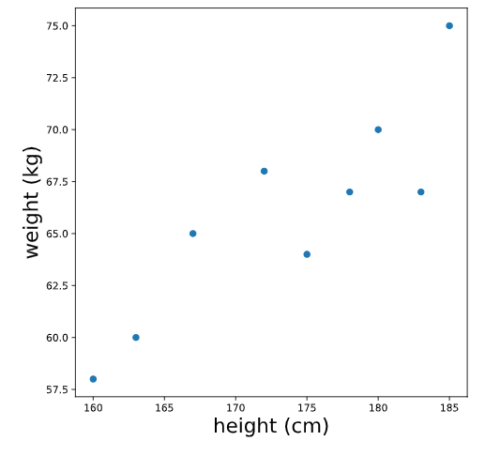
When we look at this plot, we see evidence of a relationship between height and weight: in general, taller people tend to weigh more. In the following exercises, we will learn how to model this relationship using a line.
Skill 38.1 Exercise 1

Skill 38.2: Interpret a linear regression line

Skill 38.2 Concepts

As the name suggests, linear regression involves fitting a line to a set of data points. Before we can understand how a best-fit line is chosen, it helps to review the equation of a line, which is often written

y = mx + b

In this equation:
- x and y represent variables, such as height and weight or hours studied and quiz score.
- b represents the y-intercept, which is the point where the line crosses the y-axis. This happens when x=0.
- m represents the slope, which tells us how steep the line is.
If we choose any two points on a line, the slope is the ratio of the vertical change to the horizontal change between those points. This is often written as,

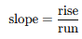

For example, the following graph shows the line,

y = 2x + 12

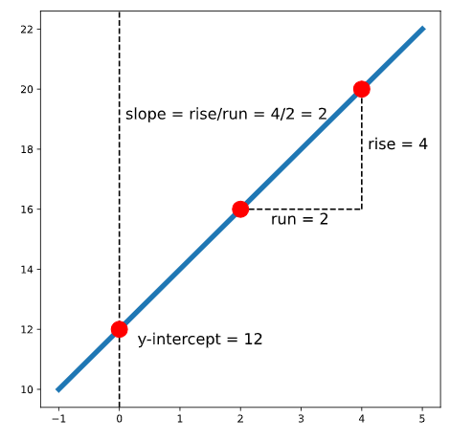

In this line, the slope is 2, which means that for every increase of 1 unit in x, the value of y increases by 2 units. The y-intercept is 12, so the line crosses the y-axis at (0,12).
A line can also have a negative slope. For example, the line
y = −2x + 8y

has a slope of -2, which means that as x increases, y decreases. Its y-intercept is 8, so the line crosses the y-axis at (0,8).

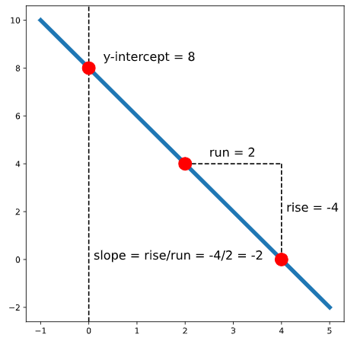

When working with real data, though, the points usually do not fall perfectly on a line. That means we need a way to decide which line is the best fit for the data.

One common method is called ordinary least squares (OLS). In simple linear regression, we model the relationship between two variables with the equation

y = mx + b + error

The error is the vertical distance between an actual data point and the line. Some points fall above the line, and some fall below it. To choose the best-fit line, we define “best” to mean the line that makes the total squared error as small as possible. This total squared error is often called the loss.

For example, in the graph below, one point is 1 unit below the line, and another point is 3 units above the line. The total squared error is,

Loss = (−1)² + (3)² = 1 + 9 = 10

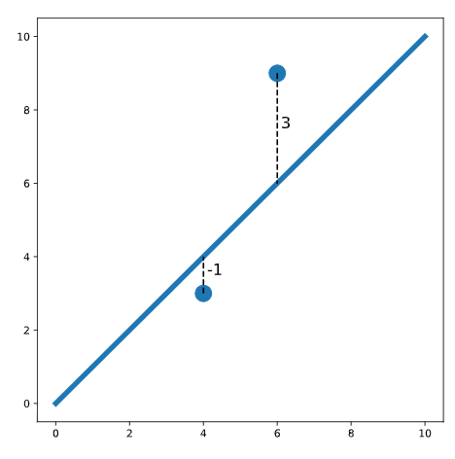
We square the errors so that points above and below the line do not cancel each other out. Squaring also makes larger mistakes count more heavily than smaller ones.
So, in linear regression, our goal is to find the values of m and b for the line that minimizes this total squared error.
Skill 38.2 Exercise 1

Skill 38.3: Fit a linear regression model in Python

Skill 38.3 Concepts

There are several Python libraries that can be used to fit a linear regression model. In this course, we will use sm.OLS.from_formula() from the statsmodels library because it uses simple syntax and provides a detailed summary of the model results.

Suppose we have a dataset named body_measurements with columns height and weight. If we want to fit a model that can predict weight based on height, we can create the model as follows,

model = sm.OLS.from_formula('weight ~ height', data = body_measurements)

We used the formula 'weight ~ height' because we want to predict weight (it is the outcome variable) using height as a predictor. Then, we can fit the model using .fit():

results = model.fit()

Finally, we can inspect a summary of the results using print(results.summary()). For now, we’ll only look at the coefficients using results.params, but the full summary table is useful because it contains other important diagnostic information.

Code
import pandas as pd
import pandas as pd
import numpy as np
import matplotlib.pyplot as plt
import statsmodels.api as sm

model = sm.OLS.from_formula('weight ~ height', data = body_measurements)
results = model.fit()
print(results.params)
Output
Intercept -21.67
height 0.50
dtype: float64

The result above tells us that the best-fit intercept is -21.67, and the best-fit slope is 0.50. So the equation of the regression line is,

weight = 0.50(height) − 21.67

Skill 38.3 Exercise 1

Skill 38.4: Apply regression model to make predictions

Skill 38.4 Concepts

Suppose that we have a dataset of heights and weights for 100 adults. We fit a linear regression and print the coefficients:

Code
import pandas as pd
import numpy as np
import matplotlib.pyplot as plt
import statsmodels.api as sm

model = sm.OLS.from_formula('weight ~ height', data = body_measurements)
results = model.fit()
print(results.params)
Output
Intercept -21.67
height 0.50
dtype: float64

This regression model allows us to predict the weight of an adult if we know their height. To make a prediction, we substitute the intercept and slope into the equation of a line.

weight = 0.50 ∗ height − 21.67

For example, to predict the weight of a person who is 160 cm tall, we substitute 160 for height:

Weight = 0.50 ∗ 160 − 21.67 = 58.33
So, the model predicts that a person who is 160 cm tall will weigh about 58.33 kg.

In Python, we can calculate this directly by plugging the value into the equation, or by using the coefficients stored in results.params,

Code
print(0.50 * 160 - 21.67)
# OR:
print(results.params[1]*160 + results.params[0])
Output
58.33

We can also make predictions using the .predict() method on the fitted model. To predict the weight of a person with height 160 cm, we first create a new dataset with height = 160:

Code
newdata = {"height":[160]}
print(results.predict(newdata))

Output
0 58.33
dtype: float64

Notice that we get the same prediction, 58.33, as before. This time, the result is returned as a pandas Series.

Skill 38.4 Exercise 1

Skill 38.5: Interpret a regression model

Skill 38.5 Concepts

Let’s again inspect the output for a regression that predicts weight based on height. The regression line looks something like this,

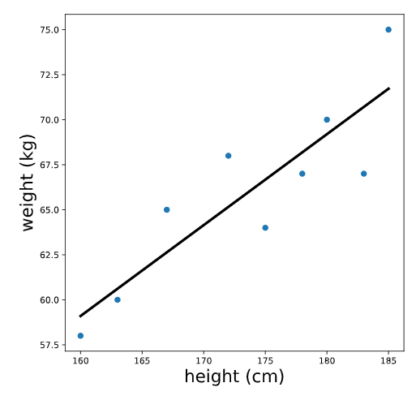
Note that the units of the intercept and slope of a regression line match the units of the original variables; the intercept of this line is measured in kg, and the slope is measured in kg/cm. To make sense of the intercept (which we calculated previously as -21.67 kg), let’s zoom out on this plot,

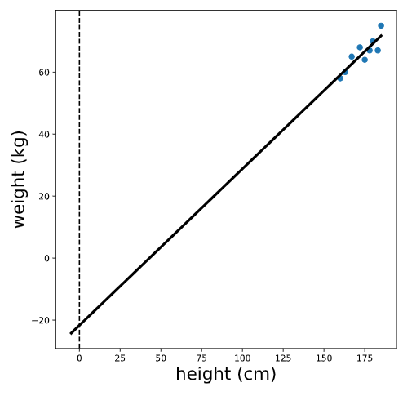

We see that the intercept is the predicted value of the outcome variable (weight) when the predictor variable (height) is equal to zero. In this case, the interpretation of the intercept is that a person who is 0 cm tall is expected to weigh -21 kg. This is pretty non-sensical because it’s impossible for someone to be 0 cm tall!

However, in other cases, this value does make sense and is useful to interpret. For example, if we were predicting ice cream sales based on temperature, the intercept would be the expected sales when the temperature is 0 degrees.

To visualize the slope, let’s zoom in on our plot,

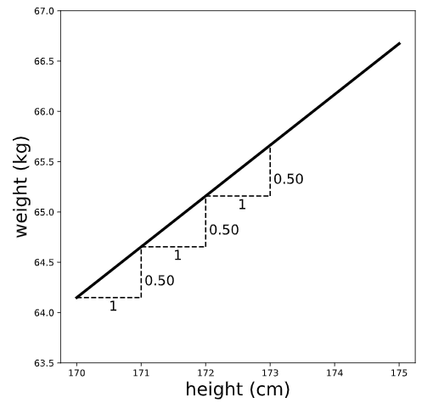

Remember that slope can be thought of as rise/run — the ratio between the vertical and horizontal distances between any two points on the line. Therefore, the slope (which we previously calculated to be 0.50 kg/cm) is the expected difference in the outcome variable (weight) for a one unit difference in the predictor variable (height). In other words, we expect that a one centimeter difference in height is associated with .5 additional kilograms of weight.

Note that the slope gives us two pieces of information: the magnitude AND the direction of the relationship between the x and y variables. For example, suppose we had instead fit a regression of weight with minutes of exercise per day as a predictor — and calculated a slope of -.1. We would interpret this to mean that people who exercise for one additional minute per day are expected to weigh 0.1 kg LESS.

Skill 38.5 Exercise 1
Skill 38.6: Identify the main assumptions of simple linear regression

Skill 38.6 Concepts

There are several assumptions of simple linear regression that are important to check when fitting a linear model.

Assumption 1: The relationship is linear

The first assumption is that the relationship between the predictor variable and the outcome variable is approximately linear, meaning it can be reasonably modeled with a line. We can check this before fitting the regression by looking at a scatterplot of the two variables.

The next two assumptions — normality and homoscedasticity — are easier to examine after fitting the model. Before we can check those assumptions, we need to calculate two quantities: fitted values and residuals.

Again, consider our regression model predicting weight from height using the formula 'weight ~ height'. The fitted values are the predicted weights for each person in the dataset used to fit the model. The residuals are the differences between the actual weights and the predicted weights.

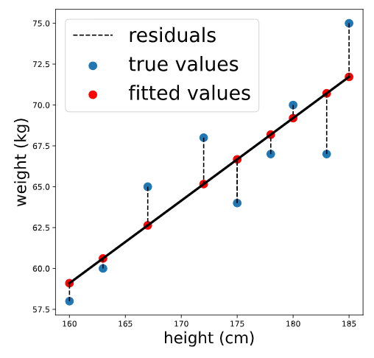

We can calculate the fitted values using .predict() by passing in the original data. The result is a Pandas Series containing predicted values for each person in the original dataset,

Code
fitted_values = results.predict(body_measurements)
print(fitted_values.head())

Output
0 66.673077
1 59.100962
2 71.721154
3 70.711538
4 65.158654
dtype: float64

The residuals are the differences between the actual values of the outcome variable and these fitted values. We can calculate them by subtracting the fitted values from the actual values. In Python, this works element by element when we subtract one pandas Series from another.

Code
residuals = body_measurements.weight - fitted_values
print(residuals.head())

Output
0 -2.673077
1 -1.100962
2 3.278846
3 -3.711538
4 2.841346
dtype: float64

Assumption 2: The residuals are approximately distributed

Once we have calculated the fitted values and residuals, we can begin checking the normality assumption.

This assumption says that the residuals should be approximately normally distributed around 0. In practice, we often check this by looking at a histogram of the residuals and seeing whether it looks roughly bell-shaped, without strong skew or multiple peaks.
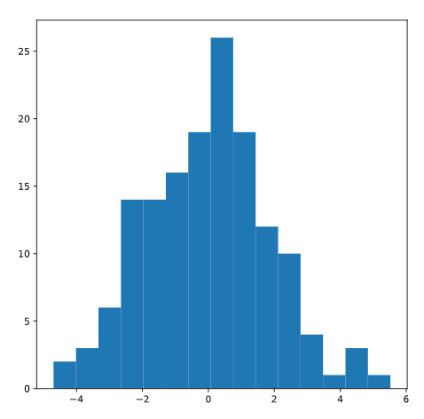

These residuals appear approximately normal, so the normality assumption seems reasonable.

If the histogram instead looked more like the distribution below, which is strongly skewed to the right, we would be concerned that the normality assumption may not be met.
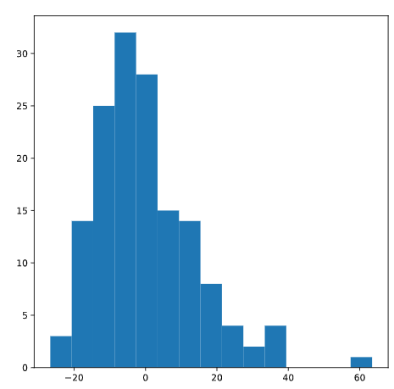

Assumption 3: The residuals are homoscedastic

Homoscedasticity means that the residuals have roughly equal variation across the range of predicted values or across the range of the predictor variable. In simpler terms, the spread of the errors should stay fairly consistent.

When this assumption is not met, it is called heteroscedasticity, which means that the size of the errors changes across the data. For example, the residuals might be tightly clustered for small fitted values but much more spread out for large fitted values.

A common way to check this assumption is to make a residual plot, where we plot the residuals against the fitted values.
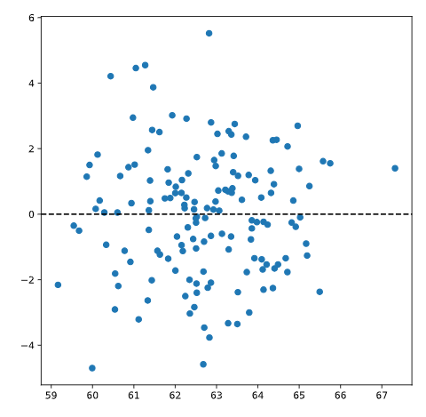
If the residual plot shows a fairly even vertical spread with no obvious pattern, then the homoscedasticity assumption appears reasonable.

However, if the plot shows a clear pattern, asymmetry, or a widening or narrowing spread, that suggests heteroscedasticity and may indicate that a linear model is not appropriate.
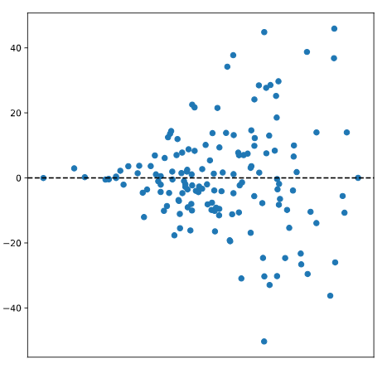

Skill 38.6 Exercise 1

Skill 38.7: Interpret the slope and intercept of a linear regression model with a categorical predictor

Skill 38.7 Concepts

In the previous exercises, we used a quantitative predictor in our linear regression models. However, linear regression can also be used with a categorical predictor. The simplest case is a binary predictor, which has only two categories.

For example, suppose we survey 100 adults and record their height in centimeters and whether they play basketball. We code the variable bball_player so that,

- 0 means the person does not play basketball
- 1 means the person does play basketball

A plot of height by basketball-player status is shown below:

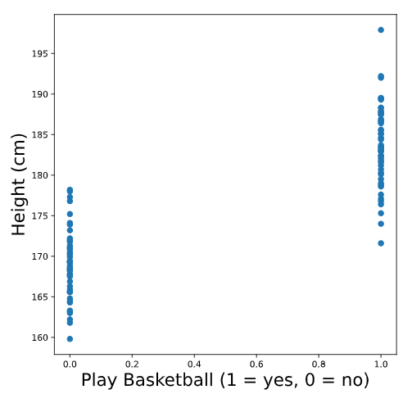
From the plot, we can see that people who play basketball tend to be taller than people who do not.

Because the predictor only takes on two values, 0 and 1, the best-fit line is determined by the predicted value at each of those two x-values. In this case, the regression line passes through the mean height of the non-basketball players and the mean height of the basketball players.

To recreate the scatterplot with the best-fit line, we could use the following code:

Code
# Create scatter plot
plt.scatter(data.play_bball, data.height)

# Add the line using calculated group means
plt.plot([0,1], [169.016, 183.644])

Output
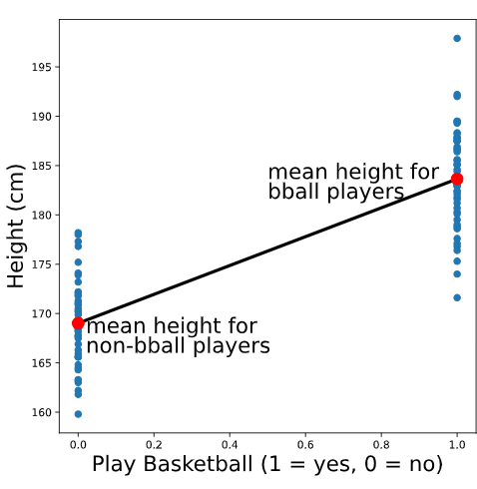

We can also fit this regression model using statsmodels,

Code
import statsmodels.api as sm

model = sm.OLS.from_formula('height ~ play_bball', data)
results = model.fit()
print(results.params)

Output
Intercept 169.016
play_bball 14.628
dtype: float64
To interpret this output, remember,

- The intercept is the predicted value of the outcome when the predictor equals 0.
- The slope is the predicted change in the outcome for a 1-unit increase in the predictor.
In this example:
- The intercept, 169.016, is the predicted height for a person with play_bball = 0, so it represents the mean height of people who do not play basketball.
- The slope, 14.628, is the difference in predicted height between play_bball = 1 and play_bball = 0, so it represents the difference in mean height between basketball players and non-basketball players.
So, the model predicts that basketball players are about 14.628 cm taller, on average, than non-basketball players.
This same approach works whether the binary variable is coded as 0 and 1, True and False, or categories such as "yes" and "no".

Skill 38.7 Exercise 1

