Set 37: Introduction to Machine Learning

Skill 37.1: Define Machine Learning
Skill 37.2: Identify features and labels in a dataset
Skill 37.3: Distinguish labeled data from unlabeled data
Skill 37.4: Distinguish supervised learning from unsupervised learning
Skill 37.5: Distinguish between regression, classification, and clustering
Skill 37.6: Justify the machine learning task for a real-world scenario

Skill 37.1: Define Machine Learning

Skill 37.1 Concepts
So far in this course, most of the programs we have written have followed rules that a human created. For example, suppose we want to write a program that decides whether a student passed a class.
if grade >= 60:
print("Pass")
else:
print("Fail")
In this example, the computer is following a rule that we gave it. The computer did not discover the rule on its own. A human decided that 60 or higher means “Pass,” and then the program followed those instructions.
Machine learning is different.
In machine learning, we give the computer data, and the computer looks for patterns in that data. Then the computer uses those patterns to make predictions, decisions, or groups for new data.
One way to think about this is,
Traditional programming: humans write the rules.
Machine learning: the computer learns patterns from examples
For example, imagine an email app that needs to decide whether a message is spam. It would be very difficult for a human to write every possible spam rule. Some spam emails use certain words. Some contain strange links. Some come from suspicious senders. Some are designed to look normal.
Instead of writing every rule by hand, we can show a machine learning model many emails that have already been marked as spam or not spam. The model can look for patterns in those examples. Later, when a new email arrives, the model can use the patterns it learned to predict whether the new email is spam.
A simple definition is,
Machine learning uses data to learn patterns and make predictions or find groups

Skill 37.1 Exercise 1

Skill 37.2: Identify features and labels in a dataset

Skill 37.2 Concepts

A machine learning model usually learns from a dataset.
- Each row in a dataset is one example or observation.
- Each column gives information about that example.

When we use machine learning to make predictions, we often describe the columns using two important words,

- Features
- Label

Features are the input columns the model uses to make a prediction.
Label is the answer column the model is trying to predict.

For example, suppose we have data about houses.

square_feet | bedrooms | age_of_home | price
1400 | 3 | 20 | 310000
2100 | 4 | 12 | 450000
900 | 2 | 40 | 220000

If our goal is to predict price, then:

- square_feet, bedrooms, and age_of_home are features
- price is the label

The model uses the features to predict the label.

We can think of it like this,

features → model → predicted label

For the housing example,

square_feet, bedrooms, age_of_home → model → predicted price

This is very similar to the regression work from our lesson on linear regression. In this lesson we predicted an outcome variable using a predictor variable. For example, we used weight ~ height, where height is the predictor and weight is the outcome being predicted. In machine learning language, the predictor columns are referred to as features, and the outcome column is the label.

Skill 37.2 Exercise 1

Skill 37.3: Distinguish labeled data from unlabeled data

Skill 37.3 Concepts

Before we can decide what kind of machine learning problem we have, we need to ask,

A simple definition is,

Does the dataset already include the answer we want the model to learn

If the dataset includes the answer column, we call it labeled data.

If the dataset does not include the answer column, we call it unlabeled data.

Labeled Data

A dataset is labeled when it contains the correct answer for each row.

For example,

bill_length | flipper_length | species
39.1 | 181 | Adelie
46.5 | 210 | Gentoo
50.0 | 197 | Chinstrap
This data is labeled because species gives the known answer for each penguin.
A model could learn from this data and later predict the species of a new penguin using measurements like bill length and flipper length.
Unlabeled Data
A dataset is unlabeled when it does not contain a known answer column.
For example,
hours_video | hours_music | hours_games
8 | 2 | 15
1 | 12 | 2
4 | 5 | 6

This data is unlabeled. There is no column that says what group each user belongs to.

A model might still find patterns. For example, maybe one group mostly plays games, another group mostly listens to music, and another group has balanced screen time.

The important difference is,

Labeled data has known answers
Unlabeled data does not have known answers

Skill 37.3 Exercise 1

Skill 37.4: Distinguish supervised learning from unsupervised learning

Skill 37.4 Concepts
Machine learning problems can be grouped into different types. Two major types are:
- Supervised learning
- Unsupervised learning
Supervised Learning

Supervised learning uses labeled data.

This means the model learns from examples where the correct answer is already known.

For example, suppose we want to build a model that predicts whether an email is spam. We might train the model using thousands of emails that humans have already labeled as

- spam
- not spam

The model studies those examples and looks for patterns. Then, when it sees a new email, it predicts whether the new email is spam or not spam.

The machine learning source describes supervised learning as using labeled data so a program can learn to predict an output from input data.

Examples of supervised learning:

Goal | Known Label
Predict a house price | sale price
Predict whether an email is spam | spam/not spam
Predict a penguin species | species
Predict a final exam score | exam score

Unsupervised Learning

Unsupervised learning uses unlabeled data.

This means the model does not have a correct answer column. Instead, it tries to find patterns, structure, or groups in the data.

For example, suppose a music app has data about users,
- minutes listened per day
- number of songs skipped
- favorite time of day
- number of playlists created

The app might not know what “type” of listener each person is. But an unsupervised learning model could find groups of similar listeners.

The source content explains that unsupervised learning looks for structure in unlabeled examples, and clustering is one common way to group similar data points.

Examples of unsupervised learning,

Goal | Why Unsupervised?
Group customers by shopping habits | no known customer type
Group songs by listening patterns | no assigned group
Find student schedule patterns | no known category
Group users based on app behavior | no answer column

Skill 37.4 Exercise 1

Skill 37.5: Distinguish between regression, classification, and clustering

Skill 37.5 Concepts

Once we know whether a problem is supervised or unsupervised, we can be more specific.

In this section, we will focus on three machine learning tasks:

- Regression
- Classification
- Clustering

Regression

Regression predicts a number

Examples include,

- Predicting a house price
- Predicting a final exam score
- Predicting tomorrow’s temperature
- Predicting how many bikes will be rented

Regression is a supervised learning task because the model learns from data where the correct numerical answer is already known.

This connects directly to what we learned on are previous lesson on Linear Regression. In this lesson, we learned that linear regression can be used to study relationships between quantitative variables and make predictions.

Classification

Classification predicts a category

Examples include,

- Predicting spam or not spam
- Predicting pass or fail
- Predicting dog, cat, or bird
- Predicting low risk, medium risk, or high risk

Classification is also supervised learning because the model learns from labeled examples.

The machine learning content describes classification as predicting a discrete set of values, such as whether something is spam or whether an image belongs to one category or another.

Clustering

Clustering forms groups in unlabeled data.

Examples include,

- Grouping customers based on shopping habits
- Grouping songs based on sound features
- Grouping students based on survey responses
- Grouping app users based on behavior

Clustering is usually unsupervised learning because the model is not given the correct group labels ahead of time.

The uploaded ML content gives a similar example: a social media platform might group users based on the kind of content they engage with, such as reading posts, watching videos, or spending time in virtual reality.

Below is a summary of regression, classification, and clustering.

Question | If yes...
Are we predicting a number? | Regression
Are we predicting a category? | Classification
Are we finding groups without labels? | Clustering

Skill 37.5 Exercise 1

Skill 37.6: Justify the machine learning task for a real-world scenario

Skill 37.6 Concepts

In machine learning, a task is the job we want the model to do. The model might be asked to predict a number, predict a category, or find groups in data.

In the previous section, we learned the names of these tasks: regression, classification, and clustering. Here, we will use a decision process to choose the correct task for a real-world scenario.

Identifying the task is important because it helps us choose the right data, select useful features and labels, choose an appropriate model, and evaluate the results in a meaningful way.
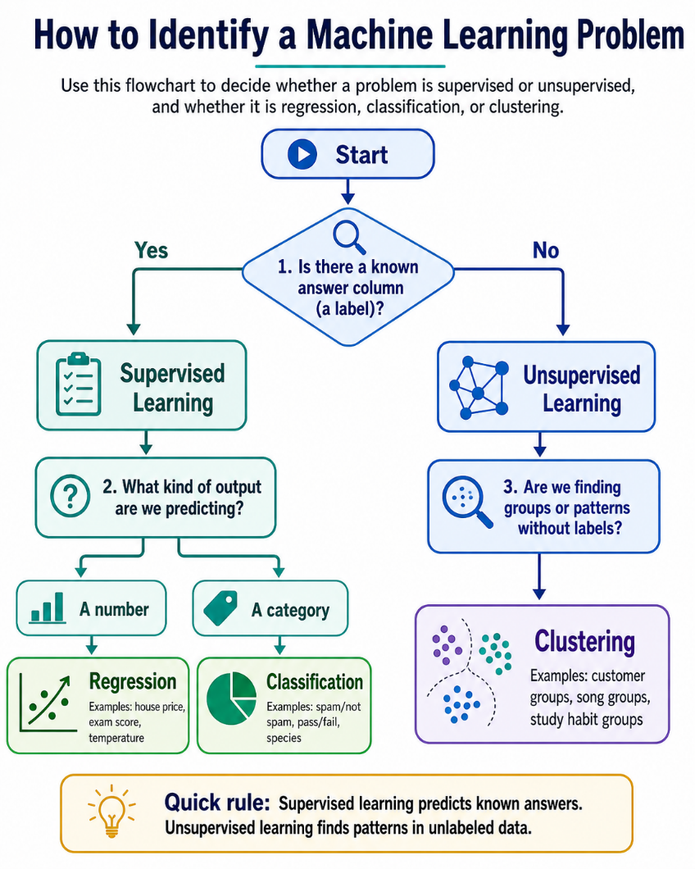

Below are examples of how we can use this questioning workflow to identify the machine learning task

Example 1
Step | Question | Example Answer | Result
1 | Is there a known answer column? | Yes, sale price | Supervised
2 | What are we trying to predict? | A house price | Prediction
3 | What kind of output is it? | A number | Regression

Example 2
Step | Question | Example Answer | Result
1 | Is there a known answer column? | Yes, spam/not spam | Supervised
2 | What are we trying to predict? | Whether an email is spam | Prediction
3 | What kind of output is it? | A category | Classification

Example 3
Step | Question | Example Answer | Result
1 | Is there a known answer column? | No | Unsupervised
2 | What are we trying to do? | Find similar customers | Grouping
3 | What kind of output is it? | Groups | Clustering

Skill 37.6 Exercise 1

