Set 7: Conditionals Part 1

Skill 7.1: Predict the output of an if statement
Skill 7.2: Write a Python if statement
Skill 7.3: Predict the output of an if-else statement
Skill 7.4: Write a Python if-else statement

Skill 7.1: Predict the output of an if statement

Skill 7.1 Concepts

When we consider our real-time scenario every day, we make some decisions, and based on the decisions made we will take further actions. Hence all our daily life activities depend on the decisions we make.

A similar situation arises in the programming language as well where we must make some decisions and based on that the program will execute.

Python provides four conditional statements, the most basic being the if statement. The if statement decides whether certain statements need to be executed or not. It checks for a given condition, if the condition is true, then the set of code present inside the if block will be executed otherwise not.

The if condition evaluates a Boolean expression and executes the block of code only when the Boolean expression becomes TRUE. Below is an example,

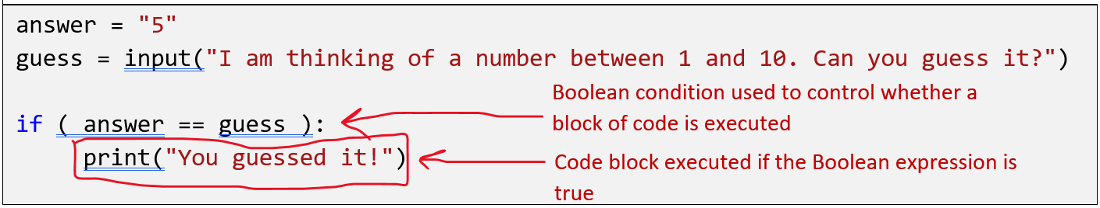

Let’s see how this looks with a flow chart,

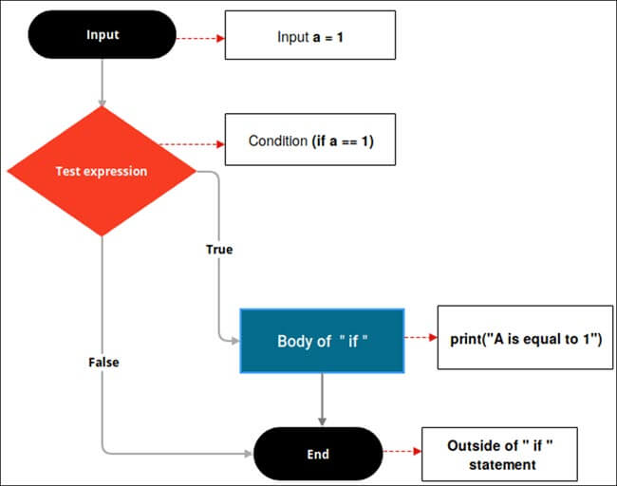

If you observe the above flow-chart, first the controller will come to an if condition and evaluate the condition if it is true, then the statements will be executed, otherwise the code present outside the block will be executed.

Skill 7.1 Exercise 1

Skill 7.2: Write a Python if stateemnt

Skill 7.2 Concepts

Notice in the example below, the conditional (b > a) is followed by a colon (:). Whatever code you write after the colon operator will be part of the “if block”. Also, notice that the code following the colon is indented. Python relies on indentation (whitespace at the beginning of a line) to define scope in the code. Other programming languages often use curly-brackets for this purpose.

a = 33
b = 200
if b > a:
print("b is greater than a")

An if statement, without indentation (will raise an error):

a = 33
b = 200
if b > a:
print("b is greater than a")

Skill 7.2 Exercise 1

Skill 7.3: Predict the output of an if-else statement

Skill 7.3 Concepts

An if-else statement says if a given condition is true then execute the statements present inside the “if block” and if the condition is false then execute the “else” block.

An if-else statement evaluates the Boolean expression. If the condition is TRUE then, the code present in the “if” block will be executed otherwise the code of the “else“ block will be executed

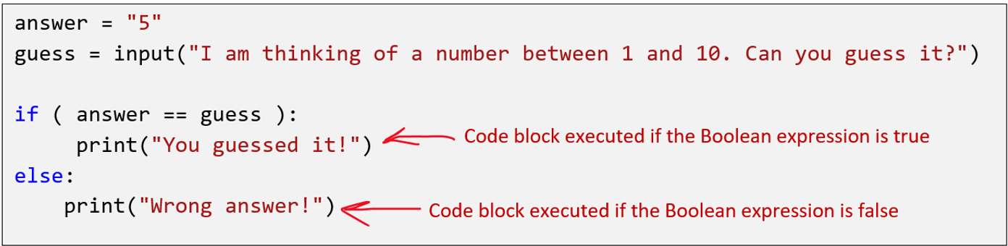

Let’s see the flowchart of if-else.

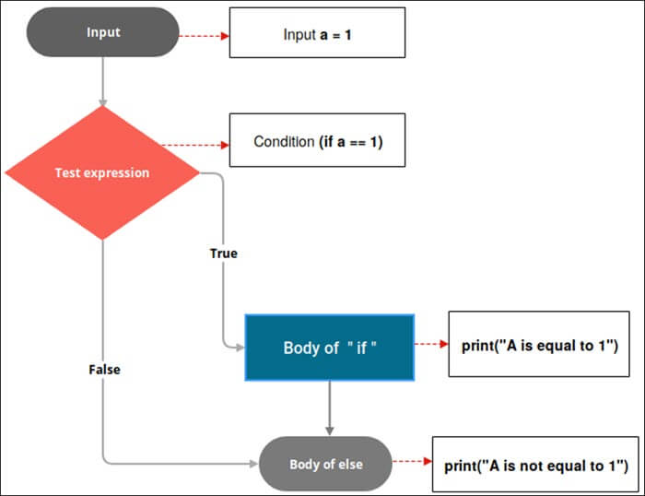

In the above code, the controller will come to the if condition and evaluate the condition. If it is true the if block will be executed otherwise the else block will be executed.

Skill 7.3 Exercise 1

Skill 7.4: Write a Python if-else statement

Skill 7.4 Concepts

Just as we saw before with simple if statements, the conditional in all the examples above is followed by a colon (:). Also, all the code written after the colon operator is indented and is part of the “if block”. Python recognizes that the if block is done once each reaches the else statement, which is not indented. The else is followed by a colon and all the code associated with the else block is indented. Some things to be aware of

- All the code within a block must be indented the same
- The code within the if and else blocks do not need to use the same indention. Although, doing so makes your code more readable

if the_weather_is_good:
print("Go for a walk")
The code in this block must be indented the same
print("Have fun")
else:
print("Go to the theater")
The code in this block must be indented the same, but in it doesn’t need to have the same indention as the if block.
print("Enjoy a movie")
print("Have lunch")

Skill 7.4 Exercise 1

