Set 8: Conditionals Part 2

Skill 8.1: Predict the output of an elif statement
Skill 8.2: Write a Python elif statement
Skill 8.3: Predict the output of nested if-else statement
Skill 8.4: Write a nested if-else statement

Skill 8.1: Predict the output of an elif statement

Skill 8.1 Concepts

In addition to the if and else-if statements we learned previously, in Python, we have one more conditional statement called elif statements. The elif statement is used to check multiple conditions only if the given condition is false. It’s similar to an if-else statement – the only difference is that elif statements can be applied to evaluate multiple conditions.

Below is an example,

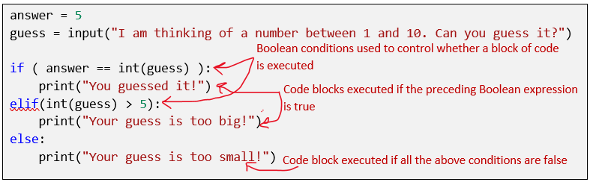

Skill 8.1 Exercise 1

Skill 8.2: Write a Python elif stateemnt

Skill 8.2 Concepts

Notice each logical statement above is followed by a colon (:) and all the code that is part of the logical statement is indented. But, also notice that in the example that evaluates the time variable we used two and statements for every conditional. While the code works, there is a simpler way to write this code!

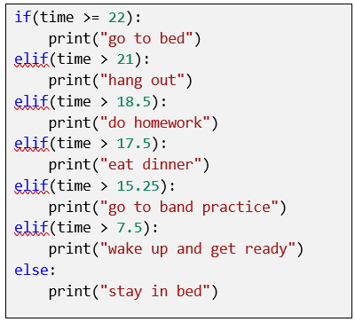

In the example above, we wrote the code with the most restrictive option first. This eliminated the need to check for two boundary conditions. This is a good rule of thumb for both simplifying the logic reducing unexpected outcomes.

Skill 8.2 Exercise 1

Skill 8.3: Predict the output of nested if-else statement

Skill 8.3 Concepts

Nested “if-else” statements mean that an “if” statement or “if-else” statement is present inside another if or if-else block. This feature allows us to evaluate complex logical conditions in a given program.

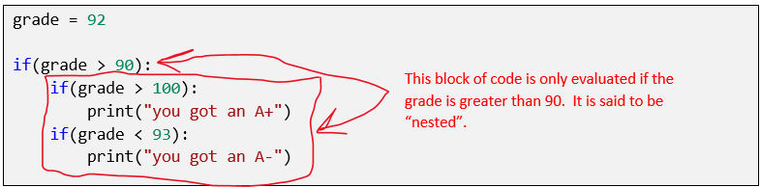

Skill 8.3 Exercise 1

Skill 8.4: Write nested if-else statement

Skill 8.4 Concepts

In the examples above we see that when writing nested if-else statements, each nested statement must be indented and follow the same format as the parent. You can write as many nested statements as you like, just remember to use proper indention for each nested block.

Code
age = 25
has_driver_license = True

if age >= 18:
print("You are old enough to drive.")
if has_driver_license:
print("You also have a driver's license, so you can legally drive.")
else:
print("You are old enough, but you need a driver's license to legally drive.")
else:
print("You are not old enough to drive.")

Output
You are old enough to drive
You also have a driver’s license, so you can legally drive

Skill 8.4 Exercise 1

