Set 8: Two-Dimensional Lists

Skill 8.1: Create a two-dimensional list in Python
Skill 8.2: Access two-dimensional lists elements
Skill 8.3: Modify elements in a two-dimensional list
Skill 8.4: Apply the zip() function to combine lists

Skill 8.1: Create a two-dimensional list in Python

Skill 8.1 Concepts

We’ve seen that the items in a list can be numbers or strings. Lists can contain other lists! We will commonly refer to these as two-dimensional (2D) lists.

Let’s look at a class height example,

- Noelle is 61 inches tall
- Ava is 70 inches tall
- Sam is 67 inches tall
- Mia is 64 inches tall

Previously, we saw that we could create a list representing both Noelle’s name and height,

noelle = ["Noelle", 61]

Conversely, we could create parallel lists, where the name of each person maps to their height in a separate list.

Code | Output
names = ["Noelle", "Ava", "Sam", "Mia"]  heights = [61, 70, 67, 64]  print(names[0], "is", heights[0], "inches tall")  print(names[1], "is", heights[1], "inches tall")  print(names[2], "is", heights[2], "inches tall")  print(names[3], "is", heights[3], "inches tall") | Noelle is 61 inches tall  Ava is 70 inches tall  Sam is 67 inches tall  Mia is 64 inches tall

Another way to manage this data is to create a list for each person and store all the individual lists in one bigger list,

heights = [["Noelle", 61], ["Ava", 70], ["Sam", 67], ["Mia", 64]]

We will often find that a two-dimensional list is a very good structure for representing grids such as games like tic-tac-toe.

tic_tac_toe = [
["X","O","X"],
["O","X","O"],
["O","O","X"]
]

Skill 8.1 Exercise 1

Skill 8.2: Access two-dimensional lists elements

Skill 8.2 Concepts

To understand how to access elements in a two-dimensional list, let’s consider the gradebook below,

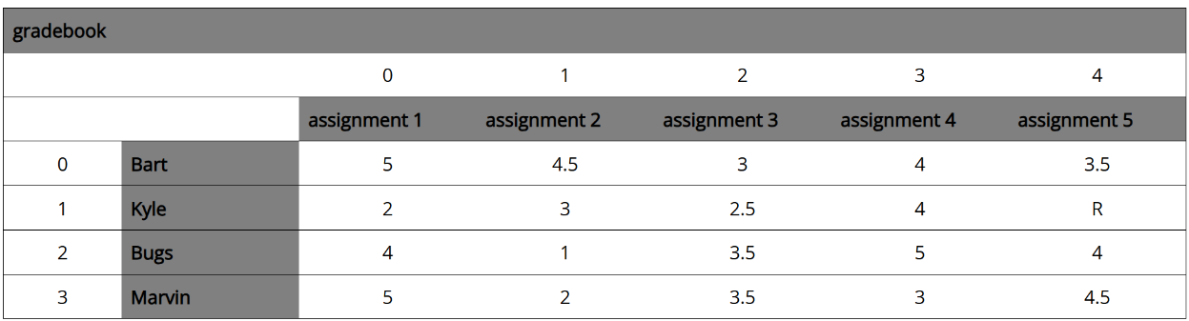
Rows
Columns

The gradebook can be visualized as a collection of rows and columns. From the diagram above we see that Bart’s grades are in row 0, Kyle’s grades are in row 1, etc. The grades for each student are stored in sub-lists represented by the columns. For example, Bart’s grade on assignment 1 is stored in column 0, his grade on assignment 2 is stored in column 1.

We can access any data member in the 2D list above by referencing the appropriate row and col.

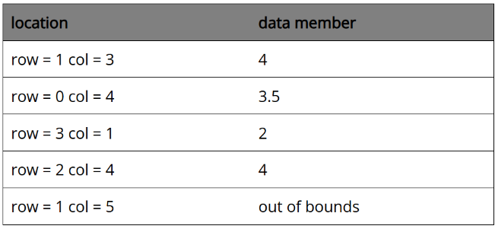

The gradebook can be represented as a two-dimensional list in Python,

grade_book = [
[5, 4.5, 3, 4, 3,5],
[2, 3, 2.5, 4, "R"],
[4, 1, 3.5, 5, 4],
[5, 2, 3.5, 3, 4.5]
]

To access elements in the two-dimensional list, we can use the following convention,

list[row_number][col_number]

For example,

Code | Output
result = grade_book[1][4]  print(result) | R

Skill 8.2 Exercises 1 thru 2

Skill 8.3: Modify elements in a two-dimensional list

Skill 8.3 Concepts

Now that we know how to access two-dimensional lists, modifying the elements should come naturally.
Let’s return to a classroom example, but now instead of heights or test scores, our list stores the student’s favorite hobby!

class_name_hobbies = [["Jenny", "Breakdancing"], ["Alexus", "Photography"], ["Grace", "Soccer"]]

"Jenny" changed their mind and is now more interested in "Meditation".

We will need to modify the list to accommodate the change to our class_name_hobbies list. To change a value in a two-dimensional list, reassign the value using the specific index.

Code
class_name_hobbies = [["Jenny", "Breakdancing"], ["Alexus", "Photography"], ["Grace", "Soccer"]]
class_name_hobbies[0][1] = "Meditation"
print(class_name_hobbies)

Output
[['Jenny', 'Meditation'], ['Alexus', 'Photography'], ['Grace', 'Soccer']]

Negative indices will work as well.

Code
class_name_hobbies = [["Jenny", "Breakdancing"], ["Alexus", "Photography"], ["Grace", "Soccer"]]
class_name_hobbies[-1][-1] = "Football"
print(class_name_hobbies)

Output
[['Jenny', 'Breakdancing'], ['Alexus', 'Photography'], ['Grace', 'Football']]

Skill 8.3 Exercise 1

Skill 8.4: Apply the zip() function to combine lists

Skill 8.4 Concepts

In Python, we have an assortment of built-in functions that allow us to build our programs faster and cleaner. One of those functions is zip().

The zip() function allows us to quickly combine associated data-sets without needing to rely on multi-dimensional lists. While zip() can work with many different scenarios, we are going to explore only a single one in this article.

Let’s use a list of student names and associated heights as our example data set:

- Jenny is 61 inches tall
- Alexus is 70 inches tall
- Sam is 67 inches tall
- Grace is 64 inches tall

Suppose that we already had a list of names and a list of heights,

names = ["Jenny", "Alexus", "Sam", "Grace"]
heights = [61, 70, 67, 64]

If we wanted to create a nested list that paired each name with a height, we could use the built-in function zip().

The zip() function takes two (or more) lists as inputs and returns an object that contains a list of pairs. Each pair contains one element from each of the inputs. This is how we would do it for our names and heights lists:

Code
names = ["Jenny", "Alexus", "Sam", "Grace"]
heights = [61, 70, 67, 64]
names_and_heights = zip(names, heights)
print(names_and_heights)
Output
<zip object at 0x000001E7A66D4C80>

This zip object contains the location of this variable in our computer’s memory. Don’t worry though, it is fairly simple to convert this object into a useable list by using the built-in function list(),

Code
converted_list = list(names_and_heights)
print(converted_list)
Output
[('Jenny', 61), ('Alexus', 70), ('Sam', 67), ('Grace', 64)]

Notice two things:

- Our data set has been converted from a zip memory object to an actual list (denoted by [ ])
- Our inner lists don’t use square brackets [ ] around the values. This is because they have been converted into tuples (an immutable type of list that we will learn more about!)

Skill 8.4 Exercise 1

