Skill 0.1 Exercise 1
What is data literacy?

Why is data literacy important?

Skill 0.2 Exercise 1
Provide another example of Garbage in, garbage out. Explain the consequences.

Skill 0.3 Exercise 1
Neural Machine Translation (NMT) is trained on example text that exists in the world. Consider the Google Translate that was constructed using NMT.
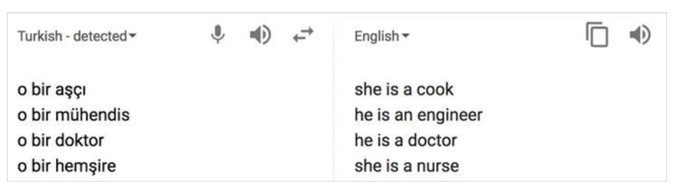
What is the bias in this translation.
How might Google Engineers modify the translation to remove bias?

Skill 0.3 Exercise 2
In 2014, Amazon experimented with using software to screen job applicants. The screening software was trained on a decade of résumés that had been previously rated by employees as part of the hiring process. Below shows the distribution of male and female employees at Amazon in 2014.

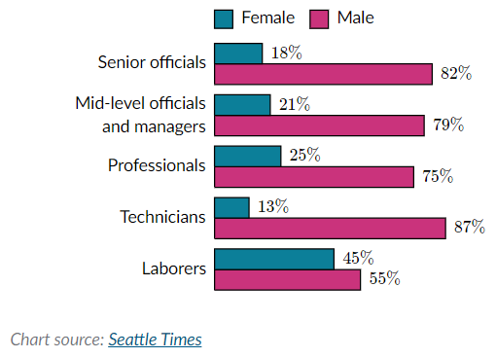
Is it statistically possible that the above results were by chance?
How might Amazon better train their software model to avoid “reckless regard” for the rights of female candidates?

Skill 0.4 Exercise 1
On January 28, 1986 the Challenger space shuttle carried seven US astronauts who were supposed to deploy a satellite and study Halley’s Comet while they were in orbit. Less than two minutes after takeoff, however, the shuttle exploded, killing all seven crew members. The explosion was caused by a failure of two O-rings: small rubber rings that helped create an airtight seal between the space shuttle and its launch fuel supply. Before the launch, engineers were concerned about how the low-temperature forecast would affect the O-rings’ ability to make a proper seal. The engineers made their arguments in favor of postponing the launch using, in part, a series of data visualizations that showed launch success rates at various temperatures. Tragically, their arguments did not prevent the launch from proceeding.

Below are the visualizations.
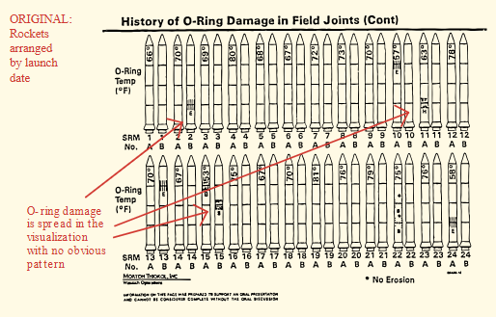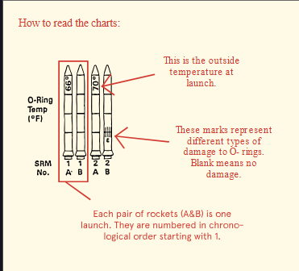
How could the engineers have improved their visualization, and potentially prevented this tragedy?

