Skill 2.2 Exercise 1
For each scenario, indicate whether a univariate or bi-variate plot would be most appropriate.
A basketball coach wants to visualize the distribution of points scored by players on his team
How does the amount of study time compare to the GPA
What are the GPAs of students at Timberline
A basketball coach wants to visualize the points scored by players and the amount of playtime

Skill 2.3 Exercise 1
Refer to the data vis below,

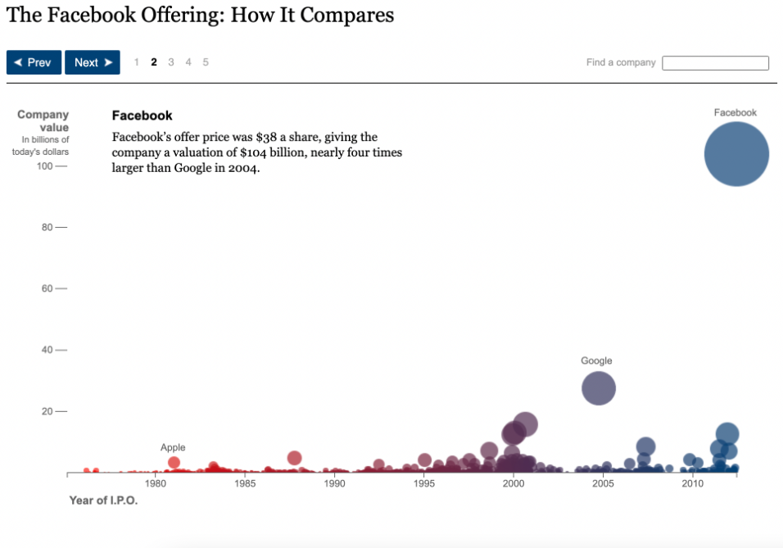

We already discussed one example of data redundancy in this graph. But there is another, explain.

Skill 2.4 Exercise 1
Below are some examples of poor data visualizations. For each, indicate what is wrong, along with how it could be improved using principles of universal design.
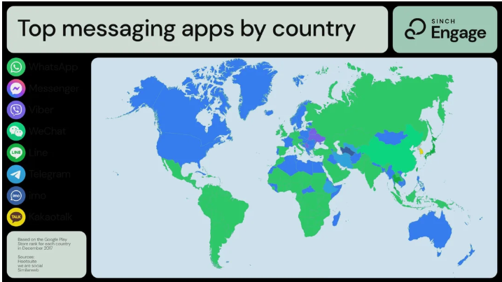
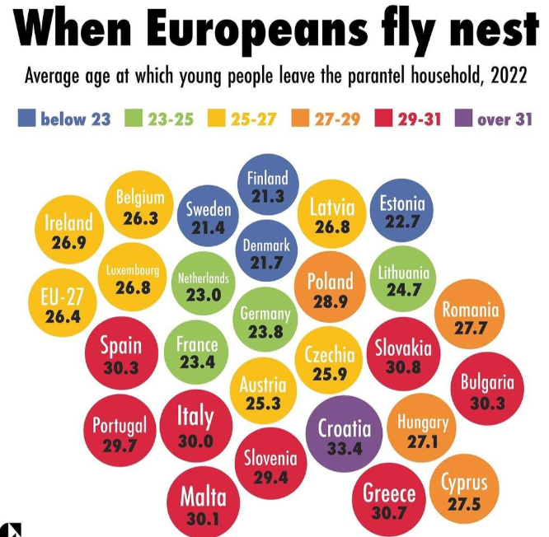
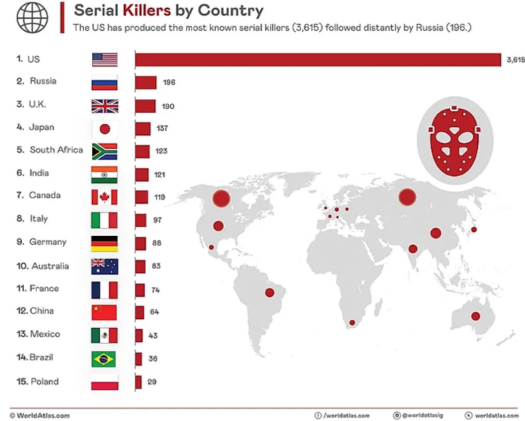
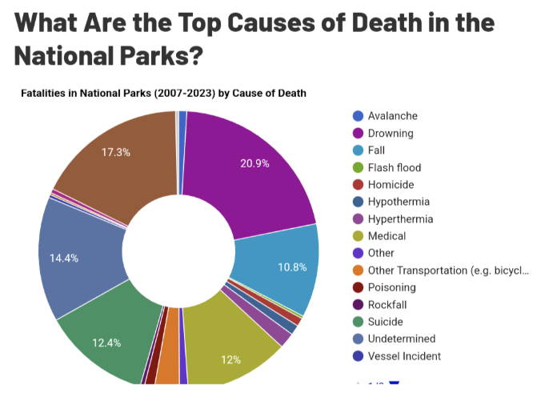

Skill 2.5 Exercise 1
You have been tasked with developing a visualization of the wingspans of the three most common backyard birds in Dandelion City: the Northern Cardinal, American Robin, and Blue Jay. With your knowledge of data visualization, your task is to make the most effective visualization of wingspan data to present to the backyard birders of Dandelion City.

Here’s the data you are working with:
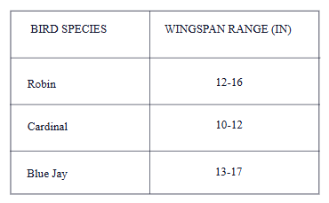

Which of graph best fits the data in the table? Explain.
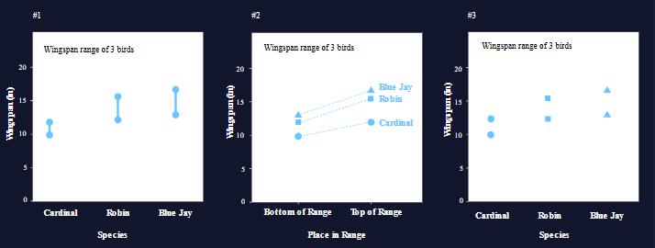
Now that we’ve gotten the chart type to align with our data, let’s move on to the next important consideration: color.

Which color palette best represents the information in the data table and will be effective for the broadest audience. Explain.

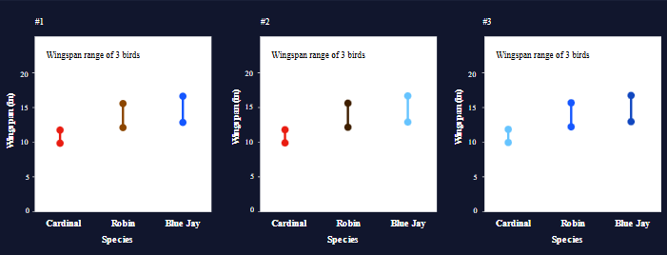
Now let’s look at annotations that will help our audience make the most of the final chart.

Which version of Janis’s annotations are most helpful? Explain.
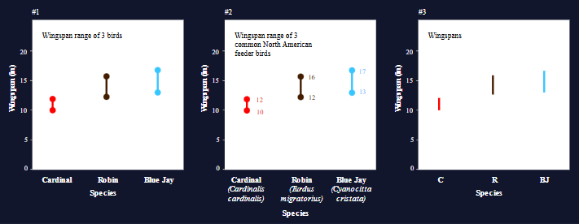
Finally, let’s finish up with some design considerations.

Which design helps to communicate information beautifully and effectively. Explain.

