Skill 12.1 Exercise 1
Consider the two types of iteration,

- Indefinite iteration, where the number of times the loop is executed depends on how many times a condition is met.
- Definite iteration, where the number of times the loop will be executed is defined in advance (usually based on the collection size).

Provide an example of each.

Skill 12.2 Exercise 1
Refer to the list below,

Categories = ['Music' 'Entertainment' 'Education' 'Shows' 'People & Blogs' 'Sports'
'Film & Animation' 'News & Politics' 'Gaming' 'Trailers' 'Comedy'
'Nonprofits & Activism' 'Science & Technology' 'Movies' 'Howto & Style'
'Pets & Animals' 'Autos & Vehicles']
- How many print statements would be required to print each element in the list.
- You are creating a number guessing game. How many guesses will the user need to guess your secret number?

Skill 12.3 Exercise 1
For each of the following, indicate what is printed. If there is an error, indicate the error.
board_games = ["Settlers of Catan", "Carcassone", "Power Grid", "Agricola", "Scrabble"]

for game in board_games:
print(game)

sum = 0
numList = [1,2, 3, 4, 5]

for n in numList:
sum = sum + n

print(sum)
alpha = "abcdefghijklmnopqrstuvwxyz"
count = 0

for letter in alpha:
if(count % 2 == 0):
print(letter)
count += 1
word = "timberline"
count = 0

for letter in word:
if(letter < "m"):
print(letter)

Skill 12.3 Exercise 2
sport_games = ["football", "hockey", "baseball", "cricket"]
Write a for loop that prints each sport in the list sport_games.

Skill 12.4 Exercise 1
Use the range() function in a for loop to print() out the provided promise variable five times.

promise = "I will learn Python loops!"

Skill 12.5 Exercise 1
Indicate what is printed,
count = 0
print("Start")
while count <= 3:
# Loop Body
# Print if the condition is still true
print("count <= 3 still true")
# Print the current value of count
print("Count is " + str(count))
# Increment count
count += 1
print(" ----- ")
print("End")

Skill 12.5 Exercise 2
Write a while loop that counts down from 10 to 0 (inclusive). Once the loop is finished print "We have liftoff!".

Skill 12.6 Exercise 1
Refer to the image below which represents a list called houses.
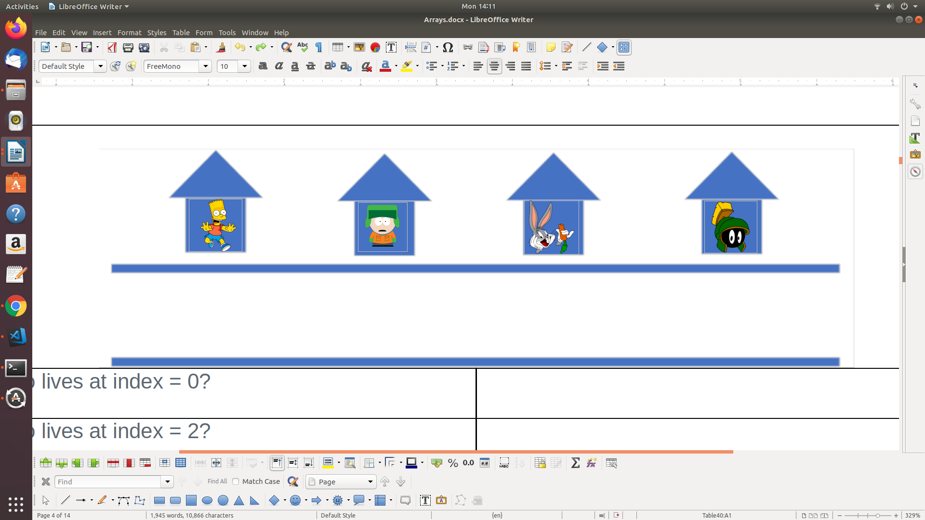

- Create a variable length and set its value to be the length of houses.
- Create a variable called index and initialize the value to be 0
- Write a while loop that prints the following, <name> lives at address <index> for each person in the list.

Skill 12.7 Exercise 1
Consider the following code segment.

j = 1
while(#Missing Code):
j = j + 2

Which of the following replacements for #Missing Code will result in an infinite loop?

- j !=6
- j !=7
- j == 7
- j > 7

Skill 12.7 Exercise 2
The code below does not work as intended. Identify the error, then indicate how you would fix it.
