Skill 17.1 Exercise 1
The code below has errors. Fix the code.
num_cameras = {"backyard": 6 "garage": 2 "driveway": 1}
Create a dictionary called sensors that keeps track of the temperature in different rooms of a house. Assign the “living room”, “kitchen”, and “bedroom” to 21, 23, and 20, respectively.

Skill 17.2 Exercise 1
Create a dictionary called translations that maps the following words in English to their definitions in Sindarin (the language of the elves):

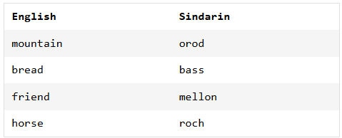

Skill 17.3 Exercise 1
The code below results in an unhashable error. Explain why, along with how you would fix the code.
children = {["Johannes", "Rosmarie", "Eleonore"]: "von Trapp", ["Sonny", "Fredo", "Michael"]: "Corleone"}

Skill 17.4 Exercise 1
Create an empty dictionary called zoo_animals. Then add 8 zebras and 12 monkeys.

Skill 17.5 Exercise 1
Use the update method, to add the following animals to the zoo_animals dictionary above: 4 lions, 10 kangaroos, 4 red pandas

Skill 17.6 Exercise 1
Below is a dictionary that stores some summary statistics,

stats = {
"mean": 72.4,
"median": 70.0,
"std": 8.1
}

Write a function called update_stats that takes three parameters: dict, stats, value
In the body of the function use the parameters to update the specified stat in the dictionary with the correct value.
Call the function you wrote above. Update the mean in stats to 69.5.

Skill 17.7 Exercise 1
The lists below show cities and the corresponding temperatures.

cities = ["NYC", "LA", "Chicago", "Houston"]
avg_temps = [70, 75, 65, 80]

Use a dict comprehension to create one dictionary called city_temps that stores the cities as the keys and the avg_temps as the values.

