Skill 17.1 Exercise 1
The code below has errors. Fix the code.
num_cameras = {"backyard": 6 "garage": 2 "driveway": 1} (Missing commas)
Create a dictionary called sensors that keeps track of the temperature in different rooms of a house. Assign the “living room”, “kitchen”, and “bedroom” to 21, 23, and 20, respectively.
Sensors = {“living room”:21, “kitchen”:23, “bedroom”:20}

Skill 17.2 Exercise 1
Create a dictionary called translations that maps the following words in English to their definitions in Sindarin (the language of the elves):

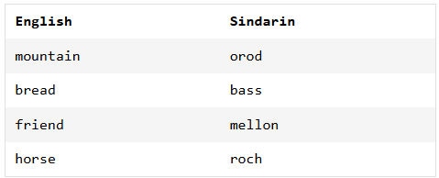

Translations = {“mountain”: “orod”, “bread”: “bass”, “friend”: “mellon”, “horse”: “roch”}

Skill 17.3 Exercise 1
The code below results in an unhashable error. Explain why, along with how you would fix the code.
children = {["Johannes", "Rosmarie", "Eleonore"]: "von Trapp", ["Sonny", "Fredo", "Michael"]: "Corleone"}

The code results in an “unhashable” error because the keys are “lists”. The values of lists can be modified – unhashable.

To fix the error, interchange the keys and values

Children = {“vontrap” : [“Johannes”, “Rosmarie”, “Eleonore”], “Corleone”: [“Sonny”, “Fredo”, “Michael”]

Skill 17.4 Exercise 1
Create an empty dictionary called zoo_animals. Then add 8 zebras and 12 monkeys.
zoo_animals = {}
zoo_animals[“zebras”] = 8
zoo_animals[“monkeys”] = 12

Skill 17.5 Exercise 1
Use the update method, to add the following animals to the zoo_animals dictionary above: 4 lions, 10 kangaroos, 4 red pandas
zoo_animals.update({“lions”:4, “kangaroos”:10, “red pandas”:4})

Skill 17.6 Exercise 1
Below is a dictionary that stores some summary statistics,

stats = {
"mean": 72.4,
"median": 70.0,
"std": 8.1
}

Write a function called update_stats that takes three parameters: dict, stats, value
In the body of the function use the parameters to update the specified stat in the dictionary with the correct value.
def update_stats(dict, stats, value):
dict[stats] = value
return dict

Call the function you wrote above. Update the mean in stats to 69.5.
update_stats(stats, mean, 69.5)

Skill 17.7 Exercise 1
The lists below show cities and the corresponding temperatures.

cities = ["NYC", "LA", "Chicago", "Houston"]
avg_temps = [70, 75, 65, 80]

Use a dict comprehension to create one dictionary called city_temps that stores the cities as the keys and the avg_temps as the values.
zipped_data = zip(cities, avg_temps)

city_temps = {key:value for key, value in zipped_data}

