Skill 22.2 Exercise 1
In the space below, import the pandas library, then create a DataFrame with the following data,

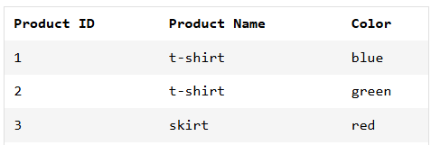

Skill 22.3 Exercise 1
You’re running a chain of pita shops. You want to create a DataFrame with information on your different store locations.

In the space below, import the pandas library, then use a list of lists to create a DataFrame with the following data:

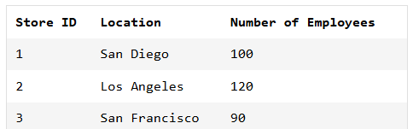

Skill 22.4 Exercise 1
Read the CSV file below into a DataFrame called df.

city_data.csv
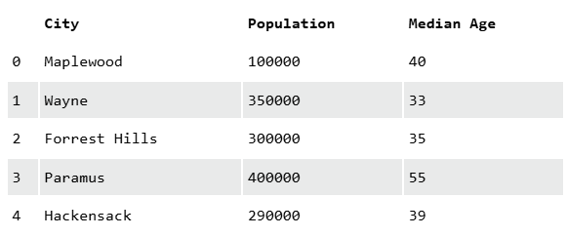
Save the DataFrame you created above to a new CSV file called new_city_data.csv

Skill 22.5 Exercise 1
Load the CSV imdb.csv into a variable called df, so that you can learn about popular movies from the past 90 years.
Print the first 5 rows of the dataset
Print the first 7 rows of the dataset
Print the info associated with the dataset

Skill 22.6 Exercise 1
Refer to the DataFrame below which shows data collected by four health clinics run by the same organization. Each row represents a month from January through June and shows the number of appointments made at four different clinics .

df = pd.DataFrame([
['January', 100, 100, 23, 100],
['February', 51, 45, 145, 45],
['March', 81, 96, 65, 96],
['April', 80, 80, 54, 180],
['May', 51, 54, 54, 154],
['June', 112, 109, 79, 129]],
columns=['month', 'clinic_east',
'clinic_north', 'clinic_south',
'clinic_west']
)

You want to analyze what’s been happening at the North location. Create a variable called clinic_north that contains ONLY the data from the column clinic_north.

Skill 22.6 Exercise 2
You want to compare visits to the Northern and Southern clinics in the DataFrame from the previous exercise.
Create a variable called clinic_ns that contains ONLY the data from the columns: clinic_north and clinic_south.

Skill 22.7 Exercise 1
Refer to the DataFrame below which shows data collected by four health clinics run by the same organization. Each row represents a month from January through June and shows the number of appointments made at four different clinics .

df = pd.DataFrame([
['January', 100, 100, 23, 100],
['February', 51, 45, 145, 45],
['March', 81, 96, 65, 96],
['April', 80, 80, 54, 180],
['May', 51, 54, 54, 154],
['June', 112, 109, 79, 129]],
columns=['month', 'clinic_east',
'clinic_north', 'clinic_south',
'clinic_west']
)

You’re getting ready to staff the clinic for March this year. Write a command that will produce a Series made up of the March data. Print the results.
One of your doctors thinks that there are more clinic visits in the late Spring. Write a command that will produce a DataFrame made up of the data for April, May, and June for all four sites. Print the results.

Skill 22.8 Exercise 1
Refer to the DataFrame below which shows data collected by four health clinics run by the same organization. Each row represents a month from January through June and shows the number of appointments made at four different clinics .
df = pd.DataFrame([
['January', 100, 100, 23, 100],
['February', 51, 45, 145, 45],
['March', 81, 96, 65, 96],
['April', 80, 80, 54, 180],
['May', 51, 54, 54, 154],
['June', 112, 109, 79, 129]],
columns=['month', 'clinic_east',
'clinic_north', 'clinic_south',
'clinic_west']
)
You’re going to staff the clinic for January of this year. You want to know how many visits took place in January of last year, to help you prepare. Create variable january using a logical statement that selects the row of df where the 'month' column is 'January'. Print the results.
You want to see how the number of clinic visits changed between March and April. Create the variable march_april, which contains the data from March and April. Do this using two logical statements combined using |, which means “or”. Print the results.
Another doctor thinks that you have a lot of clinic visits in the late Winter.
Create the variable jan_feb_mar, containing the data from January, February, and March. Do this using a single logical statement with the isin command. Print the results.

Skill 22.9 Exercise 1
Code
The code below returns the DataFrame shown,

df = pd.DataFrame([
['January', 100, 100, 23, 100],
['February', 51, 45, 145, 45],
['March', 81, 96, 65, 96],
['April', 80, 80, 54, 180],
['May', 51, 54, 54, 154],
['June', 112, 109, 79, 129]],
columns=['month', 'clinic_east',
'clinic_north', 'clinic_south',
'clinic_west']
)
result = df[df['month'].isin(['March','May'])]
print(result)
Output
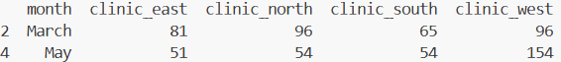
Notice the indices are not consecutive. Use the reset_index method to reset the indices and print the results.
Add the drop and inplace keywords to the index method.
What do the drop and inplace keywords do?

