Skill 21.1 Exercise 1
The DataFrame df below contains information on products sold at a hardware store.
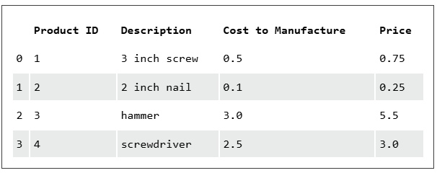
Add a column to df called Sold in Bulk?, which indicates if the product is sold in bulk or individually. The final table should look like the one below,
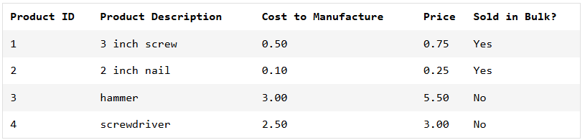

Add a column to df called Is taxed?, which indicates whether or not to collect sales tax on the product. It should be 'Yes' for all rows
Add a column to df called Margin, which is equal to the difference between the Price and the Cost to Manufacture.

Skill 21.2 Exercise 1
Refer to the DataFrame below.
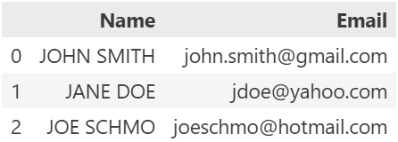

Apply the function lower to all names in column Name in df. Assign these new names to a new column of df called Lowercase Name. The final DataFrame should look like the one below,

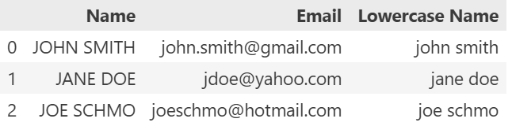

Skill 21.3 Exercise 1
Suppose we want to pay workers time-and-a-half for overtime (any work above 40 hours per week). The following function will convert the number of hours into time-and-a-half hours using an if statement:
def myfunction(x):
if x > 40:
return 40 + (x - 40) * 1.50
else:
return x

Rewrite the function above as a lambda function named adj_hours

Skill 21.4 Exercise 1
Below is a DataFrame df that contains information on employees, including their hourly wage and their hours worked.

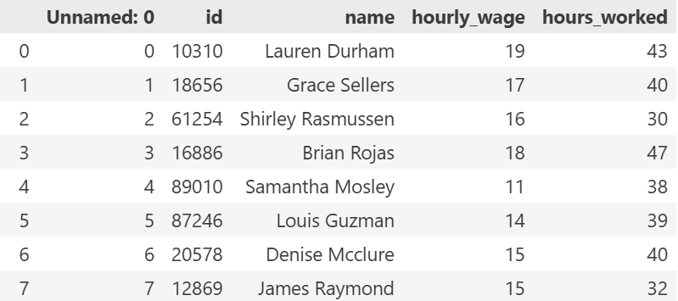

Apply the lambda function you wrote a above to the hours_worked column to calculate the time-and-a-half hours. Store the result in a new column called total_hours.
Calculate the total earned for each employee by multiplying the hourly_wage column by the hours_worked column. Store the result in a new column called earnings

Skill 21.5 Exercise 1
The DataFrame df contains data about movies from IMDb. Right now, the column names are in lower case, and are not very descriptive. Modify df using the columns attribute to make the following changes to the columns,

Old | New
id | ID
name | Title
genre | Category
year | Year Released
rating | IMDB_Rating

Skill 21.5 Exercise 2
If we didn’t know that df was a table of movie IMDB ratings, the columns name and rating might be confusing.
To clarify, rename name to movie_title and rating to IMDB_rating Use the keyword inplace=True so that you modify df rather than creating a new DataFrame!

