Skill 22.1 Exercise 1
For each of the following indicate whether the example is an aggregate statistic.
Example | Aggregate Statistic (yes/no)
Median household income in a city | yes
A single student’s test score | no
A single household’s income | no
Minimum stock price over the last 30 days | yes

What is an aggregate statistic?
An aggregate statistic is a way of creating a single number that describes a group of numbers.

Skill 22.2 Exercise 1
Refer to the shoe_fly dataframe below.
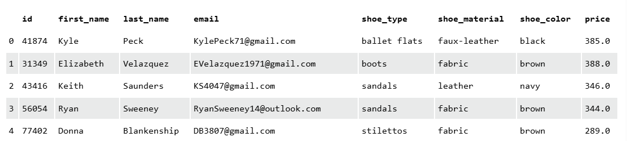

Write code to answer the following,
What is the most expensive shoe | shoe_fly.price.max()
What is the least expensive shoe | shoe.fly.price.min()
What is the number of different colors of shoes | shoe_fly.shoe_color.nunique()
What is the average cost of shoes | shoe_fly.price.mean()
What are the different types of shoes | shoe_fly.shoe_type.unique()

Skill 22.3 Exercise 1
Refer to the shoe_fly dataframe below.


Write code to answer the following,
What is the most expensive shoe for each shoe type | shoe_fly.groupby(‘shoe_type’).price.max()
What is the average cost of different colored shoes | shoe_fly.groupby(‘shoe_color’).price.mean()
What is the median cost for shoes of different material | shoe_fly.groupby(‘shoe_material’).price.mean()
What is the datatype returned for each statement above?
pandas Series
How can you convert each datatype into a dataframe?
shoe_fly.groupby('shoe_material').price.mean().reset_index() OR
shoe_fly.groupby('shoe_material')[['price']].mean()

Skill 22.4 Exercise 1
Refer to the shoe_fly dataframe below.

The following lambda function can be applied to return a value below which 25% of the data falls.

result = (lambda x: np.percentile(x, 25))

Use the lambda function above to answer the following,
What is the price threshold for the cheapest 25% of shoes of each type | result = (lambda x: np.percentile(x, 25))  shoe_fly.groupby(‘shoe_type’).price.apply(result)
What is the price threshold for the cheapest 10% of shoes of each material | result = (lambda x: np.percentile(x, 10))  shoe_fly.groupby(‘shoe_material’).price.apply(result)
What is the price threshold for the cheapest 30% of shoes of each color | result = (lambda x: np.percentile(x, 30))  shoe_fly.groupby(‘shoe_color’).price.apply(result)
What is the datatype returned for each statement above?
panda Series
How can you convert each datatype into a dataframe?
reset_index()

Skill 22.5 Exercise 1
Refer to the shoe_fly dataframe below.


Write code to answer the following, store each result in a new dataframe.
What is the total number of shoes and each type and color? | shoe_fly.groupby([‘shoe_type’, ‘shoe_color’]).id.count().reset_index()
What is the average price of each shoe and color? | shoe_fly.groupby([‘shoe_type’, ‘shoe_color’]).price.mean().reset_index()
What is the price threshold for the cheapest 30% of shoes of each color and type? | shoe_fly.groupby(["shoe_type", "shoe_color"]).price.apply(lambda x: np.percentile(x, 30)).reset_index()

Skill 22.6 Exercise 1
Refer to the Skill 22.5 Exercise 1

For each statement, use pandas to create pivot table.
What is the total number of shoes and each type and color? | pivot_table = pivot1_data.pivot( index='shoe_type', columns='shoe_color', values='id')
What is the average price of each shoe and color? | pivot_table2 = pivot2_data.pivot( index = 'shoe_type', columns = 'shoe_color', values = 'price')
What is the price threshold for the cheapest 30% of shoes of each color and type? | pivot_table3 = pivot3_data.pivot( index = 'shoe_type', columns = 'shoe_color', values = 'price' )

