Skill 24.1 Exercise 1
For each of the following indicate whether the example is an aggregate statistic.
Example | Aggregate Statistic (yes/no)
Median household income in a city
A single student’s test score
A single household’s income
Minimum stock price over the last 30 days

What is an aggregate statistic?

Skill 24.2 Exercise 1
Refer to the shoe_fly dataframe below.
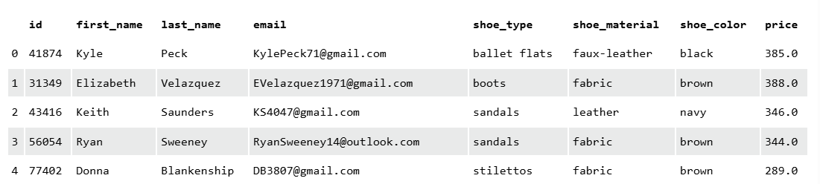

Write code to answer the following,
What is the most expensive shoe
What is the least expensive shoe
What is the number of different colors of shoes
What is the average cost of shoes
What are the different types of shoes

Skill 24.3 Exercise 1
Refer to the shoe_fly dataframe below.


Write code to answer the following,
What is the most expensive shoe for each shoe type
What is the average cost of different colored shoes
What is the median cost for shoes of different material
What is the datatype returned for each statement above?
How can you convert each datatype into a dataframe?

Skill 24.4 Exercise 1
Refer to the shoe_fly dataframe below.

The following lambda function can be applied to return a value below which 25% of the data falls.

result = (lambda x: np.percentile(x, 25))

Use the lambda function above to answer the following,
What is the price threshold for the cheapest 25% of shoes of each type
What is the price threshold for the cheapest 10% of shoes of each material
What is the price threshold for the cheapest 30% of shoes of each color
What is the datatype returned for each statement above?
How can you convert each datatype into a dataframe?

Skill 24.5 Exercise 1
Refer to the shoe_fly dataframe below.


Write code to answer the following, store each result in a new dataframe.
What is the total number of shoes and each type and color?
What is the average price of each shoe and color?
What is the price threshold for the cheapest 30% of shoes of each color and type?

Skill 24.6 Exercise 1
Refer to the Skill 22.5 Exercise 1

For each statement, use pandas to create pivot table.
What is the total number of shoes and each type and color?
What is the average price of each shoe and color?
What is the price threshold for the cheapest 30% of shoes of each color and type?

