Skill 23.1 Exercise 1
The table below stores all order, customer, and product information in a single table, which results in repeated data.

order_id | customer_id | customer_name | customer_address | product_id | product_name | product_price | quantity
101 | C01 | Alex Kim | 123 Oak St | P10 | Laptop | 999.99 | 1
102 | C01 | Alex Kim | 123 Oak St | P12 | Mouse | 25.99 | 2
103 | C02 | Jordan Lee | 45 Pine Rd | P10 | Laptop | 999.99 | 1
104 | C01 | Alex Kim | 123 Oak St | P10 | Laptop | 999.99 | 1

Identify at least two pieces of information that are repeated in the table.
How could this data be reorganized into multiple tables to reduce redundancy?
What information would belong in each table

Skill 23.2 Exercise 1
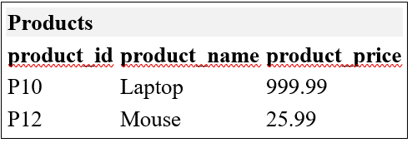
Refer to the tables below,
Customers
customer_id | customer_name | customer_address
C01 | Alex Kim | 123 Oak St
C02 | Jordan Lee | 45 Pine Rd

Orders
order_id | customer_id | product_id | quantity
101 | C01 | P10 | 1
102 | C01 | P12 | 2
103 | C02 | P10 | 1
104 | C01 | P10 | 1

What is the name of the customer who placed order 101?
What product was ordered in order 102, and what is its price?
How many laptops were ordered in total across all orders?
Which customer has placed the most orders?

Skill 23.3 Exercise 1

Refer to the tables below,
Customers
customer_id | customer_name | customer_address
C01 | Alex Kim | 123 Oak St
C02 | Jordan Lee | 45 Pine Rd

Orders
order_id | customer_id | product_id | quantity
101 | C01 | P10 | 1
102 | C01 | P12 | 2
103 | C02 | P10 | 1
104 | C01 | P10 | 1

The following causes an error. Explain.

result = customers.merge(products)

In the space below, write code that could be used to merge all three tables. The final table should like the one below,
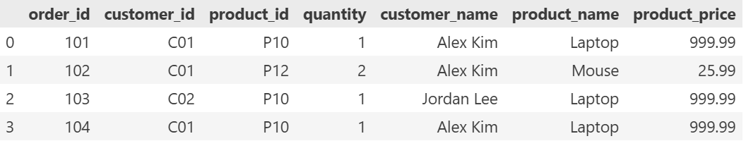
Write code to answer the following questions,
What products did Alex Kim order?
What is the total cost of each order (product_price × quantity)?
Which customer spent the most money?

Skill 23.4 Exercise 1
Refer to the tables below,
products | orders
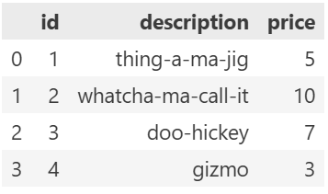 | 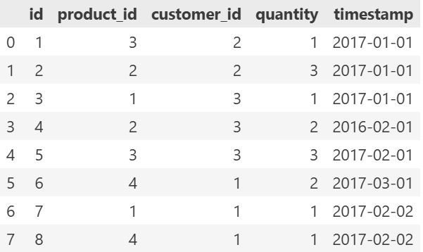
In the space below, rename the id column in products to product_id, then merge the tables. Store the result in product_orders.

Skill 23.5 Exercise 1
Refer to the tables below,
store_a | orders
item store_a_inventory  0 hammer 12  1 screwdriver 15  2 nails 200  3 screws 350  4 saw 6  5 duct tape 150  6 wrench 12  7 pvc pipe 54 | item store_b_inventory  0 hammer 6  1 nails 250  2 saw 6  3 duct tape 150  4 pvc pipe 54  5 rake 10  6 shovel 15  7 wooden dowels 192

Merge the store_a and store_b inventories with an inner merge.
What data is missing?
Merge the store_a and store_b inventories with an outer merge.
Which values are nan or None?

Skill 23.6 Exercise 1
An ice cream parlor and a bakery have decided to merge. The bakery’s menu is stored in the DataFrame bakery, and the ice cream parlor’s menu is stored in DataFrame ice_cream.
bakery | ice_cream
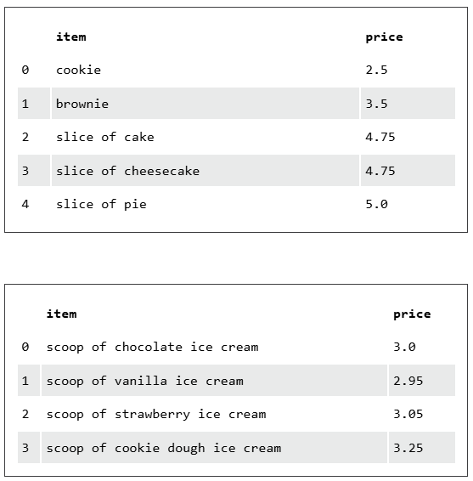 | 

Create their new menu by concatenating the two DataFrames into a DataFrame called menu.
Explain the difference between merge and concatenate as it applies to DataFrames.

