Skill 25.1 Exercise 1
Refer to the movies DataFrame below.
 | movie | production_budget | domestic_gross | worldwide_gross | mpaa_rating | genre
0 | Evan Almighty | 175000000.0 | 100289690.0 | 174131329.0 | PG | Comedy
1 | Waterworld | 175000000.0 | 88246220.0 | 264246220.0 | PG-13 | Action
2 | King Arthur: Legend of the Sword | 175000000.0 | 39175066.0 | 139950708.0 | PG-13 | Adventure
3 | 47 Ronin | 175000000.0 | 38362475.0 | 151716815.0 | PG-13 | Action
4 | Jurassic World: Fallen Kingdom | 170000000.0 | 416769345.0 | 1304866322.0 | PG-13 | Action

For each variable in the movies DataFrame, indicate whether it is quantitative or categorical
How could you use the describe() method to display the summary statistics for all the columns in the movies DataFrame?
print(movies.describe(include = 'all'))

Skill 25.2 Exercise 1
Refer to the movies DataFrame below.
 | movie | production_budget | domestic_gross | worldwide_gross | mpaa_rating | genre
0 | Evan Almighty | 175000000.0 | 100289690.0 | 174131329.0 | PG | Comedy
1 | Waterworld | 175000000.0 | 88246220.0 | 264246220.0 | PG-13 | Action
2 | King Arthur: Legend of the Sword | 175000000.0 | NaN | 139950708.0 | PG-13 | Adventure
3 | 47 Ronin | NaN | 38362475.0 | 151716815.0 | PG-13 | Action
4 | Jurassic World: Fallen Kingdom | 170000000.0 | 416769345.0 | NaN | NaN | Action

Select the production_budget column and store it in a variable called budget.
budget = df["production_budget"]

Write to code to answer the following,

- What is the data type of production_budget?
- How many missing values does it have?
- How many unique values does it have?
- What are the unique values?

# What is the data type of production_budget?
budget.dtype

# How many missing values does it have?
budget.isna().sum()

# How many unique values does it have?
budget.nunique()

# What are the unique values?
budget.unique()

Skill 25.3 Exercise 1
Refer to the movies DataFrame below which shows the first 5 rows of a larger dataset.
 | movie | production_budget | domestic_gross | worldwide_gross | mpaa_rating | genre
0 | Evan Almighty | 175000000.0 | 100289690.0 | 174131329.0 | PG | Comedy
1 | Waterworld | 175000000.0 | 88246220.0 | 264246220.0 | PG-13 | Action
2 | King Arthur: Legend of the Sword | 175000000.0 | NaN | 139950708.0 | PG-13 | Adventure
3 | 47 Ronin | NaN | 38362475.0 | 151716815.0 | PG-13 | Action
4 | Jurassic World: Fallen Kingdom | 170000000.0 | 416769345.0 | NaN | NaN | Action

Calculate the mean and median of production_budget.
display(movies.production_budget.mean())
display(movies.production_budget.median())

The actual values of the mean and median are 33284743.23 and 20000000.0, respectively, what measure better represents a "typical" movie? Justify your answer.
The median better represents a “typical” movie.
- The mean (≈ 33.3 million) is much higher than the median (20 million).
- That gap tells us the data is right-skewed, meaning a small number of very high-earning movies are pulling the mean upward.
- Most movies earn less than the mean, so using it would overstate what’s typical

Determine the mode for the mpaa_rating. Why is the mode more appropriate than the mean or median here?
display(list(movies.mpaa_rating.mode()))

mpaa_rating is a categorical feature, so the mode best represents the center by identifying the most frequent category.

Skill 25.4 Exercise 1
Refer to the movies DataFrame below which shows the first 5 rows of a larger dataset.
 | movie | production_budget | domestic_gross | worldwide_gross | mpaa_rating | genre
0 | Evan Almighty | 175000000.0 | 100289690.0 | 174131329.0 | PG | Comedy
1 | Waterworld | 175000000.0 | 88246220.0 | 264246220.0 | PG-13 | Action
2 | King Arthur: Legend of the Sword | 175000000.0 | NaN | 139950708.0 | PG-13 | Adventure
3 | 47 Ronin | NaN | 38362475.0 | 151716815.0 | PG-13 | Action
4 | Jurassic World: Fallen Kingdom | 170000000.0 | 416769345.0 | NaN | NaN | Action

Calculate the min, max, and range of production_budget.
min_production = movies["production_budget"].min()
max_production = movies["production_budget"].max()
range_production = max_production - min_production
display(range_production)

Calculate the IQR
q1 = movies["production_budget"].quantile(0.25) # Q1
q3 = movies["production_budget"].quantile(0.75) # Q3
IQR = q3 - q1
display(IQR)
The actual values of the range and IQR are 74750000.0 and 36000000.0, respectively.
How do extreme blockbuster movies affect each measure?
Which statistic better describes the spread of most movies?
Because the data contains extreme values that inflate the range, the IQR provides a more realistic description of how spread out most movies are.
Calculate the standard deviation
movies['production_budget'].std()

The actual value of the standard deviation is 34892390.59. Based on this value and the previous values, is the data symmetric or skewed?
The standard deviation (~34.9 million) is very large relative to the IQR (36 million).
In general the SD ~ .75 * IQR
The large deviation from the mean signals extreme high values.
When the spread measured by standard deviation is inflated and much larger than the typical spread (IQR), it indicates outliers pulling values upward.

Skill 25.5 Exercise 1
Below is a box blot of the movie data from the previous exercise.
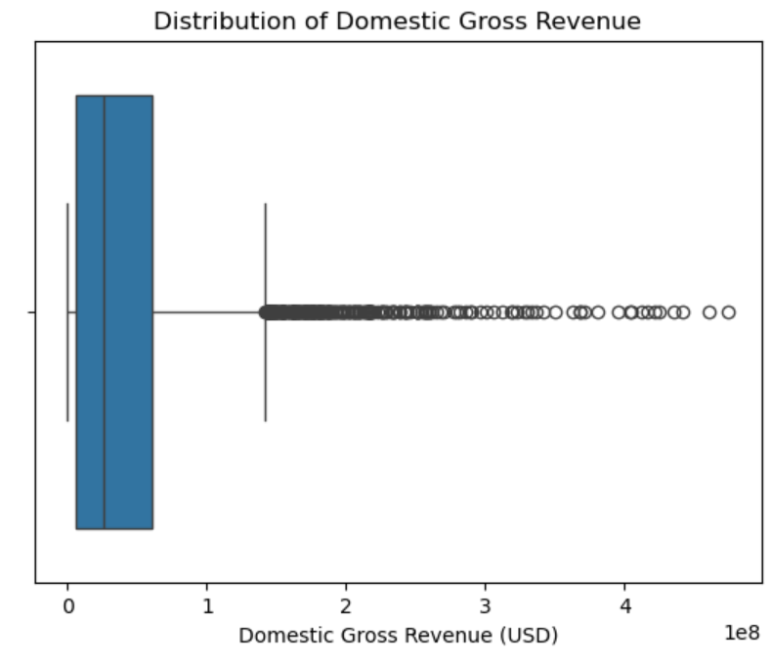

Label each of the following on the plot:
- Left whisker
- Right whisker
- Quantile 1, Quantile 2, and Quantile 3
- Outliers
- ICQ
Based on this boxplot, which measure of center and which measure of spread would best describe a typical movie? Explain why.
Best measure of center: Median
Best measure of spread: Interquartile Range (IQR)
Why this is the best choice
- The boxplot shows right skew with high-value outliers extending beyond the right whisker.
- Outliers pull the mean upward, making it larger than what most movies actually earn.
- The median is resistant to outliers, so it better represents a typical movie.
- The IQR focuses on the middle 50% of the data and ignores extreme values, giving a realistic sense of how spread out most movies are.

Below is a histogram of the movie data from the previous exercise.
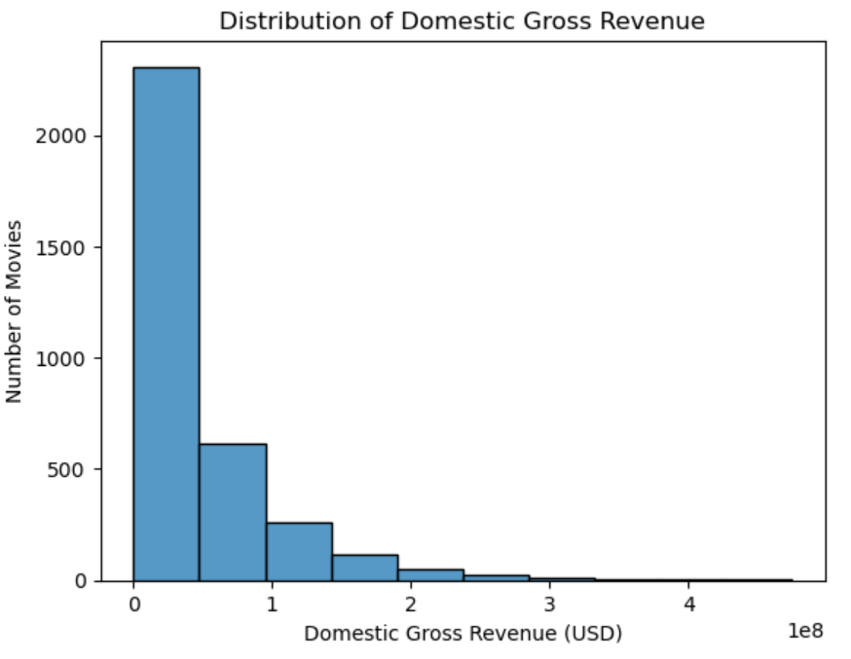
How would this histogram change if there were no extremely high-grossing movies?
Which measure of center and spread would become more appropriate?
- The long right tail would disappear or become much shorter.
- Bars would be more evenly distributed around the center.
- The distribution would look more symmetric (less right-skewed).
- The x-axis would cover a smaller range of values, so the bins would be more tightly packed.
In short, the histogram would look more like a bell-shaped or roughly symmetric distribution rather than one with a long tail.
Measure of center Center: Mean
Measure of Spread: Standard deviation

Skill 25.6 Exercise 1
Refer to the movies DataFrame below which shows the first 5 rows of a larger dataset.
 | movie | production_budget | domestic_gross | worldwide_gross | mpaa_rating | genre
0 | Evan Almighty | 175000000.0 | 100289690.0 | 174131329.0 | PG | Comedy
1 | Waterworld | 175000000.0 | 88246220.0 | 264246220.0 | PG-13 | Action
2 | King Arthur: Legend of the Sword | 175000000.0 | NaN | 139950708.0 | PG-13 | Adventure
3 | 47 Ronin | NaN | 38362475.0 | 151716815.0 | PG-13 | Action
4 | Jurassic World: Fallen Kingdom | 170000000.0 | 416769345.0 | NaN | NaN | Action

Use the value_counts() method to count how many movies fall into each mpaa_rating. Describe the expected output.
rating_counts = movies["mpaa_rating"].value_counts()
Use the normalize attribute to convert the MPAA rating counts above to proportions.
rating_counts = movies["mpaa_rating"].value_counts(normalize = True)
Use sns.countplot() to create a bar chart of the counts.
sns.countplot(x='mpaa_rating', data=movies)
plt.show()
plt.close()
Below is a bar chart which shows the counts for each movie in the mpaa_rating column.
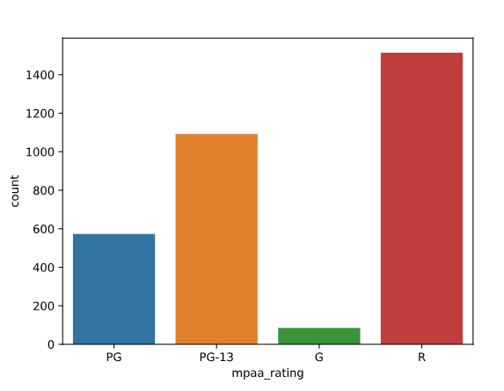
What type of movie is most/least common?
Most = R
Least = G

