Skill 27.1 Exercise 1
Refer to the movies DataFrame below.
 | movie | production_budget | domestic_gross | worldwide_gross | mpaa_rating | genre
0 | Evan Almighty | 175000000.0 | 100289690.0 | 174131329.0 | PG | Comedy
1 | Waterworld | 175000000.0 | 88246220.0 | 264246220.0 | PG-13 | Action
2 | King Arthur: Legend of the Sword | 175000000.0 | 39175066.0 | 139950708.0 | PG-13 | Adventure
3 | 47 Ronin | 175000000.0 | 38362475.0 | 151716815.0 | PG-13 | Action
4 | Jurassic World: Fallen Kingdom | 170000000.0 | 416769345.0 | 1304866322.0 | PG-13 | Action

For each variable in the movies DataFrame, indicate whether it is quantitative or categorical
How could you use the describe() method to display the summary statistics for all the columns in the movies DataFrame?

Skill 27.2 Exercise 1
Refer to the movies DataFrame below.
 | movie | production_budget | domestic_gross | worldwide_gross | mpaa_rating | genre
0 | Evan Almighty | 175000000.0 | 100289690.0 | 174131329.0 | PG | Comedy
1 | Waterworld | 175000000.0 | 88246220.0 | 264246220.0 | PG-13 | Action
2 | King Arthur: Legend of the Sword | 175000000.0 | NaN | 139950708.0 | PG-13 | Adventure
3 | 47 Ronin | NaN | 38362475.0 | 151716815.0 | PG-13 | Action
4 | Jurassic World: Fallen Kingdom | 170000000.0 | 416769345.0 | NaN | NaN | Action

Select the production_budget column and store it in a variable called budget.
Write to code to answer the following,

- What is the data type of production_budget?
- How many missing values does it have?
- How many unique values does it have?
- What are the unique values?

Skill 27.3 Exercise 1
Refer to the movies DataFrame below which shows the first 5 rows of a larger dataset.
 | movie | production_budget | domestic_gross | worldwide_gross | mpaa_rating | genre
0 | Evan Almighty | 175000000.0 | 100289690.0 | 174131329.0 | PG | Comedy
1 | Waterworld | 175000000.0 | 88246220.0 | 264246220.0 | PG-13 | Action
2 | King Arthur: Legend of the Sword | 175000000.0 | NaN | 139950708.0 | PG-13 | Adventure
3 | 47 Ronin | NaN | 38362475.0 | 151716815.0 | PG-13 | Action
4 | Jurassic World: Fallen Kingdom | 170000000.0 | 416769345.0 | NaN | NaN | Action

Calculate the mean and median of production_budget.
The actual values of the mean and median are 33284743.23 and 20000000.0, respectively, what measure better represents a "typical" movie? Justify your answer.
Determine the mode for the mpaa_rating. Why is the mode more appropriate than the mean or median here?

Skill 27.4 Exercise 1
Refer to the movies DataFrame below which shows the first 5 rows of a larger dataset.
 | movie | production_budget | domestic_gross | worldwide_gross | mpaa_rating | genre
0 | Evan Almighty | 175000000.0 | 100289690.0 | 174131329.0 | PG | Comedy
1 | Waterworld | 175000000.0 | 88246220.0 | 264246220.0 | PG-13 | Action
2 | King Arthur: Legend of the Sword | 175000000.0 | NaN | 139950708.0 | PG-13 | Adventure
3 | 47 Ronin | NaN | 38362475.0 | 151716815.0 | PG-13 | Action
4 | Jurassic World: Fallen Kingdom | 170000000.0 | 416769345.0 | NaN | NaN | Action

Calculate the min, max, and range of production_budget.
Calculate the IQR
The actual values of the range and IQR are 74750000.0 and 36000000.0, respectively.
How do extreme blockbuster movies affect each measure?
Which statistic better describes the spread of most movies?
Calculate the standard deviation
The actual value of the standard deviation is 34892390.59. Based on this value and the previous values, is the data symmetric or skewed?

Skill 27.5 Exercise 1
Below is a box blot of the movie data from the previous exercise.
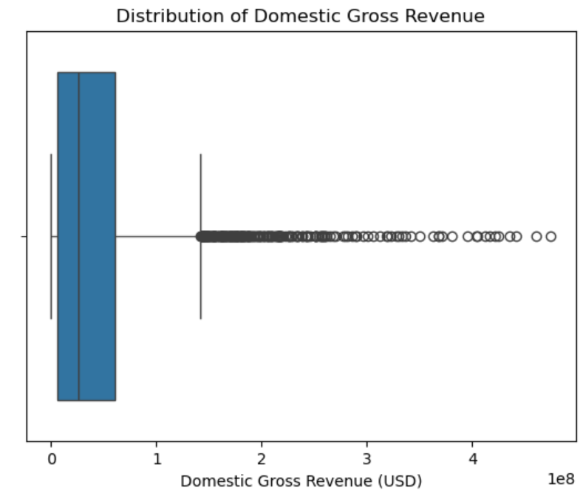

Label each of the following on the plot:
- Left whisker
- Right whisker
- Quantile 1, Quantile 2, and Quantile 3
- Outliers
- ICQ
Based on this boxplot, which measure of center and which measure of spread would best describe a typical movie? Explain why.
Below is a histogram of the movie data from the previous exercise.
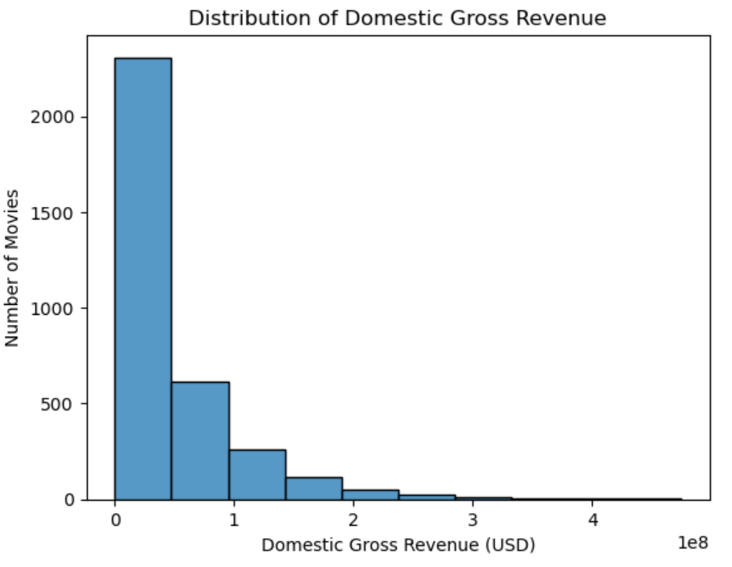
How would this histogram change if there were no extremely high-grossing movies?
Which measure of center and spread would become more appropriate?

Skill 27.6 Exercise 1
Refer to the movies DataFrame below which shows the first 5 rows of a larger dataset.
 | movie | production_budget | domestic_gross | worldwide_gross | mpaa_rating | genre
0 | Evan Almighty | 175000000.0 | 100289690.0 | 174131329.0 | PG | Comedy
1 | Waterworld | 175000000.0 | 88246220.0 | 264246220.0 | PG-13 | Action
2 | King Arthur: Legend of the Sword | 175000000.0 | NaN | 139950708.0 | PG-13 | Adventure
3 | 47 Ronin | NaN | 38362475.0 | 151716815.0 | PG-13 | Action
4 | Jurassic World: Fallen Kingdom | 170000000.0 | 416769345.0 | NaN | NaN | Action

Use the value_counts() method to count how many movies fall into each mpaa_rating. Describe the expected output.
Use the normalize attribute to convert the MPAA rating counts above to proportions.
Use sns.countplot() to create a bar chart of the counts.
Below is a bar chart which shows the counts for each movie in the mpaa_rating column.
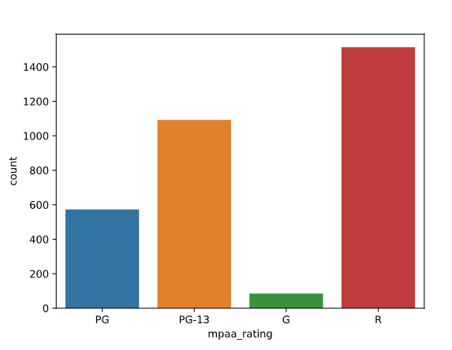
What type of movie is most/least common?

