Skill 26.1 Exercise 1
Refer to the movies DataFrame below.
 | movie | production_budget | domestic_gross | worldwide_gross | mpaa_rating | genre
0 | Evan Almighty | 175000000.0 | 100289690.0 | 174131329.0 | PG | Comedy
1 | Waterworld | 175000000.0 | 88246220.0 | 264246220.0 | PG-13 | Action
2 | King Arthur: Legend of the Sword | 175000000.0 | 39175066.0 | 139950708.0 | PG-13 | Adventure
3 | 47 Ronin | 175000000.0 | 38362475.0 | 151716815.0 | PG-13 | Action
4 | Jurassic World: Fallen Kingdom | 170000000.0 | 416769345.0 | 1304866322.0 | PG-13 | Action

Suppose we want to compare the production_budgets for PG and R movies. Create two lists: one that has the production_budget for PG movies and another that has the production_budget for R movies.
Calculate the mean and median difference.

Skill 26.2 Exercise 1
Refer to the movies DataFrame below.
 | movie | production_budget | domestic_gross | worldwide_gross | mpaa_rating | genre
0 | Evan Almighty | 175000000.0 | 100289690.0 | 174131329.0 | PG | Comedy
1 | Waterworld | 175000000.0 | 88246220.0 | 264246220.0 | PG-13 | Action
2 | King Arthur: Legend of the Sword | 175000000.0 | NaN | 139950708.0 | PG-13 | Adventure
3 | 47 Ronin | NaN | 38362475.0 | 151716815.0 | PG-13 | Action
4 | Jurassic World: Fallen Kingdom | 170000000.0 | 416769345.0 | NaN | NaN | Action

Filter the dataframe for the movies with an mpaa_rating of R and PG only. Store the results in a new dataframe, PG_R
Complete the spaces below to make side by side box plots for R and PG movies.
sns.boxplot(data = ,
x = ,
y = ,
hue = ,
legend = )
plt.show()

Below are the actual box plots for PG and R movies,

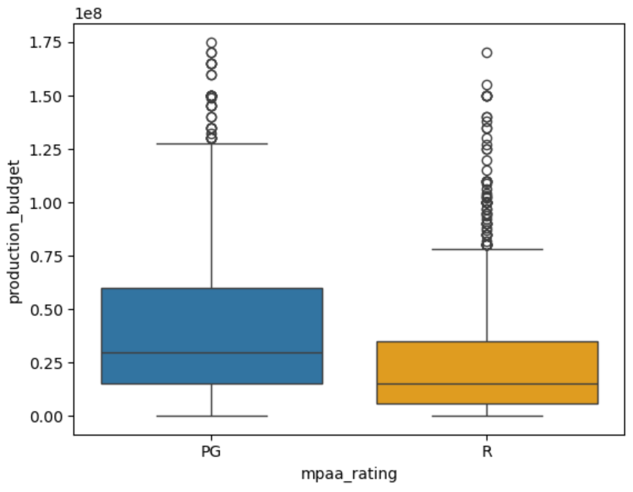
Based on the box plots, does movie rating appear to be associated with budget — that is, do PG and R movies have different budget distributions?

Skill 26.3 Exercise 1
Refer to the lists previously created in Skill 26.1 Exercise 1. One has the production_budget for PG movies and the other has the production_budget for R movies. Complete the spaces below to make overlapping histograms.
plt.hist( , color="blue", label= , density= , alpha= )
plt.hist( , color="red", label= , density= , alpha= )
plt.legend()
plt.show()

Below are the actual overlapping histograms for PG and R movie production budgets,

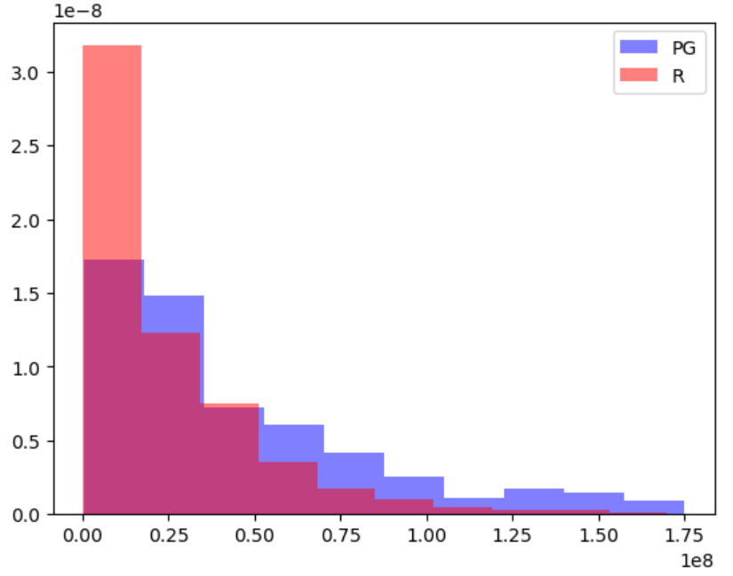

Based on the overlapping histograms, does production budget appear to be associated with movie rating? Support your answer with evidence from the graph.

Skill 26.4 Exercise 1
Refer to the movies dataframe from above
Complete the spaces below to make side by side box plots for all mpaa_ratings
sns.boxplot(data = ,
x = ,
y = ,
hue = ,
legend = )
plt.show()

Below are the actual box plots for all mpaa_ratings

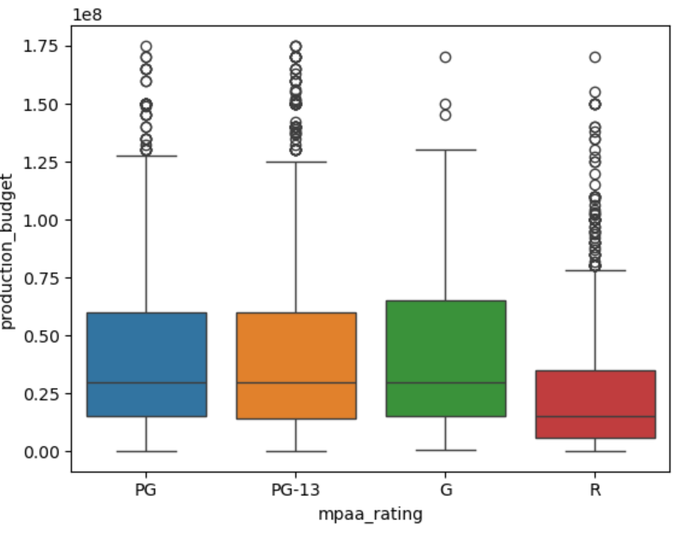
Based on the box plots, does movie rating appear to be associated with budget?

